Lesson 29
Objective: Solve subtraction problems using ten as a unit, and write
two-step solutions.

Suggested Lesson Structure
 Fluency Practice (15 minutes)
 Application Problem (5 minutes)
 Concept Development (30 minutes)
 Student Debrief (10 minutes)
Total Time (60 minutes)
Fluency Practice (15 minutes)
- Say Ten: 5-group Columns 1.NBT.2 (3 minutes)
- Magic Counting Sticks 1.OA.6 (4 minutes)
- Happy Counting by Fives 1.OA.5 (3 minutes)
- Take from Ten Subtraction 1.OA.6 (5 minutes)
Say Ten: 5-group Columns (3 minutes)
Materials: (T) 5-group column cards (Lesson 27 Fluency Template)
Note: This fluency activity reviews the unit of 1 ten as a 5-group column, which was introduced in the last lesson.
T: (Hold up the card showing 13.) Tell me how many, the Say Ten way.
S: Ten 3.
T: How many tens?
S: 1 ten.
T: How many ones?
S: 3 ones.
Repeat this process and alternate between requesting that students respond the Say Ten way and saying the number of tens and ones.
Magic Counting Sticks (4 minutes)
Materials: (T) Hide Zero cards (Lesson 18 Fluency Template 1)
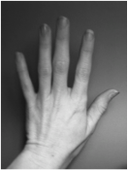
Note: This activity reviews decomposing teen numbers in order to subtract.
T: (Assign partners. Show 15 with Hide Zero cards.) Partner A, show the ones. Partner B, show the tens. How many ones are in 15?
S: 5.
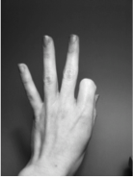
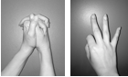
T: How many tens?
S: 1.
T: If we wanted to subtract 2, which partner should do it?
S: Partner A.
T: Yes. Subtract 2 from 15. What number do you see?
S: 13.
Alternate partners and continue with the suggested sequence: 12 – 2, 13 – 1, 14 – 2, 14 – 3, 15 – 3, 16 – 4, etc. Differences should be between 10 and 19.
Happy Counting by Fives (3 minutes)
Note: This maintenance fluency activity reviews adding and subtracting 5.
Repeat the Happy Counting activity from Lesson 4, counting by fives from 0 to 40 and back. First, count the Say Ten way, and then, count the regular way.
Take from Ten Subtraction (5 minutes)
Materials: (T) Subtract 9 flashcards (Lesson 17 Fluency Template), subtract 8 flashcards (Lesson 20 Fluency Template), subtract 7 and 6 flashcards (Fluency Template)
Note: This activity reviews the take from ten subtraction strategy.
Show a flashcard (e.g., 12 – 8 = ____). Cold call a student or group of students to answer. If students need additional help subtracting 8, use the following vignette.
T: Say 12 the Say Ten way.
S: Ten 2.
T: 10 – 8 = ____. (Snap.)
S: 2.
T: 2 + 2 = ____. (Point to the 2 on the flashcard, and snap.)
S: 4.
T: So, 12 – 8 = ____. (Snap.)
S: 4.
Repeat the process using subtract 9, 8, 7, and 6 flashcards.
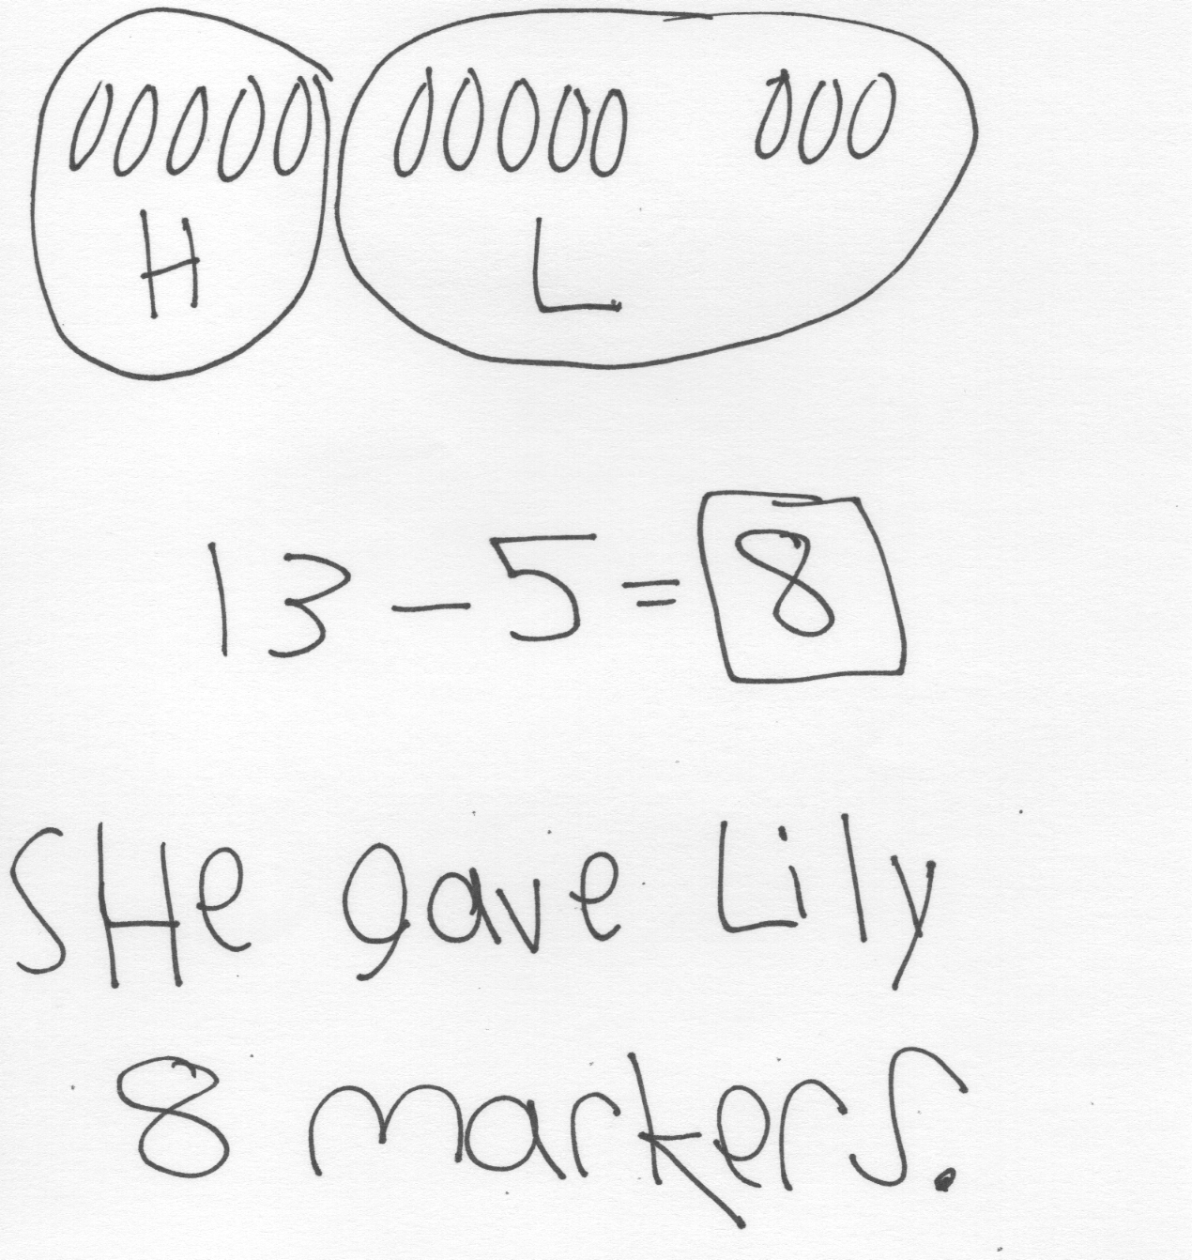
Application Problem (5 minutes)
Hae Jung had 13 markers, and she gave some to Lily. If Hae Jung then had 5 markers, how many markers did she give to Lily?
Note: Students continue to consider take apart with addend unknown problem types in this problem. During the Debrief, students have the opportunity to apply today’s objective to the problem, writing number sentences to show the two steps in the Level 3 strategy of taking from ten.
Concept Development (30 minutes)
Materials: (T) Hide Zero cards (Lesson 18 Fluency Template 1) (S) Personal white board
Have students gather in a semi-circle in the meeting area with their personal white boards.
T: (Project and read.) Suhani has some presents left to open. If she received 13 presents and already opened 8 of them, how many presents does Suhani still need to open? Solve this problem with your partner.

NOTES ON
MULTIPLE MEANS
OF REPRESENTATION:
Some students may benefit from connecting the abstract number bonds and equations with concrete materials. Linking cubes in sticks of 10 and separated ones or Rekenreks can be used along with the numbers. Using concrete and abstract representations simultaneously develops stronger mental images. Moving to the use of the abstract while visualizing the concrete materials can increase students’ confidence and math fluency.
T: I see that many of you used a subtraction sentence,
13 – 8, to solve this problem. What is 13 – 8? How many presents does Suhani need to open?
S: 5 presents!
T: In the number 13, do we have any tens? How many tens do we have?
S: Yes! 1 ten!
T: Along with 1 ten, do we have any extra ones? How many?
S: Yes! 3 ones!
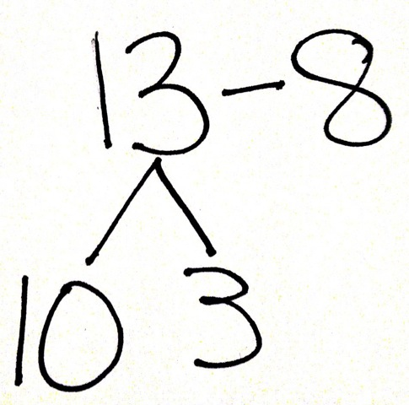
T: (Hold up the number 13 with Hide Zero cards.) The number 13 is made of 1 ten and 3 ones. (Pull apart the two cards to show the 10 card and the 3 card separately.)
T: Where should I take 8 from? The 1 ten or the 3 ones?
S: From the ten.
T: How many ones are left over when we take 8 from the ten?
MP.7
S: 2 ones.
T: Write down the number sentence to show how we just subtracted 8.
S: 10 – 8 = 2.
T: (Put down the 10 card and hold up 2 fingers next to the 3 card.)
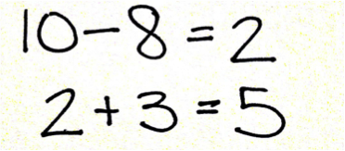
T: Did we have any extra ones from the starting number?
S: Yes. We had 3 ones.
MP.7
T: Let’s put the ones together. (Continue to hold up 2 fingers and the 3 card.) Write down the number sentence that tells how many ones we have altogether.
S: 2 ones + 3 ones = 5 ones.

NOTES ON
MULTIPLE MEANS
OF EXPRESSION:
As students explain their thinking, the teacher can support them by recording their strategies using mathematical number sentences. This helps students make the connection between abstract equations and their oral language.
T: So, when we solved 13 – 8 and got 5, we started with
1 ten and 3 ones. We ended with no tens and 5 ones. Where did the ten go? Turn and talk to your partner. Point to the number sentence that shows how we ended with 0 tens.
S: We don’t have a ten anymore because we used it to take away 8. (Point to 10 – 8.)
T: Explain to your partner how we then ended with
5 ones. (Point to 2 + 3 = 5.)
S: We had 2 ones left from 10 – 8, and we still had 3 extra ones, so we added 2 and 3 to get 5.
T: Today, let’s write two number sentences each time we solve a problem like this, so we can see how we took away from the ten first and then added the extra ones.
Repeat the process, having students write two number sentences to show taking away from the ten and adding the extra ones, using the following sequence with add to with change unknown and take apart/put together with addend unknown problem types: 11 – 5, 12 – 9, 14 – 6, 17 – 8, and 16 – 7. If students appear to require more support at the onset, complete the first problem or two as a class.
Note: Some students may find it easier to count back when subtracting. When solving 13 – 8, students may subtract 3 first to make a ten, then subtract 5 more, writing 13 – 3 = 10 and 10 – 5 = 5 as their number sentences. This is another efficient Level 3 strategy that uses two steps. Today, however, students are asked to solve the problems by taking from ten first.
Problem Set (10 minutes)
Students should do their personal best to complete the Problem Set within the allotted 10 minutes. For some classes, it may be appropriate to modify the assignment by specifying which problems they work on first. Some problems do not specify a method for solving. Students should solve these problems using the RDW approach used for Application Problems.
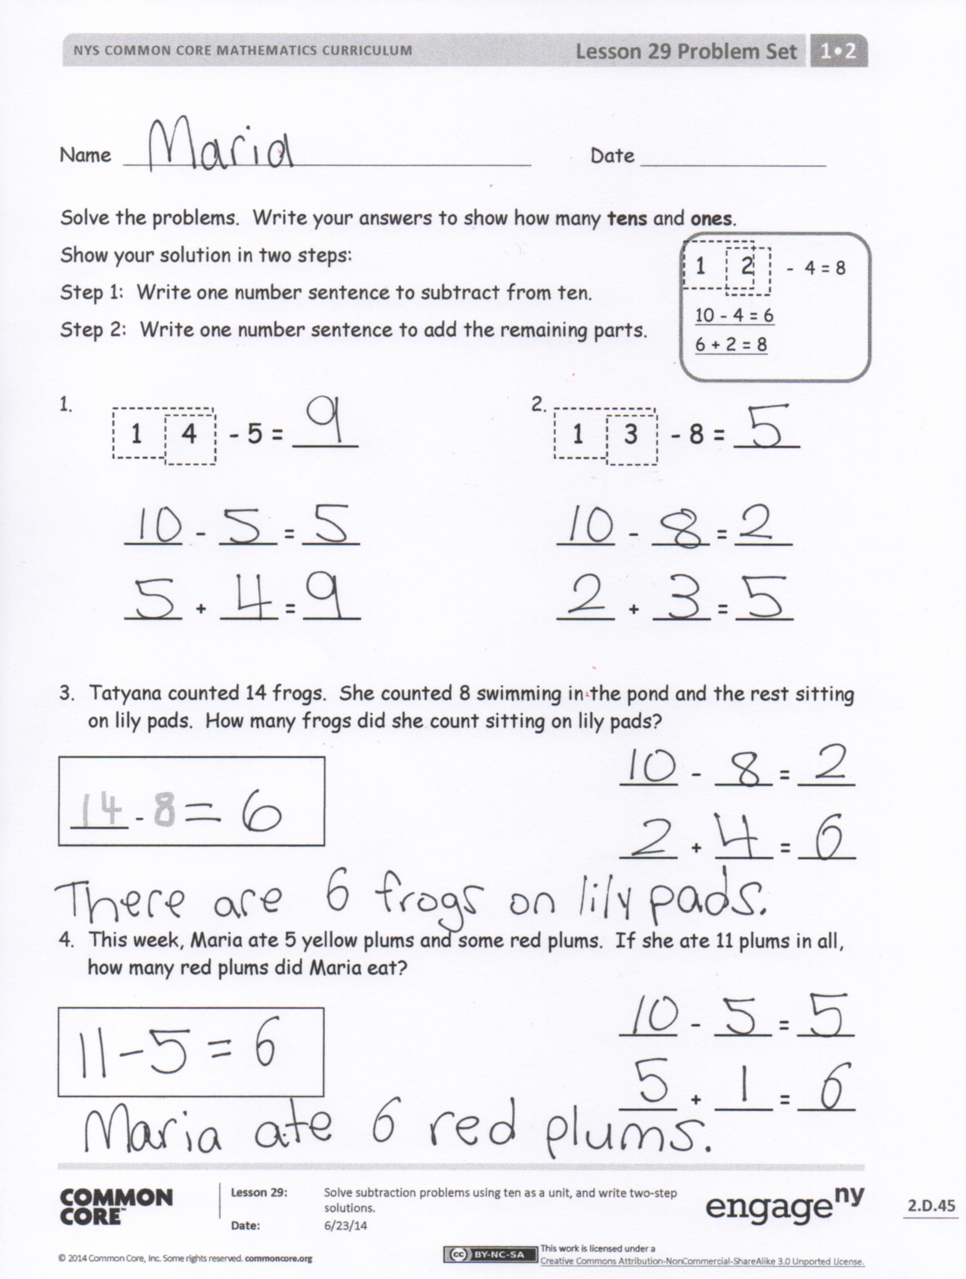
Student Debrief (10 minutes)
Lesson Objective: Solve subtraction problems using ten as a unit, and write two-step solutions.
The Student Debrief is intended to invite reflection and active processing of the total lesson experience.
Invite students to review their solutions for the Problem Set. They should check work by comparing answers with a partner before going over answers as a class. Look for misconceptions or misunderstandings that can be addressed in the Debrief. Guide students in a conversation to debrief the Problem Set and process the lesson.
You may choose to use any combination of the questions below to lead the discussion.
- Look at Problem 7 in your Problem Set. How many tens do you have left? Explain how we started with 1 ten and some ones and ended with 0 tens and some ones.
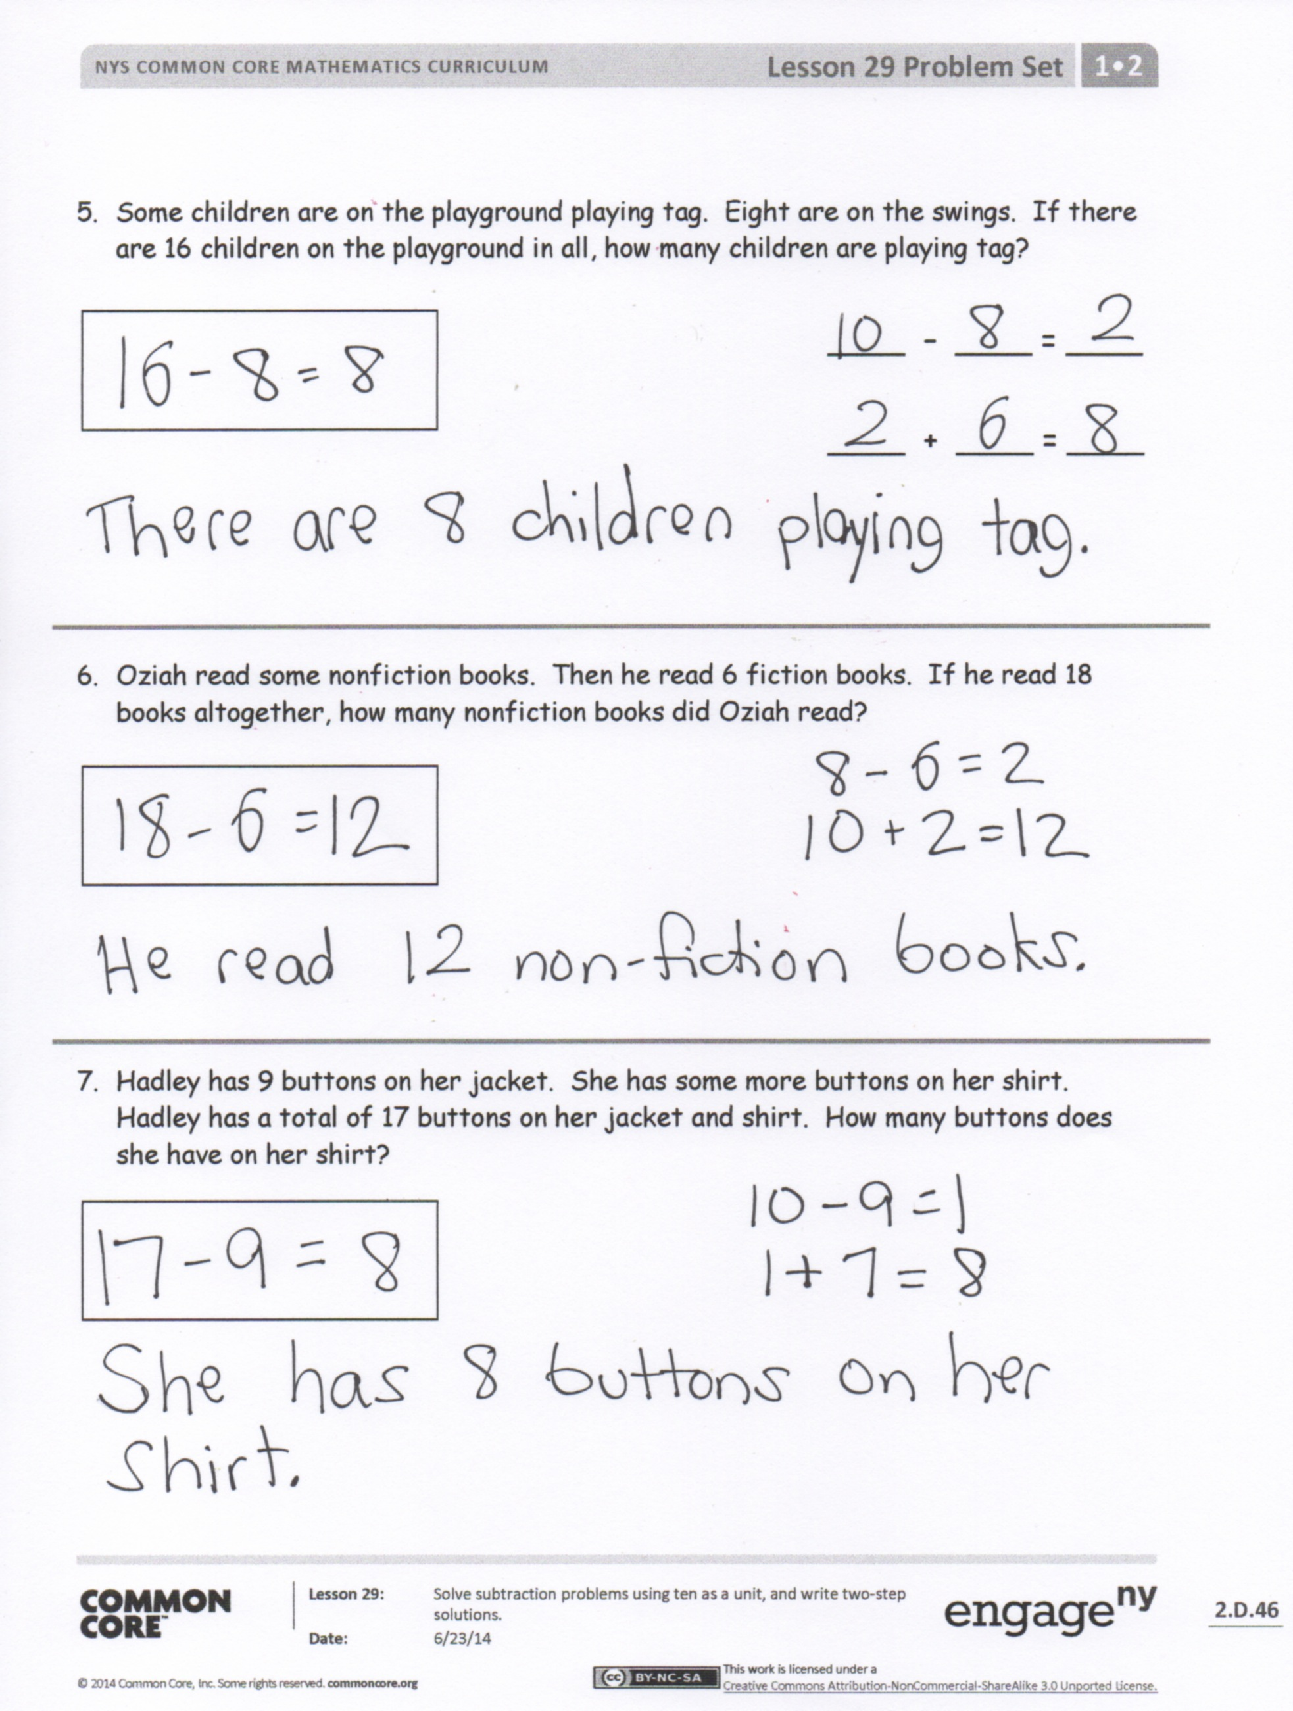
- How is Problem 6 different from the rest of the problems in your Problem Set? How did you solve Problem 6 using two number sentences? Explain why we still have 1 ten as a part of your answer.
- In what new way did we solve subtraction problems today?
- How can you solve today’s Application Problem using two number sentences so we can see how we took away from the ten first and then added the extra ones?
Exit Ticket (3 minutes)
After the Student Debrief, instruct students to complete the Exit Ticket. A review of their work will help you assess the students’ understanding of the concepts that were presented in the lesson today and plan more effectively for future lessons. You may read the questions aloud to the students.

Name Date
Solve the problems. Write your answers to show how many tens and ones.
1 2 – 4 = 8
10 – 4 = 6
6 + 2 = 8
Show your solution in two steps:
Step 1: Write one number sentence to subtract from ten.
Step 2: Write one number sentence to add the remaining parts.

1. 2.
1 3 - 8 = ____
1 4 - 5 = ____

____ – ____ = ____
____ + ____ = ____

3. Tatyana counted 14 frogs. She counted 8 swimming in the pond and the rest sitting on lily pads. How many frogs did she count sitting on lily pads?
____ - ____ = ____
____ – ____ = ____
____ + ____ = ____

4. This week, Maria ate 5 yellow plums and some red plums. If she ate 11 plums in all, how many red plums did Maria eat?

____ – ____ = ____
____ + ____ = ____

5. Some children are on the playground playing tag. Eight are on the swings. If there are 16 children on the playground in all, how many children are playing tag?

____ – ____ = ____
____ + ____ = ____

6. Oziah read some nonfiction books. Then, he read 6 fiction books. If he read 18 books altogether, how many nonfiction books did Oziah read?

7. Hadley has 9 buttons on her jacket. She has some more buttons on her shirt. Hadley has a total of 17 buttons on her jacket and shirt. How many buttons does she have on her shirt?

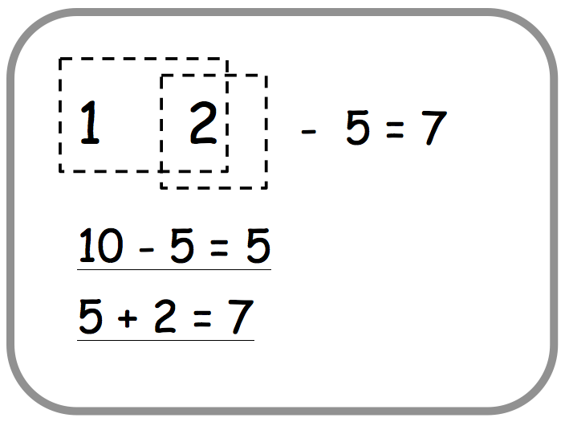
Name Date
Solve the problems. Write your answers to show how many tens and ones.

1. 2.
1 4 - 8 = ____
1 5 - 6 = ____

____ – ____ = ____
____ + ____ = ____
____ – ____ = ____
____ + ____ = ____

Name Date
Solve the problems. Write your answers to show how many tens and ones.

1. 2.
1 6 - 7 = ____
1 7 - 8 = ____

____ – ____ = ____
____ + ____ = ____
____ – ____ = ____
____ + ____ = ____

Solve. Write the two number sentences for each step to show how you take from ten. Remember to put a box around your solution and write a statement.
3. Yvette counted 12 kids at the park. She counted 3 on the playground and the rest playing in the sand. How many kids did she count playing in the sand?
____ - ____ = ____
____ – ____ = ____
____ + ____ = ____

4. Eli read some science magazines. Then, he read 9 sports magazines. If he read 18 magazines altogether, how many science magazines did Eli read?

____ – ____ = ____
____ + ____ = ____

5. On Monday, Paulina checked out 6 whale books and some turtle books from the library. If she checked out 13 books in all, how many turtle books did Paulina check out?
____ – ____ = ____
____ + ____ = ____
____ – ____ = ____
____ + ____ = ____

6. Some children are at the park playing soccer. Seven are wearing white shirts. If there are 14 children playing soccer in all, how many children are not wearing white shirts?

7. Dante has 9 stuffed animals in his room. The rest of his stuffed animals are in the TV room. Dante has 15 stuffed animals. How many of Dante’s stuffed animals are in the TV room?
____ – ____ = ____
____ + ____ = ____

10 - 7 | 11 - 7
12 - 7 | 13 - 7
14 - 7 | 15 - 7
16 - 7 | 17 - 7
10 – 6 | 11 – 6
12 – 6 | 13 – 6
14 – 6 | 15 – 6
16 – 6

subtract 7 and 6 flashcards
subtract 7 and 6 flashcards

