Lesson 28
Objective: Solve addition problems using ten as a unit, and write two-step solutions.
Suggested Lesson Structure
 Fluency Practice (13 minutes)
 Application Problem (5 minutes)
 Concept Development (32 minutes)
 Student Debrief (10 minutes)
Total Time (60 minutes)
Fluency Practice (13 minutes)
- Magic Counting Sticks 1.NBT.2 (3 minutes)
- Sprint: Adding by Decomposing Teen Numbers 1.OA.6 (10 minutes)
Magic Counting Sticks (3 minutes)
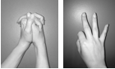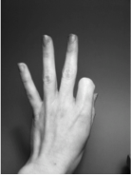Materials: (T) Hide Zero cards (Lesson 18 Fluency Template 1)
Note: This activity reviews the concept of ten as a unit and prepares students for today’s lesson.
T: (Divide students into partners. Show 13 with Hide Zero cards.) Partner A, show the ones. Partner B, show the tens. How many tens are in 13?
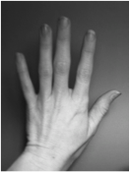
S: 1.
T: How many ones?
S: 3.
T: If I wanted to add 2, which partner could do it?
S: Partner A.
T: Yes. Add 2 to 13. What number do you see?
S: 15.
Alternate partners and continue with the suggested sequence: 12 + 2, 14 + 1, 15 + 3, 14 + 2, 15 + 3, 16 + 3, etc. All sums should be between 11 and 19.
Sprint: Adding by Decomposing Teen Numbers (10 minutes)
Materials: (S) Adding by Decomposing Teen Numbers Sprint
Note: This Sprint addresses the Grade 1 core fluency objective of adding and subtracting within 20.
Application Problem (5 minutes)
Ruben has 7 blue cars and 6 red cars. If Ruben puts all of the blue cars in his car carrier that carries 10 cars, how many red cars will fit in the carrier, and how many will be left out of the carrier?
Note: This Application Problem serves multiple purposes. Some students may respond to the problem with an answer of 13 cars, anticipating the question as, “How many cars does Ruben have?” Look for such misinterpretations as an opportunity to reinforce the importance of reading the question carefully. In addition, the problem gives students a chance to focus on the decomposition of the second addend when creating a unit of ten. This leads into today’s lesson in which students write number sentences to show the two steps in the Level 3 strategy of making ten.
Concept Development (32 minutes)
Materials: (T) Hide Zero cards (Lesson 18 Fluency Template 1) (S) Personal white board
Have students gather in a semi-circle in the meeting area with their personal white boards.
T: (Project 8 + 4.) Solve this problem with a partner.
S: (Discuss with partners.)
T: How many is 8 + 4?
S: 12!
T: In the number 12, do we have any tens? How many tens do we have?
S: Yes! 1 ten!
T: Along with 1 ten, do we have any extra ones? How many?
S: Yes! 2 ones!
T: (Hold up the number 12 with Hide Zero cards.) Right, the number 12 is made of 1 ten and 2 ones. (Pull apart the two cards to show 10 card and 2 card separately.)
T: How many tens in the number 8?
S: None!
T: How many tens in the number 4?
S: None!
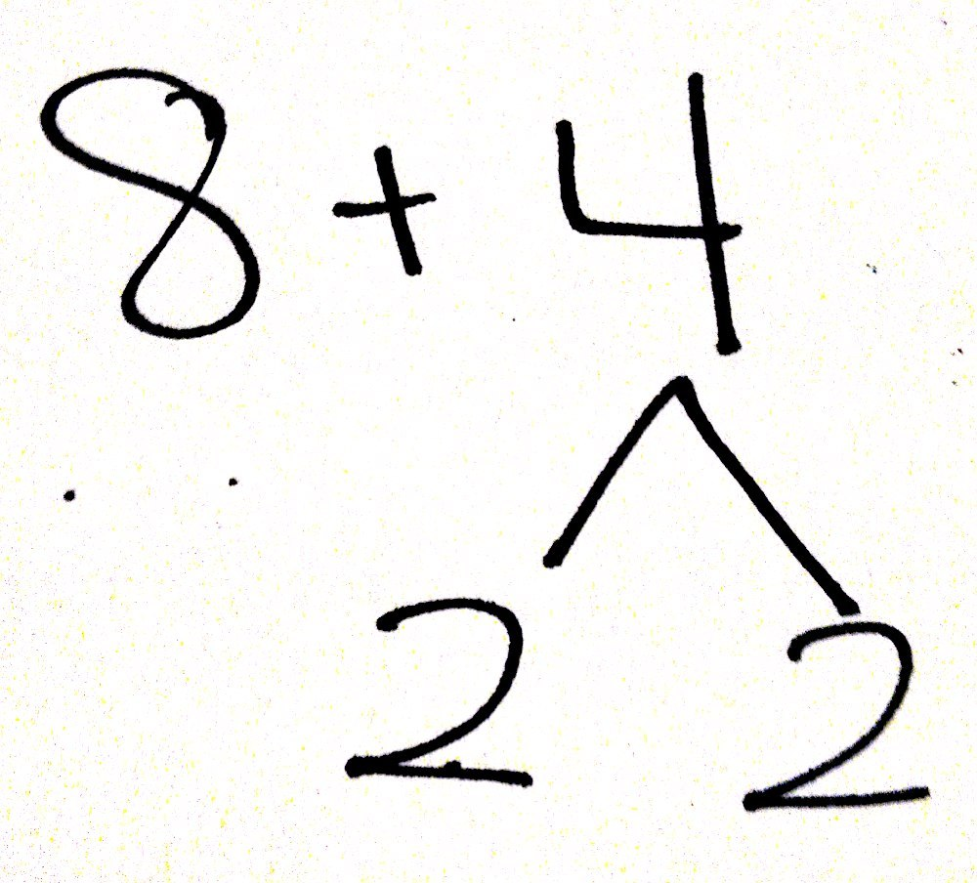
T: Then, how did we take 8 and 4, which didn’t have any tens, to make a number that has 1 ten and 2 ones? Talk with your partner.
S: (Discuss with partners.)
T: (Listen for students to articulate the making of 1 ten and extra ones when adding 8 and 4.)
T: How did we add 8 and 4 to make 12, which has 1 ten and 2 ones?
As students share, the goal is to create two number sentences. The first shows the addition that makes ten, and the second shows the addition of the ten and extra ones to make the final total as pictured to the right.
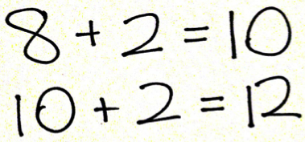
S: Break apart 4 into 2 and 2. Add 8 and 2 to make 1 ten, and then add 2 more ones. If you start at 8 and count on, you get to ten after 2 counts. That’s 1 ten. Then, you still have 2 more. That makes 12. 1 ten and 2 ones.
T: While you were sharing, I wrote your explanations as number sentences. You said that to solve 8 + 4, you started with 8 and added 2 out of the 4. That made 1 ten. (Point to 8 + 2 = 10 in the first number sentence.)

NOTES ON
MULTIPLE MEANS
OF ACTION
AND EXPRESSION:
In the beginning, students may get confused about which numbers go where when writing their two number sentences. Emphasize the importance of the addition of the ten for the first number sentence. Some students may need number sentences more concretely framed out. Have an example of a completed problem where they can easily see it to reference if they get confused.

T: Then, we have 2 more left from the 4, so you added your 1 ten and 2 ones to make 12. (Point to 10 + 2 = 12 in the second number sentence.) Did I explain that correctly?
S: Yes!
T: Write down the two number sentences I have on the board, and talk with your partner to explain how it shows the way we made 1 ten and 2 ones when adding 8 + 4.
S: (Discuss with partners.)
T: (Listen for students who are using accurate language. If students are not explaining 1 ten, emphasize the creation of 1 ten in upcoming examples.)
T: Today, let’s write two number sentences each time we solve a problem like this, so we can see how we made 1 ten first and then added the ones.

NOTES ON
MULTIPLE MEANS
OF REPRESENTATION:
For those students who have difficulty writing, provide the sentence frame when doing word problems. This helps students focus on their math without worrying about the writing.

Repeat the process, having students write two number sentences to show making 1 ten and adding the extra ones, using the following sequence: 8 + 5, 8 + 6, 9 + 6, 7 + 5, and
7 + 9. If students appear to require more support at the onset, complete the first problem or two as a class.

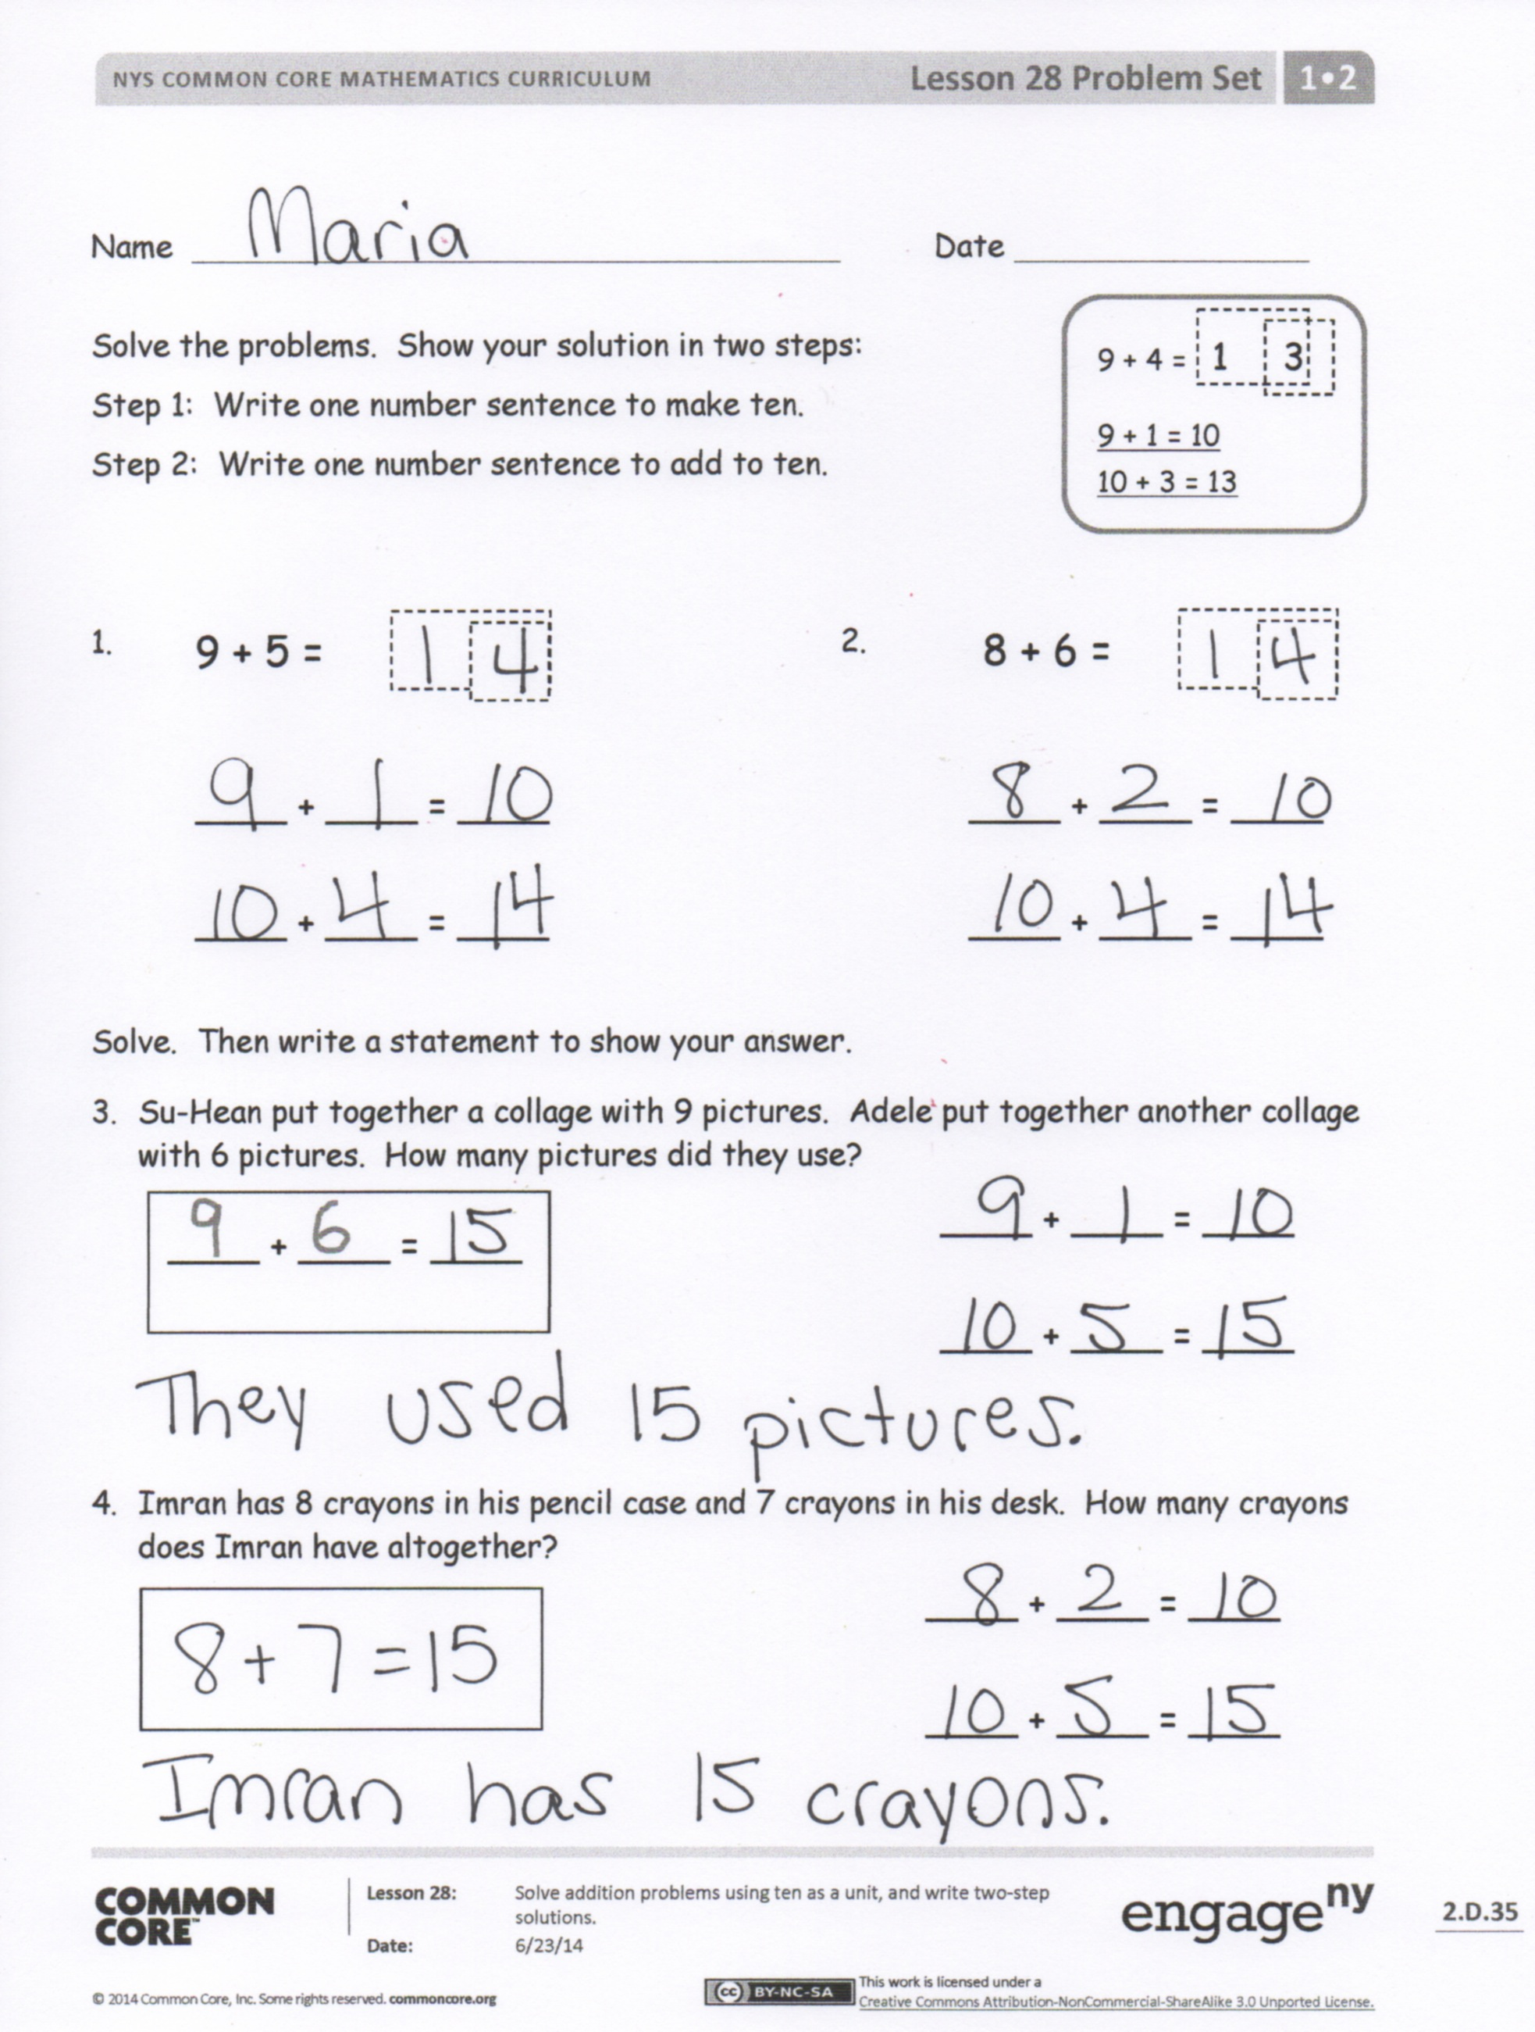
Problem Set (10 minutes)
Students should do their personal best to complete the Problem Set within the allotted 10 minutes. For some classes, it may be appropriate to modify the assignment by specifying which problems they work on first. Some problems do not specify a method for solving. Students should solve these problems using the RDW approach used for Application Problems.
Student Debrief (10 minutes)
Lesson Objective: Solve addition problems using ten as a unit, and write two-step solutions.
The Student Debrief is intended to invite reflection and active processing of the total lesson experience.
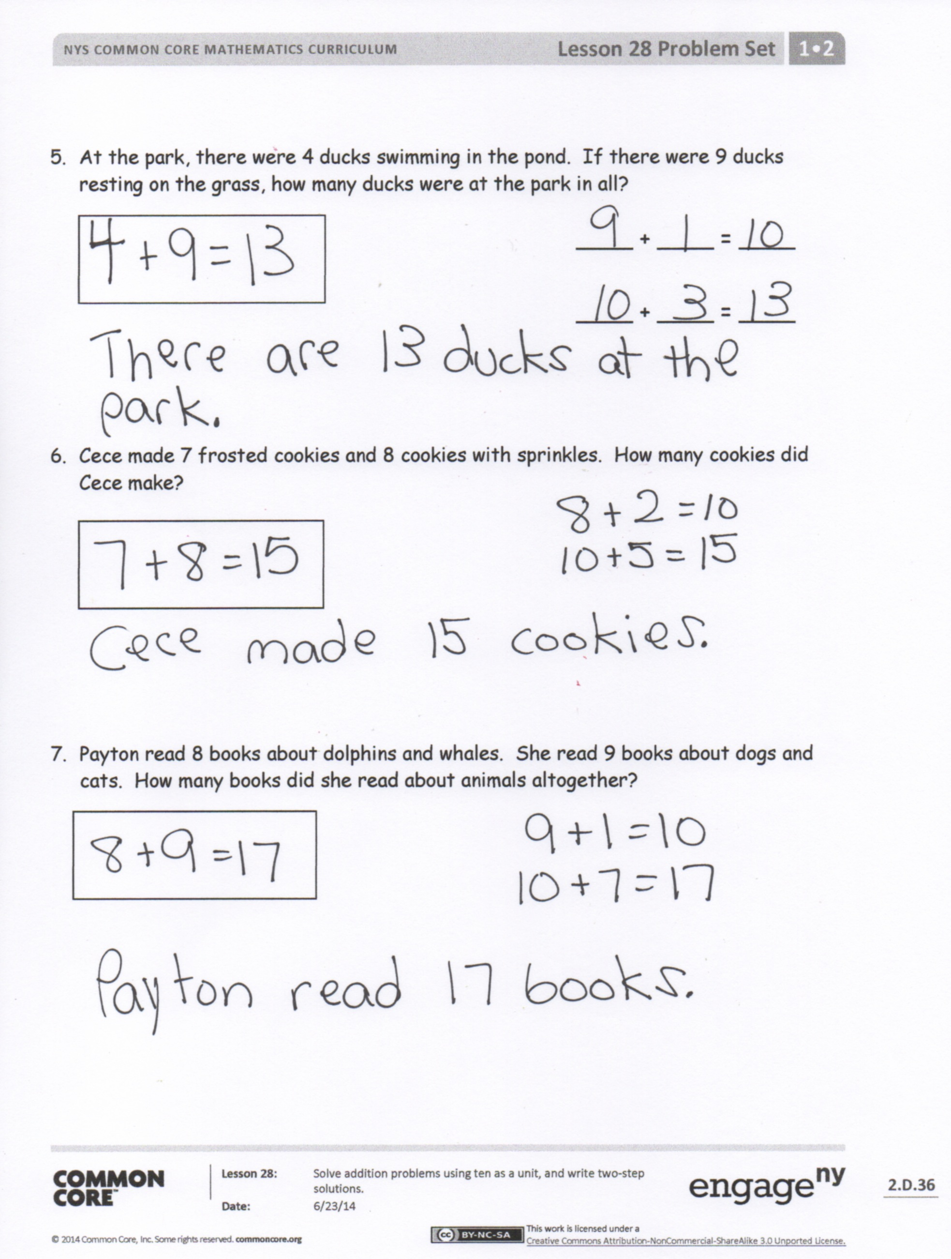
Invite students to review their solutions for the Problem Set. They should check work by comparing answers with a partner before going over answers as a class. Look for misconceptions or misunderstandings that can be addressed in the Debrief. Guide students in a conversation to debrief the Problem Set and process the lesson.
You may choose to use any combination of the questions below to lead the discussion.
- Look at Problem 1. How many tens and how many ones are there? Use a yellow crayon and find all of the places 1 ten is hiding within the Problem Set. (Color the 1 in all numbers from 10 through 19 within the Problem Set. They may also color the two-digit representation of 10.)
- Look at Problems 1 and 3. What do the number sentences have in common? (The first number sentence is the same.) Do you have any other problems on the Problem Set that have 9 + 1 = 10 as the first number sentence? What is similar about the problems that caused them to have the same number sentence as part of the solution?
- Look at Problems 1 and 2. How are they the same, and how are they different?
- Look at the Application Problem. Ruben has a carrier that fits 10 cars. How is Ruben’s 1 carrier like 1 ten?
- How many cars does Ruben have? Use two number sentences to show how we can make 1 ten and then add the extra ones.
Exit Ticket (3 minutes)
After the Student Debrief, instruct students to complete the Exit Ticket. A review of their work will help you assess the students’ understanding of the concepts that were presented in the lesson today and plan more effectively for future lessons. You may read the questions aloud to the students.

Name Date
Number correct:
A
*Write the missing number.
1 | 10 + 2 = ☐ |  | 16 | 12 + 3 = ☐
2 | 2 + 1 = ☐ |  | 17 | 13 + 3 = ☐
3 | 10 + 3 = ☐ |  | 18 | 14 + 3 = ☐
4 | 4 + 10 = ☐ |  | 19 | 13 + 5 = ☐
5 | 4 + 2 = ☐ |  | 20 | 14 + 5 = ☐
6 | 6 + 10 = ☐ |  | 21 | 15 + 5 = ☐
7 | 10 + 3 = ☐ |  | 22 | 4 + 14 = ☐
8 | 3 + 3 = ☐ |  | 23 | 4 + 15 = ☐
9 | 10 + 6 = ☐ |  | 24 | 12 + ☐ = 14
10 | 2 + 1 = ☐ |  | 25 | 12 + ☐ = 15
11 | 12 + 1 = ☐ |  | 26 | 12 + ☐ = 16
12 | 2 + 2 = ☐ |  | 27 | ☐ + 4 = 16
13 | 12 + 2 = ☐ |  | 28 | 5 + ☐ = 16
14 | 3 + 3 = ☐ |  | 29 | 5 + ☐ = 26
15 | 13 + 3 = ☐ |  | 30 | 4 + ☐ = 36
Name Date
Number correct:
B
*Write the missing number.
1 | 10 + 1 = ☐ |  | 16 | 12 + 2 = ☐
2 | 1 + 1 = ☐ |  | 17 | 13 + 2 = ☐
3 | 10 + 2 = ☐ |  | 18 | 14 + 2 = ☐
4 | 3 + 10 = ☐ |  | 19 | 13 + 4 = ☐
5 | 3 + 2 = ☐ |  | 20 | 14 + 4 = ☐
6 | 5 + 10 = ☐ |  | 21 | 15 + 4 = ☐
7 | 10 + 2 = ☐ |  | 22 | 5 + 14 = ☐
8 | 2 + 2 = ☐ |  | 23 | 5 + 15 = ☐
9 | 10 + 4 = ☐ |  | 24 | 11 + ☐ = 12
10 | 2 + 1 = ☐ |  | 25 | 11 + ☐ = 13
11 | 12 + 1 = ☐ |  | 26 | 11 + ☐ = 14
12 | 1 + 1 = ☐ |  | 27 | ☐ + 3 = 14
13 | 11 + 1 = ☐ |  | 28 | 6 + ☐ = 19
14 | 3 + 2 = ☐ |  | 29 | 6 + ☐ = 29
15 | 13 + 2 = ☐ |  | 30 | 5 + ☐ = 39

Name Date
Solve the problems. Show your solution in two steps:
9 + 4 = 1 3
9 + 1 = 10
10 + 3 = 13
Step 1: Write one number sentence to make ten.
Step 2: Write one number sentence to add to ten.

9 + 5 =
8 + 6 =
- 2.
____ + ____ = ____
____ + ____ = ____
____ + ____ = ____
____ + ____ = ____

Solve. Then, write a statement to show your answer.
- Su-Hean put together a collage with 9 pictures. Adele put together another collage with 6 pictures. How many pictures did they use?
____ + ____ = ____
____ + ____ = ____
____ + ____ = ____

- Imran has 8 crayons in his pencil case and 7 crayons in his desk. How many crayons does Imran have altogether?
____ + ____ = ____
____ + ____ = ____

- At the park, there were 4 ducks swimming in the pond. If there were 9 ducks resting on the grass, how many ducks were at the park in all?
____ + ____ = ____
____ + ____ = ____

- Cece made 7 frosted cookies and 8 cookies with sprinkles. How many cookies did Cece make?

- Payton read 8 books about dolphins and whales. She read 9 books about dogs and cats. How many books did she read about animals altogether?

Name Date
9 + 7 = 1 6
9 + 1 = 10
10 + 6 = 16
Solve the problems. Write your answers to show how many tens
and ones.

8 + 7 =
9 + 4 =
- 2.
____ + ____ = ____
____ + ____ = ____
____ + ____ = ____
____ + ____ = ____

Name Date
Solve the problems. Write your answers to show how many tens and ones.
9 + 3 = 1 2
9 + 1 = 10
10 + 2 = 12

8 + 5 =
9 + 7 =
1. 2.
____ + ____ = ____
____ + ____ = ____
____ + ____ = ____
____ + ____ = ____

Solve. Write the two number sentences for each step to show how you make a ten.
- Boris has 9 board games on his shelf and 8 board games in his closet. How many board games does Boris have altogether?
____ + ____ = ____
____ + ____ = ____
____ + ____ =

- Sabra built a tower with 8 blocks. Yuri put together another tower with 7 blocks. How many blocks did they use?

- Camden solved 6 addition word problems. She also solved 9 subtraction word problems. How many word problems did she solve altogether?

- Minna made 4 bracelets and 8 necklaces with her beads. How many pieces of jewelry did Minna make?

- I put 5 peaches into my bag at the farmer’s market. If I already had 7 apples in my bag, how many pieces of fruit did I have in all?

