Lesson 6: Area in the Real World

Classwork

Exploratory Challenge 1: Classroom Wall Paint

The custodians are considering painting our classroom next summer. In order to know how much paint they must buy, the custodians need to know the total surface area of the walls. Why do you think they need to know this and how can we find the information?

Make a prediction of how many square feet of painted surface there are on one wall in the room. If the floor has square tiles, these can be used as a guide.

Estimate the dimensions and the area. Predict the area before you measure.

My prediction: ______________ .

* 1. Measure and sketch one classroom wall. Include measurements of windows, doors, or anything else that would not be painted.

*Sketch:*

|  |  |  |  |  |  |  |
| --- | --- | --- | --- | --- | --- | --- |
| **Object or item to be measured** | **Measurement units** | **Precision (measure to the nearest)** | **Length** | **Width** | **Expression that shows the area** | **Area** |
| door | feet | half foot |  |  |  |  |
|  |  |  |  |  |  |  |
|  |  |  |  |  |  |  |
|  |  |  |  |  |  |  |
|  |  |  |  |  |  |  |

* 1. Work with your partners and your sketch of the wall to determine the area that will need paint. Show your sketch and calculations below; clearly mark your measurements and area calculations.

C:\Users\glenn.gebhard\AppData\Local\Microsoft\Windows\Temporary Internet Files\Content.IE5\M22XH0CZ\MC900333154[1].wmf

* 1. A gallon of paint covers about. Write an expression that shows the total area. Evaluate it to find how much paint will be needed to paint the wall.
  2. How many gallons of paint would need to be purchased to paint the wall?

Exploratory Challenge 2

|  |  |  |  |  |  |
| --- | --- | --- | --- | --- | --- |
| **Object or item to be measured** | **Measurement units** | **Precision (measure to the nearest)** | **Length** | **Width** | **Area** |
| door | feet | half foot |  |  |  |
|  |  |  |  |  |  |
|  |  |  |  |  |  |
|  |  |  |  |  |  |
|  |  |  |  |  |  |

Problem Set

1. Below is a drawing of a wall that is to be covered with either wallpaper or paint. The wall is high and long. The window, mirror, and fireplace will not be painted or papered. The window measures by The fireplace is wide and high, while the mirror above the fireplace is by.

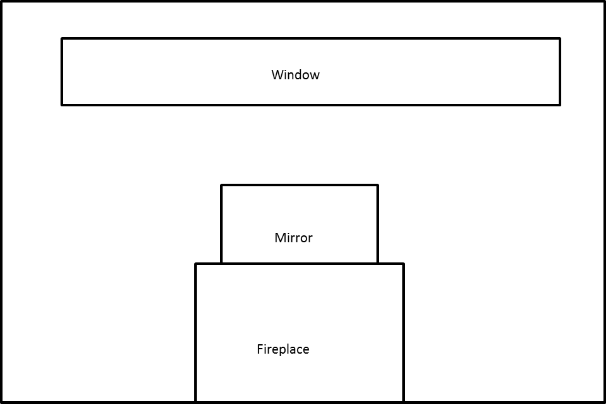

* 1. How many square feet of wallpaper are needed to cover the wall?
  2. The wallpaper is sold in rolls that are wide and long. Rolls of solid color wallpaper will be used, so patterns do not have to match up.
     1. What is the area of one roll of wallpaper?
     2. How many rolls would be needed to cover the wall?
  3. This week, the rolls of wallpaper are on sale for/roll. Find the cost of covering the wall with wallpaper.
  4. A gallon of special textured paint covers and is on sale for/gallon. The wall needs to be painted twice (the wall needs two coats of paint). Find the cost of using paint to cover the wall.

1. A classroom has a length of and a width of . The flooring is to be replaced by tiles. If each tile has a length of and a width of , how many tiles are needed to cover the classroom floor?
2. Challenge: Assume that the tiles from Problem 2 are unavailable. Another design is available, but the tiles are square, on a side. If these are to be installed, how many must be ordered?
3. A rectangular flower bed measures by. It has a path wide around it. Find the area of the path.

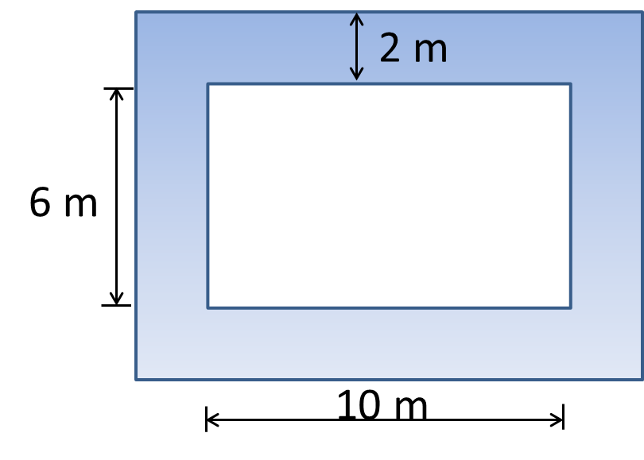

1. Tracy wants to cover the missing portion of his deck with soil in order to grow a garden.
   1. Find the missing portion of the deck. Write the expression and evaluate it.

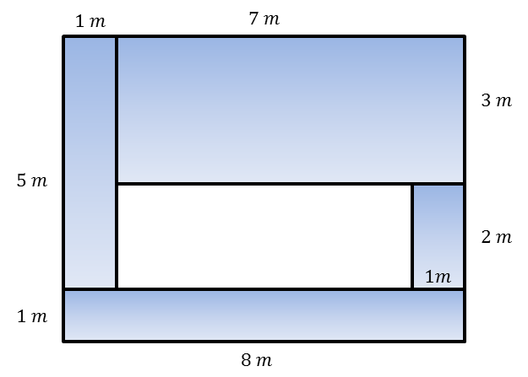

* 1. Find the missing portion of the deck using a different method. Write the expression and evaluate it.
  2. Write your two equivalent expressions.
  3. Explain how each demonstrates a different understanding of the diagram.

1. The entire large rectangle below has an area of. If the dimensions of the white rectangle are as shown below, write and solve an equation to find the area,, of the shaded region.

