|  |
| --- |
|  |

Lesson 6: Area in the Real World

Student Outcomes

* Students determine the area of composite figures in real-life contextual situations using composition and decomposition of polygons.
* Students determine the area of a missing region using composition and decomposition of polygons.

Lesson Notes

Finding area in real-world contexts can be done around the classroom, in a hallway, or in different locations around the school. This lesson will require the teacher to measure and record the dimensions of several objects and calculate the area ahead of time. Choices will be dependent on time available and various students’ needs. Different levels of student autonomy can be taken into account when grouping and deciding which objects will be measured. Further, the measurement units and precision can be adjusted to the students’ ability level.

Floor tile, carpet area, walls, and furniture in the classroom can be used for this lesson. Smaller objects within the classroom may also be used, such as bulletin boards, notebooks, windows, and file cabinets. Exploring the school building for other real-world area problems might lead to a stage in an auditorium or walkway around a school pool. Of course, adhere to school policy regarding supervision of students, and be vigilant about safety. Students should not have to climb to make measurements.

Throughout the lesson, there are opportunities to compare unsimplified numerical expressions. These are important and should be emphasized because they help prepare students for algebra.

Classwork

Gauge students’ ability level regarding which units and level of precision will be used in this lesson. Using metric units for length and height of the classroom wall will most likely require measuring to the nearestmeter or meter and will require multiplying decimals to calculate area. Choosing standard units allows precision to be set to the nearest foot, half foot, etc. but could require multiplying fractional lengths.

**MP.5&**

**MP.6**

*Scaffolding:*

As noted in the classwork section, there is great flexibility in this lesson, so it can be tailored to the needs of the class and can be easily individualized for both struggling and advanced learners. English language learners might need a mini-lesson on the concept of wallpaper with accompanying visuals and video, if possible.

Discussion (5 minutes)

Decide if the whole group will stay in the classroom or if carefully selected groups will be sent out on a measurement mission to somewhere outside the classroom. All students will need to understand which measurement units to use and to what precision they are expected to measure.

* Area problems in the real world are all around us. Can you give an example of when you might need to know the area of something?
  + *Area needs to be considered when covering an area with paint, carpet, tile, or wallpaper; wrapping a present; etc.*
* The Problem Set from the last lesson had a wall that was to be painted. What measurement units were used in that problem?
  + *All linear measurements were made in feet. Paint was calculated in quarts.*
* How precisely were the measurements made?
  + *Measurements were most likely measured to the nearest foot. Paint was rounded up to the next quart.*
* Could those measurements have been made more precisely?
  + *Yes, measurements could have been made to the nearest inch, half inch, or some other smaller fraction of an inch. Paint can be purchased in pints.*
* We can measure the dimensions of objects and use those measurements to calculate the surface area of the object. Our first object will be a wall in this classroom.

Exploratory Challenge 1: Classroom Wall Paint (34 minutes)

*Scaffolding:*

This same context can be worded more simply for ELL students, and beginner-level students would benefit from a quick pantomime of painting a wall. A short video clip might also set the context quickly.

Exploratory Challenge 1: Classroom Wall Paint

The custodians are considering painting our classroom next summer. In order to know how much paint they must buy, the custodians need to know the total surface area of the walls. Why do you think they need to know this, and how can we find the information?

All classroom walls are different. Taking overall measurements then subtracting windows, doors, or other areas will give a good approximation.

Make a prediction of how many square feet of painted surface there are on one wall in the room. If the floor has square tiles, these can be used as a guide.

Students make a prediction of how many square feet of painted surface there are on one wall in the room. If the floor has square tiles, these can be used as a guide.

Decide beforehand the information in the first three columns. Measure lengths and widths, and calculate areas. Ask students to explain their predictions.

Estimate the dimensions and the area. Predict the area before you measure. My prediction: ______________ .

* 1. Measure and sketch one classroom wall. Include measurements of windows, doors, or anything else that would not be painted.

Student responses will be determined by the teacher’s choice of wall.

|  |  |  |  |  |  |  |
| --- | --- | --- | --- | --- | --- | --- |
| Object or item to be measured | Measurement units | Precision  (measure to the nearest) | Length | Width | Expression that shows the area | Area |
| door | feet | half foot |  |  |  |  |
|  |  |  |  |  |  |  |
|  |  |  |  |  |  |  |
|  |  |  |  |  |  |  |
|  |  |  |  |  |  |  |

* 1. Work with your partners and your sketch of the wall to determine the area that will need paint. Show your sketch and calculations below; clearly mark your measurements and area calculations.

C:\Users\glenn.gebhard\AppData\Local\Microsoft\Windows\Temporary Internet Files\Content.IE5\M22XH0CZ\MC900333154[1].wmf

* 1. A gallon of paint covers about. Write an expression that shows the total area. Evaluate it to find how much paint will be needed to paint the wall.

Answers will vary based on the size of the wall. Fractional answers are to be expected.

* 1. How many gallons of paint would need to be purchased to paint the wall?

Answers will vary based on the size of the wall. The answer from part (d) should be an exact quantity because gallons of paint are discrete units. Fractional answers from part (c) must be rounded up to the nearest whole gallon.

Exploratory Challenge 2 (Optional—15 minutes)

Assign other walls in the classroom for groups to measure and calculate the area, or send some students to measure and sketch other real-world area problems found around the school. The teacher should measure the objects prior to the lesson using the same units and precision the students will be using. Objects may have to be measured multiple times if the activity has been differentiated using different units or levels of precision.

Exploratory Challenge 2

|  |  |  |  |  |  |
| --- | --- | --- | --- | --- | --- |
| Object or item to be measured | Measurement units | Precision  (measure to the nearest) | Length | Width | Area |
| Door | feet | half foot |  |  |  |
|  |  |  |  |  |  |
|  |  |  |  |  |  |
|  |  |  |  |  |  |
|  |  |  |  |  |  |

Closing (3 minutes)

* What real-life situations require us to use area?
  + *Floor covering, like carpets and tiles, require area measurements. Wallpaper and paint also call for area measurements. Fabric used for clothing and other items also demand that length and width be considered. Wrapping a present, installing turf on a football field, or laying bricks, pavers, or concrete for a deck or patio are other real-world examples.*
* Sometimes measurements are given in inches and area is calculated in square feet. How many square inches are in a square foot?
  + *There are square inches in a square foot,*

Exit Ticket (3 minutes)

Name Date

Lesson 6: Area in the Real World

Exit Ticket

Find the area of the deck around this pool. The deck is the white area in the diagram.

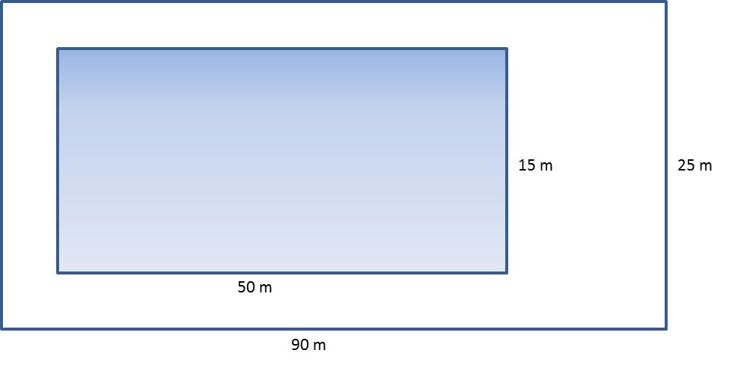

Exit Ticket Sample Solutions

Find the area of the deck around this pool. The deck is the white area in the diagram.



|  |  |  |
| --- | --- | --- |
| Area of Walkway and Pool | Area of Pool | Area of Walkway |

Problem Set Sample Solutions

1. Below is a drawing of a wall that is to be covered with either wallpaper or paint. The wall is high and long. The window, mirror, and fireplace will not be painted or papered. The window measures by . The fireplace is wide and high, while the mirror above the fireplace is by.

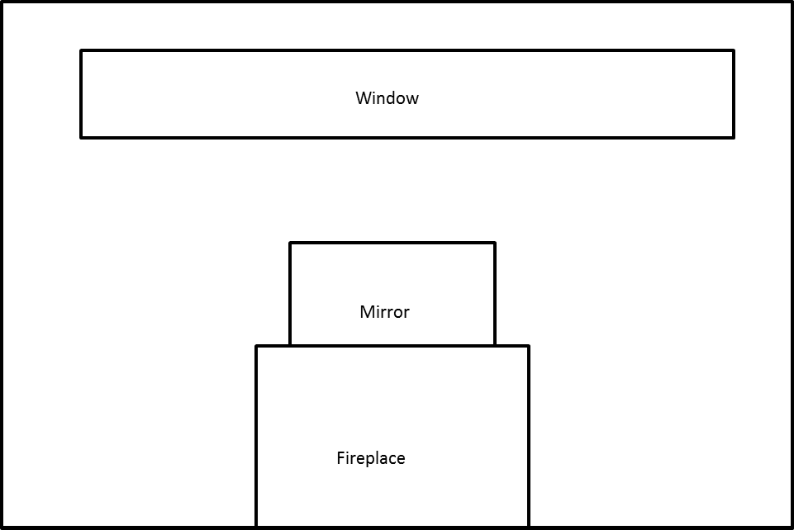

* 1. How many square feet of wallpaper are needed to cover the wall?

*Total wall area* *Window area*

*Fireplace area* *Mirror area*

*Net wall area to be covered*

* 1. The wallpaper is sold in rolls that are wide and long. Rolls of solid color wallpaper will be used, so patterns do not have to match up.
     1. What is the area of one roll of wallpaper?

*Area of one roll of wallpaper*:

* + 1. How many rolls would be needed to cover the wall?

*; therefore, rolls would need to be purchased.*

* 1. This week, the rolls of wallpaper are on sale for/roll. Find the cost of covering the wall with wallpaper.

*We need two rolls of wallpaper to cover the wall, which will cost .*

* 1. A gallon of special textured paint covers and is on sale for/gallon. The wall needs to be painted twice (the wall needs two coats of paint). Find the cost of using paint to cover the wall.

*Total wall area*

*Window area*

*Fireplace area*

*Mirror area*

*Net wall area to be covered*

*If the wall needs to be painted twice, we need to paint a total area of* . *One gallon is enough paint for this wall, so the cost will be* .

1. A classroom has a length of and a width of . The flooring is to be replaced by tiles. If each tile has a length of and a width of , how many tiles are needed to cover the classroom floor?

*Area of the classroom*:

*Area of each tile*:

*Allow for students who say that if the tiles are* , *and they orient them in a way that corresponds to the*  r*oom, then they will have ten rows of ten tiles giving them tiles. Using this method, the students do not need to calculate the areas and divide. Orienting the tiles the other way, students could say that they will need tiles as they will need rows of tiles, and since of a tile cannot be purchased, they will need rows of tiles.*

1. Challenge: Assume that the tiles from Problem 2 are unavailable. Another design is available, but the tiles are square, on a side. If these are to be installed, how many must be ordered?

*Solutions will vary. An even number of tiles fit on the foot width of the room* ( *tiles*)*, but the length requires tiles. This accounts for a tile by tile array tiles tiles tiles.*

*The remaining area is*  ()

*Since of the tiles are needed, additional tiles must be cut to form. of these will be used with of tile left over.*

*Using the same logic as above, some students may correctly say they will need tiles.*

1. A rectangular flower bed measures by . It has a path wide around it. Find the area of the path.

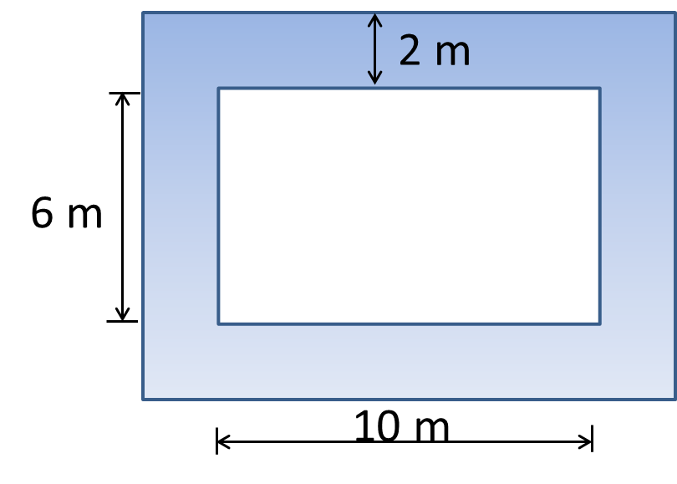

*Total area:*

*Flower bed area:* 2

*Area of path:* 2

1. Tracy wants to cover the missing portion of his deck with soil in order to grow a garden.
   1. Find the missing portion of the deck. Write the expression and evaluate it.

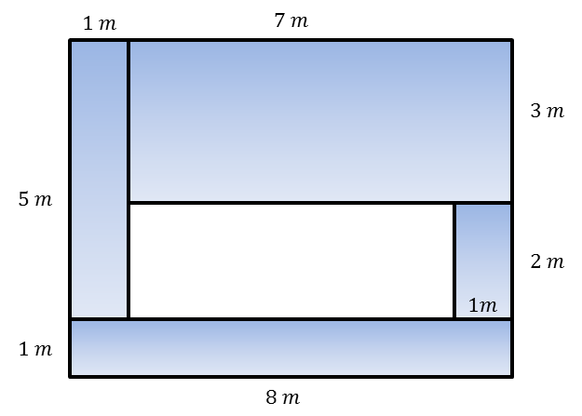

*Students will use one of two methods to find the area: finding the dimensions of the garden area (interior rectangle,) or finding the total area minus the sum of the four wooden areas, shown below.*

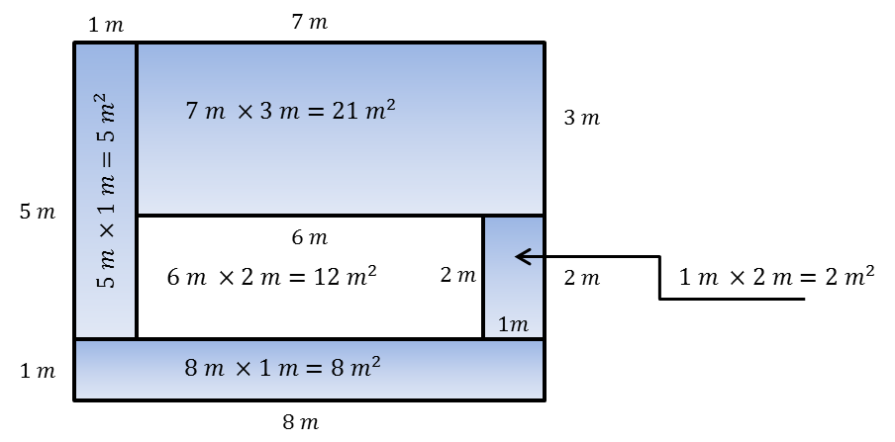

*OR*

*(All linear units are in meters; area is in square meters.)*

* 1. Find the missing portion of the deck using a different method. Write the expression and evaluate it.

Students should choose whichever method was not used in part (a).

* 1. Write your two equivalent expressions.
  2. Explain how each demonstrates a different understanding of the diagram.

*One expression shows the dimensions of the garden area (interior rectangle,), and one shows finding the total area minus the sum of the four wooden areas.*

1. The entire large rectangle below has an area of. If the dimensions of the white rectangle are as shown below, write and solve an equation to find the area,, of the shaded region.

