Lesson 5: The Area of Polygons Through Composition and Decomposition

Classwork
Opening Exercise
Here is an aerial view of a woodlot.
A
B
C
D
E
F

If $AB=10$ units, $FE=8$ units, $AF=6$ units, and $DE=7$ units, find the lengths of both other sides.
$$DC=$$
$$BC=$$

If $DC=10$ units,$FE=30$ units, $AF=28$ units, and $BC=54$ units, find the lengths of both other sides.
$$AB=$$
$$DE=$$

Discussion
$$4 m$$
$$2 m$$
$$2 m$$
$$7 m$$
$$9 m$$

Example 1: Decomposing Polygons into Rectangles
The Intermediate School is producing a play that needs a special stage built. A diagram is shown below (not to scale).
- On the first diagram, divide the stage into three rectangles using two horizontal lines. Find the dimensions of these rectangles and calculate the area of each. Then, find the total area of the stage.

- On the second diagram, divide the stage into three rectangles using two vertical lines. Find the dimensions of these rectangles and calculate the area of each. Then, find the total area of the stage.

- On the third diagram, divide the stage into three rectangles using one horizontal line and one vertical line. Find the dimensions of these rectangles and calculate the area of each. Then, find the total area of the stage.

$$9 m$$
$$2 m$$
$$2 m$$
$$4 m$$
$$7 m$$
$$9 m$$
$$2 m$$
$$2 m$$
$$4 m$$
$$7 m$$
$$9 m$$
$$2 m$$
$$2 m$$
$$4 m$$
$$7 m$$
- Consider this as a large rectangle with a piece removed.

- What are the dimensions of the large rectangle and the small rectangle?

- What are the areas of the two rectangles?

- What operation is needed to find the area of the original figure?

- What is the difference in area between the two rectangles?

- What do you notice about your answers to (a), (b), (c), and (d)?

- Why do you think this is true?

Example 2: Decomposing Polygons into Rectangles and Triangles
Parallelogram $ABCD$ is part of a large solar power experiment. The base measures $6$ m and the height is $4 m$.
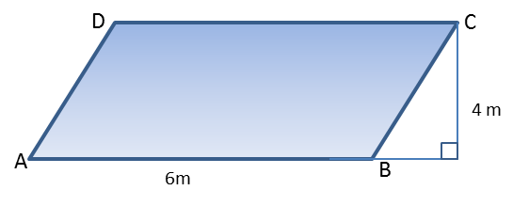
- Draw a diagonal from$A$ to $C$. Find the area of both triangles$ABC$ and $ACD$.

- Draw in the other diagonal, from$B$ to $D$. Find the area of both triangles$ABD$and $BCD$.

Example 3: Decomposing Trapezoids
The trapezoid below is a scale drawing of a garden plot.
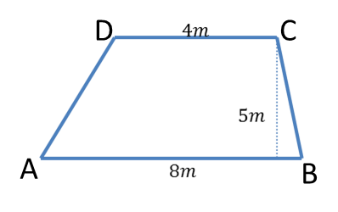
Find the area of both triangles$ABC$ and $ACD$. Then find the area of the trapezoid.

Find the area of both triangles$ABD$ and $BCD$. Then find the area of the trapezoid.

How else can we find this area?

Problem Set

- If $AB=20$, $FE=12$, $AF=9$, and $DE=12$, find the length of both other sides. Then, find the area of the irregular polygon.
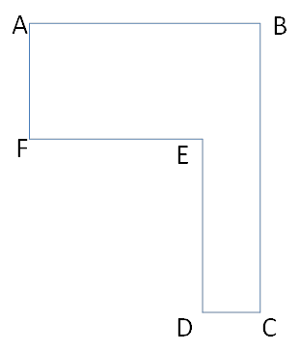

- If $DC=1.9 cm$, $FE=5.6 cm$, $AF=4.8 cm$, and $BC=10.9 cm$, find the length of both other sides. Then, find the area of the irregular polygon.

- Determine the area of the trapezoid below. The trapezoid is not drawn to scale.
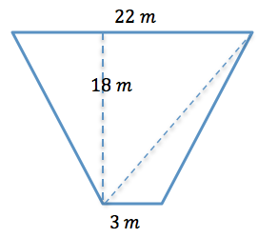

- Determine the area of the isosceles trapezoid below. The image is not drawn to scale.
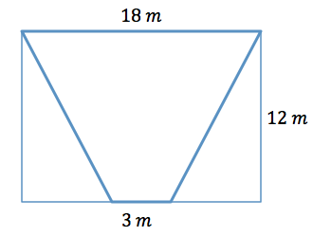

- Here is a sketch of a wall that needs to be painted:
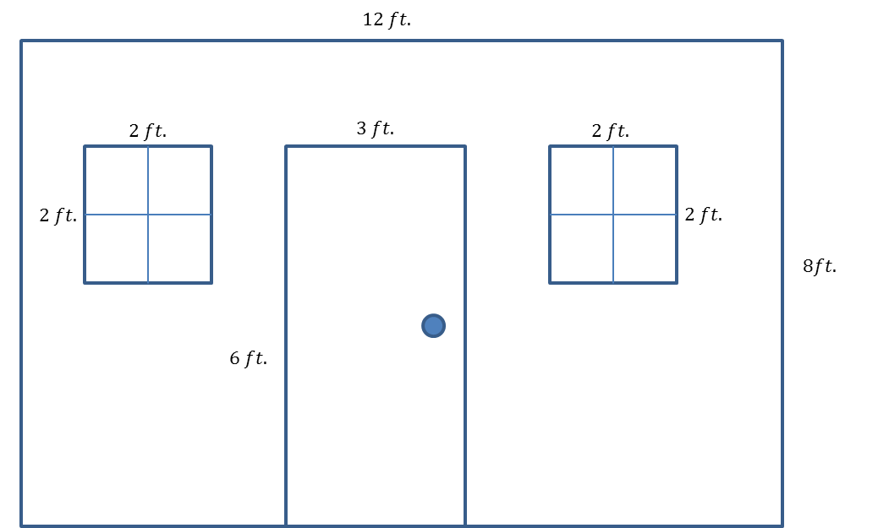

- The windows and door will not be painted. Calculate the area of the wall that will be painted.
- If a quart of Extra-Thick Gooey Sparkle paint covers$30 {ft}^{2}$, how many quarts must be purchased for the painting job?

- The figure below shows a floor plan of a new apartment. New carpeting has been ordered, which will cover the living room and bedroom but not the kitchen or bathroom. Determine the carpeted area by composing or decomposing in two different ways, and then explain why they are equivalent.
