Lesson 5: The Area of Polygons Through Composition and Decomposition

Student Outcomes
- Students show the area formula for the region bounded by a polygon by decomposing the region into triangles and other polygons. They understand that the area of a polygon is actually the area of the region bounded by the polygon.
- Students find the area for the region bounded by a trapezoid by decomposing the region into two triangles. They understand that the area of a trapezoid is actually the area of the region bounded by the trapezoid. Students decompose rectangles to determine the area of other quadrilaterals.

Lesson Notes
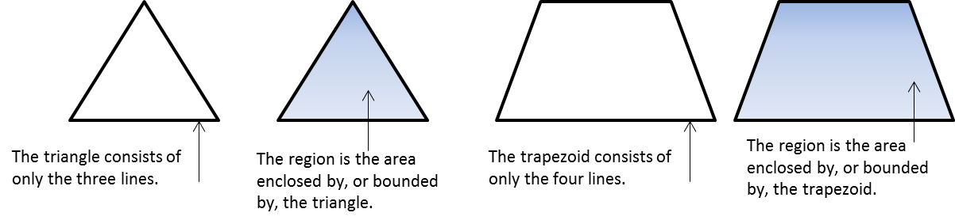
This graphic can be displayed for students to make sense of the second part of each Student Outcome.

Decomposing irregularly shaped polygons into rectangles involves making a choice of where to separate the figure. This very often involves calculating the length of unknown sides of the new figures. This may be more intuitive for some students than others. Mastering missing length problems will make the objectives of this lesson more easily achieved.
Scaffolding:
The words composition and decomposition are likely new words. The base word, compose, is a verb that means the act of joining or putting together. Decompose means the opposite, to take apart. In this lesson, the words composition and decomposition are used to describe how irregular figures can be separated into triangles and other polygons. The area of these parts can then be added together to calculate the area of the whole figure.
MP.2
&
MP.7
When decomposing irregularly shaped polygons into triangles and other polygons, identifying the base and height of the triangle also sometimes requires missing length skills.

Classwork
Opening Exercise (5 minutes): Missing Length Problems
There are extra copies of this figure at the end of this lesson. Project this image with a document camera or interactive white board, if desired. Specify the length of two horizontal lengths and two vertical lengths, and have students find the missing side lengths. Highlighting vertical sides in one color and horizontal sides in another color is valuable for many students.
Opening Exercise
A
B
C
D
E
F
Here is an aerial view of a woodlot.

If $AB=10$ units, $FE=8$ units, $AF=6$ units, and $DE=7$ units, find the lengths of both other sides.
Scaffolding:
If students have difficulty seeing these relationships, it can be helpful to show progressions of figures, such as those below, which move gradually from the sides of a rectangle to an irregular rectilinear figure. Consistent use of visuals, as well as manipulatives, such as cut-outs of these figures, will aid in understanding.
$DC=2$ units
$BC=13$ units

If $DC=10$ units, $FE=30$ units, $AF=28$ units, and $BC=54$ units, find the lengths of both other sides.
$AB=40$ units
$DE=26$ units

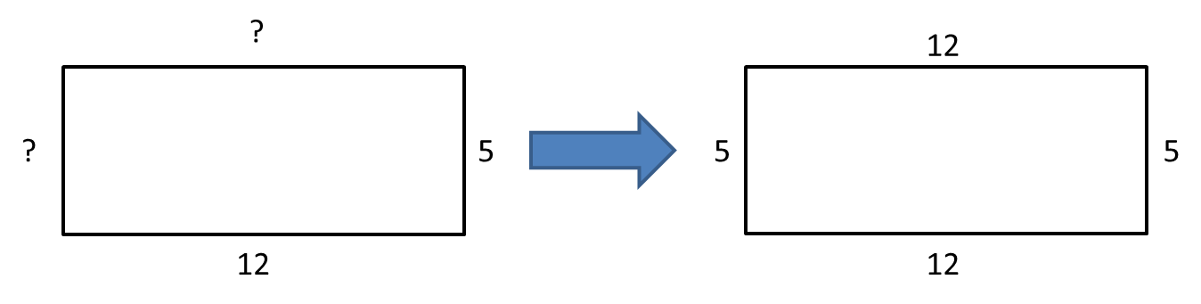

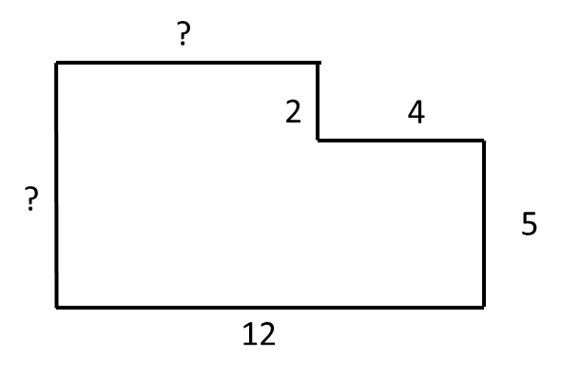
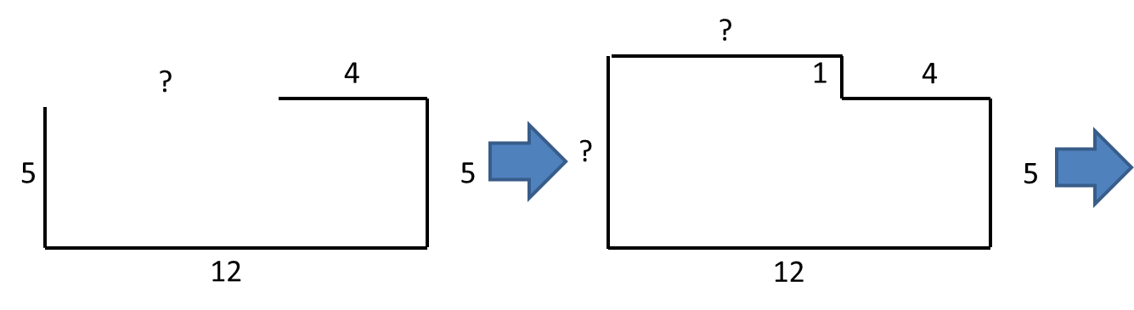
Discussion (5 minutes)
If students are struggling to see this relationship, it might be helpful for them to complete the rectangle that encloses the figure:
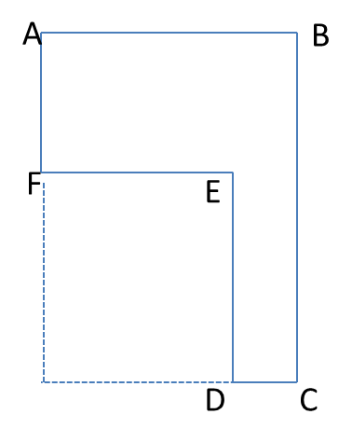

- How do you know which operation to use when finding missing side lengths?
  - If we know two short sides (vertical or horizontal), we add to find the longer side.
  - If we know the long side and one short side (vertical or horizontal), we subtract.
- These examples used whole numbers for the lengths of the sides. What would you do if there were decimal lengths?
  - We would add or subtract the decimal numbers.
- Would the process be the same for deciding whether to add or subtract?
MP.7
  - Yes.
- When adding or subtracting decimals, what is one step that is critical to arriving at the correct answer?
  - One critical step is making sure you add and subtract numbers that have the same place value by lining up the decimal points.
- What if the lengths were given as fractions or mixed numbers?
  - We would add or subtract the fractions or the mixed numbers.
- Would the process be the same for deciding whether to add or subtract?
  - Yes.
Ask students to find the next diagram on their classwork page. Work through the scenario with them. The area of this figure can be found in at least three ways: using two horizontal cuts, using two vertical cuts, or subtracting the missing area from the larger rectangle (using overall length and width). There is a drawing included at the end of this lesson that has the grid line inserted.

$$4 m$$
$$2 m$$
$$2 m$$
$$7 m$$
$$9 m$$

- How could we determine the total area?
MP.1
  - Using two horizontal lines, two vertical lines, or one of each.
- Let’s divide the figure using two horizontal lines. Will that make any rectangles with two known sides?
Scaffolding:
Some students will benefit from actually cutting the irregularly shaped polygons before marking the dimensions on the student pages. If needed, there are reproducible copies included at the end of the lesson.
  - Yes, it makes two $2$ by $4$ rectangles.
- Can we then use this $9 m$ measure directly? Why or why not?
  - No. The $9 m$ includes the top part of the figure, but we have already found the dimensions of this part.
- What is the height of that third rectangle and how do you find it?
  - The entire $9 m$ side cannot be used. Part has been removed, $4 m$, leaving only$5 m$. We use subtraction.
- What are the dimensions of the three resulting rectangles?
  - $2 m$ by $4 m$, $2 m$ by $4 m$, and $7 m$ by $5 m$.
- Calculate and mark each of these areas.
  - $2 m×4 m=8 m^{2}$, $2 m×4 m=8 m^{2}$, $7 m×5 m=35 m^{2}$
- What is the total area of the figure?
  - $51 m^{2}$
- Divide the next figure using two vertical lines. Will that make any rectangles with two known sides?
  - Yes, it makes two $2$ by $9$ rectangles.
- Can we then use this $7 m$ measure directly? Why or why not?
  - No, the entire $7 m$ side cannot be used. Part has been removed, two $2 m$segments, leaving only$3 m$.
- What are the dimensions of the three resulting rectangles?
  - $2 m$ by $9 m$, $2 m$ by $9 m$, and $3 m$ by $5 m$
- Calculate and mark each of these areas.
  - $2 m×9 m=18 m^{2}$, $2 m×9 m=18 m^{2}$, $3 m×5 m=15 m^{2}$
- What is the total area of the figure?
  - $51 m^{2}$

- Divide the last figure using one vertical line and one horizontal line. Are there missing sides to calculate?
  - Yes, both sides of the $5$ by $5$ rectangle had to be found by decomposing the other measures.
- What are the dimensions of the three resulting rectangles?
  - $2 m$ by $9 m$, $2 m$ by $4 m$, and $5 m$ by $5 m$
- Calculate and mark each of these areas.
  - $2 m×9 m=18 m^{2}$,$2 m×4 m=8 m^{2}$, $5 m×5 m=25 m^{2}$
- What is the total area of the figure?
  - $51 m^{2}$
- Finally, if we look at this as a large rectangle with a piece removed, what are the dimensions of the large rectangle?
  - $9 m$ by $7 m$
- What are the dimensions of the missing piece that looks like it was cut out?
  - $3 m$ by $4 m$
- Calculate these two areas.
  - $9 m×7 m=63 m^{2}$,$3 m×4 m=12 m^{2}$
- How can we use these two areas to find the area of the original figure?
  - Subtract the smaller area from the larger one.
- What is the difference between $63 m^{2}$ and$12 m^{2}$?
  - $63 m^{2}-12 m^{2}=51 m^{2}$
- Is there an advantage to one of these methods over the others?
  - Answers will vary. In this example, either one or two calculations are necessary when decomposing the figure.
- Consider the two expressions: $18 m^{2}+8 m^{2}+25 m^{2}$ and $63 m^{2}-12 m^{2}$.
- What do the terms in these expressions represent in this problem?
  - The first is a “sum of the parts” expression, and the second is a “whole minus part” expression. More specifically, the first expression shows that the total area is the sum of the areas of three rectangles; the second expression shows that the total area is the area of a large rectangle minus the area of a small one.
MP.2
Allow some time for discussion before moving on.

Example 1 (10 minutes): Decomposing Polygons into Rectangles
Example 1: Decomposing Polygons into Rectangles
The Intermediate School is producing a play that needs a special stage built. A diagram is shown below (not to scale).
  - On the first diagram, divide the stage into three rectangles using two horizontal lines. Find the dimensions of these rectangles and calculate the area of each. Then, find the total area of the stage.
Dimensions:$2 m$by$4 m$, $2 m$by$4 m$, and $7 m$by $5 m$
Area: $2 m×4 m=8 m^{2}$, $2 m×4 m=8 m^{2}$, $7 m×5 m=35 m^{2}$
Total: $8 m^{2}+8 m^{2}+35 m^{2}=51 m^{2}$

  - On the second diagram, divide the stage into three rectangles using two vertical lines. Find the dimensions of these rectangles and calculate the area of each. Then, find the total area of the stage.
Dimensions: $2 m$ by$9 m$,$2 m$ by$9 m$, and $3 m$by$5 m$
Area: $2 m×9 m=18 m^{2}$, $2 m×9 m=18 m^{2}$, $3 m×5 m=15 m^{2}$
Total: $51 m^{2}$

  - On the third diagram, divide the stage into three rectangles using one horizontal line and one vertical line. Find the dimensions of these rectangles and calculate the area of each. Then, find the total area of the stage.
Dimensions: $2 m$ by $9 m$, $2$m by $4 m$, and $5 m$ by$5 m$
Area: $2 m×9 m=18{ m}^{2}$,$2 m×4 m=8{ m}^{2}$, $5 m×5 m=25 m^{2}$
Total: $51 m^{2}$
$$9 m$$
$$2 m$$
$$2 m$$
$$4 m$$
$$7 m$$
$$9 m$$
$$2 m$$
$$2 m$$
$$4 m$$
$$7 m$$
$$9 m$$
$$2 m$$
$$2 m$$
$$4 m$$
$$7 m$$

  - Think of this as a large rectangle with a piece removed.
    - What are the dimensions of the large rectangle and the small rectangle?
Dimensions: $9 m$ by $7 m$and $3 m$by$4 m$

    - What are the areas of the two rectangles?
Area: $9 m×7 m=63 m^{2}$, $3 m×4 m=12 m^{2}$

    - What operation is needed to find the area of the original figure?
Subtraction

    - What is the difference in area between the two rectangles?
$63 m^{2}-12 m^{2}=51{ m}^{2}$

    - What do you notice about your answers to (a), (b), (c), and (d)?
The area is the same.

    - Why do you think this is true?
No matter how we decompose the figure, the total area is the sum of its parts. Even if we take the area around the figure and subtract the part that is not included, the area of the figure remains the same, $51 m^{2}$.
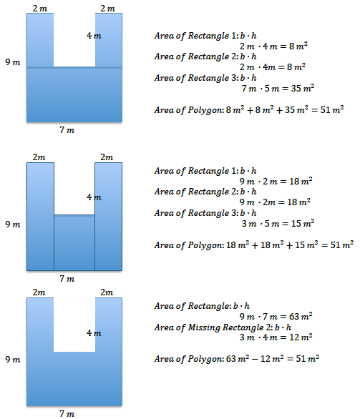
Scaffolding:
As an extension, ask students to manipulate these un-simplified numerical expressions to demonstrate equivalence of areas (MP.2).
For example, using the factors of the area, showing that
$$2×4+2×4+7×5= \\ 2×9+2×9+3×5$$by applying the distributive property and using decomposition of whole numbers.
Using the products (areas), the equivalence should be made clear:
$$8+8+35=18+18+15 \\ =63-12$$
1
2
3
2
1
3

Example 2 (10 minutes): Decomposing Polygons into Rectangles and Triangles
In this example, a parallelogram is bisected along a diagonal. The resulting triangles are congruent, with the same base and height of the parallelogram. Students should see that the area for a parallelogram is equal to the base times the height, regardless of how much the bases are skewed. Ask how we could find the area using only triangles.
Scaffolding:
Some students will benefit from actually cutting the parallelograms from paper to prove their congruency. There are reproducible copies included.
Example 2: Decomposing Polygons into Rectangles and Triangles
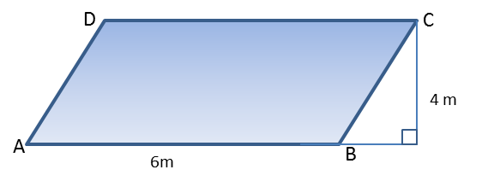
Parallelogram $ABCD$ is part of a large solar power collector. The base measures $6 m$ and the height is $4 m$.

  - Draw a diagonal from$A$ to$C$. Find the area of both triangles$ABC$and $ACD$.
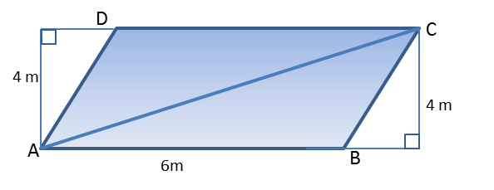
Student drawing and calculations are shown here.
$$△ABC$$  $$A=\frac{1}{2}bh \\ A=\frac{1}{2}\left(6 m\right)\left(4 m\right) \\ A=12 m^{2}$$ | $$△ACD$$  $$A=\frac{1}{2}bh \\ A=\frac{1}{2}\left(6 m\right)\left(4 m\right) \\ A=12 m^{2}$$

- What is the area of each triangle?
  - $12 m^{2}$
- What is the area of the parallelogram?
  - $24 m^{2}$

  - Draw in the other diagonal, from$B$ to $D$. Find the area of both triangles$ABD$and$BCD$.
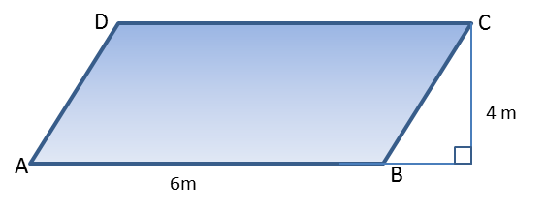
Student drawing and calculations are shown here.
$$△ABD$$  $$A=\frac{1}{2}bh \\ A=\frac{1}{2}\left(6 m\right)\left(4 m\right) \\ A=12 m^{2}$$ | $$△BCD$$  $$A=\frac{1}{2}bh \\ A=\frac{1}{2}\left(6 m\right)\left(4 m\right) \\ A=12 m^{2}$$

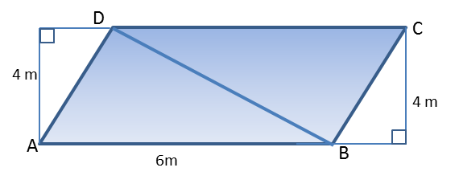

Example 3 (10 minutes): Decomposing Trapezoids
Drawing one of the diagonals in a trapezoid separates the figure into two non-congruent triangles. Note that the height of these triangles is the same if the two bases of the trapezoid are used as bases of the triangles. If students want to consider the area of the rectangle around the trapezoid, two exterior right triangles will be formed. For isosceles trapezoids, these triangles will be congruent. For scalene trapezoids, two non-congruent triangles will result. A reproducible copy of trapezoids is included at the end of this lesson for use in further investigation. In all cases, the area can be found by averaging the length of the bases and multiplying by the height.
- What is the area of the garden plot? Use what you know about decomposing and composing to determine the area.
Example 3: Decomposing Trapezoids
The trapezoid below is a scale drawing of a garden plot.
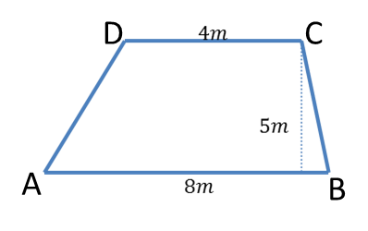

If students need prompting, ask them to draw a diagonal from$A$to$C$.

Find the area of both triangles$ABC$and $ACD$. Then find the area of the trapezoid.
Student drawing and calculations are shown here.
$$△ABC$$  $$A=\frac{1}{2}bh \\ A=\frac{1}{2}\left(8 m\right)\left(5 m\right) \\ A=20 m^{2}$$ | $$△ACD$$  $$A=\frac{1}{2}bh \\ A=\frac{1}{2}\left(4 m\right)\left(5 m\right) \\ A=10 m^{2}$$
$$A=20 m^{2}+10 m^{2}=30 m^{2}$$

If necessary, further prompt students to draw in the other diagonal, from$B$to $D$.
Find the area of both triangles$ABD$and $BCD$. Then find the area of the trapezoid.
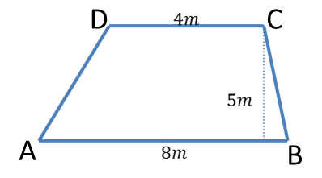
Student drawing and calculations are shown here.
$$△ABD$$  $$A=\frac{1}{2}bh \\ A=\frac{1}{2}\left(8 m\right)\left(5 m\right) \\ A=20 m^{2}$$ | $$△BCD$$  $$A=\frac{1}{2}bh \\ A=\frac{1}{2}\left(4 m\right)\left(5 m\right) \\ A=10 m^{2}$$
$$A=20 m^{2}+10 m^{2}=30 m^{2}$$
How else could we find this area?
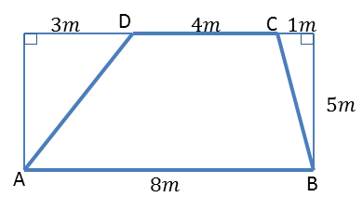
We could consider the rectangle that surrounds the trapezoid. Find the area of that rectangle, and then subtract the area of both right triangles.

Student drawing and calculations are shown here.
Area of Rectangle  $$A=bh \\ A=8 m×5 m \\ A=40 m^{2}$$ | $$△1$$  $$A=\frac{1}{2}bh \\ A=\frac{1}{2}\left(3 m\right)\left(5 m\right) \\ A=7.5 m^{2}$$ | $$△2$$  $$A=\frac{1}{2}bh \\ A=\frac{1}{2}\left(1 m\right)\left(5 m\right) \\ A=2.5 m^{2}$$
$$A=40 m^{2}-7.5 m^{2}-2.5 m^{2}=30 m^{2}$$
OR
$$A=40 m^{2}-(7.5 m^{2}+2.5 m^{2})=30 m^{2}$$

Closing (2 minutes)
- How can we find the area of irregularly shaped polygons?
  - They can be broken into rectangles and triangles; we can then calculate the area of the figure using the formulas we already know.
- Which operations did we use today to find the area of our irregular polygons?
  - Some methods used addition of the area of the parts. Others used subtraction from a surrounding rectangle.

Exit Ticket (3 minutes)
Name ___________________________________________________ Date____________________
Lesson 5: The Area of Polygons Through Composition and Decomposition

Exit Ticket

- Find the missing dimensions of the figure below, and then find the area. The figure is not drawn to scale.
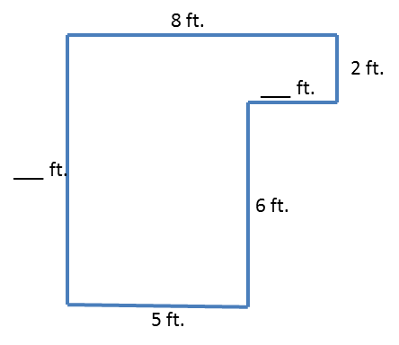

- Find the area of the parallelogram below. The figure is not drawn to scale.
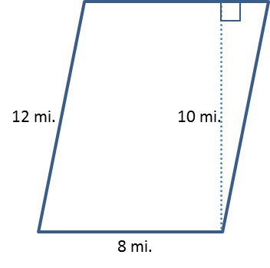

Exit Ticket Sample Solutions

- Find the missing dimensions of the figure below, and then find the area. The figure is not drawn to scale.
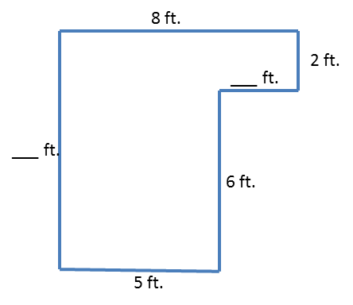
Solutions can be any of the below.
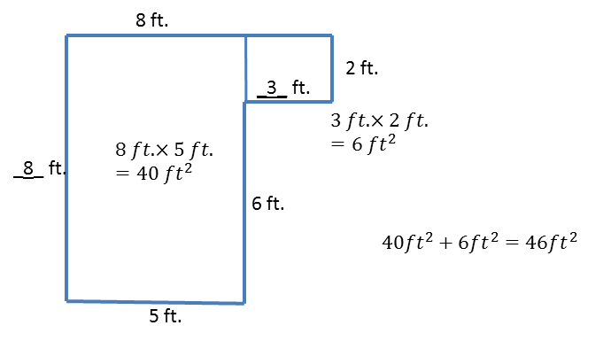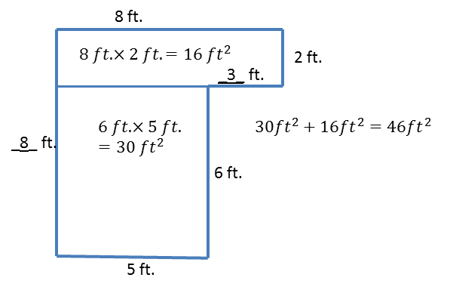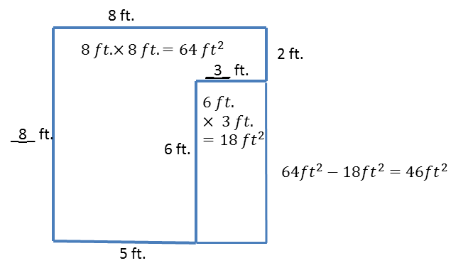
- Find the area of the parallelogram below. The figure is not drawn to scale.
8 mi. | $$Area of Triangle 1$$  $$A=\frac{1}{2}bh \\ A=\frac{1}{2}×8 mi\text{.}×10 mi. \\ A=40 {mi}^{2}$$ | $$Area of Triangle 2$$  $$A=\frac{1}{2}bh \\ A=\frac{1}{2}×8 mi\text{.}×10 mi. \\ A=40 {mi}^{2}$$
$$Area of Parallelogram=Area of Triangle 1+Area of Triangle 2 \\ A=40 {mi}^{2}+40{ mi}^{2}=90{ mi}^{2}$$
The area of the parallelogram is $80 {mi}^{2}$.
Problem Set Sample Solutions

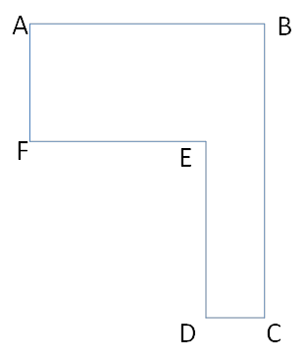
- If $AB=20$, $FE=12$, $AF=9$, and $DE=12$, find the length of both other sides. Then, find the area of the irregular polygon.

$CD=8$, $BC=21$, $Area=276 units^{2}$

- If $DC=1.9 cm$, $FE=5.6 cm$, $AF=4.8 cm$, and $BC=10.9 cm$, find the length of both other sides. Then, find the area of the irregular polygon.
$AB=7.5 cm$, $DE=6.1 cm$, $Area=47.59 cm^{2}$

- Determine the area of the trapezoid below. The trapezoid is not drawn to scale.
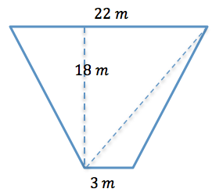 | Area of Triangle 1  $$A=\frac{1}{2}bh \\ A=\frac{1}{2}×22 m×18 m \\ A=198 m^{2}$$ | Area of Triangle 2  $$A=\frac{1}{2}bh \\ A=\frac{1}{2}×3 m×18 m \\ A=27 m^{2}$$
$$Area of Trapezoid=Area of Triangle 1+Area of Triangle 2 \\ Area=198 m^{2}+27 m^{2}=225 m^{2}$$

- Determine the area of the isosceles trapezoid below. The image is not drawn to scale.
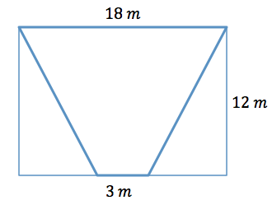 | Area of Rectangle  $$A=bh \\ A=18 m×12 m \\ A=216 m^{2}$$ | Area of Triangles 1 and 2  $$A=\frac{1}{2}bh \\ A=\frac{1}{2}×7.5 m×12 m \\ A=45 m^{2}$$
$$Area of Trapezoid=Area of Rectangle-Area of Triangle 1-Area of Triangle 2 \\ A=216 m^{2}-45 m^{2}-45 m^{2}=126 m^{2}$$

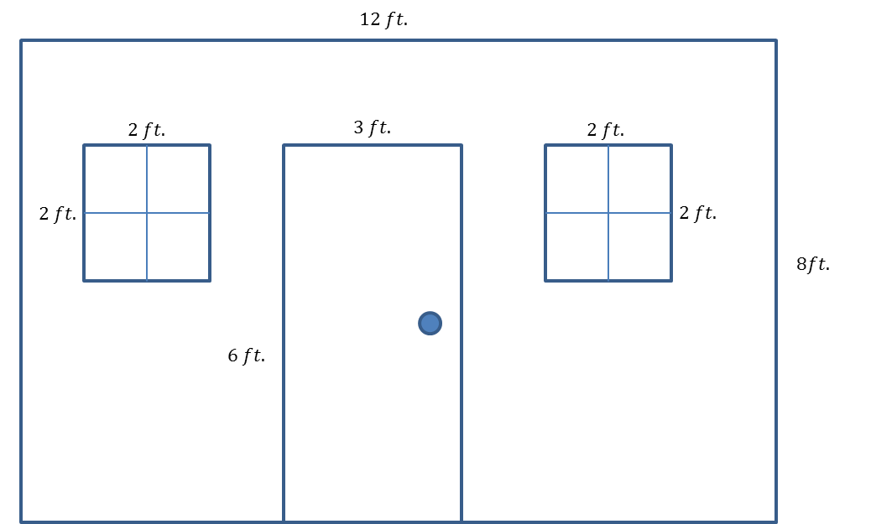
- Here is a sketch of a wall that needs to be painted:

  - The windows and door will not be painted. Calculate the area of the wall that will be painted.
Whole wall: $12 ft\text{.}×8 ft\text{.}=96 ft^{2}$
Window: $2 ft. ×2 ft. =4 ft^{2}$ There are two identical windows, $4 ft^{2}×2=8 ft^{2}$
Door: $6 ft. ×3 ft. =18 ft^{2}$
$$96 ft^{2}-8 ft^{2}-18 ft^{2}=70 ft^{2}$$

  - If a quart of Extra-Thick Gooey Sparkle paint covers$30 ft^{2}$, how many quarts must be purchased for the painting job?
$$70÷30=2\frac{1}{3}$$
Therefore, $3$ quarts must be purchased.

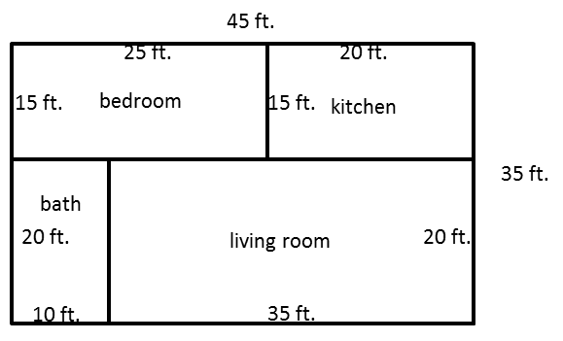
- The figure below shows a floor plan of a new apartment. New carpeting has been ordered, which will cover the living room and bedroom but not the kitchen or bathroom. Determine the carpeted area by composing or decomposing in two different ways, and then explain why they are equivalent.
MP.7
Answers will vary. Sample student responses are shown.
Bedroom: $15 ft\text{.}×25 ft\text{.}=375 ft^{2}$
Living room: $35 ft\text{.}×20 ft\text{.}=700 ft^{2}$
Sum of bedroom and living room: $375 ft^{2}+700 ft^{2}=1075 ft^{2}$

Alternatively, the whole apartment is $45 ft\text{.}×35 ft\text{.}=1575 ft^{2}$
Subtracting the kitchen and bath ($300 ft^{2}$ and $200 ft^{2}$) still gives $1075 ft^{2}$.
The two areas are equivalent because they both represent the area of the living room and bedroom.

A
B
C
D
E
F
A
B
C
D
E
F
A
B
C
D
E
F
A
B
C
D
E
F

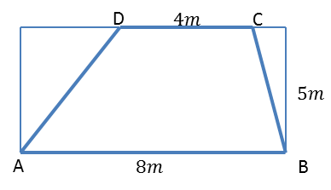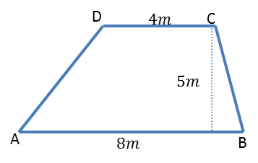

Horizontal

Vertical

