Lesson 4: The Area of All Triangles Using Height and Base

Classwork
Opening Exercises
Draw and label the altitude of each triangle below.
- 2.

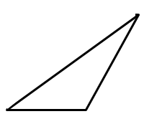

Exploratory Challenge/Exercises 1–5
- Use rectangle X and the triangle with the altitude inside (triangle X) to show that the area formula for the triangle is $A=\frac{1}{2}×base×height$.
  - Step One: Find the area of rectangle X.

  - Step Two: What is half the area of rectangle X?

  - Step Three: Prove, by decomposing triangle X, that it is the same as half of rectangle X. Please glue your decomposed triangle onto a separate sheet of paper. Glue it next to rectangle X. What conclusions can you make about the triangle’s area compared to the rectangle’s area?

- Use rectangle Y and the triangle with a side that is the altitude (triangle Y) to show the area formula for the triangle is $A=\frac{1}{2}×base×height$.
  - Step One: Find the area of rectangle Y.

  - Step Two: What is half the area of rectangle Y?

  - Step Three: Prove, by decomposing triangle Y, that it is the same as half of rectangle Y. Please glue your decomposed triangle onto a separate sheet of paper. Glue it next to rectangle Y. What conclusions can you make about the triangle’s area compared to the rectangle’s area?

- Use rectangle Z and the triangle with the altitude outside (triangle Z) to show the area formula for the triangle is $A=\frac{1}{2}×base×height$.
  - Step One: Find the area of rectangle Z.

  - Step Two: What is half the area of rectangle Z?

  - Step Three: Prove, by decomposing triangle Z, that it is the same as half of rectangle Z. Please glue your decomposed triangle onto a separate sheet of paper. Glue it next to rectangle Z. What conclusions can you make about the triangle’s area compared to the rectangle’s area?

- When finding the area of a triangle, does it matter where the altitude is located?

- How can you determine which part of the triangle is the base and which is the height?

Exercises 6–8
Calculate the area of each triangle. Figures are not drawn to scale.
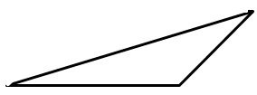
$$42 in.$$
$$8 in.$$
$$24 in.$$
$$6 in.$$
$$10 in.$$

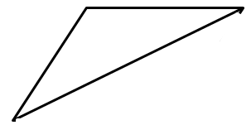
$$9\frac{1}{2} ft.$$
$$14\frac{1}{8} ft.$$
$$34\frac{5}{6} ft.$$
$$12\frac{3}{4} ft.$$

- Draw three triangles (acute, right, and obtuse) that have the same area. Explain how you know they have the same area.

Problem Set

Calculate the area of each triangle below. Figures are not drawn to scale.
- 2.
$$21 m$$
$$72 m$$
$$75 m$$
$$10 in.$$
$$8 in.$$
$$17 in.$$
$$15 in.$$
$$6 in.$$

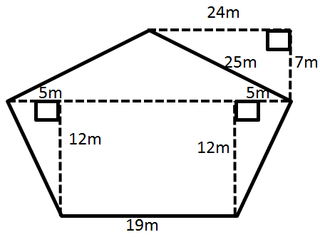
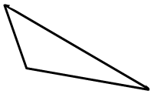
$$21.9 km$$
$$100.5 km$$
$$75.8 km$$
$$29.2 km$$
- 4.

- The Anderson’s were going on a long sailing trip during the summer. However, one of the sails on their sailboat ripped, and they have to replace it. The sail is pictured below.
If the sailboat sails on are sale for $\$2$ per square foot, how much will the new sale cost?
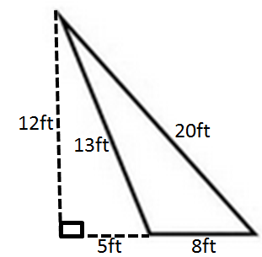

- Darnell and Donovan are both trying to calculate the area of an obtuse triangle. Examine their calculations below.
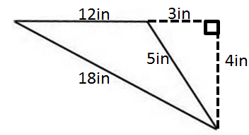

Darnell’s Work | Donovan’s Work
$$A=\frac{1}{2}×3 in\text{.}×4 in. \\ A=6 in^{2}$$ | $$A=\frac{1}{2}×12 in\text{.}×4 in. \\ A=24 in^{2}$$
Which student calculated the area correctly? Explain why the other student is not correct.

- Russell calculated the area of the triangle below. His work is shown.
$$25 cm$$
xxxx
$$7 cm$$
$$24 cm$$
$$25 cm$$
$$43 cm$$
$$A=\frac{1}{2}×43 cm×7 cm \\ A=150.5 {cm}^{2}$$
Although Russell was told his work is correct, he had a hard time explaining why it is correct. Help Russell explain why his calculations are correct.

- The larger triangle below has a base of $10.14 m$; the gray triangle has an area of $40.325 m^{2}$.
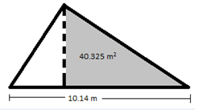

  - Determine the area of the larger triangle if it has a height of $12.2 m$.
  - Let $A$ be the area of the unshaded (white) triangle in square meters. Write and solve an equation to determine the value of $A$, using the areas of the larger triangle and the gray triangle.

