Lesson 4: The Area of All Triangles Using Height and Base

Student Outcomes
- Students construct the altitude for three different cases: an altitude that is a side of a right angle, an altitude that lies over the base, and an altitude that is outside the triangle.
- Students deconstruct triangles to justify that the area of a triangle is exactly one half the area of a parallelogram.

Lesson Notes
Students will need the attached templates, scissors, a ruler, and glue to complete the Exploratory Challenge.

Classwork
Opening Exercise (5 minutes)
Opening Exercise
Draw and label the altitude of each triangle below.

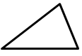
altitude

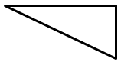
altitude

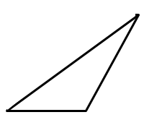

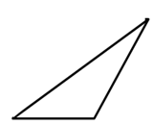
altitude

Discussion (3 minutes)
- The last few lessons showed that the area formula for triangles is $A=\frac{1}{2}×base×height$. Today we are going to show that the formula works for three different types of triangles.
- Examine the triangles in the Opening Exercise. What is different about them?
  - The height, or altitude, is in a different location for each triangle. The first triangle has an altitude inside the triangle. The second triangle has a side length that is the altitude, and the third triangle has an altitude outside of the triangle.
- If we wanted to calculate the area of these triangles, what formula do you think we would use? Explain.
  - We will use $A=\frac{1}{2}×base×height$ because that is the area formula we have used for both right triangles and acute triangles.

Exploratory Challenge/Exercises 1–5 (22 minutes)
Students work in small groups to show that the area formula is the same for all three types of triangles shown in the Opening Exercise. Each group will need the attached templates, scissors, a ruler, and glue. Each exercise comes with steps that might be useful to provide for students who work better with such scaffolds.
Exploratory Challenge
- Use rectangle X and the triangle with the altitude inside (triangle x) to show that the area formula for the triangle is $A=\frac{1}{2}×base×height$.
  - Step One: Find the area of rectangle X.
MP.1
$$A=3 in\text{.}×2.5 in\text{.} =7.5 in^{2}$$

  - Step Two: What is half the area of rectangle X?
Half of the area of the rectangle is $7.5 in^{2}÷2=3.75 in^{2}$.

  - Step Three: Prove, by decomposing triangle X, that it is the same as half of rectangle X. Please glue your decomposed triangle onto a separate sheet of paper. Glue it next to rectangle X. What conclusions can you make about the triangle’s area compared to the rectangle’s area?
Students will cut their triangle and glue it into half of the rectangle. This may take more than one try, so extra copies of the triangles may be necessary.
Because the triangle fits inside half of the rectangle, we know the triangle’s area is half of the rectangle’s area.

- Use rectangle Y and the triangle with a side that is the altitude (triangle Y) to show the area formula for the triangle is $A=\frac{1}{2}×base×height$.
  - Step One: Find the area of rectangle Y.
$$A=3 in\text{.}×3 in\text{.}=9 in^{2}$$

  - Step Two: What is half the area of rectangle Y?
Half the area of the rectangle is $9 in^{2} ÷2=4.5 in^{2}$.

  - Step Three: Prove, by decomposing triangle Y, that it is the same as half of rectangle Y. Please glue your decomposed triangle onto a separate sheet of paper. Glue it next to rectangle Y. What conclusions can you make about the triangle’s area compared to the rectangle’s area?
Students will again cut triangle Y and glue it into the rectangle. This may take more than one try, so extra copies of the triangles may be necessary.
Scaffolding:
- Students may struggle with this step since they have yet to see an obtuse angle. The teacher may want to model this step if he or she feels students may become confused.
- After modeling, the students can then try this step on their own.
The right triangle also fits in exactly half of the rectangle, so the triangle’s area is once again half the size of the rectangle’s area.

- Use rectangle Z and the triangle with the altitude outside (triangle Z) to show that the area formula for the triangle is $A=\frac{1}{2}×base×height$.
MP.1
  - Step One: Find the area of rectangle Z.
$$A=3 in\text{.}×2.5 in\text{.}=7.5 in^{2}$$

  - Step Two: What is half the area of rectangle Z?
Half of the area of the rectangle is $7.5 in^{2}÷2=3.75 in^{2}$.

  - Step Three: Prove, by decomposing triangle Z, that it is the same as half of rectangle Z. Please glue your decomposed triangle onto a separate sheet of paper. Glue it next to rectangle Z. What conclusions can you make about the triangle’s area compared to the rectangle’s area?
Students will cut their triangle and glue it onto the rectangle to show that obtuse triangles also have an area that is half the size of a rectangle that has the same dimensions. This may take more than one try, so extra copies of the triangles may be necessary.
Note: In order for students to fit an obtuse triangle into half of a rectangle, they will need to cut the triangle into three separate triangles.
MP.1
Similar to the other two triangles, when the altitude is outside the triangle, the area of the triangle is exactly half of the area of the rectangle.

- When finding the area of a triangle, does it matter where the altitude is located?
It does not matter where the altitude is located. To find the area of a triangle the formula is always
$A=\frac{1}{2}×base×height$.

- How can you determine which part of the triangle is the base and which is the height?
The base and the height of any triangle form a right angle because the altitude is always perpendicular to the base.
Take time to show how other groups may have calculated the area of the triangle using a different side for the base and how this still results in the same area.
After discussing how any side of a triangle can be labeled the base, students write a summary to explain the outcomes of the Exploratory Challenge.

Exercises 6–8 (5 minutes)
Exercises 6–8
Calculate the area of each triangle. Figures are not drawn to scale.
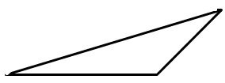
$$42 in.$$
$$8 in.$$
$$24 in.$$
$$6 in.$$
$$10 in.$$

$$A=\frac{1}{2}\left(24 in\text{.}\right)\left(8 in\text{.}\right)=96{ in}^{2}$$
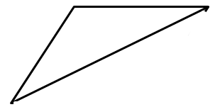
$$9\frac{1}{2} ft.$$
$$14\frac{1}{8} ft.$$
$$34\frac{5}{6} ft.$$
$$12\frac{3}{4} ft.$$

$$A=\frac{1}{2}\left(12\frac{3}{4} ft.\right)\left(9\frac{1}{2} ft.\right)=\frac{1}{2}\left(\frac{51}{4} ft.\right)\left(\frac{19}{2} ft.\right)=\frac{969}{16}{ ft}^{2}=60\frac{9}{16} {ft}^{2}$$

- Draw three triangles (acute, right, and obtuse) that have the same area. Explain how you know they have the same area.
Answers will vary.
Closing (5 minutes)
- Different groups share their Exploratory Challenge and discuss the outcomes.
- Why does the area formula for a triangle work for every triangle?
  - Every type of triangle fits inside exactly half of a rectangle that has the same base and height lengths.

Exit Ticket (5 minutes)
Name Date
Lesson 4: The Area of All Triangles Using Height and Base

Exit Ticket

Find the area of each triangle. Figures are not drawn to scale.
$$12.6 cm$$
$$21 cm$$
$$16.8 cm$$

$$17 in.$$
$$8 in.$$
$$25 in.$$
$$15 in.$$
$$20 in.$$

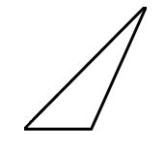
$$8 ft.$$
$$29 ft.$$
$$21 ft.$$
$$12 ft.$$

Exit Ticket Sample Solutions

Find the area of each triangle. Figures are not drawn to scale.
$$12.6 cm$$
$$21 cm$$
$$16.8 cm$$

$$A=\frac{1}{2}\left(12.6 cm\right)\left(16.8 cm\right)=105.84 {cm}^{2}$$

$$17 in.$$
$$8 in.$$
$$25 in.$$
$$15 in.$$
$$20 in.$$

$$A=\frac{1}{2}\left(28 in\text{.}\right)\left(15 in\text{.}\right)=210{ in}^{2}$$
$$8 ft.$$
$$29 ft.$$
$$21 ft.$$
$$12 ft.$$

$$A=\frac{1}{2}\left(12 ft\text{.}\right)\left(21 ft\text{.}\right)=126 {ft}^{2}$$

Problem Set Sample Solutions

Calculate the area of each triangle below. Figures are not drawn to scale.
$$10 in.$$
$$8 in.$$
$$17 in.$$
$$15 in.$$
$$6 in.$$

$$A=\frac{1}{2}\left(21 in\text{.}\right)\left(8 in\text{.}\right)=84 {in}^{2}$$

$$21 m$$
$$72 m$$
$$75 m$$

$$A=\frac{1}{2}\left(72 m\right)\left(21 m\right)=756{ m}^{2}$$
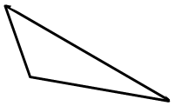
$$21.9 km$$
$$100.5 km$$
$$75.8 km$$
$$29.2 km$$

$$A=\frac{1}{2}\left(75.8 km\right)\left(29.2 km\right)=1106.68 {km}^{2}$$
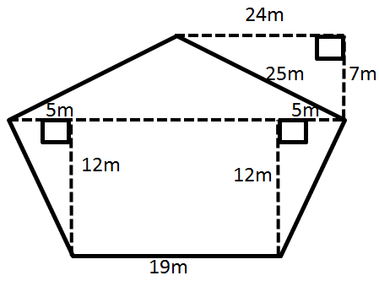

$$A=\frac{1}{2}\left(5 m\right)\left(12 m\right)=30{ m}^{2} \\ A=\frac{1}{2}\left(7 m\right)\left(29 m\right)=101.5{ m}^{2} \\ A=12 m\left(19 m\right)=228 m^{2} \\ A=30 m^{2}+30 m^{2}+101.5 m^{2}+228 m^{2} \\ A=389.5{ m}^{2}$$

- The Andersons are going on a long sailing trip during the summer. However, one of the sails on their sailboat ripped, and they have to replace it. The sail is pictured below.
If the sailboat sails are on sale for $\$2$ per square foot, how much will the new sail cost?
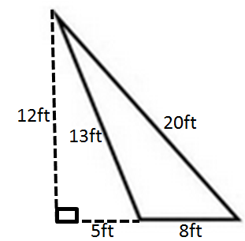 | $$A=\frac{1}{2}bh \\ =\frac{1}{2}\left(8 ft\text{.}\right)\left(12 ft\text{.}\right) \\ =48 ft^{2} \\ \frac{\$2}{ft^{2}}×48 ft^{2}=\$96$$  The cost of the new sail is $\$96$.

- Darnell and Donovan are both trying to calculate the area of an obtuse triangle. Examine their calculations below.
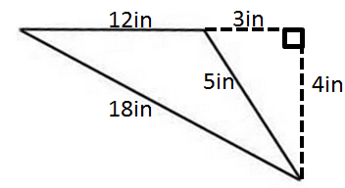

Darnell’s Work | Donovan’s Work
$$A=\frac{1}{2}×3 in\text{.}×4 in. \\ A=6 in^{2}$$ | $$A=\frac{1}{2}×12 in\text{.}×4 in. \\ A=24 in^{2}$$
Which student calculated the area correctly? Explain why the other student is not correct.
Donovan calculated the area correctly. Although Darnell did use the altitude of the triangle, he used the length between the altitude and the base rather than the length of the actual base.

- Russell calculated the area of the triangle below. His work is shown.
$$25 cm$$
xxxx
$$7 cm$$
$$24 cm$$
$$25 cm$$
$$43 cm$$

$$A=\frac{1}{2}×43 cm×7 cm \\ A=150.5 cm^{2}$$
Although Russell was told his work is correct, he had a hard time explaining why it is correct. Help Russell explain why his calculations are correct.
The formula for the area of the a triangle is $A=\frac{1}{2}bh$. Russell followed this formula because $7 cm$ is the height of the triangle, and $43 cm$ is the base of the triangle.

- The larger triangle below has a base of $10.14 m$; the gray triangle has an area of $40.325 m^{2}$.
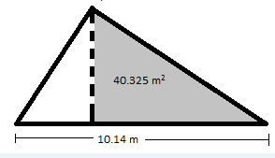

  - Determine the area of the larger triangle if it has a height of $12.2 m$.
$$A=\frac{1}{2}\left(10.14 m\right)\left(12.2 m\right) \\ =61.854{ m}^{2}$$

  - Let $A$ be the area of the unshaded (white) triangle in square meters. Write and solve an equation to determine the value of $A$, using the areas of the larger triangle and the gray triangle.
$$40.325 m^{2}+A=61.854 m^{2} \\ 40.325{ m}^{2}+A-40.325{ m}^{2}=61.854 m^{2}-40.325{ m}^{2} \\ A=21.529 m^{2}$$
X
X
Y
Y

Z
Z

