Lesson 3: The Area of Acute Triangles Using Height and Base

Classwork
Exercises
- Work with a partner on the exercises below. Determine if the area formula $A=\frac{1}{2}bh$ is always correct. You may use a calculator, but be sure to record your work on your paper as well. Figures are not drawn to scale.
 | Area of Two Right Triangles | Area of Entire Triangle
$$17.4 cm$$
$$12 cm$$
$$15 cm$$
$$9 cm$$
$$12.6 cm$$

$$8 ft.$$
$$3.9 ft.$$
$$5.2 ft.$$
$$6.5 ft.$$
$$2\frac{5}{6} in.$$
$$2 in.$$
$$\frac{5}{6} in.$$

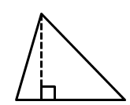
$$34 m$$
$$32 m$$
$$12 m$$
- Can we use the formula $A=\frac{1}{2}×base×height$ to calculate the area of triangles that are not right triangles? Explain your thinking.

- Examine the given triangle and expression.
$$3 ft.$$
$$8 ft.$$
$$4 ft.$$

$\frac{1}{2}(11 ft\text{.})(4 ft\text{.})$

Explain what each part of the expression represents according to the triangle.

- Joe found the area of a triangle by writing $A=\frac{1}{2}(11 in.)(4 in.)$, while Kaitlyn found the area by writing
$A=\frac{1}{2}(3 in.)(4 in.)+\frac{1}{2}(8 in.)(4 in.)$. Explain how each student approached the problem.

- The triangle below has an area of $4.76 sq. in$. If the base is $3.4 in.$, let $h$ be the height in inches.
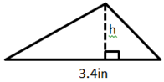

  - Explain how the equation $4.76 in^{2}=\frac{1}{2}\left(3.4 in.\right)h$ represents the situation.

  - Solve the equation.

Problem Set

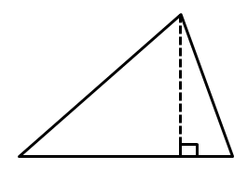
Calculate the area of each shape below. Figures are not drawn to scale.
$$8 m$$
$$14 m$$
$$16 m$$
$$16 m$$
- 2.
$$4.4 in.$$
$$3.3 in.$$
$$6.1 in.$$
$$5.5 in.$$

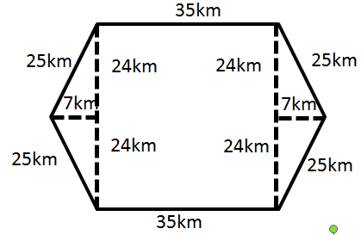
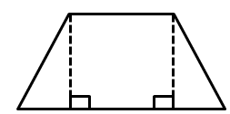
- 4.
$$5 ft.$$
$$12 ft.$$
$13$ ft.
$$13 ft.$$
$12$ ft.
$$12 ft.$$
$$5 ft.$$

- Immanuel is building a fence to make an enclosed play area for his dog. The enclosed area will be in the shape of a triangle with a base of $48 in.$ and an altitude of $32 in$. How much space does the dog have to play?

- Chauncey is building a storage bench for his son’s playroom. The storage bench will fit into the corner and against two walls to form a triangle. Chauncey wants to buy a cover for the bench.
If the storage bench is $2\frac{1}{2} ft.$ along one wall and $4\frac{1}{4} ft.$ along the other wall, how big will the cover
have to be in order to cover the entire bench?

- Examine the triangle to the right.
$5$ in.
$3$ in.
$4$ in.
$7$ in.
  - Write an expression to show how you would calculate the area.
  - Identify each part of your expression as it relates to the triangle.

- A triangular room has an area of $32\frac{1}{2} sq. m.$ If the height is $7\frac{1}{2} m$, write an equation to determine the length of the base, $b$, in meters. Then solve the equation.

