Lesson 2: The Area of Right Triangles

Classwork
Exploratory Challenge
  - Use the shapes labeled with an X to predict the formula needed to calculate the area of a right triangle. Explain your prediction.

Formula for the area of right triangles: ______________________________________

Area of the given triangle: _________________________________

  - Use the shapes labeled with a Y to determine if the formula you discovered in part (a) is correct.

Does your area formula for triangle Y match the formula you got for triangle X?

If so, do you believe you have the correct formula needed to calculate the area of a right triangle? Why or why not?

If not, which formula do you think is correct? Why?

Area of the given triangle: _____________________________________

Exercises
Calculate the area of each triangle below. Each figure is not drawn to scale.
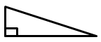
$$15 ft.$$
$$8 ft.$$
$$17 ft.$$
$$17.7 cm$$
$$11.4 cm$$
$$24.8 cm$$
$8$ $in.$
$$10 in.$$
$$6 in.$$

$$5\frac{3}{5} m$$
$$10\frac{1}{3} m$$
$$8\frac{2}{3} m$$

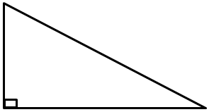
$$21.4 km$$
$$32.7 km$$

- Mr. Jones told his students they each need a half of a piece of paper. Calvin cut his piece of paper horizontally and Matthew cut his piece of paper diagonally. Which student has the larger area on their half piece of paper? Explain.
Calvin’s Paper
Matthew’s Paper

- Ben requested that the rectangular stage be split into two equal sections for the upcoming school play. The only instruction he gave was that he needed the area of each section to be half of the original size. If Ben wants the stage to be split into two right triangles, did he provide enough information? Why or why not?

- If the area of a right triangle is $6.22 sq. in.$ and its base is $3.11 in.$, write an equation that relates the area to the height, $h$, and the base. Solve the equation to determine the height.

Problem Set

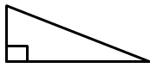
Calculate the area of each right triangle below. Note that the figures are not drawn to scale.
$$9.1 cm$$
$$31.2 cm$$
$$32.5 cm$$
- 2.
$$3\frac{3}{4} km$$
$$5 km$$
$$6\frac{1}{4} km$$

- 4.
$$5 in.$$
$$2.4 in.$$
$$3.2 in.$$
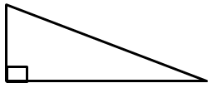
$$11 mm$$
$$60 mm$$
$$61 mm$$

$$16\frac{2}{3} ft.$$
$$10 ft.$$
$$13\frac{1}{3} ft.$$

- Elania has two congruent rugs at her house. She cut one vertically down the middle, and she cut diagonally through the other one.

A
B
C
D

After making the cuts, which rug (labeled A, B, C, or D) has the larger area? Explain.

- Give the dimensions of a right triangle and a parallelogram with the same area. Explain how you know.

- If the area of a right triangle is $\frac{9}{16} sq. ft.$ and the height is $\frac{3}{4} ft.$, write an equation that relates the area to the base, $b$, and the height. Solve the equation to determine the base.

