Lesson 27
Objective: Solve addition and subtraction problems decomposing and composing teen numbers as 1 ten and some ones.

Suggested Lesson Structure
 Fluency Practice (15 minutes)
 Application Problem (5 minutes)
 Concept Development (30 minutes)
 Student Debrief (10 minutes)
Total Time (60 minutes)
Fluency Practice (15 minutes)
- Say Ten: 5-Group Column 1.NBT.2 (2 minutes)
- Sprint: 10 More and 10 Less 1.NBT.5 (10 minutes)
- Magic Counting Sticks 1.NBT.2 (3 minutes)
Say Ten: 5-Group Column (2 minutes)
Materials: (T) 5-group column cards (Fluency Template)
Note: This fluency activity reviews the unit of 1 ten as a 5-group column, which was introduced in yesterday’s lesson.
T: (Hold up the card showing 14.) Tell me how many the Say Ten way.
S: Ten 4.
T: How many tens?
S: 1 ten.
T: How many ones?
S: 4 ones.
Repeat this process and alternate between requesting that students respond the Say Ten way and saying the number of tens and ones.

Sprint: 10 More and 10 Less (10 minutes)
Materials: (S) 10 More and 10 Less Sprint
Note: This activity addresses the grade level standard of mentally finding 10 more and 10 less than a number.
Magic Counting Sticks (3 minutes)
Materials: (T) Hide Zero cards (Lesson 18 Fluency Template 1)
Note: This activity reviews the concept of ten as a unit and prepares students for today’s lesson.
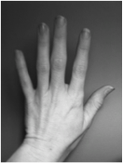
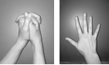
Assign partners. Show a teen number with Hide Zero cards (e.g., 15). Partner A uses his “magic counting sticks” (fingers) to show a bundle of ten and Partner B shows 5 ones. Ask students to identify how many tens and ones they made. Repeat with other teen numbers, alternating the roles of Partner A and B. Extend the game by calling out a teen number and letting one partner choose whether to show the ten or the ones. Then, ask the other partner to show the missing part.
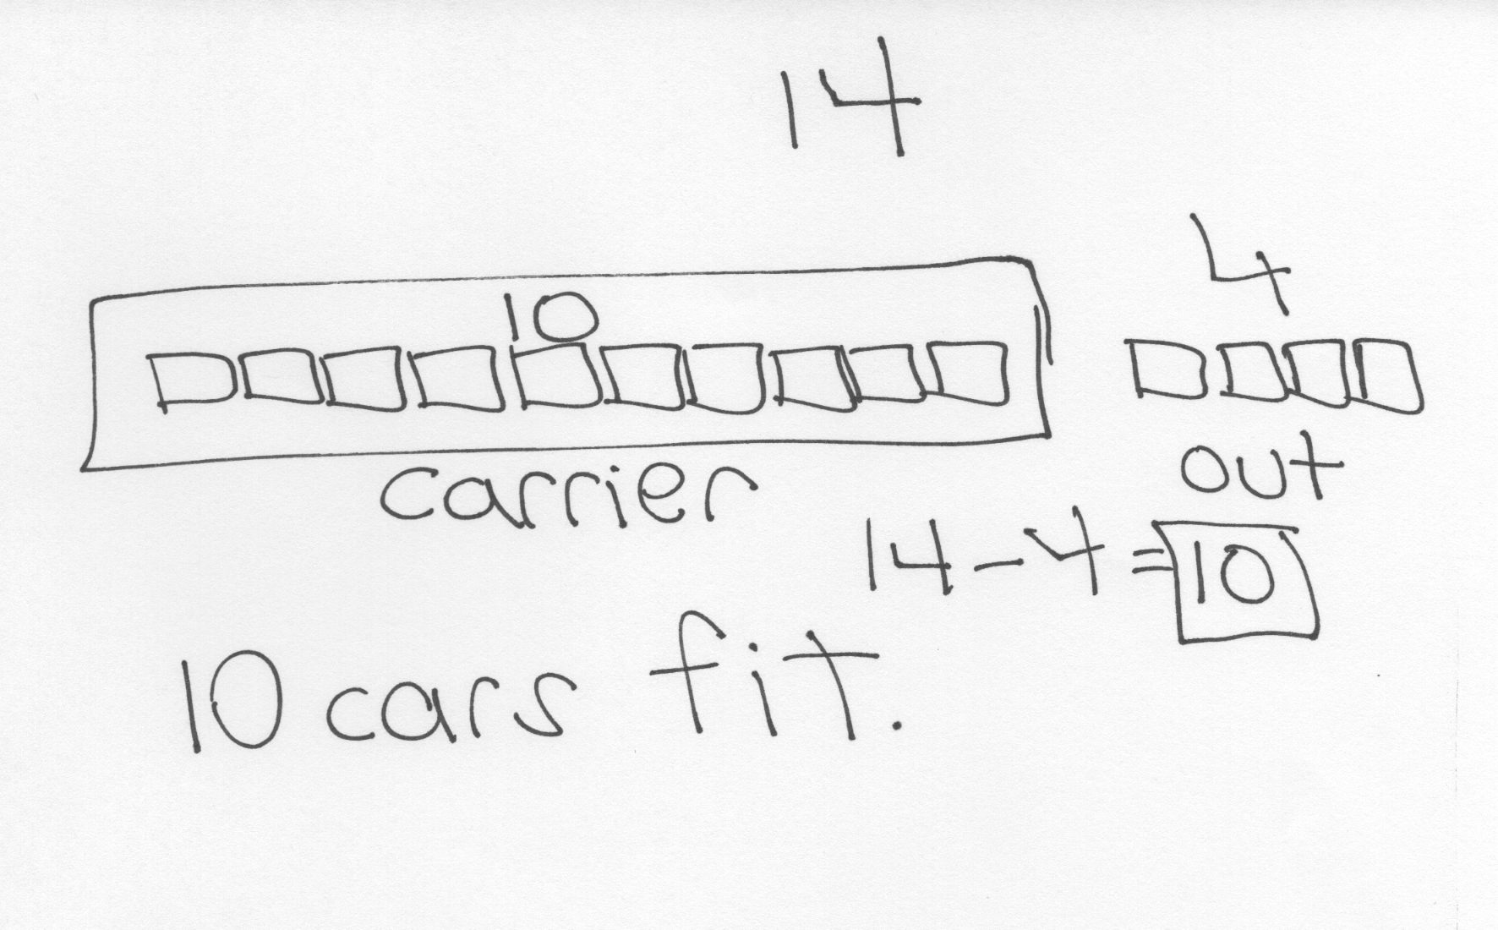
Application Problem (5 minutes)
Ruben was putting away his 14 toy cars. He filled his car carrier and had 4 cars left that could not fit. How many cars fit in his car carrier?
Note: This problem continues to consider contexts where 10 is grouped together within a unit. During the Debrief, the unitization
of ten is discussed.
Concept Development (30 minutes)
Materials: (T) Hide Zero cards (Lesson 18 Fluency Template 1) (S) Personal white board, Hide Zero cards (Lesson 18 Fluency Template 1)
Students sit in a semi-circle next to their partner in the meeting area with their personal boards.
T: Get out your magic counting sticks! With your partner, show 13.
S: (One student bundles 10 fingers by clasping their hands together; the other student shows 3 fingers.)
T: Good! Now, make 13 with your Hide Zero cards. You can talk with your partner if you’re stuck.
S: (Layer 3 on top of 10 to make 13.)
T: How many tens do you have in 13?
S: 1 ten!
T: (Hold up the 10 Hide Zero card.) How many extra ones do you have in 13?
S: 3 ones!
T: (Hold up the 3 Hide Zero card.) Yes, 13 is made of 1 ten (hold the 10 card out) and 3 ones
(hold the 3 card out). (Layer the Hide Zero cards again to show 13.)
T: (Project 13 – 3.) How can you use your Hide Zero cards to solve this?
S: Just take away 3.
T: And, how many are left?
S: Ten!
T: We can also call that…
S: 1 ten.
Repeat this process as needed with the following suggested sequence: 15 – 5, 16 – 4, and 18 – 7 (asking, “How many tens and ones are left?”).
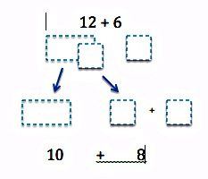T: Work with your partner to show 14 with your magic counting sticks and your Hide Zero cards.
14 + 2
10 + 4 + 2
1 0
4
4
2
1 0
2
S: (One student bundles 10 fingers by clasping hands together; the other student shows 4 fingers. They put 14 in front of them.)
T: (Project 14 + 2.) How can you do this? Will you add to the ten or the ones?
S: Just add more to the ones! Count 2 more! Use your fingers to count 2 more!
T: So, we don’t have to add to the ten in order to figure this out, we can just add to the ones?
S: Yes! It’s 16!

NOTES ON
MULTIPLE MEANS
OF REPRESENTATION:
While some students are experts at solving these number sentences, others may need more support with their Hide Zero cards. Students should use the Hide Zero cards as much as you see fit. Remove the scaffold for students who are able to do more mental calculations. Others can use the cards to help develop their ability to calculate mentally.

T: How many tens and ones make up 16?
S: 1 ten and 6 extra ones.
Project 14 + 2 and ask students to model it with their Hide Zero cards. As they take apart the 4 from 14, they add 4 ones and 2 ones together first to make 6. Now, with a ten and a 6, they layer these to make their total. Discuss the tens and ones that comprise the total each time. Repeat this process as needed with the following suggested sequence: 15 + 3, 17 + 2, and
13 + 7 (be sure to discuss the significance of 2 tens).
T: (Project 8 + 5.) Work with your partner. Partner A, use your personal board to show how to make 1 ten. Partner B, when she’s done, use your Hide Zero cards to show the solution.
S: (Partner A models the addition with the number sentence and number bond. Partner B shows 13 with Hide Zero cards.)
T: Point to the card that tells how many tens are in your answer, and say the number of tens. If you’re not sure, you can check!
S: (Point to the 1 in 13.) 1 ten.
T: Point to the card on your Hide Zero cards that tells how many ones are in your answer, and say how many ones.
S: 3 ones.
If students need more practice with this process, switch the partners, and repeat the same process with the following suggested sequence: 8 + 6, 7 + 5, and 6 + 9.
T: Hmm. I wonder how we can use our Hide Zero cards and personal white boards to help us solve
13 – 4?
S: Take from the ten! Count back! Count on!

NOTES ON
MULTIPLE MEANS
OF ENGAGEMENT:
Remember to challenge advanced learners. Students enjoy working with larger numbers, so extend their knowledge of place value. Give them a larger two-digit number, and they can articulate how many ones and tens are in that number. Find interactive games online by searching with the keywords place value games. These games can be played with numbers appropriate for the students in class.

T: Let’s try taking from the ten, just like [Student 1] said. Let’s make our total of 13 with our cards.
S: (Make 13 with Hide Zero cards.)
T: How can we take from the ten here?
S: Take apart the 10 and take 4 away from the ten!
T: (Draw a matching illustration on the board, showing 10 and 3 separated. Touch the 10.) And, how many are left?
MP.7
S: 6.
T: (Write 10 – 4 = 6 on the board.) How many do we have altogether? (Touch the 6 and the remaining 3.)
S: 9. (Write 6 + 3 = 9 on the board when students answer.)
T: 9 tens or 9 ones?
S: 9 ones!
T: How many tens are left?
S: 0 tens!
Repeat this process as needed with the following suggested sequence: 12 – 5, 14 – 8, and 15 – 7.
Problem Set (10 minutes)
Students should do their personal best to complete the Problem Set within the allotted 10 minutes. For some classes, it may be appropriate to modify the assignment by specifying which problems they work on first. Some problems do not specify a method for solving. Students should solve these problems using the RDW approach used for Application Problems.

Student Debrief (10 minutes)
Lesson Objective: Solve addition and subtraction problems decomposing and composing teen numbers as 1 ten and some ones.
The Student Debrief is intended to invite reflection and active processing of the total lesson experience.
Invite students to review their solutions for the Problem Set. They should check work by comparing answers with a partner before going over answers as a class.
Look for misconceptions or misunderstandings that can be addressed in the Debrief. Guide students in a conversation to debrief the Problem Set and process the lesson.
You may choose to use any combination of the questions below to lead the discussion.
- How did you use what we learned during the lesson to help you solve the word problems in the Problem Set?
- How was Problem 3 helpful in solving Problem 4?
- Look at Problem 4. How many tens are there altogether? Explain how you solved this.
- What do you notice about the problems that have 0 tens in the answer? What is similar about them?
- What do you notice about the problems that have 1 ten in the answer? How are they similar and different?
- Look at your work from the Application Problem. What’s another way to say the answer using tens and ones? If Ruben and his friend played with a total of 6 cars, how many tens and ones would be left in the carrier?
Exit Ticket (3 minutes)
After the Student Debrief, instruct students to complete the Exit Ticket. A review of their work will help you assess the students’ understanding of the concepts that were presented in the lesson today and plan more effectively for future lessons. You may read the questions aloud to the students.

Name Date
Number correct:
A
*Write the missing number.
1 | 10 + 3 = ☐ |  | 16 | 10 + ☐ = 11
2 | 10 + 2 = ☐ |  | 17 | 10 + ☐ = 12
3 | 10 + 1 = ☐ |  | 18 | 5 + ☐ = 15
4 | 1 + 10 = ☐ |  | 19 | 4 + ☐ = 14
5 | 4 + 10 = ☐ |  | 20 | ☐ + 10 = 17
6 | 6 + 10 = ☐ |  | 21 | 17 - ☐ = 7
7 | 10 + 7 = ☐ |  | 22 | 16 - ☐ = 6
8 | 8 + 10 = ☐ |  | 23 | 18 - ☐ = 8
9 | 12 - 10 = ☐ |  | 24 | ☐ - 10 = 8
10 | 11 - 10 = ☐ |  | 25 | ☐ - 10 = 9
11 | 10 - 10 = ☐ |  | 26 | 1 + 1 + 10 = ☐
12 | 13 - 10 = ☐ |  | 27 | 2 + 2 + 10 = ☐
13 | 14 - 10 = ☐ |  | 28 | 2 + 3 + 10 = ☐
14 | 15 - 10 = ☐ |  | 29 | 4 + ☐ + 3 = 17
15 | 18 - 10 = ☐ |  | 30 | ☐ + 5 + 10 = 18
Name Date
Number correct:
B
*Write the missing number.
1 | 10 + 1 = ☐ |  | 16 | 10 + ☐ = 10
2 | 10 + 2 = ☐ |  | 17 | 10 + ☐ = 11
3 | 10 + 3 = ☐ |  | 18 | 2 + ☐ = 12
4 | 4 + 10 = ☐ |  | 19 | 3 + ☐ = 13
5 | 5 + 10 = ☐ |  | 20 | ☐ + 10 = 13
6 | 6 + 10 = ☐ |  | 21 | 13 - ☐ = 3
7 | 10 + 8 = ☐ |  | 22 | 14 - ☐ = 4
8 | 8 + 10 = ☐ |  | 23 | 16 - ☐ = 6
9 | 10 - 10 = ☐ |  | 24 | ☐ - 10 = 6
10 | 11 - 10 = ☐ |  | 25 | ☐ - 10 = 8
11 | 12 - 10 = ☐ |  | 26 | 2 + 1 + 10 = ☐
12 | 13 - 10 = ☐ |  | 27 | 3 + 2 + 10 = ☐
13 | 15 - 10 = ☐ |  | 28 | 2 + 3 + 10 = ☐
14 | 17 - 10 = ☐ |  | 29 | 4 + ☐ + 4 = 18
15 | 19 - 10 = ☐ |  | 30 | ☐ + 6 + 10 = 19
Name Date
Solve the problems. Write your answers to show how many tens and ones. If there is only 1 ten, cross off the “s.”
Add.
1. 2.
____ tens and ____ ones
5 + 13 =
____ tens and ____ ones
12 + 6 =

3. 4.
____ tens and ____ ones
= 8 + 12
____ tens and ____ ones
8 + 7 =

Subtract.
5. 6.
____ tens and ____ ones
17 - 4 =
____ tens and ____ ones
17 – 5 =

7. 8.
____ tens and ____ ones
14 – 6 =
____ tens and ____ ones
= 16 – 7

Read the word problem. Draw and label. Write a number sentence and statement. Rewrite your answer to show its tens and ones.
9. Frankie and Maya made 4 big sandcastles at the beach. If they made 10 small sandcastles, how many total sandcastles did they make?

____ tens and ____ ones

10. Ronnie has 8 stickers that are stars. Her friend Sina gives her 7 more. How many stickers does Ronnie have now?

____ tens and ____ ones

11. We tied 14 balloons to the tables for a party, but 3 floated away! How many
balloons were still tied to the tables?

____ tens and ____ ones

12. I ate 5 of the 16 strawberries that I picked. How many did I have left over?

____ tens and ____ ones
Name Date
Solve the problems. Write the answers to show how many tens and ones. If there is only one ten, cross off the “s.”

1. 2.
13 + 6 = 7 + 6 =
____ tens and ____ ones
____ tens and ____ ones

Read the word problem. Draw and label. Write a number sentence and statement that matches the story. Rewrite your answer to show its tens and ones.

3. Kendrick went bowling. He knocked down 16 pins in the first two frames. If he knocked down 9 in the first frame, how many pins did he knock down in the second frame?

____ tens and ____ ones

Name Date
Solve the problems. Write the answers to show how many tens and ones. If there is only one ten, cross off the “s.”

1. 2.
8 + 5 = 12 – 4 =

____ tens and ____ ones
____ tens and ____ ones

3. 4.
15 - 6 = 14 + 5 =

____ tens and ____ ones
____ tens and ____ ones

5. 6.
13 + 5 = 17 – 8 =

____ tens and ____ ones
____ tens and ____ ones
Read the word problem. Draw and label. Write a number sentence and statement that matches the story. Rewrite your answer to show its tens and ones.
7. Mike has some red cars and 8 blue cars. If Mike has 9 red cars, how many cars does he have in all?

____ tens and ____ ones

8. Yani and Han had 14 golf balls. They lost some balls. They had 8 golf balls left. How many balls did they lose?

____ tens and ____ ones

9. Nick rides his bike for 6 miles over the weekend. He rides 14 miles during the week. How many total miles does Nick ride?

____ tens and ____ ones

5-group column cards
5-group column cards

