Lesson 34: Writing and Graphing Inequalities in Real-World Problems

Classwork
Example 1
Statement Inequality Graph
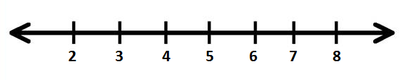
  - Caleb has at least $\$5$.

  - Tarek has more than $\$5$.

  - Vanessa has at most $\$5$.

  - Li Chen has less than $\$5$.

Example 2
Kelly works for Quick Oil Change. If customers have to wait longer than $20$ minutes for the oil change, the company does not charge for the service. The fastest oil change that Kelly has ever done took $6$ minutes. Show the possible customer wait times in which the company charges the customer.
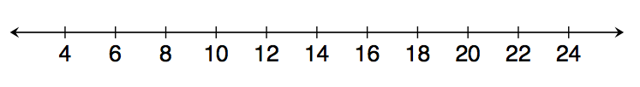

Example 3
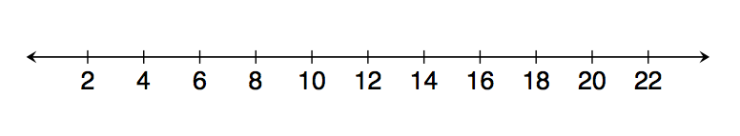
Gurnaz has been mowing lawns to save money for a concert. Gurnaz will need to work for at least six hours to save enough money, but he must work fewer than $16$ hours this week. Write an inequality to represent this situation, and then graph the solution.

Exercises 1–5
Write an inequality to represent each situation. Then, graph the solution.
- Blayton is at most $2$ meters above sea level.
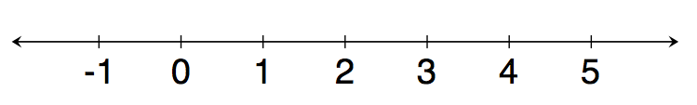

- Edith must read for a minimum of $20$ minutes.
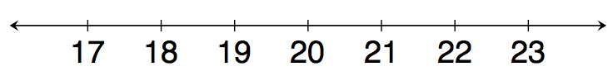
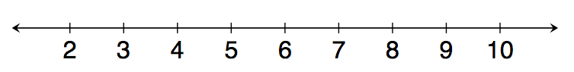

- Travis milks his cows each morning. He has never gotten fewer than $3$ gallons of milk; however, he always gets fewer than $9$ gallons of milk.

- Rita can make $8$ cakes for a bakery each day. So far she has orders for more than $32$ cakes. Right now, Rita needs more than four days to make all $32$ cakes.

- Rita must have all the orders placed right now done in $7$ days or fewer. How will this change your inequality and your graph?

Possible Extension Exercises 6–10
- Kasey has been mowing lawns to save up money for a concert. He earns $\$15$ per hour and needs at least $\$90$ to go to the concert. How many hours should he mow?
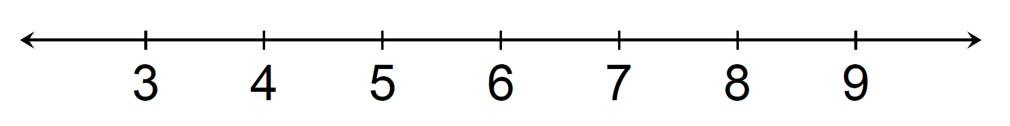

- Rachel can make $8$ cakes for a bakery each day. So far, she has orders for more than $32$ cakes. How many days will it take her to complete the orders?

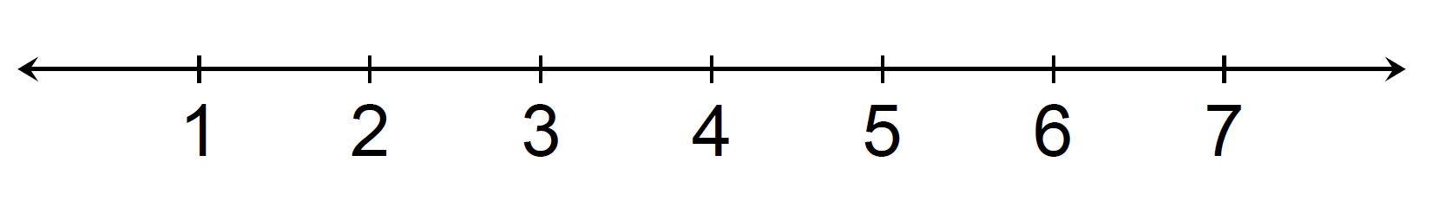

- Ranger saves $\$70$ each week. He needs to save at least $\$2,800$ to go on a trip to Europe. How many weeks will he need to save?

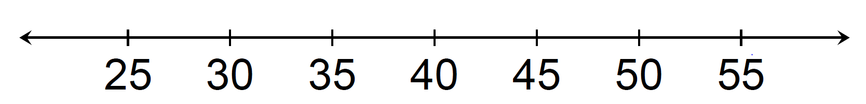

- Clara has less than $\$75$. She wants to buy $3$ pairs of shoes. What price shoes can Clara afford if all the shoes are the same price?
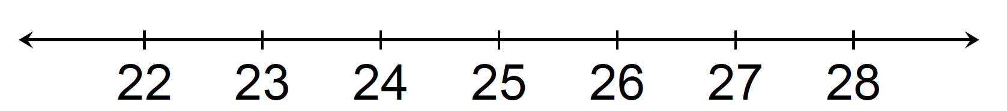

- A gym charges $\$25$ per month plus $\$4$ extra to swim in the pool for an hour. If a member only has $\$45$ to spend each month, at most how many hours can the member swim?
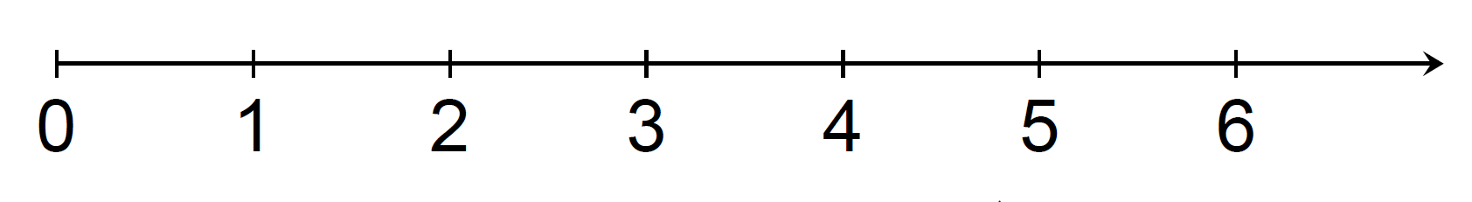

Problem Set

Write and graph an inequality for each problem.
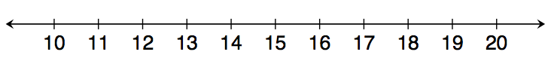
- At least $13$.

- Less than $7$.

- Chad will need at least $24$ minutes to complete the $5$K race. However, he wants to finish in under $30$ minutes.
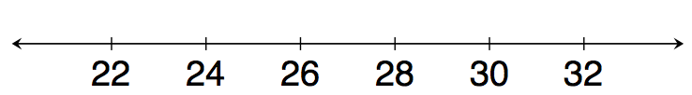

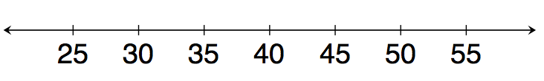
- Eva saves $\$60$ each week. Since she needs to save at least $\$2,400$ to go on a trip to Europe, she will need to save for at least $40$ weeks.

- Clara has $\$100$. She wants to buy $4$ pairs of the same pants. Due to tax, Clara can afford pants that are less than $\$25$.
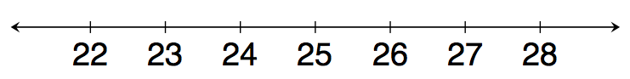

- A gym charges $\$30$ per month plus $\$4$ extra to swim in the pool for an hour. Because a member has just $\$50$ to spend at the gym each month, the member can swim at most $5$ hours.
