Lesson 34: Writing and Graphing Inequalities in Real-World Problems

Student Outcomes
- Students recognize that inequalities of the form $x<c$ and $x>c$, where $x$ is a variable and $c$ is a fixed number, have infinitely many solutions when the values of $x$ come from a set of rational numbers.

Classwork
Example 1 (10 minutes)
Begin with a discussion of what each of these statements means. Have students share possible amounts of money that could fit the given statement to build towards a graph and an inequality.
Example 1
Statement Inequality Graph
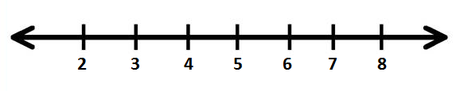
  - Caleb has at least $\$5$.
$$c≥5$$

$$t>5$$
  - Tarek has more than $\$5$.

$$v≤ 5$$
  - Vanessa has at most $\$5$.
MP.4
$$L<5$$
  - Li Chen has less than $\$5$.

- How much money could Caleb have?
  - He could have $\$5$, $\$5.01$, $\$5.90$, $\$6$, $\$7$,$\$8$,$\$9$, …. More simply, he could have $\$5$ or any amount greater than $\$5$.
- How would we show this as an inequality?
  - $c≥5$, where $c$ is the amount of money that Caleb has in dollars.
- What numbers on the graph do we need to show as a solution?
  - $5$ is a solution and everything to the right.
- Because we want to include $5$ in the solution, we will draw a solid circle over the $5$ and then an arrow to the right to show that all the numbers $5$ and greater are part of the solution.
MP.4
- How does the statement about Tarek differ from the statement about Caleb?
  - Tarek has more than $\$5$, but he cannot have exactly $\$5$, where Caleb might have had exactly $\$5$.
- So, how would we show this as an inequality?
  - $t>5$, where $t$ is the amount of money Tarek has in dollars.
- When we graph the inequality for Tarek, we still want a circle on the $5$, but this time it will not be solid to show that $5$ is not included in the solution.
- What does “at most” mean in Vanessa’s example?
  - Vanessa could have $\$5$, but no more than $5$. So, she could have less than $\$5$, including $\$4$,$\$3$, $\$2$,$\$1$, $\$0$, or even a negative amount if she owes someone money.
- How would we write this as an inequality?
  - $v≤5$, where $v$ is the amount of money Vanessa has in dollars.
- How would you show this on the graph?
  - We would put a circle on the $5$ and then an arrow towards the smaller numbers.
- Would we have a solid or open circle?
  - It would be solid to show that $5$ is part of the solution.
- Would the inequality and graph for Li Chen be the same as Vanessa’s solution? Why or why not?
  - No, they would be similar but not exactly the same. Li Chen cannot have $\$5$ exactly. So, the circle in the graph would be open, and the inequality would be $L<5$, where $L$ represents the amount of money Li Chen has in dollars.
MP.4
Example 2 (5 minutes)
Example 2
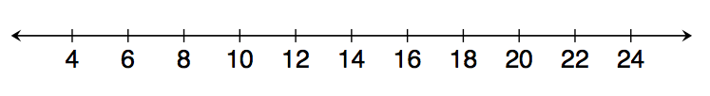
Kelly works for Quick Oil Change. If customers have to wait longer than $20$ minutes for the oil change, the company does not charge for the service. The fastest oil change that Kelly has ever done took $6$ minutes. Show the possible customer wait times in which the company charges the customer.

$$6≤x≤20$$

- How is this example different from the problems in Example 1?
  - This one is giving a range of possible values. The number of minutes he takes to change the oil should be somewhere between two values instead of greater than just one or less than just one.
- Let’s start with the first bit of information. What does the second sentence of the problem tell us about the wait times for paying customers?
  - The oil change must take $20$ minutes or less.
- How would we show this on a number line?
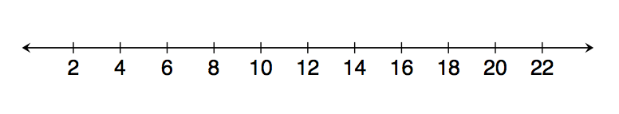
  - Because $20$ minutes is part of the acceptable time limit, we will use a solid circle and shade to the left.

- Now, let’s look at the other piece of information. The fastest Kelly has ever completed the oil change is $6$ minutes. What does this mean about the amount of time it will take?
  - This means that it will take $6$ minutes or more to complete an oil change.
- How would we show this on a number line?
  - Because $6$ minutes is a possible amount of time, we will use a solid circle. Then we will shade to the right.
MP.4

- Now, we need to put both of these pieces of information together to make one model of the inequality.
- How could we show both of these on one number line?
  - Instead of an arrow, we would have two circles and we would shade inbetween.
- Should the circles be open or solid?
  - Because he has to change the oil in $20$ minutes or less, the $20$ is part of the solution and the circle will be closed. The $6$ minutes is also part of the solution because it is an actual time that Kelly has completed the work. The circle at $6$ should also be closed.

Example 3 (5 minutes)
Example 3
Gurnaz has been mowing lawns to save money for a concert. Gurnaz will need to work for at least six hours to save enough money, but he must work fewer than $16$ hours this week. Write an inequality to represent this situation, and then graph the solution.

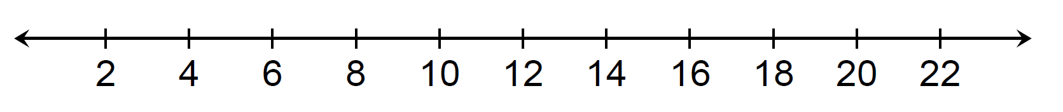
$6$ $≤x<16$

- How would we represent Gurnaz working at least six hours?
  - “At least” tells us that Gurnaz must work $6$ hours or more.
  - $x≥6$

- What inequality would we use to show that he must work fewer than $16$ hours?
  - Fewer than means that Gurnaz cannot actually work $16$ hours. So, we will use $x<16$.

Exercises 1–5 (15 minutes)
Students work individually.

Exercises 1–5
Write an inequality to represent each situation. Then, graph the solution.
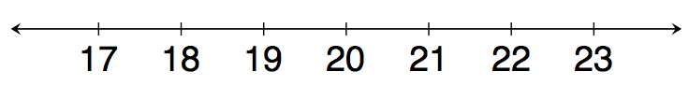
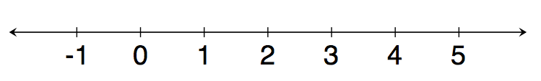
- Blayton is at most $2$ meters above sea level.
$b≤2$, where $b$ is Blayton’s position in relationship to sea level in meters.

- Edith must read for a minimum of $20$ minutes.
$E≥20$, where $E$ is the number of minutes Edith reads.

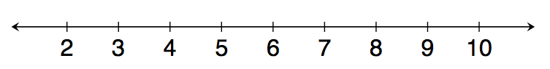
- Travis milks his cows each morning. He has never gotten fewer than $3$ gallons of milk; however, he always gets fewer than $9$ gallons of milk.
$3≤x<9$, where $x$ represents the gallons of milk.

- Rita can make $8$ cakes for a bakery each day. So far, she has orders for more than $32$ cakes. Right now, Rita needs more than four days to make all $32$ cakes.
$x>4$, where $x$ is the number of days Rita has to bake the cakes.

- Rita must have all the orders placed right now done in $7$ days or fewer. How will this change your inequality and your graph?
$$4<x≤7$$
Our inequality will change because there is a range for the number of days Rita has to bake the cakes. The graph has changed because Rita is more limited in the amount of time she has to bake the cakes. Instead of the graph showing any number larger than $4$, the graph now has a solid circle at $7$ because Rita must be done baking the cakes in a maximum of $7$days.

Possible Extension Exercises 6–10
The following problems combine the skills used to solve equations in previous lessons within this module and inequalities.
Possible Extension Exercises 6–10
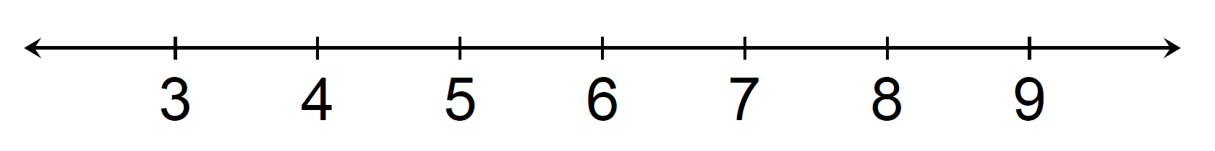
- Kasey has been mowing lawns to save up money for a concert. He earns $\$15$ per hour and needs at least $\$90$ to go to the concert. How many hours should he mow?
$$15x≥90 \\ \frac{15x}{15}≥\frac{90}{15} \\ x≥6$$
Kasey will need to mow for $6$ or more hours.
- Rachel can make $8$ cakes for a bakery each day. So far, she has orders for more than $32$ cakes. How many days will it take her to complete the orders?
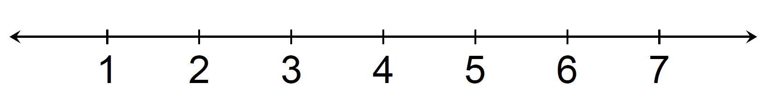
$$8x>32 \\ \frac{8x}{8}>\frac{32}{8} \\ x>4$$
Rachel will need to work more than $4$ days.

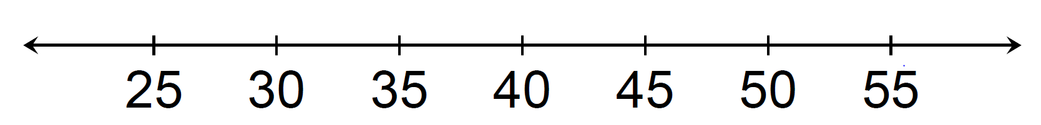
- Ranger saves $\$70$ each week. He needs to save at least $\$2,800$ to go on a trip to Europe. How many weeks will he need to save?
$$70x ≥ 2,800 \\ \frac{70x}{70}≥\frac{2,800}{70} \\ x≥40$$
Ranger needs to save for at least $40$ weeks.

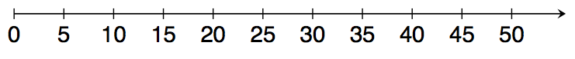
- Clara has less than $\$75$. She wants to buy $3$ pairs of shoes. What price shoes can Clara afford if all the shoes are the same price?
$$3x < 75 \\ \frac{3x}{3}<\frac{75}{3} \\ x<25$$
Clara can afford shoes that are greater than $\$0$ and less than $\$25$.

- A gym charges $\$25$ per month plus $\$4$ extra to swim in the pool for an hour. If a member only has $\$45$ to spend each month, at most how many hours can the member swim?
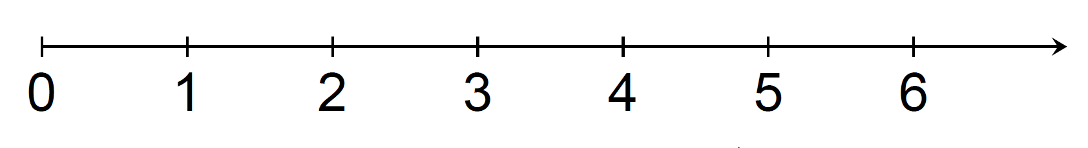
$4x+25≤45$$$4x+25-25≤45-25 \\ 4x≤20 \\ \frac{4x}{4}≤\frac{20}{4} \\ x ≤5$$
The member can swim in the pool for $5$ hours. However, we also know that the total amount of time the member spends in the pool must be greater than or equal to $0$ hours because the member may choose not to swim.
$$0≤x≤5$$

Closing (5 minutes)
- How are inequalities different from equations?
  - Inequalities can have a range of possible values that make the statement true, where equations do not.
- Does the phrase “at most” refer to being less than or greater than something? Give an example to support your answer.
  - At most means that you can have that amount or less than that amount. You cannot go over. My mom says that I can watch at most $3$ TV shows after I do my homework. This means that I can watch $3$ or fewer than $3$ TV shows.

Exit Ticket (5 minutes)
Name Date
Lesson 34: Writing and Graphing Inequalities in Real-World Problems

Exit Ticket

For each question, write an inequality. Then, graph your solution.
- Keisha needs to make at least $28$ costumes for the school play. Since she can make $4$ costumes each week, Keisha plans to work on the costumes for at least $7$ weeks.

- If Keisha has to have the costumes complete in $10$ weeks or fewer, how will our solution change?

Exit Ticket Sample Solutions

For each question, write an inequality. Then, graph your solution.
- Keisha needs to make at least $28$ costumes for the school play. Since she can make $4$ costumes each week, Keisha plans to work on the costumes for at least $7$weeks.
$$x≥7$$
Keisha should plan to work on the costumes for $7$ or more weeks.

- If Keisha has to have the costumes complete in $10$ weeks or fewer, how will our solution change?
Keisha had $7$ or more weeks in Problem $1$. It will still take her at least $7$ weeks, but she cannot have more than $10$ weeks.
$7≤x≤10$

Problem Set Sample Solutions

Write and graph an inequality for each problem.
- At least $13$.
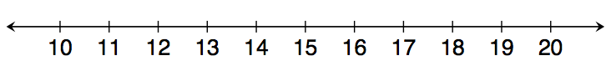
$x≥13$

- Less than $7$.
$x<7$

- Chad will need at least $24$ minutes to complete the $5$K race. However, he wants to finish in under $30$ minutes.
$$24≤x<30$$
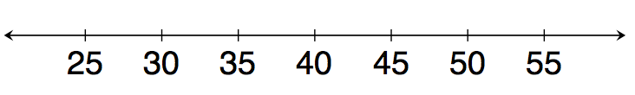
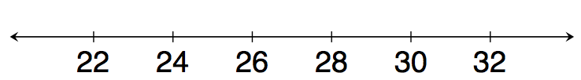

- Eva saves $\$60$ each week. Since she needs to save at least $\$2,400$ to go on a trip to Europe, she will need to save for at least $40$ weeks.
$$x≥40$$

- Clara has $\$100$. She wants to buy $4$ pairs of the same pants. Due to tax, Clara can afford pants that are less than $\$25$.
Clara must spend less than $\$25$, but we also know that Clara will spend more than $\$0$ when she buys pants at the store.
$0<x<25$

- A gym charges $\$30$ per month plus $\$4$ extra to swim in the pool for an hour. Because a member has just $\$50$ to spend at the gym each month, the member can swim at most $5$ hours.
The member can swim in the pool for $5$ hours. However, we also know that the total amount of time the member spends in the pool must be greater than or equal to $0$ hours because the member may choose not to swim.
$$0≤x≤5$$
