Lesson 32: Multi-Step Problems in the Real World

Student Outcomes
- Students analyze an equation in two variables, choose an independent variable and a dependent variable, make a table, and make a graph for the equation by plotting the points in the table. For the graph, the independent variable is usually represented by the horizontal axis, and the dependent variable is usually represented by the vertical axis.

Classwork
Opening Exercise (5 minutes)
Opening Exercise
Xin is buying beverages for a party that come in packs of $8$. Let $p$ be the number of packages Xin buys and $t$ be the total number of beverages. The equation $t=8p$ can be used to calculate the total number of beverages when the number of packages is known. Determine the independent and dependent variable in this scenario. Then, make a table using whole number values of $p$ less than $6$.
The total number of beverages is the dependent variable because the total number of beverages depends on the number of packages purchased. Therefore, the independent variable is the number of packages purchased.
# of Packages ($p$) | Total Number of Beverages ($t=8p$)
$$0$$ | $$0$$
$$1$$ | $$8$$
$$2$$ | $$16$$
$$3$$ | $$24$$
$$4$$ | $$32$$
$$5$$ | $$40$$

Example 1 (7 minutes)
Example 1
$$48$$
$$40$$
$$32$$
$$24$$
$$16$$
$$8$$
Number of Packages
Beverages for the Party
$0$ $1$ $2$ $3$ $4$ $5$ $6$
Total Number of Beverages
Make a graph for the table in the Opening Exercise.

- To make a graph, we must determine which variable is measured along the horizontal axis and which variable is measured along the vertical axis.
- Generally, the independent variable is measured along the $x$-axis. Which axis is the $x$-axis?
  - The $x$-axis is the horizontal axis.
- Where would you put the dependent variable?
  - On the $y$-axis. It travels vertically, or up and down.
- We want to show how the number of beverages changes when the number of packages changes. To check that you have set up your graph correctly, try making a sentence out of the labels on the axes. Write your sentence using the label from the $y$-axis first followed by the label from the $x$-axis. The total number of beverages depends on the number of packages purchased.

Example 2 (3 minutes)
Example 2
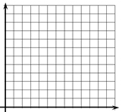
Use the graph to determine which variable is the independent variable and which is the dependent variable. Then, state the relationship between the quantities represented by the variables.
$$250$$
$$200$$
$$150$$
$$50$$
$$100$$
Number of Hours
$0$ $1$ $2$ $3$ $4$ $5$
Number of Miles
Road Trip
MP.2

The number of miles driven depends on how many hours they drive. Therefore, the number of miles driven is the dependent variable, and the number of hours is the independent variable. This graph shows that they can travel $50$ miles every hour. So, the total number of miles driven increases by $50$ every time the number of hours increases by $1$.

Exercises (20 minutes)
Students work individually.
Exercises
- Each week Quentin earns $\$30$. If he saves this money, create a graph that shows the total amount of money Quentin has saved from week $1$ through week $8$. Write an equation that represents the relationship between the number of weeks that Quentin has saved his money, $w$, and the total amount of money in dollars he has saved, $s$. Then, name the independent and dependent variables. Write a sentence that shows this relationship.
$s=30w$
$0$ $1$ $2$ $3$ $4$ $5$ $6$ $7$ $8$ $9$
Number of Weeks
$$240$$
$$210$$
$$180$$
$$150$$
$$120$$
$$90$$
$$60$$
$$30$$
Money Saved
The amount of money saved, $s$, is the dependent variable, and the number of weeks, $w$, is the independent variable.
Number of Weeks | Total Saved ($\$$)
$$1$$ | $$30$$
$$2$$ | $$60$$
$$3$$ | $$90$$
$$4$$ | $$120$$
$$5$$ | $$150$$
$$6$$ | $$180$$
$$7$$ | $210$  Amount of Money ($\$$)
$$8$$ | $$240$$

Therefore, the amount of money Quentin has saved increases by $\$30$ for every week he saves money.

- Zoe is collecting books to donate. She started with $3$ books and collects two more each week. She is using the equation $b=2w+3$, where$b$ is the total number of books collected and $w$ is the number of weeks she has been collecting books. Name the independent and dependent variables. Then, create a graph to represent how many books Zoe has collected when $w$ is $5$ or less.
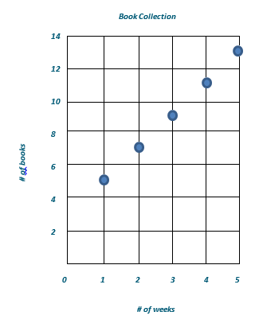
The number of weeks is the independent variable. The number of books collected is the dependent variable.
Number of weeks
Number of books
Number of Weeks | Number of Books Collected
$$0$$ | $$3$$
$$1$$ | $$5$$
$$2$$ | $$7$$
$$3$$ | $$9$$
$$4$$ | $$11$$
$$5$$ | $$13$$

- Eliana plans to visit the fair. She must pay $\$5$ to enter the fair grounds and an additional $\$3$ per ride. Write an equation to show the relationship between $r$, the number of rides, and $t$, the total cost. State which variable is dependent and which is independent. Then, create a graph that models the equation.
$$t=3r+5$$
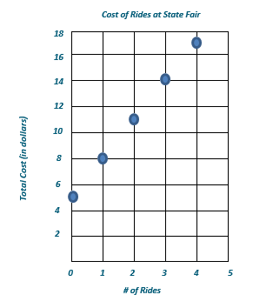
The number of rides is the independent variable, and the total cost is the dependent variable.
# of Rides | Total Cost (in dollars)
$$0$$ | $$5$$
$$1$$ | $$8$$
$$2$$ | $$11$$
$$3$$ | $$14$$
$$4$$ | $$17$$

Closing (5 minutes)
- Imagine that you are helping a friend with his math work. Here is the problem he was solving:
Henry is taking a taxicab home. The cab company charges an initial fee of $\$5$ plus $\$2$ for each additional mile. Henry uses the equation $t=2m+5$ to calculate the cost of the ride, where $t$ is the total cost and $m$ is the number of miles.
Your friend states that $t$ is the dependent variable and $m$ is the independent variable. Then the friend starts to sketch a graph.
Total Cost of Ride
Number of Miles
- What would you tell your friend when looking over his/her work?
  - I would tell my friend that the dependent variable should go on the vertical axis or the $y$-axis. Then your graph will show that the total cost of the ride depends on how many miles you travel in the taxicab.

Exit Ticket (5 minutes)

Name Date
Lesson 32: Multi-Step Problems in the Real World

Exit Ticket

Determine which variable is the independent variable and which variable is the dependent variable. Write an equation, make a table, and plot the points from the table on the graph.
Enoch can type $40$ words per minute. Let $w$ be the number of words typed and $m$ be the number of minutes spent typing.

Independent variable

Dependent variable

Equation

Exit Ticket Sample Solutions

Determine which variable is the independent variable and which variable is the dependent variable. Write an equation, make a table, and plot the points from the table on the graph.
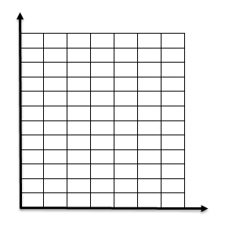
Enoch can type $40$ words per minutes. Let $w$ be the number of words typed and $m$ be the number of minutes spent typing.
$$40$$
$$80$$
$0$ $1$ $2$ $3$ $4$ $5$ $6$
# of Minutes Spent Typing
$$120$$
$$160$$
$$200$$
$$240$$
Words Typed per Minute
# of Words Typed
The independent variable is the number of minutes spent typing. The dependent variable is the number of words typed.
The equation is $w=40m$.
# of Minutes | # of Words
$$0$$ | $$0$$
$$1$$ | $$40$$
$$2$$ | $$80$$
$$3$$ | $$120$$
$$4$$ | $$160$$
$$5$$ | $$200$$

Problem Set Sample Solutions

- Caleb started saving money in a cookie jar. He started with $\$25$. He adds $\$10$ to the cookie jar each week. Write an equation where $w$ is the number of weeks Caleb saves his money and $t$ is the total amount in dollars in the cookie jar. Determine which variable is the independent variable and which is the dependent variable. Then, graph the total amount in the cookie jar for $w$ being less than $6$ weeks.
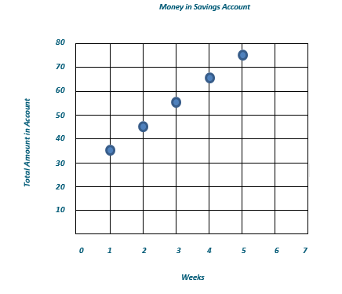
$t=10w+25$
Total Amount in Cookie Jar ($)
# of Weeks
Money in Cookie Jar
The total amount, $t$, is the dependent variable.
The number of weeks, $w$, is the independent variable.
# of Weeks | Total Amount in Cookie Jar ($)
$$0$$ | $$25$$
$$1$$ | $$35$$
$$2$$ | $$45$$
$$3$$ | $$55$$
$$4$$ | $$65$$
$$5$$ | $$75$$

- Kevin is taking a taxi from the airport to his home. There is a $\$6$ flat fee for riding in the taxi. In addition, Kevin must also pay $\$1$ per mile. Write an equation where $m$ is the number of miles and $t$ is the total cost in dollars of the taxi ride. Determine which variable is independent and which is dependent. Then, graph the total cost for $m$ being less than $6$ miles.
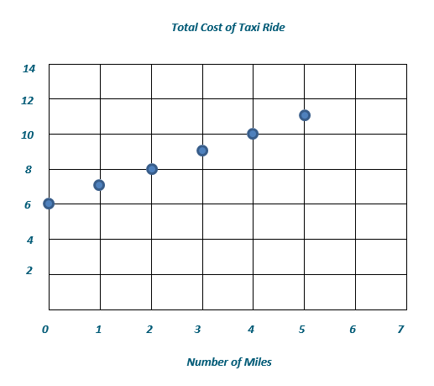
$t=1m + 6$
Total Cost ($\$$)
Total Cost of a Taxi Ride
Number of Miles
The total cost, $t$, is the dependent variable.
The number of miles, $m$, is the independent variable.
# of Miles | Total Cost ($\$$)
$$0$$ | $$6$$
$$1$$ | $$7$$
$$2$$ | $$8$$
$$3$$ | $$9$$
$$4$$ | $$10$$
$$5$$ | $$11$$

- Anna started with$\$10$. She saved an additional$\$5$ each week. Write an equation that can be used to determine the total amount saved in dollars, $t$, after a given number of weeks, $w$. Determine which variable is independent and which is dependent. Then, graph the total amount saved for the first $8$ weeks.
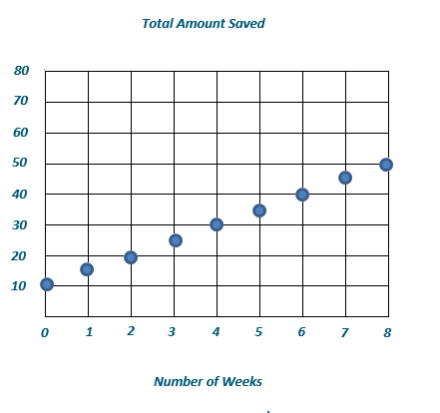
$t=5w + 10$
# of Weeks
Total Amount ($\$$)
Total Amount Saved
The total amount saved, $t$, is the dependent variable.
The number of weeks, $w$, is the independent variable.
# of Weeks | Total Amount ($\$$)
$$0$$ | $$10$$
$$1$$ | $$15$$
$$2$$ | $$20$$
$$3$$ | $$25$$
$$4$$ | $$30$$
$$5$$ | $$35$$
$$6$$ | $$40$$
$$7$$ | $$45$$
$$8$$ | $$50$$

- Aliyah is purchasing produce at the farmers’ market. She plans to buy $\$10$ worth of potatoes and some apples. The apples cost $\$1.50$ per pound. Write an equation to show the total cost of the produce, where$T$is the total cost, in dollars, and $a$ is the number of pounds of apples. Determine which variable is dependent and independent. Then, graph the equation on the coordinate plane.
$$T=1.50a+10$$
The total cost is the dependent variable. The number of pounds of apples is the independent variable.
# of Pounds of Apples | Total Cost ($\$$)
$$0$$ | $$10$$
$$1$$ | $$11.50$$
$$2$$ | $$13$$
$$3$$ | $$14.50$$
$$4$$ | $$16$$
$$5$$ | $$17.50$$
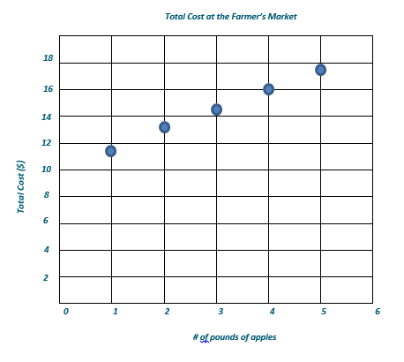
# of lb. of Apples
Total Cost at the Farmers’ Market
Total Cost ($\$$)

