Lesson 30: One-Step Problems in the Real World

Classwork
Opening Exercise
Draw an example of each term, and write a brief description.

Acute

Obtuse

Right

Straight

Reflex

Example 1
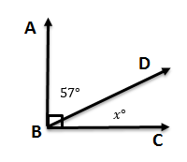
$∠ABC$ measures $90°$. The angle has been separated into two angles. If one angle measures $57°$, what is the measure of the other angle?
How are these two angles related?

What equation could we use to solve for $x$?

Now let’s solve.

Example 2
Michelle is designing a parking lot. She has determined that one of the angles should be $115°$. What is the measure of angle $x$ and angle $y$?
How is angle $x$ related to the $115°$ angle?
$$115°$$
$$x°$$
$$y°$$

What equation would we use to show this?

How would you solve this equation?

How is angle $y$ related to the angle that measures $115°$?

Example 3
A beam of light is reflected off a mirror. Below is a diagram of the reflected beam. Determine the missing angle measure.
$$x°$$
$$55°$$
$$55°$$

How are the angles in this question related?

What equation could we write to represent the situation?

How would you solve an equation like this?

Exercises 1–5
Write and solve an equation in each of the problems.
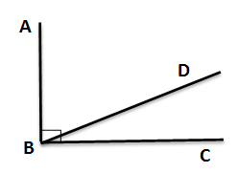
- $∠ABC$ measures $90°$. It has been split into two angles, $∠ABD$ and $∠DBC$. The measure of the two angles is in a ratio of $2:1$. What are the measures of each angle?

- Solve for $x$.
$$64°$$
$$x°$$
$$37°$$

- Candice is building a rectangular piece of a fence according to the plans her boss gave her. One of the angles is not labeled. Write an equation and use it to determine the measure of the unknown angle.
$$x°$$
$$49°$$

- Rashid hit a hockey puck against the wall at a $38°$ angle. The puck hit the wall and traveled in a new direction. Determine the missing angle in the diagram.

$38$°
$x$°
$38$°

- Jaxon is creating a mosaic design on a rectangular table. He has added two pieces to one of the corners. The first piece has an angle measuring$38°$ and is placed in the corner. A second piece has an angle measuring $27°$ and is also placed in the corner. Draw a diagram to model the situation. Then, write an equation and use it to determine the measure of the unknown angle in a third piece that could be added to the corner of the table.

Problem Set

Write and solve an equation for each problem.
- Solve for $x$.
$$x˚$$
$$52˚$$
$$x˚$$
$$52˚$$

- $∠BAE$ measures $90°$. Solve for $x$.
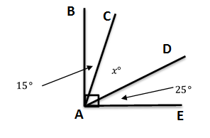

- Thomas is putting in a tile floor. He needs to determine the angles that should be cut in the tiles to fit in the corner. The angle in the corner measures $90°$. One piece of the tile will have a measure of $24°$. Write an equation, and use it to determine the measure of the unknown angle.

- Solve for $x$.
$105$°
$62$°
$x$°

- Aram has been studying the mathematics behind pinball machines. He made the following diagram of one of his observations. Determine the measure of the missing angle.
$52$°
$$68°$$
$x$°

- The measures of two angles have a sum of $90°$. The measures of the angles are in a ratio of $2:1$. Determine the measures of both angles.

- The measures of two angles have a sum of $180°$. The measures of the angles are in a ratio of $5:1$. Determine the measures of both angles.

