Lesson 22: Writing and Evaluating Expressions—Exponents

Student Outcomes
- Students evaluate and write formulas involving exponents for given values in real-world problems.

Lesson Notes
Exponents are used in calculations of both area and volume. Other examples of exponential applications involve bacterial growth (powers of $2$) and compound interest.
Students will need a full size sheet of paper ($8\frac{1}{2}×11$inches) for the first example. Teachers should try the folding activity ahead of time to anticipate outcomes. If time permits at the end of the lesson, a larger sheet of paper can be used to experiment further.

Classwork
Fluency Exercise (10 minutes): Multiplication of Decimals
RWBE: Refer to the Rapid White Board Exchanges sections in the Module Overview for directions on how to administer a RWBE.

Example 1 (5 minutes): Folding Paper
Scaffolding:
Some students will benefit from unfolding and counting rectangles on the paper throughout Example 1. This provides a concrete representation of the exponential relationship at the heart of this lesson.
Ask students to predict how many times they can fold a piece of paper in half. Allow a short discussion before allowing students to try it.
- Predict how many times you can fold a piece of paper in half. The folds must be as close to a half as possible. Record your prediction in Exercise 1.
Students will repeatedly fold a piece of paper until it is impossible, about seven folds. Remind students they must fold the paper the same way each time.
- Fold the paper once. Record the number of layers of paper that result in the table in Exercise 2.
  - $2$
- Fold again. Record the number of layers of paper that result.
  - $4$
Ensure that students see that doubling the two sheets results in four sheets. At this stage, the layers can easily be counted. During subsequent stages, it will be impractical to do so. Focus the count on the corner that has four loose pieces.
- Fold again. Count and record the number of layers you have now.
  - $8$

The number of layers is doubling from one stage to the next; so, the pattern is modeled by multiplying by $2$, not adding$2$. It is critical that students find that there are eight layers here, not six.
- Continue folding and recording the number of layers you make. Use a calculator if desired. Record your answers as both numbers in standard form and exponential form, as powers of$2$.

Exercises (5 minutes)
Exercises
- Predict how many times you can fold a piece of paper in half.
My Prediction:

- Before any folding (zero folds), there is only one layer of paper. This is recorded in the first row of the table.
Fold your paper in half. Record the number of layers of paper that result. Continue as long as possible.
Number of Folds | Number of Paper Layers that Result | Number of Paper Layers Written as a Power of $2$
$$0$$ | $$1$$ | $$2^{0}$$
$$1$$ | $$2$$ | $$2^{1}$$
$$2$$ | $$4$$ | $$2^{2}$$
$$3$$ | $$8$$ | $$2^{3}$$
$$4$$ | $$16$$ | $$2^{4}$$
$$5$$ | $$32$$ | $$2^{5}$$
$$6$$ | $$64$$ | $$2^{6}$$
$$7$$ | $$128$$ | $$2^{7}$$
$$8$$ | $$256$$ | $$2^{8}$$
  - Are you able to continue folding the paper indefinitely? Why or why not?
No. The stack got too thick on one corner because it kept doubling each time.

  - How could you use a calculator to find the next number in the series?
I could multiply the number by $2$ to find the number of layers after another fold.

  - What is the relationship between the number of folds and the number of layers?
As the number of folds increases by one, the number of layers doubles.

  - How is this relationship represented in exponential form of the numerical expression?
I could use $2$ as a base and the number of folds as the exponent.

  - If you fold a paper $f$times, write an expression to show the number of paper layers.
There would be $2^{f}$layers of paper.

- If the paper were to be cut instead of folded, the height of the stack would double at each successive stage, and it would be possible to continue.
  - Write an expression that describes how many layers of paper result from $16$ cuts.
$$2^{16}$$

  - Evaluate this expression by writing it in standard form.
$$2^{16}=65,536$$

Example 2 (10 minutes): Bacterial Infection
- Modeling of exponents in real life leads to our next example of the power of doubling. Think about the last time you had a cut or a wound that became infected. What caused the infection?
  - Bacteria growing in the wound.
- When colonies of certain types of bacteria are allowed to grow unchecked, serious illness can result.
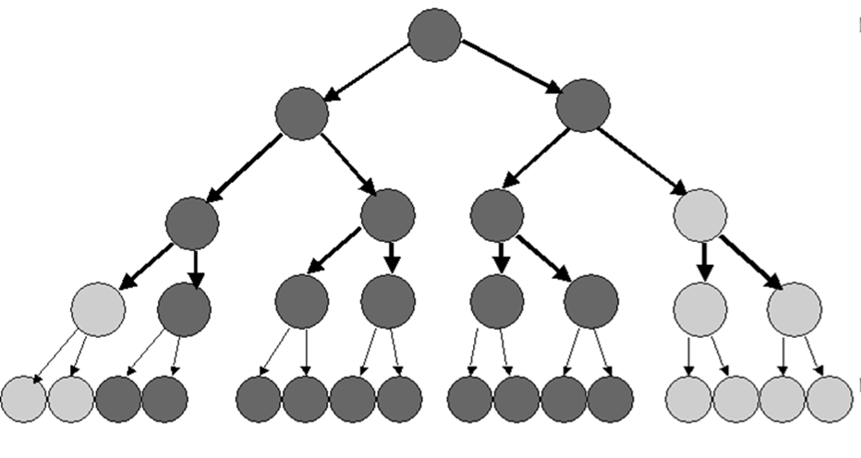
Example 2: Bacterial Infection
Bacteria are microscopic single-celled organisms that reproduce in a couple of different ways, one of which is called binary fission. In binary fission, a bacterium increases its size until it is large enough to split into two parts that are identical. These two grow until they are both large enough to split into two individual bacteria. This continues as long as growing conditions are favorable.

  - Record the number of bacteria that result from each generation.
Generation | Number of Bacteria | Number of Bacteria Written as a Power of $2$
$$1$$ | $$2$$ | $$2^{1}$$
$$2$$ | $$4$$ | $$2^{2}$$
$$3$$ | $$8$$ | $$2^{3}$$
$$4$$ | $$16$$ | $$2^{4}$$
$$5$$ | $$32$$ | $$2^{5}$$
$$6$$ | $$64$$ | $$2^{6}$$
$$7$$ | $$128$$ | $$2^{7}$$
$$8$$ | $$256$$ | $$2^{8}$$
$$9$$ | $$512$$ | $$2^{9}$$
$$10$$ | $$1,024$$ | $$2^{10}$$
$$11$$ | $$2,048$$ | $$2^{11}$$
$$12$$ | $$4,096$$ | $$2^{12}$$
$$13$$ | $$8,192$$ | $$2^{13}$$
$$14$$ | $$16,384$$ | $$2^{14}$$

  - How many generations would it take until there were over one million bacteria present?
$20$ generations will produce more than one million bacteria. $2^{20}=1,048,576$.

  - Under the right growing conditions, many bacteria can reproduce every $15$ minutes. Under these conditions, how long would it take for one bacterium to reproduce itself into more than one million bacteria?
It would take $20$fifteen-minute periods, or $5$ hours.

  - Write an expression for how many bacteria would be present after $g$ generations.
There will be $2^{g}$ bacteria present after $g$ generations.

Example 3 (10 minutes): Volume of a Rectangular Solid
- Exponents are used when we calculate the volume of rectangular solids.
Example 3: Volume of a Rectangular Solid
$$w$$

$$h=2w$$
$$l=3w$$

This box has a width,$w$. The height of the box,$h$, is twice the width. The length of the box,$l$, is three times the width. That is, the width, height, and length of a rectangular prism are in the ratio of $1:2:3$.
MP.3
For rectangular solids like this, the volume is calculated by multiplying length times width times height.
$$V=l·w·h \\ V=3w·w·2w \\ V=3·2·w·w·w \\ V=6w^{3}$$
Follow the above example to calculate the volume of these rectangular solids, given the width, $w$.
Width in centimeters ($cm$) | Volume in cubic centimeters ($cm^{3}$)
$$1$$ | $$1 cm×2 cm×3 cm=6 cm^{3}$$
$$2$$ | $$2 cm×4 cm×6 cm=48 cm^{3}$$
$$3$$ | $$3 cm×6 cm×9 cm= 162 cm^{3}$$
$$4$$ | $$4 cm×8 cm×12 cm=384 cm^{3}$$
$$w$$ | $$w ×2w×3w =6 w^{3} cm^{3}$$

Closing (2 minutes)
- Why is $5^{3}$ different from$5×3$?
  - $5^{3}$means$5×5×5$. Five is the factor that will be multiplied by itself $3$ times. That equals $125$.
  - On the other hand, $5×3$ means $5+5+5$. Five is the addend that will be added to itself $3$times. This equals $15$.

Exit Ticket (3 minutes)

Name Date
Lesson 22: Writing and Evaluating Expressions—Exponents

Exit Ticket

- Naomi’s allowance is $\$2.00$ per week. If she convinces her parents to double her allowance each week for two months, what will her weekly allowance be at the end of the second month (week $8$)?
Week Number | Allowance
$$1$$ | $$\$2.00$$
$$2$$
$$3$$
$$4$$
$$5$$
$$6$$
$$7$$
$$8$$
$$w$$

- Write the expression that describes Naomi’s allowance during week$w$ in dollars.

Exit Ticket Sample Solutions

- Naomi’s allowance is $\$2.00$ per week. If she convinces her parents to double her allowance each week for two months, what will her weekly allowance be at the end of the second month (week $8$)?

Week Number | Allowance
$$1$$ | $$\$2.00$$
$$2$$ | $$\$4.00$$
$$3$$ | $$\$8.00$$
$$4$$ | $$\$16.00$$
$$5$$ | $$\$32.00$$
$$6$$ | $$\$64.00$$
$$7$$ | $$\$128.00$$
$$8$$ | $$\$256.00$$
$$w$$ | $${\$2}^{w}$$

- Write the expression that describes Naomi’s allowance during week$w$ in dollars.
$${\$2}^{w}$$

Problem Set Sample Solutions

- A checkerboard has $64$ squares on it.
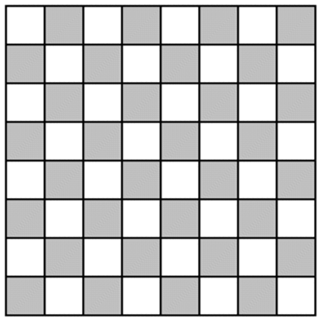
  - If one grain of rice is put on the first square, $2$ grains of rice on the second square, $4$ grains of rice on the third square, $8$ grains of rice on the fourth square, etc. (doubling each time), complete the table to show how many grains of rice are on each square. Write you answers in exponential form on the table below.
Checkerboard Square | Grains of Rice | Checkerboard Square | Grains of Rice | Checkerboard Square | Grains of Rice | Checkerboard Square | Grains of Rice
$$1$$ | $$2^{0}$$ | $$17$$ | $$2^{16}$$ | $$33$$ | $$2^{32}$$ | $$49$$ | $$2^{48}$$
$$2$$ | $$2^{1}$$ | $$18$$ | $$2^{17}$$ | $$34$$ | $$2^{33}$$ | $$50$$ | $$2^{49}$$
$$3$$ | $$2^{2}$$ | $$19$$ | $$2^{18}$$ | $$35$$ | $$2^{34}$$ | $$51$$ | $$2^{50}$$
$$4$$ | $$2^{3}$$ | $$20$$ | $$2^{19}$$ | $$36$$ | $$2^{35}$$ | $$52$$ | $$2^{51}$$
$$5$$ | $$2^{4}$$ | $$21$$ | $$2^{20}$$ | $$37$$ | $$2^{36}$$ | $$53$$ | $$2^{52}$$
$$6$$ | $$2^{5}$$ | $$22$$ | $$2^{21}$$ | $$38$$ | $$2^{37}$$ | $$54$$ | $$2^{53}$$
$$7$$ | $$2^{6}$$ | $$23$$ | $$2^{22}$$ | $$39$$ | $$2^{38}$$ | $$55$$ | $$2^{54}$$
$$8$$ | $$2^{7}$$ | $$24$$ | $$2^{23}$$ | $$40$$ | $$2^{39}$$ | $$56$$ | $$2^{55}$$
$$9$$ | $$2^{8}$$ | $$25$$ | $$2^{24}$$ | $$41$$ | $$2^{40}$$ | $$57$$ | $$2^{56}$$
$$10$$ | $$2^{9}$$ | $$26$$ | $$2^{25}$$ | $$42$$ | $$2^{41}$$ | $$58$$ | $$2^{57}$$
$$11$$ | $$2^{10}$$ | $$27$$ | $$2^{26}$$ | $$43$$ | $$2^{42}$$ | $$59$$ | $$2^{58}$$
$$12$$ | $$2^{11}$$ | $$28$$ | $$2^{27}$$ | $$44$$ | $$2^{43}$$ | $$60$$ | $$2^{59}$$
$$13$$ | $$2^{12}$$ | $$29$$ | $$2^{28}$$ | $$45$$ | $$2^{44}$$ | $$61$$ | $$2^{60}$$
$$14$$ | $$2^{13}$$ | $$30$$ | $$2^{29}$$ | $$46$$ | $$2^{45}$$ | $$62$$ | $$2^{61}$$
$$15$$ | $$2^{14}$$ | $$31$$ | $$2^{30}$$ | $$47$$ | $$2^{46}$$ | $$63$$ | $$2^{62}$$
$$16$$ | $$2^{15}$$ | $$32$$ | $$2^{31}$$ | $$48$$ | $$2^{47}$$ | $$64$$ | $$2^{63}$$

  - How many grains of rice would be on the last square? Represent your answer in exponential form and standard form. Use the table above to help solve the problem.
There would be $2^{63}=9,223,372,036,854,775,808$ grains of rice.

  - Would it have been easier to write your answer to part (b) in exponential form or standard form?
Answers will vary. Exponential form is more concise: ${ 2}^{63}$. Standard form is longer and more complicated to calculate: $9,223,372,036,854,775,808$. (In word form: nine quintillion, two hundred twenty-three quadrillion, three hundred seventy-two trillion, thirty-six billion, eight hundred fifty-four million, seven hundred seventy-five thousand, eight hundred eight.)
- If an amount of money is invested at an annual interest rate of $6\%$, it doubles every $12$ years. If Alejandra invests$\$500$, how long will it take for her investment to reach $\$2,000$ (assuming she does not contribute any additional funds)?
It will take $24$ years. After $12$ years, Alejandra will have doubled her money and will have$\$1,000$. If she waits an additional $12$ years, she will have$\$2,000$.

- The athletics director at Peter’s school has created a phone tree that is used to notify team players in the event a game has to be canceled or rescheduled. The phone tree is initiated when the director calls two captains. During the second stage of the phone tree, the captains each call two players. During the third stage of the phone tree, these players each call two other players. The phone tree continues until all players have been notified. If there are $50$ players on the teams, how many stages will it take to notify all of the players?
It will take five stages. After the first stage, two players have been called, and $48$ will not have been called. After the second stage, four more players will have been called, for a total of six; $44$ players will remain uncalled. After the third stage, $2^{3}$players (eight) more will have been called, totaling$14$; $36$ remain uncalled. After the $4^{th}$stage, $2^{4}$ more players ($16$) will have gotten a call, for a total of $30$ players notified. Twenty remain uncalled at this stage. The fifth round of calls will cover all of them because $2^{5}$ includes $32$ more players.

Multiplication of Decimals
Progression of Exercises

- $0.5×0.5=$
$$0.25$$

- $0.6×0.6=$
$$0.36$$

- $0.7×0.7=$
$$0.49$$

- $0.5×0.6=$
$$0.3$$

- $1.5×1.5=$
$$2.25$$

- $2.5×2.5=$
$$6.25$$

- $0.25×0.25=$
$$0.0625$$

- $0.1×0.1=$
$$0.01$$

- $0.1×123.4=$
$$12.34$$

- $0.01×123.4=$
$$1.234$$

