Lesson 22: Writing and Evaluating Expressions—Exponents

Classwork
Example 1: Folding Paper
Exercises
- Predict how many times you can fold a piece of paper in half.

My Prediction:

- Before any folding (zero folds), there is only one layer of paper. This is recorded in the first row of the table.
Fold your paper in half. Record the number of layers of paper that result. Continue as long as possible.
Number of Folds | Number of Paper Layers That Result | Number of Paper Layers Written as a Power of $2$
$$0$$ | $$1$$ | $$2^{0}$$
$$1$$
$$2$$
$$3$$
$$4$$
$$5$$
$$6$$
$$7$$
$$8$$
  - Are you able to continue folding the paper indefinitely? Why or why not?

  - How could you use a calculator to find the next number in the series?

  - What is the relationship between the number of folds and the number of layers?

  - How is this relationship represented in exponential form of the numerical expression?

  - If you fold a paper $f$times, write an expression to show the number of paper layers.

- If the paper were to be cut instead of folded, the height of the stack would double at each successive stage, and it would be possible to continue.
  - Write an expression that describes how many layers of paper result from $16$ cuts.

  - Evaluate this expression by writing it in standard form.

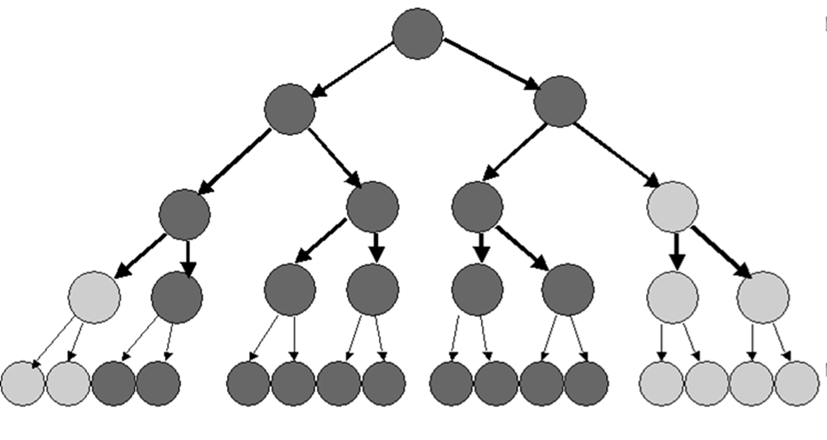
Example 2: Bacterial Infection
Bacteria are microscopic single-celled organisms that reproduce in a couple of different ways, one of which is called binary fission. In binary fission, a bacterium increases its size until it is large enough to split into two parts that are identical. These two grow until they are both large enough to split into two individual bacteria. This continues as long as growing conditions are favorable.

  - Record the number of bacteria that result from each generation.
Generation | Number of bacteria | Number of bacteria written as a power of $2$
$$1$$ | $$2$$ | $$2^{1}$$
$$2$$ | $$4$$ | $$2^{2}$$
$$3$$ | $$8$$ | $$2^{3}$$
$$4$$
$$5$$
$$6$$
$$7$$
$$8$$
$$9$$
$$10$$
$$11$$
$$12$$
$$13$$
$$14$$

  - How many generations would it take until there were over one million bacteria present?

  - Under the right growing conditions, many bacteria can reproduce every $15$ minutes. Under these conditions, how long would it take for one bacterium to reproduce itself into more than one million bacteria?

  - Write an expression for how many bacteria would be present after $g$ generations.

Example 3: Volume of a Rectangular Solid
$$w$$

$$h=2w$$
$$l=3w$$
This box has a width,$w$. The height of the box,$h$, is twice the width. The length of the box,$l$, is three times the width. That is, the width, height, and length of a rectangular prism are in the ratio of $1:2:3$.
For rectangular solids like this, the volume is calculated by multiplying length times width times height.
$$V=l·w·h \\ V=3w·w·2w \\ V=3·2·w·w·w \\ V=6 w^{3}$$
Follow the above example to calculate the volume of these rectangular solids, given the width, $w$.
Width in centimeters ($cm$) | Volume in cubic centimeters ($cm^{3}$)
$$1$$
$$2$$
$$3$$
$$4$$
$$w$$

Problem Set

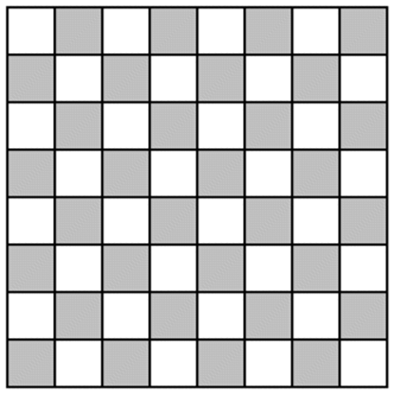
- A checkerboard has $64$ squares on it.

  - If one grain of rice is put on the first square, $2$ grains of rice on the second square, $4$ grains of rice on the third square, $8$ grains of rice on the fourth square, etc. (doubling each time), complete the table to show how many grains of rice are on each square. Write your answers in exponential form on the table below.
Checkerboard Square | Grains of Rice | Checkerboard Square | Grains of Rice | Checkerboard Square | Grains of Rice | Checkerboard Square | Grains of Rice
$$1$$ |  | $$17$$ |  | $$33$$ |  | $$49$$
$$2$$ |  | $$18$$ |  | $$34$$ |  | $$50$$
$$3$$ |  | $$19$$ |  | $$35$$ |  | $$51$$
$$4$$ |  | $$20$$ |  | $$36$$ |  | $$52$$
$$5$$ |  | $$21$$ |  | $$37$$ |  | $$53$$
$$6$$ |  | $$22$$ |  | $$38$$ |  | $$54$$
$$7$$ |  | $$23$$ |  | $$39$$ |  | $$55$$
$$8$$ |  | $$24$$ |  | $$40$$ |  | $$56$$
$$9$$ |  | $$25$$ |  | $$41$$ |  | $$57$$
$$10$$ |  | $$26$$ |  | $$42$$ |  | $$58$$
$$11$$ |  | $$27$$ |  | $$43$$ |  | $$59$$
$$12$$ |  | $$28$$ |  | $$44$$ |  | $$60$$
$$13$$ |  | $$29$$ |  | $$45$$ |  | $$61$$
$$14$$ |  | $$30$$ |  | $$46$$ |  | $$62$$
$$15$$ |  | $$31$$ |  | $$47$$ |  | $$63$$
$$16$$ |  | $$32$$ |  | $$48$$ |  | $$64$$
  - How many grains of rice would be on the last square? Represent your answer in exponential form and standard form. Use the table above to help solve the problem.
  - Would it have been easier to write your answer to part (b) in exponential form or standard form?

- If an amount of money is invested at an annual interest rate of $6\%$, it doubles every $12$ years. If Alejandra invests $\$500$, how long will it take for her investment to reach $\$2,000$ (assuming she doesn’t contribute any additional funds)?
- The athletics director at Peter’s school has created a phone tree that is used to notify team players in the event a game has to be canceled or rescheduled. The phone tree is initiated when the director calls two captains. During the second stage of the phone tree, the captains each call two players. During the third stage of the phone tree, these players each call two other players. The phone tree continues until all players have been notified. If there are $50$ players on the teams, how many stages will it take to notify all of the players?

