Lesson 14: Writing Division Expressions

Classwork
Example 1
Fill in the three remaining squares so that all the squares contain equivalent expressions.

$$15÷3$$
Equivalent
Expressions

Example 2
Fill in a blank copy of the four boxes using the words dividend and divisor so that it is set up for any example.

$$÷$$
Equivalent
Expressions

Exercises
Complete the missing spaces in each rectangle set.
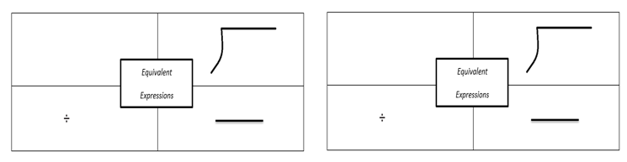

Problem Set

Complete the missing spaces in each rectangle set.
$$2$$
$$y+13$$
$7$ divided by $x$
$$b - 33$$
$$m$$
$h$ $16$

