|  |
| --- |
|  |

Lesson 14: Writing Division Expressions

Student Outcomes

* Students write numerical expressions in two forms, and , and note the relationship between the two.

Lesson Notes

This is the second day of a two-day lesson.

Classwork

Fluency Exercise (5 Minutes): Long Division Algorithm

*RWBE*: Refer to the Rapid White Board Exchanges sections in the Module Overview for directions on how to administer a RWBE.

Example 1 (5 minutes)

MP.2

Example 1

Fill in the three remaining squares so that all the squares contain equivalent expressions.

The quotient of and

***Equivalent***

***Expressions***

Example 2 (5 minutes)

MP.2

**Example 2**

**Fill in a blank copy of the four boxes using the words *dividend* and *divisor* so that it is set up for any example.**

The quotient of the dividend and   
the divisor

***Equivalent***

***Expressions***

***divisor***

***dividend***

***dividend***

***divisor***

Exercises (20 minutes)

Students will work in pairs. Each pair will be given a set of expressions to work on. There are several different versions that can be printed and used so that a variety of questions can be used throughout the classroom. The students will fill in the four rectangles, one with the given information and three with equivalent expressions.

*Scaffolding:*

The sets of eight questions used in the Exercises can be tailored to fit the level at which students are working. You may write a set for lower-level learners and/or a set for advanced learners as needed.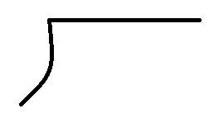

Exercises

Complete the missing spaces in each rectangle set.

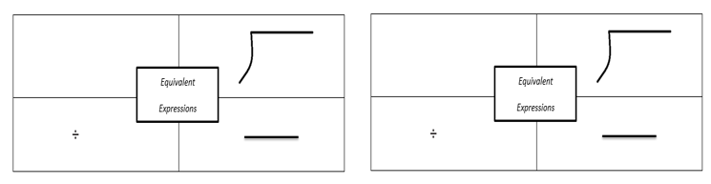

Set A **Answers**

1. **divided by , ,**
2. **The quotient of and , ,****
3.  **divided by , ,**
4. **divided by the sum of and , ,** 
5. **divided by the quantity minus , ,** **
6.  **The sum of and divided by , ,**
7. **The sum of and divided by , ,** **
8. **The quotient of minus and plus , ,** **

Set B **Answers:**

1. **The quotient of and ,** **,**
2. **The quotient of and ,** ****,**
3.  **The quotient of and , ,**
4. **divided by the quantity minus , ,** **
5. **divided by the quantity minus ,** ****,**
6.  **The sum of and divided by , ,**
7. **The quantity minus divided by ,** ****,**
8. **The quantity plus divided by the quantity minus ,   
    , **

Set C **Answers:**

1. **divided by ,** ****,**
2. **The quotient of and ,** ****,**
3.   **divided by , ,**
4. **divided by the quantity minus , ,****
5. **divided by the sum of and**  **,** ****,**
6.  **The sum of plus divided by , ,**
7. **The quantity minus divided by ,** ****,**
8. **The quantity minus divided by the sum of and ,**

**,****

Closing (7 minutes)

Two pairs of students trade pages to check each other’s work. If all of the boxes are correct, students write a sentence that summarizes why the expressions are equivalent. If there are mistakes, students write sentences to explain how to correct it.

Students evaluate some of the expressions. Many answers will need to be written as fractions or decimals.

Set A: , ,   
Set B: , Set C: , ,

Exit Ticket (3 minutes)

Name Date

Lesson 14: Writing Division Expressions

Exit Ticket

1. Write the division expression in words and as a fraction.
2. Write the following division expression using the division symbol and as a fraction: divided by the quantity minus.

Exit Ticket Sample Solutions

1. Write the division expression in words and as a fraction.

***The*** sum of and divided by, .

1. Write the following division expression using the division symbol and as a fraction: divided by the quantity minus .

***and***

Problem Set Sample Solutions

Complete the missing spaces in each rectangle set.



**divided by**

The quotient of and , ,

divided by the quantity minus , ,



, ,

The sum of and divided by , ,

Exercise Handout

Set A

2. The quotient of and
3. 
5. divided by the quantity minus
6. 

Set B

2. The quotient of and
3. 
5. divided by the quantity minus
6. 

Set C

2. The quotient of and
3. 
5. divided by the sum of and
6. 

Long Division Algorithm

Progression of Exercises