Lesson 4: The Relationship of Division and Subtraction

Student Outcomes
- Students build and clarify the relationship of division and subtraction by determining that $12÷x=4$ means $12-x-x-x-x=0$.

Lesson Notes
Students will continue to use the squares from Lessons 1–3 to create tape diagrams. Each pair of students will need $30$ squares to complete the activities.

Classwork
Discussion (20 minutes)
Provide each pair of students with a collection of $30$ squares so they can use these squares to create tape diagrams throughout the lesson.
- Build a tape diagram that has $20$ squares.
- Divide the tape diagram into $4$ equal sections.
- How many squares are in each of the $4$ sections?
  - $5$
- Write a number sentence to demonstrate what happened.
  - $20÷4=5$
- Combine your squares again to have a tape diagram with $20$ squares.
- Now, subtract $4$ squares from your tape diagram.
- Write an expression to demonstrate what happened.
  - $20-4$
- Subtract $4$ more squares, and alter your expression to represent the new tape diagram.
  - $20-4-4$
- Subtract $4$ more squares, and alter your expression to represent the new tape diagram.
  - $20-4-4-4$
- Subtract $4$ more squares, and alter your expression to represent the new tape diagram.
  - $20-4-4-4-4$
- Last time, subtract $4$ more squares, and alter your expression to an equation in order to represent a number sentence showing the complete transformation of the tape diagram.
  - No squares should remain.
  - $20-4-4-4-4-4=0$
- Let’s take a look at the process we took to determine the difference to be zero.
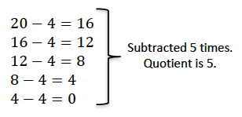
Discuss the process step by step to determine that the number of times the divisor was subtracted from the dividend is the same number as the quotient.

- Do you recognize a relationship between $20÷4=5$ and $20-4-4-4-4-4=0$? If so, what is it?
  - Possible answer: If you subtract the divisor from the dividend $5$ times (the quotient), there will be no remaining squares.
$$x$$
$$x$$
$$x$$
$$x$$
$$x$$
$$20÷x=5$$
$$x$$
$$x$$
$$x$$
$$x$$
$$20-x$$
$$x$$
$$x$$
$$x$$
$$20-x-x$$
$$x$$
$$x$$
$$20-x-x-x$$
$$x$$
$$20-x-x-x-x$$
$$20-x-x-x-x-x=0$$
- Let’s take a look at a similar problem, $20÷5=4$, to see if the quotient is the number of times the divisor is subtracted from the dividend.
- Let’s create a number sentence when we subtract the divisor.
MP.8
- $20-5-5-5-5=0$
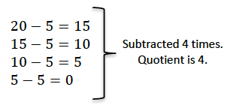
Discuss the process to determine that the number of times the divisor is subtracted from the dividend is the same number as the quotient.
- Determine the relationship between $20÷5=4$ and
$20-5-5-5-5=0$.
MP.8
- $20÷5=4$ is equivalent to $20-5-5-5-5=0$.
- Is this relationship always true? Let’s try to prove that it is.
Model the following set of tape diagrams with leading questions for discussion.
- $x$ is a number. What does $20÷x=5$ mean?
- Exactly five $x$’s can be subtracted from twenty.
- What must $x$ be in this division sentence?
- $4$
- Let’s keep taking $x$away until we reach zero.
Model taking each $x$ away and creating subtraction expressions to record.
$$x$$
$$x$$
$$x$$
$$x$$
$$20÷x=5$$
$$x$$
$$x$$
$$x$$
$$20-x \text{or} 20-5$$
$$x$$
$$x$$
$$20-x-x \text{or} 20-5-5$$
$$x$$
$$20-x-x-x \text{or} 20-5-5-5$$
$$20-x-x-x-x=0 \text{or} 20-5-5-5-5=0$$
- Build a subtraction expression.
- $20-x-x-x-x-x=0$
- Is $20-4-4-4-4-4=0$?
- Yes.
- Develop two equations using numbers and letters to show the relationship of division and subtraction.
MP.2
  - Possible answers: $20÷x=5$ and
$$20-x-x-x-x-x=0$$
- Or $20÷x=5$ means that $5$ can be subtracted exactly $x$ number of times from $20$. Is it true when $x=4$?
- To determine if $x=4,$let’s keep taking $x$away until we reach zero.
Model taking each $x$ away and creating subtraction expressions to record by following the diagram to the right.
- Build a subtraction equation.
- $20-5-5-5-5=0$
- What two operations are we relating in the problems we completed?
- Division and subtraction

Exercise 1 (10 minutes)
Students work in pairs to answer the following questions.
Exercise 1
Build subtraction equations using the indicated equations. The first example has been completed for you.
Division Equation | Divisor Indicates the Size of the Unit | Tape Diagram | What is $x, y,z$?
$$12÷x=4$$ | $$12-x-x-x-x=0$$ | 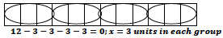 | $$x=3$$
$$18÷x=3$$ | $$18-x-x-x=0$$ | 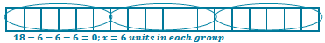 | $$x=6$$
$$35÷y=5$$ | $$35-y-y-y-y-y=0$$ |  | $$y=7$$
$$42÷z=6$$ | $$42-z-z-z-z-z-z=0$$ |  | $$z=7$$

Division Equation | Divisor Indicates the Number of Units | Tape Diagram | What is $x, y,z$?
$$12÷x=4$$ | $$12-4-4-4=0$$ | 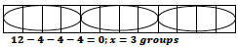 | $$x=3$$
$$18÷x=3$$ | $$18-3-3-3-3-3-3=0$$ | 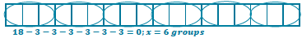 | $$x=6$$
$$35÷y=5$$ | $$35-5-5-5-5-5-5-5=0$$ |  | $$y=7$$
$$42÷z=6$$ | $$42-6-6-6-6-6-6-6=0$$ |  | $$z=7$$

Exercise 2 (5 minutes)

Exercise 2
Answer each question using what you have learned about the relationship of division and subtraction.
  - If $12÷x=3$, how many times would $x$ have to be subtracted from $12$ in order for the answer to be zero? What is the value of $x$?
$3$; $x=4$

  - $36-f-f-f-f=0$. Write a division sentence for this repeated subtraction sentence. What is the value of $f$?
$36÷4=f$ or $36÷f=4$; $f=9$

  - If $24÷b=12$, which number is being subtracted $12$ times in order for the answer to be zero?
Two

Closing (5 minutes)
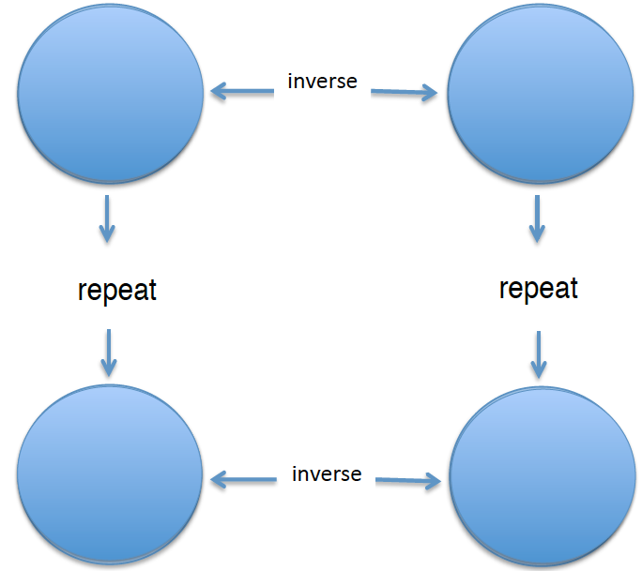
Display the graphic organizer provided at the end of the lesson. Copies of the organizer can be made for students to follow along and record.
- In each of the circles, we can place an operation to satisfy the organizer. In the last four lessons, we have discovered that each operation has a relationship with other operations, whether they are inverse operations or they are repeats of another.
Place the addition symbol in the upper left-hand circle.
- Let’s start with addition. What is the inverse operation of addition?
- Subtraction
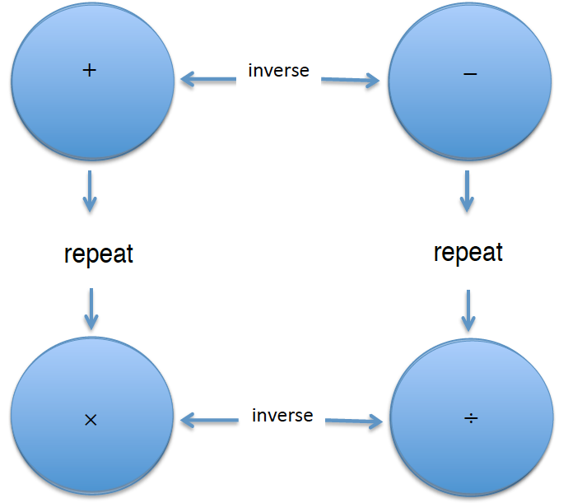
Place the subtraction symbol in the upper right-hand circle.
- After our discussion today, repeated subtraction can be represented by which operation?
- Division
Place the division symbol in the lower right-hand circle.
- Which operation is the inverse of division?
- Multiplication
Place the multiplication symbol in the lower left-hand circle.
- Let’s see if this is correct. Is multiplication the repeat operation of addition?
- Yes
Understanding the relationships of operations is going to be instrumental when solving equations later in this unit.

Exit Ticket (5 minutes)
Name Date
Lesson 4: The Relationship of Division and Subtraction

Exit Ticket

- Represent $56÷8=7$ using subtraction. Explain your reasoning.

- Explain why $30÷x=6$ is the same as $30-x-x-x-x-x-x=0$. What is the value of $x$ in this example?

Exit Ticket Sample Solutions

- Represent $56÷8=7$ using subtraction. Explain your reasoning.
$56-7-7-7-7-7-7-7-7=0$ because
$56-7=49$; $49-7=42$; $42-7=35$; $35-7=28$; $28-7=21$; $21-7=14$; $14-7=7$; $7-7=0.$
OR
$56-8-8-8-8-8-8-8=0$ because
$56-8=48$; $48-8=40$; $40-8=32$; $32-8=24$; $24-8=16$; $16-8=8$; $8-8=0.$

- Explain why $30÷x=6$ is the same as $30-x-x-x-x-x-x=0$. What is the value of $x$in this example?
$30÷5=6$, so $x=5$. When I subtract $5$ from $30$ six times, the result is zero. Division is a repeat operation of subtraction.

Problem Set Sample Solutions

Build subtraction equations using the indicated equations.
 | Division Equation | Divisor Indicates the Size of the Unit | Tape Diagram | What is $x, y,z$?
1. | $$24÷x=4$$ | $24-x-x-x-x=0$ | 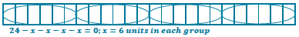 | $$x=6$$
2. | $$36÷x=6$$ | $36-x-x-x-x-x-x=0$ |  | $$x=6$$
3. | $$28÷y=7$$ | $28-y-y-y-y-y-y-y=0$ |  | $$y=4$$
4. | $$30÷y=5$$ | $30-y-y-y-y-y=0$ |  | $$y=6$$
5. | $$16÷z=4$$ | $16-z-z-z-z=0$ | 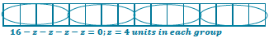 | $$z=4$$

 | Division Equation | Divisor Indicates the Number of Units | Tape Diagram | What is $x, y,z$?
1. | $$24÷x=4$$ | $24-4-4-4-4-4-4=0$ | 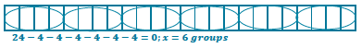 | $$x=6$$
2. | $$36÷x=6$$ | $36-6-6-6-6-6-6=0$ |  | $$x=6$$
3. | $$28÷y=7$$ | $28-7-7-7-7=0$ |  | $$y=4$$
4. | $$30÷y=5$$ | $30-5-5-5-5-5-5=0$ |  | $$y=6$$
5. | $$16÷z=4$$ | $16-4-4-4-4=0$ | 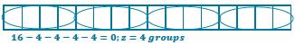 | $$z=4$$

Graphic Organizer Reproducible

