Lesson 26

Objective: Identify 1 ten as a unit by renaming representations of 10.

Suggested Lesson Structure

 Fluency Practice (11 minutes)

 Application Problem (4 minutes)

 Concept Development (35 minutes)

 Student Debrief (10 minutes)

**Total Time (60 minutes)**

Fluency Practice (11 minutes)

* Addition with Partners **1.OA.6** (6 minutes)
* Happy Counting by Fives **1.OA.5** (2 minutes)
* 10 More/10 Less **1.NBT.5** (3 minutes)

Addition with Partners (6 minutes)

Materials: (S) Personal white board

Note: This fluency activity reviews the make ten addition strategy with addends of 7, 8, and 9. Allow students to draw 5-groups if they still need pictorial representations to solve.

Assign partners of equal ability. Partners assign each other a number from 1 to 10 (e.g., 5). On their personal white boards, they write number sentences with 9, 8, and 7 as the other addend and solve them (e.g., 9 + 5 = 14, 8 + 5 = 13, 7 + 5 = 12). Partners then exchange boards and check each other’s work.

Happy Counting by Fives (2 minutes)

Note: This maintenance fluency activity reviews adding and subtracting 5.

Do the Happy Counting activity from Lesson 4, counting by fives from 0 to 40 and back. First count the Say Ten way, and then count the regular way.

10 More/10 Less (3 minutes)

Materials: (T) 20-bead Rekenrek

Note: This activity addresses the grade level standard of finding 10 more and 10 less than a number without having to count and prepares students to see ten as a unit.

Practice identifying 10 more and 10 less on the Rekenrek.

T: (Show a number within 3 on the Rekenrek.) Say the number.

S: 3.

T: (Slide over 10 from the next row). What’s 10 more than 3, the Say Ten way?

S: Ten 3.

T: What is it the regular way?

S: 13.

Repeat a few times to practice 10 more. Next, show a teen number and have students practice identifying 10 less. Then, put the Rekenrek away, and switch to cold calling students or groups of students.

T: 10 more than 5? Boys.

S: (Boys only.) 15.

T: 10 less than 14? Girls.

S: (Girls only.) 4.

Continue playing, varying the sentences: Take 10 out of 16. Add 10 to 2. 12 is 10 more than…?

Application Problem (4 minutes)

Ruben has 18 toy cars. His car carrier holds 10 toy cars. If Ruben’s carrier is full, how many cars are in the carrier and how many cars are outside of the carrier?

Note: This problem enables students to continue considering situations with missing parts where the context presents a grouping of 10. This grouping of 10 leads into today’s lesson during which students focus on ten as a unit.

Concept Development (35 minutes)

|  |  |
| --- | --- |
|  | NOTES ON  MULTIPLE MEANS  OF ENGAGEMENT: |
| Students demonstrate an understanding of math concepts when they can apply them in a variety of situations. It is important for students to recognize the relationship between 1 ten and the tools used in this lesson. They are seeing that no matter the tool used, they still think about 1 ten. | |

Materials: (T) Rekenrek bracelet stretched into a straight line (first used in G1–M1–Lesson 8), 5-group cards (Lesson 1 Fluency Template), Hide Zero cards (Lesson 18 Fluency Template 1), 9 Rekenrek beads (separated from pipe cleaner), grouping ten images (Template) (S) Personal white board

Students sit in a semi-circle in the meeting area, next to their partners.

T: (Lay materials in front of class.) We have used many different tools during math this year. Can you name each of these models?

S: The Rekenrek bracelet! 🡪 A 5-group card of 10! 🡪 A ten-frame!

T: Talk with a partner. What do these models have in common?

S: (Discuss.) They all show ten!

T: We have another math tool that we carry around with us everywhere we go. Show me the math tools you carry everywhere.

S: (Wave hands.)

T: (Wiggle your fingers.) These fingers can help us with our math in so many ways. How many fingers do we carry around with us?

S: Ten!

T: (Pick up the Rekenrek.) We can carry around loose beads to count, but instead we use Rekenrek bracelets. Why do we like using the bracelet?

S: It keeps the beads together. 🡪 They’re organized and we can count them quickly. 🡪 We can look at it and see the amount right away.

T: Right! Instead of having 10 loose beads to count one by one, we can pick up this Rekenrek bracelet and count all 10 at once. When I pick up this one bracelet, I know that I have 10 beads altogether. I can call this 1 group of…

S: Ten!

T: We call this **1 ten**.

T: Why do we frame the 10 circles when we use 5-group rows?

S: It’s easier to see ten. 🡪 We don’t have to recount them, because we know there are ten. 🡪 Then, we can just count on the extras and quickly know how many there.

T: Just like we called our Rekenrek bracelet 1 ten, when we frame 10 circles in the 5-group rows, we have 1 frame of ten, or…

S: 1 ten!

T: Let’s see if we can make 1 ten with our fingers. Let’s bundle them up into a set of 10. First, show me all 10 of your fingers.

S: (Raise hands, palms out.)

T: Count with me.

S/T: (Count on fingers from left to right, starting with the pinky.) 1, 2, 3, 4, 5, 6, 7, 8, 9, 10. (As you say 10, clasp two hands together.)

T: With our hands bundled like this, we’ve taken our 10 fingers and put them together to show 1 set of ten, or 1 ten.

T: Let’s make 12 with real and imaginary fingers now. Put out all of your fingers. How many imaginary ones can you see to make 12?

S: 2!

T: Let’s bundle the 10 fingers on our hands. 1, 2, 3, 4, 5, 6, 7, 8, 9, 10. (Clasp hands.) We have 1 ten, and, hmm, how many more fingers?

S: 2 more fingers!

T: Let’s make more with a partner. (Show the number 19 with Hide Zero cards.) Use your fingers to show the number 19.

S: (Show 10 on one partner’s hands and 9 on the other partner’s hands.)

T: (Pull apart Hide Zero cards.) Right now, you are showing 10 fingers (hold up the 10 card) and 9 fingers (hold up the 9 card).

T: If you are showing 10 fingers, bundle them together to make 1 ten.

S: (One student in partnership bundles to form clasped hands, illustrating 1 ten.)

T: Do you still have 19 fingers?

S: Yes!

T: How many tens do you have?

S: 1 ten.

T: How many extra ones do you have out?

S: 9!

T: We call these 9 ones, since they are all apart and we can count them one by one. (Touch each extended finger of a student’s hand who is holding out 9 fingers.)

|  |  |
| --- | --- |
|  | NOTES ON  MULTIPLE MEANS  OF REPRESENTATION: |
| When using the new format of drawing 5-groups as a stick and some circles, it is important to be sure that students grasp the meaning and are able to connect this new representation to ways of drawing they already know. Allow for some time to transition from drawing them horizontally to vertically. | |

T: So, our 10 fingers and our 9 fingers become how many tens and how many ones? (Hold up the 10 and 9 Hide Zero cards.)

S: 1 ten and 9 ones!

T: (Slip the Hide Zero cards together to show 19.)

Repeat the process with the following numbers: 18, 15, and 14.

T: (Place 1 Rekenrek bracelet and 4 separate beads in front of the class.) How many beads are here?

S: 14!

T: How did you know that so quickly?

*5-group column*

S: There are 10 on the Rekenrek, and I can see 4 more.

T: So, I have how many tens and how many ones?

S: 1 ten and 4 ones!

T: When we draw our 5-groups, let’s draw a stick through our circles, like the beads, whenever it is 1 ten. (Draw a vertical line, add 10 circles to it. Then, draw 4 circles in a vertical formation without the line.) We can call this a **5-group column**. Can you pick out the ten from the ones? Draw 14 in 5-group columns like mine.

S: (Draw the same picture.)

T: Put your finger on your 1 ten.

**MP.4**

S: (Touch 1 ten in 5-group column.)

T: Put your finger on your 4 ones.

S: (Touch 4 ones in 5-group drawing.)

Project images, one at a time. Have students draw 5-group columns as above and state the number of tens and ones for each picture. Use the Hide Zero cards to show students the ten and ones separated as well as together.

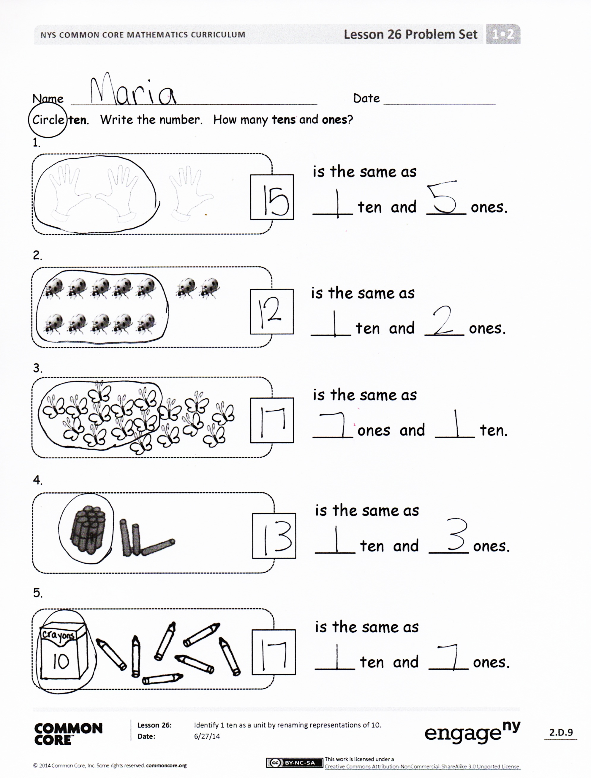Problem Set (10 minutes)

Students should do their personal best to complete the Problem Set within the allotted 10 minutes. For some classes, it may be appropriate to modify the assignment by specifying which problems they work on first. Some problems do not specify a method for solving. Students should solve these problems using the RDW approach used for Application Problems.

Student Debrief (10 minutes)

**Lesson Objective:** Identify 1 ten as a unit by renaming representations of 10.

The Student Debrief is intended to invite reflection and active processing of the total lesson experience.

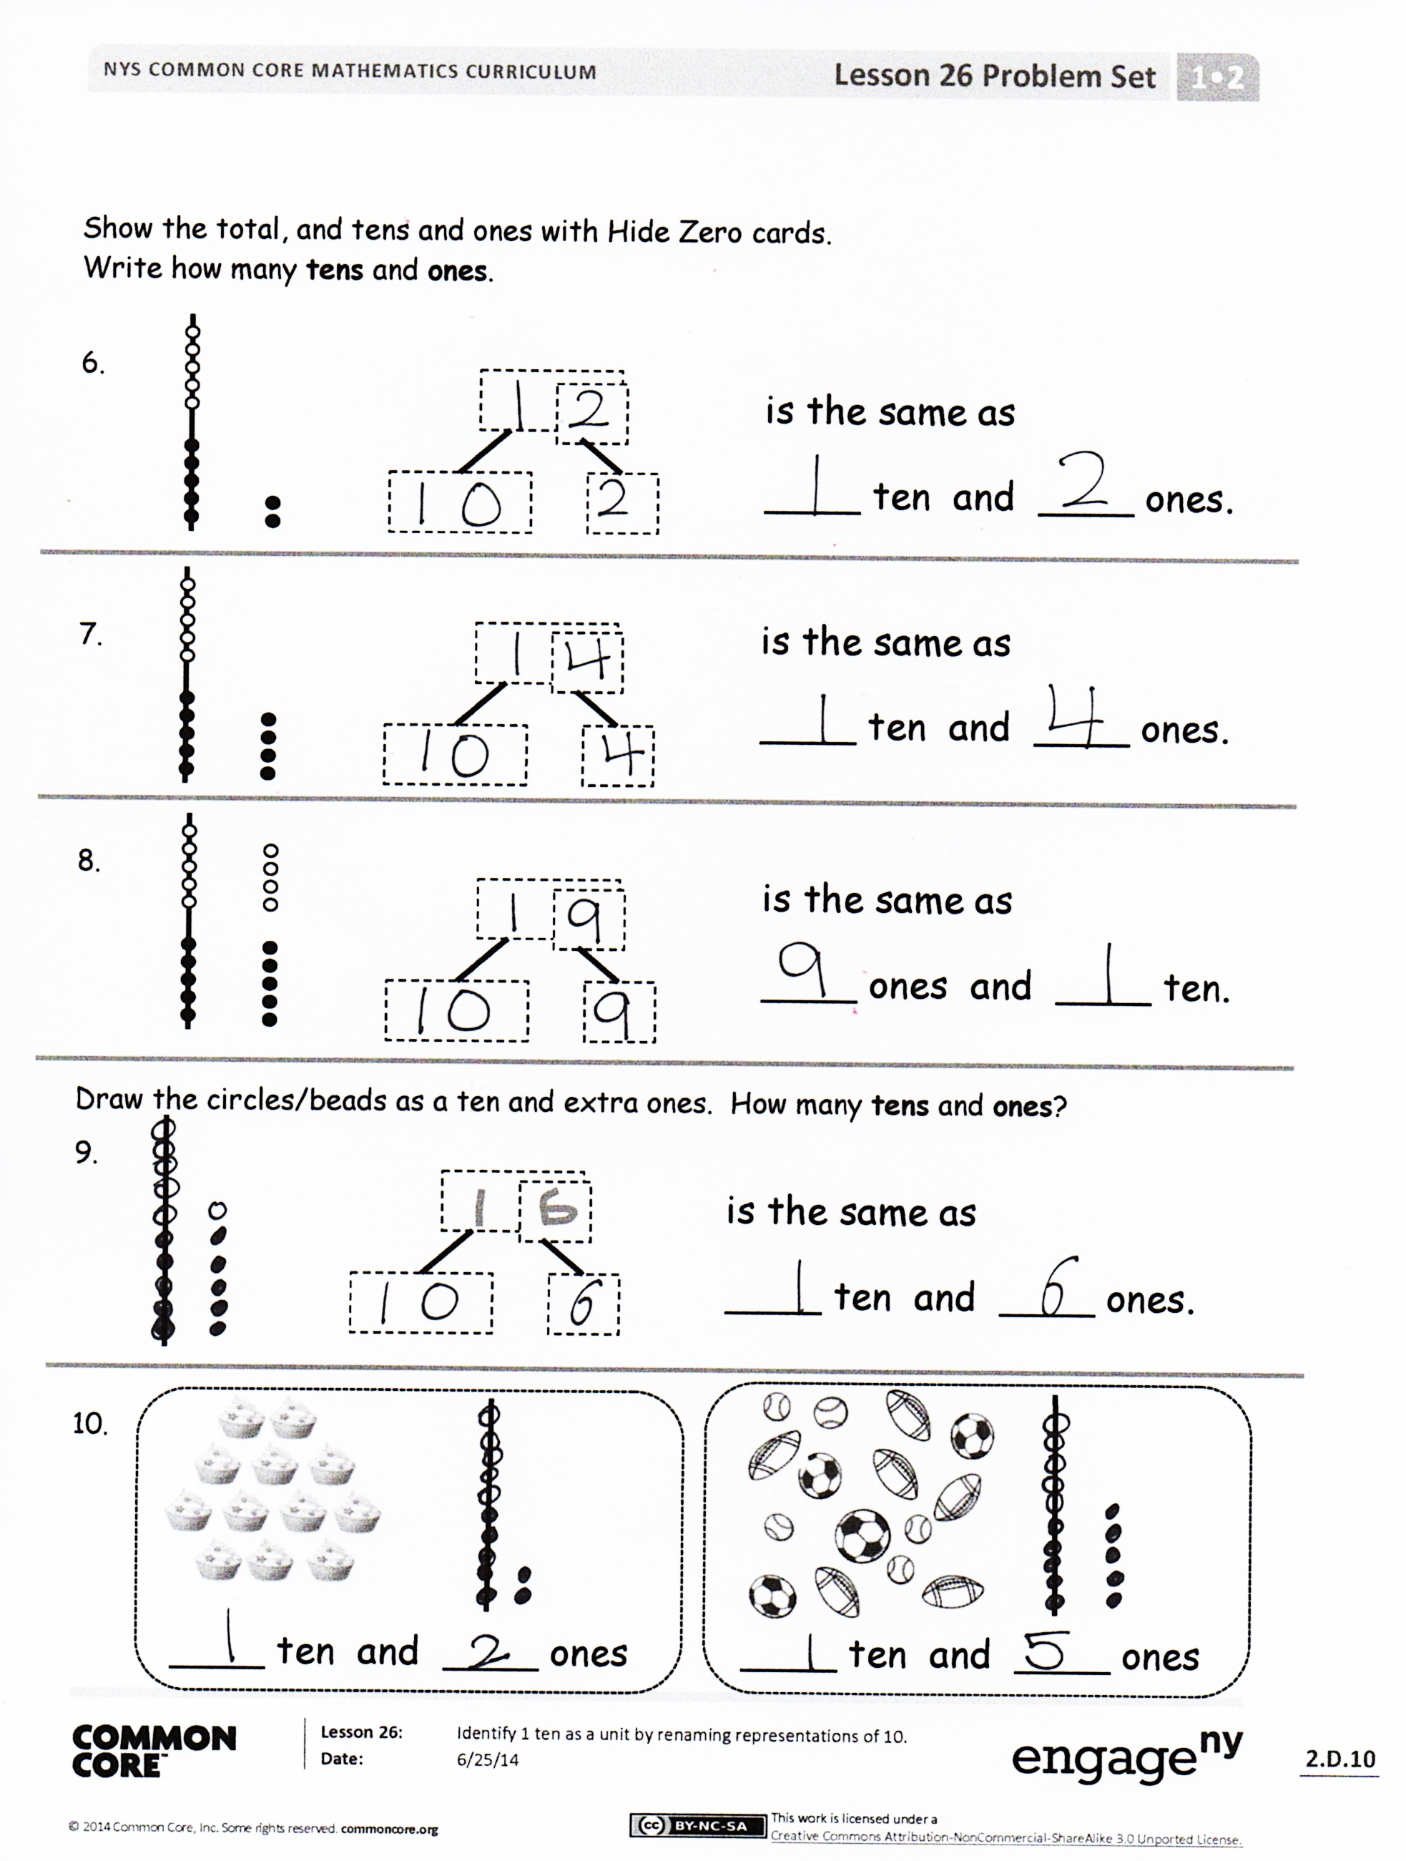Invite students to review their solutions for the Problem Set. They should check work by comparing answers with a partner before going over answers as a class. Look for misconceptions or misunderstandings that can be addressed in the Debrief. Guide students in a conversation to debrief the Problem Set and process the lesson. You may choose to use any combination of the questions below to lead the discussion.

* Look at Problems 1–5. Which were you able to answer most quickly? Why?
* The cards we used today are called Hide Zero cards. Why do you think they have that name? Explain how they work.
* Look at Problems 6 and 7. What is the same about them? What is different?
* Talk with a partner. How do you know 9 ones and 1 **ten** is the same as 1 ten and 9 ones? How is this like other addition rules we have learned?
* (Hold up a 5-group row next to a **5-group column**.) How are these different? How are they the same? How can the 5-group column help us *see* the ten better than with the 5-group row?
* Today, we talked about 1 ten. How is 1 ten the same as having 10 ones? How is it different?
* How did the Application Problem connect to today’s lesson?

Exit Ticket (3 minutes)

After the Student Debrief, instruct students to complete the Exit Ticket. A review of their work will help you assess the students’ understanding of the concepts that were presented in the lesson today and plan more effectively for future lessons. You may read the questions aloud to the students.

Name Date

Circle **ten**.Write the number.How many **tens** and **ones**?

is the same as

____ ten and ____ ones.

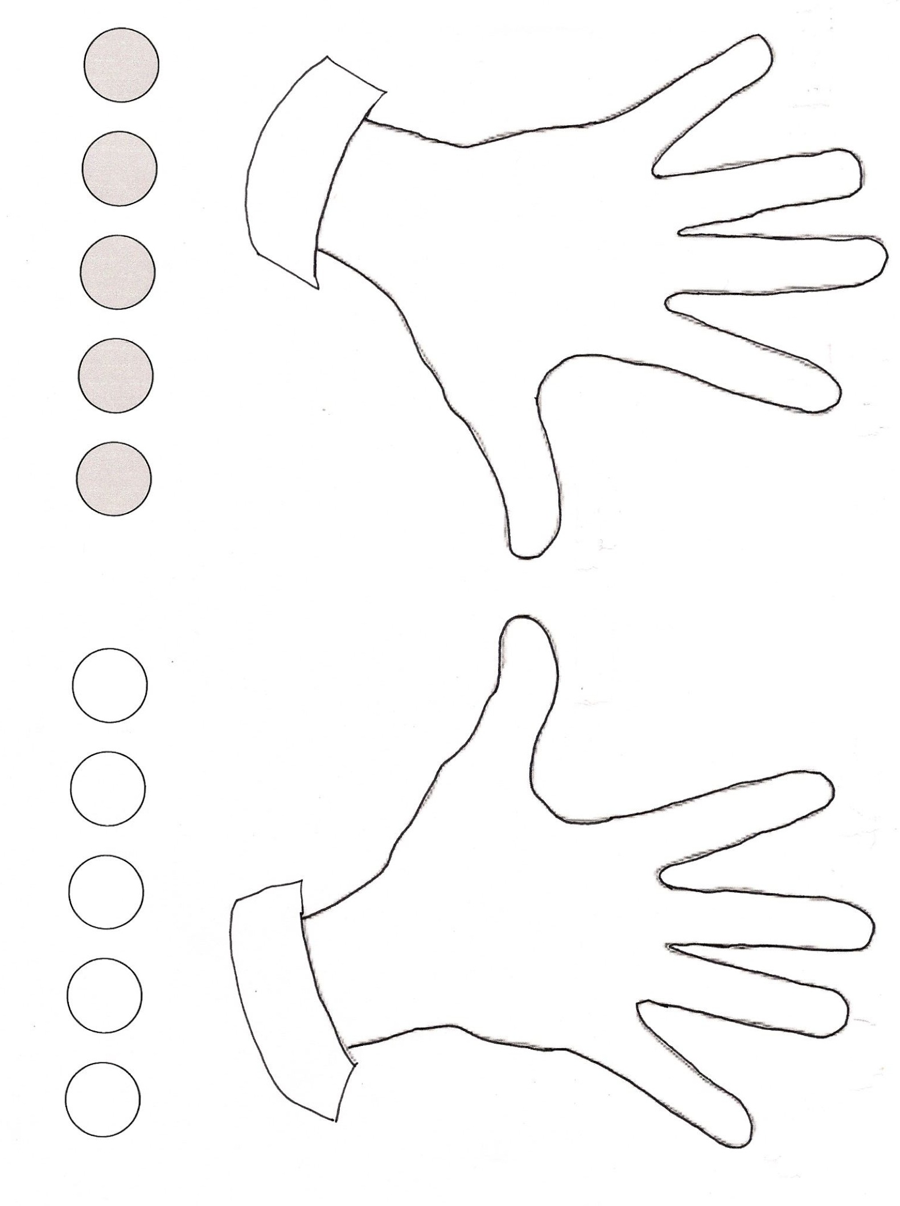

is the same as

____ ten and ____ ones.

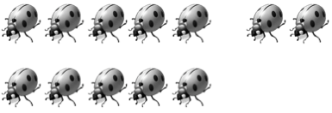

is the same as

____ ones and ____ ten.

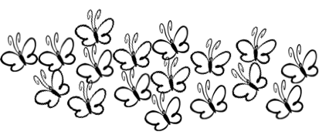





is the same as

____ ten and ____ ones.

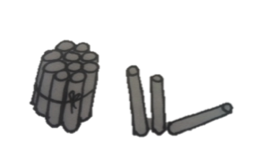

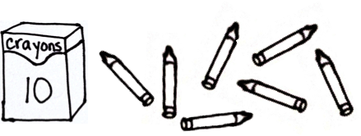Show the total and tens and ones with Hide Zero cards.   
Write how many **tens** and **ones**.

is the same as

____ ten and ____ ones.

is the same as

____ ten and ____ ones.

is the same as

____ ten and ____ ones.

is the same as

____ ones and ____ ten.

Draw the circles as a ten and extra ones. How many **tens** and **ones**?

is the same as

____ ten and ____ ones.

____ ten and ____ ones

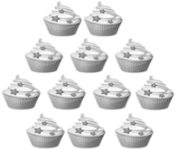

____ ten and ____ ones

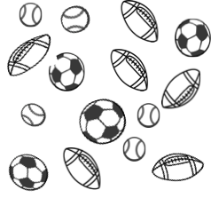

Name Date

Match the pictures of tens and ones to the Hide Zero cards. How many tens and ones?

is the same as

____ ten and ____ ones.

is the same as

____ ten and ____ ones.

is the same as

____ ten and ____ ones.

Name Date

Circle **ten**. Write the number. How many **tens** and **ones**?

1.

is the same as

____ ones and ____ ten.

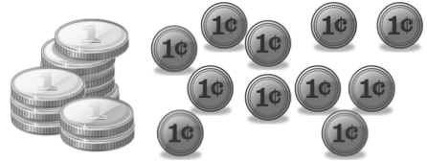

10

is the same as

____ ten and ____ ones.

2.



10

Use the Hide Zero pictures to draw the ten and ones shown on the cards.

3. 4.

1 ten

____ ten and ____ ones ____ ten and ____ ones

Draw using 5-groups columns to show the tens and ones.

5. 6.

____ ten and ____ ones

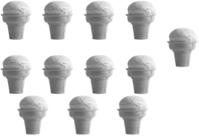

____ ten and ____ ones

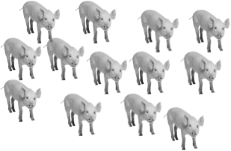

Draw your own examples using 5-groups columns to show the tens and ones.

7. 16

16 is the same as

___ ten and ____ ones.

8. 19

19 is the same as

____ ones and ____ ten.

[1]

How many beads?

How many animals?

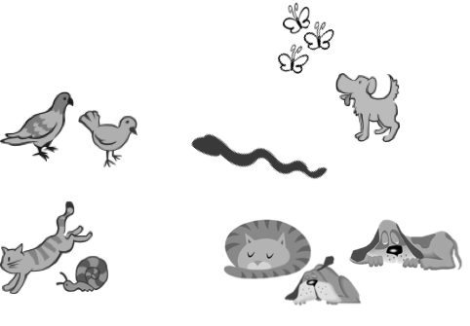

How many pineapples?

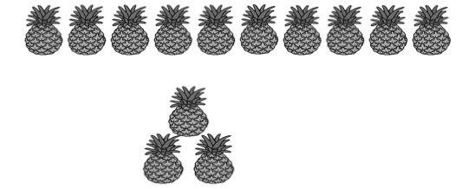



How many cupcakes?

How many pieces of fruit?

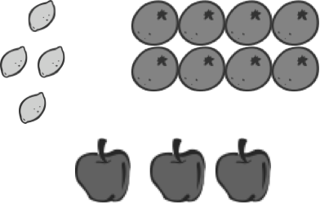

How many lunches?

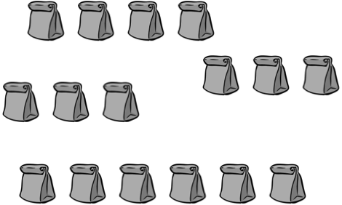

10 cupcakes

1. grouping ten images