Lesson 9
Objective: Fluently multiply multi-digit whole numbers using the standard algorithm to solve multi-step word problems.

Suggested Lesson Structure
 Fluency Practice (10 minutes)
 Concept Development (40 minutes)
 Student Debrief (10 minutes)
Total Time (60 minutes)
Fluency Practice (10 minutes)
- Multiply and Divide by Exponents 5.NBT.2 (4 minutes)
- Estimate Products by Rounding 5.NBT.6 (6 minutes)
Multiply and Divide by Exponents (4 minutes)
Materials: (T/S) Millions to thousandths place value chart (Lesson 1 Template) (S) Personal white board
Note: This review fluency exercise encourages flexible thinking because of the inclusion of division. The notation of the exponent form is also important to revisit and reuse, so that it becomes natural to the students to think of powers of 10 written either as multiples of 10 or as exponents.
T: (Project place value chart from millions to thousandths.) Write 45 tenths as a decimal.
S: (Write 4 in the ones column and 5 in the tenths column.)
T: Say the decimal.
S: Four and five tenths.
T: Multiply it by 10².
S: (Cross out 4.5 and write 450.)
Repeat the process and sequence for 0.4 × 10², 0.4 ÷ 10², 3.895 × 10³, and 5,472 ÷ 10³.
Estimate Products by Rounding (6 minutes)
Materials: (S) Personal white board
Note: This fluency activity’s focus is estimation, which will be used during this lesson.
T: (Write 412 × 231 ≈ ____ × ____.) Round both factors to the nearest hundred.
S: 400 × 200.
T: Write 412 × 231 ≈ 400 × 200. What is 400 × 200?
S: 80,000.
Repeat the process and procedure for 523 × 298 ≈ 500 × 300, 684 × 347, and 908 × 297.
Concept Development (40 minutes)
Materials: (T/S) Problem Set
Note: This lesson omits the Application Problem component since the entire lesson is devoted to problem solving. Problems for this section are found in this lesson’s Problem Set.
Problem 1
An office space in New York City measures 48 feet by 56 feet. If it sells for $565 per square foot, what is the selling price of the office space?
T: We will work Problem 1 on your Problem Set together. (Project the problem on the board.) Let’s read the word problem aloud.
S: (Read chorally.)
T: Now, let’s re-read the problem sentence by sentence, and draw as we go.
S: (Read the first sentence.)
T: What do you see? Can you draw something?
S: (Draw.)
T: Read the next sentence. (Give students time to read.) What is the important information, and how can we show that in our drawing?
S: The office space sells for $565 for each square foot. We can draw a single square unit inside our rectangle to remind us. We can write that 1 unit = $565.

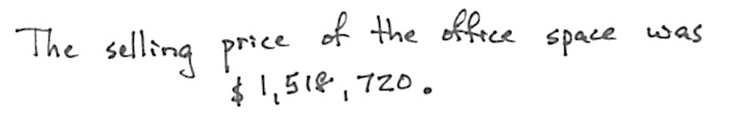
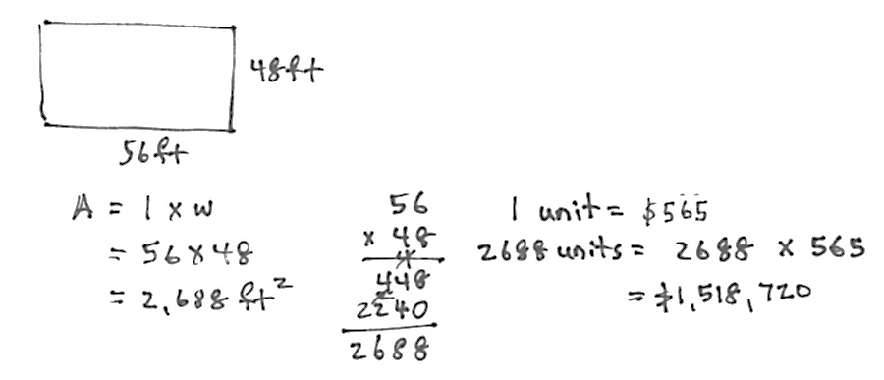
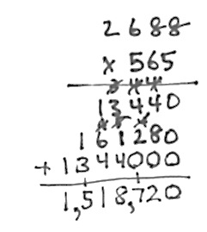

T: How do we solve this problem? Turn and talk.
S: We have to multiply. We have to find the total square feet of the office space, and then multiply by $565. We have to first find the area of the office space, and then multiply by $565.
T: What information are we given that would help us figure out the area?
S: We can multiply the length times the width.
NOTES ON
Multiple Means
of Representation:
Guide students to select and practice using various models (tape diagram, area model, etc.) to represent the given information in each problem .

S: (Solve to find 2,688 ft².)
T: Have we answered the question?
S: No. We need to multiply the area by the cost of one square foot, $565, to find the total cost.
T: Solve and express your answer in a complete sentence.
S: (Work.) The cost of the office space is $1,518,720.
Problem 2
Gemma and Leah are both jewelry makers. Gemma made 106 beaded necklaces. Leah made 39 more necklaces than Gemma.
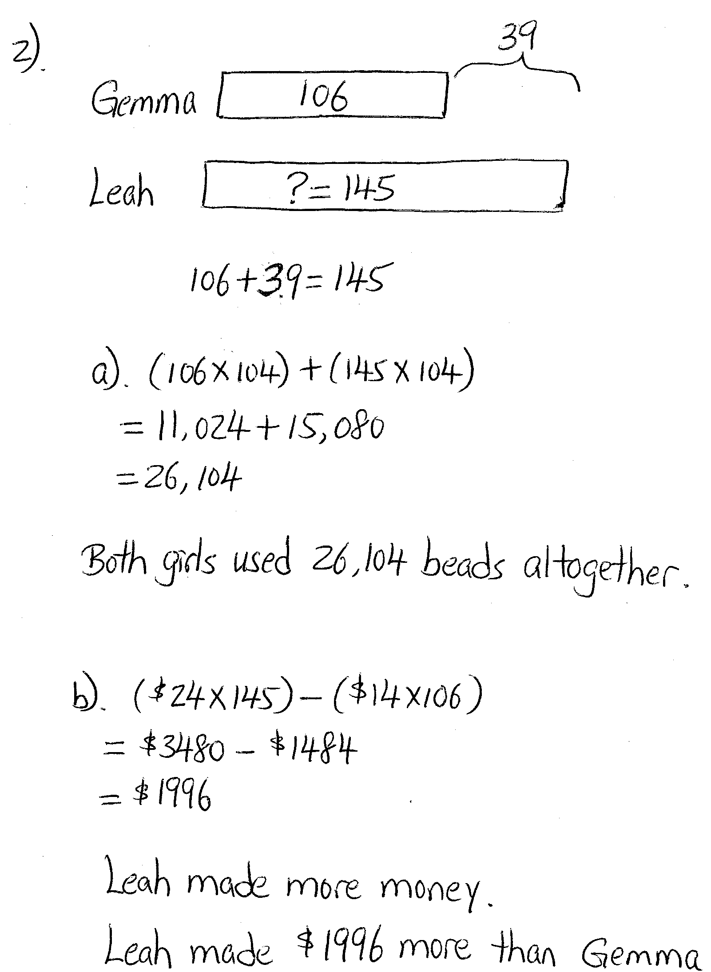
- Each necklace they make has exactly 104 beads on it. How many beads did both girls use altogether while making their necklaces?
- At a recent craft fair, Gemma sold her necklaces for $14 each. Leah sold her necklaces for $10 more. Who made more money at the craft fair? How much more?
MP.2
T: (Allow students to read the problem chorally, in pairs, or in silence.)
T: Can you draw something?
S: Yes.
T: What can you draw?
S: A tape for Gemma’s necklaces and a second, longer bar for Leah’s.
T: Go ahead and draw and label your tape diagrams. (Allow time for students to work.)
T: What is the question asking?
S: We have to find the total number of beads on all the necklaces.
T: What do we need to think about to solve this problem? What do you notice about it?
S: It is a multi-step problem. We need to know how many necklaces Leah made before we can find the total number of necklaces. Then, we need to find the number of beads.
T: Work together to complete the first steps by finding the total number of necklaces.
T: We haven’t answered the question yet. Turn and talk to your partner about how we can finish solving Part (a).
S: We have to multiply to find the total beads for both girls. Multiply Gemma’s number of necklaces times 104 beads, multiply Leah’s number of necklaces times 104, and then add them together. Add Gemma and Leah’s necklaces together, and then multiply by 104.
T: Use an expression to show your strategy for solving.
NOTES ON
MULTIPLE MEANS
OF ACTIONS AND EXPRESSION:
Vary the grouping size in the classroom. Smaller groups support English language learners to navigate the language of word problems and allow students to find full proficiency of the mathematics first, without the obstacles of vocabulary.
S: (106 × 104) + (145 × 104) or (106 + 145) × 104.
T: Solve the problem with your partner and make a statement to answer the question.
S: Gemma and Leah used 26,104 beads altogether.
T: Let’s read Part (b) together.
S: (Read.)
T: Who made more money? Without calculating, can we answer this question? Turn and talk.
S: Leah made more necklaces than Gemma, and she charged more per necklace. Therefore, it makes sense that Leah made more money than Gemma.
T: Find out how much more money Leah made.
S: (Work.)
S: Leah made $1,996 more than Gemma.
T: Complete Problems 3, 4, 5, and 6 of the Problem Set independently or in pairs.
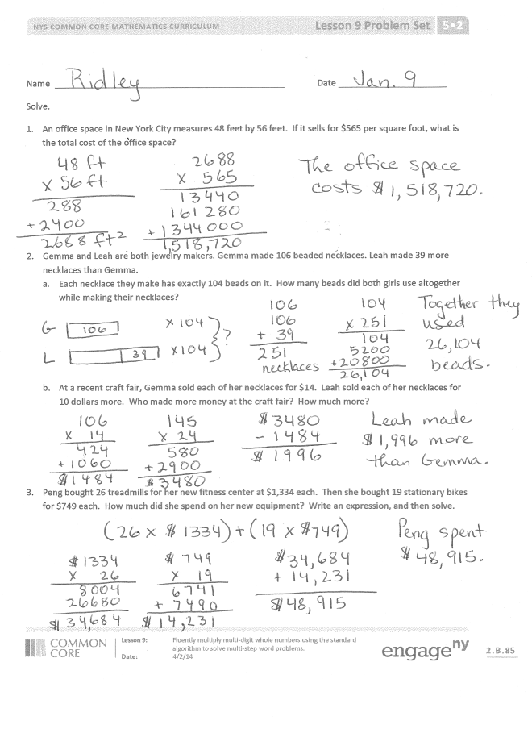
Problem Set (10 minutes)
Students should do their personal best to complete the Problem Set within the allotted 10 minutes. For some classes, it may be appropriate to modify the assignment by specifying which problems they work on first. Some problems do not specify a method for solving. Students should solve these problems using the RDW approach used for Application Problems.
Student Debrief (10 minutes)
Lesson Objective: Fluently multiply multi-digit whole numbers using the standard algorithm to solve multi-step word problems.
The Student Debrief is intended to invite reflection and active processing of the total lesson experience.

Invite students to review their solutions for the Problem Set. They should check work by comparing answers with a partner before going over answers as a class. Look for misconceptions or misunderstandings that can be addressed in the Debrief. Guide students in a conversation to debrief the Problem Set and process the lesson.
You may choose to use any combination of the questions below to lead the discussion.
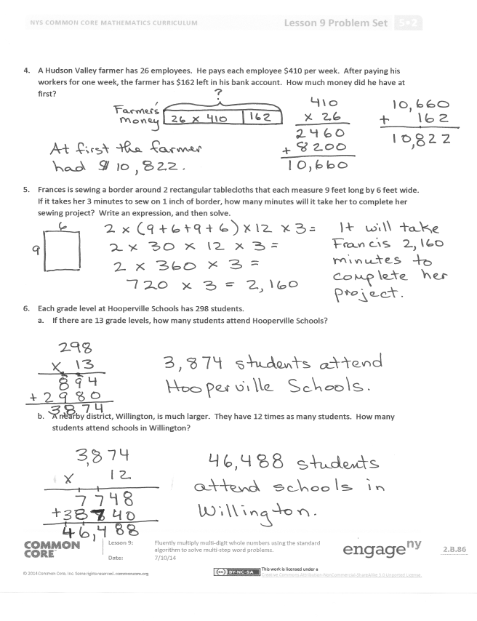
- Share and explain to your partner the numerical expressions you wrote to help you solve Problems 3 and 5.
- Explain how Problems 3 and 5 could both be solved in more than one way.
- What type of problem are Problem 1 and Problem 5? How are these two problems different from the others? (Problems 1 and 5 are measurement problems.)
Exit Ticket (3 minutes)
After the Student Debrief, instruct students to complete the Exit Ticket. A review of their work will help you assess the students’ understanding of the concepts that were presented in the lesson today and plan more effectively for future lessons. You may read the questions aloud to the students.

Name Date
Solve.
- An office space in New York City measures 48 feet by 56 feet. If it sells for $565 per square foot, what is the total cost of the office space?

- Gemma and Leah are both jewelry makers. Gemma made 106 beaded necklaces. Leah made 39 more necklaces than Gemma.
  - Each necklace they make has exactly 104 beads on it. How many beads did both girls use altogether while making their necklaces?

  - At a recent craft fair, Gemma sold each of her necklaces for $14. Leah sold each of her necklaces for 10 dollars more. Who made more money at the craft fair? How much more?

- Peng bought 26 treadmills for her new fitness center at $1,334 each. Then, she bought 19 stationary bikes for $749 each. How much did she spend on her new equipment? Write an expression, and then solve.

- A Hudson Valley farmer has 26 employees. He pays each employee $410 per week. After paying his workers for one week, the farmer has $162 left in his bank account. How much money did he have at first?

- Frances is sewing a border around 2 rectangular tablecloths that each measure 9 feet long by 6 feet wide. If it takes her 3 minutes to sew on 1 inch of border, how many minutes will it take her to complete her sewing project? Write an expression, and then solve.

- Each grade level at Hooperville Schools has 298 students.
  - If there are 13 grade levels, how many students attend Hooperville Schools?

  - A nearby district, Willington, is much larger. They have 12 times as many students. How many students attend schools in Willington?

Name Date
Solve.
- Juwad picked 30 bags of apples on Monday and sold them at his fruit stand for $3.45 each. The following week he picked and sold 26 bags.
  - How much money did Juwad earn in the first week?

  - How much money did he earn in the second week?

  - How much did Juwad earn selling bags of apples these two weeks?

  - Extension: Each bag Juwad picked holds 15 apples. How many apples did he pick in two weeks? Write an expression to represent this problem.

Name Date
Solve.
- Jeffery bought 203 sheets of stickers. Each sheet has a dozen stickers. He gave away 907 stickers to his family and friends on Valentine’s Day. How many stickers does Jeffery have remaining?

- During the 2011 season, a quarterback passed for 302 yards per game. He played in all 16 regular season games that year.
  - For how many total yards did the quarterback pass?

  - If he matches this passing total for each of the next 13 seasons, how many yards will he pass for in his career?

- Bao saved $179 a month. He saved $145 less than Ada each month. How much would Ada save in three and a half years?

- Mrs. Williams is knitting a blanket for her newborn granddaughter. The blanket is 2.25 meters long and 1.8 meters wide. What is the area of the blanket? Write the answer in centimeters.

- Use the chart to solve. Soccer Field Dimensions

 | FIFA Regulation  (in yards) | New York State High Schools  (in yards)
Minimum Length | 110 | 100
Maximum Length | 120 | 120
Minimum Width | 70 | 55
Maximum Width | 80 | 80

- Write an expression to find the difference in the maximum area and minimum area of a NYS high school soccer field. Then, evaluate your expression.

- Would a field with a width of 75 yards and an area of 7,500 square yards be within FIFA regulation? Why or why not?

- It costs $26 to fertilize, water, mow, and maintain each square yard of a full size FIFA field (with maximum dimensions) before each game. How much will it cost to prepare the field for next week’s match?

