Lesson 25
Objective: Strategize and apply understanding of the equal sign to solve equivalent expressions.

Suggested Lesson Structure
 Fluency Practice (15 minutes)
 Application Problem (7 minutes)
 Concept Development (28 minutes)
 Student Debrief (10 minutes)
Total Time (60 minutes)
Fluency Practice (15 minutes)
- Make It Equal: Addition Expressions 1.OA.6 (5 minutes)
- Sprint: Make It Equal 1.OA.6 (10 minutes)
Make It Equal: Addition Expressions (5 minutes)
Materials: (S) Personal white board, counters
Note: This activity builds fluency with the make ten addition strategy and reinforces the meaning of the equal sign, which prepares students for today’s lesson.
Write or project 9 + ☐ = 8 + ☐ . Students find different numbers that make the equation true and check their answers with a partner. If necessary, students can use counters in addition to drawings that they can make on their personal white boards. During the last minute, ask for volunteers to share the equations they found. Write them on the board and ask if anyone notices a pattern (that the numbers are always consecutive).
Sprint: Make It Equal (10 minutes)
Materials: (S) Make It Equal Sprint
Note: This Sprint uses review addition facts to strengthen students’ understanding of the equal sign.

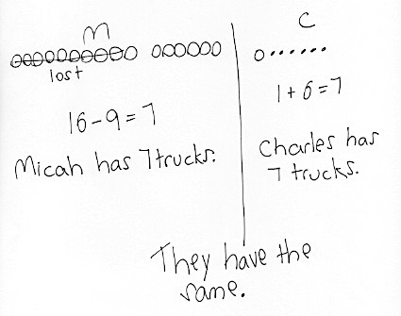
Application Problem (7 minutes)
Micah had 16 trucks and lost 9 of them. Charles had 1 truck and received 6 more trucks from his mother. Who has more trucks, Micah or Charles?
Note: Students apply their prior understanding of take from with result unknown and add to with result unknown problems as they solve this two-part problem. This provides a context for exploring today’s objective of further understanding the meaning of the equal sign by pairing equivalent expressions and constructing true number sentences.
Concept Development (28 minutes)
Materials: (T) Expression cards (Template) for use in small groups during Problem Set (S) Personal white board, work from Application Problem, linking cubes
Students may sit in the meeting area or at their seats, next to a partner, with all materials.
T: Who has more trucks, Micah or Charles? (Write Micah on the left side of the board and Charles on the right side of the board.)
S: Neither. They have the same number of trucks!
T: Talk with a partner. Use your drawings to help you prove to your partner that Micah and Charles have the same number of trucks.
S: (Discuss, using their drawings to explain.)
T: (Circulate and listen to ensure that all students see that Micah and Charles have the same number of trucks.) What number sentence did you write to match Micah’s part of the story?
S: 16 – 9 = 7. (Write 16 – 9 = 7 below Micah.)
T: What number sentence did you write to match Charles’ part of the story?
S: 1 + 6 = 7. (Write 1 + 6 = 7 below Charles.)

NOTES ON
MULTIPLE MEANS
OF ENGAGEMENT:
For those students who are able to quickly repeat the process, cultivate excitement by connecting on-level math to higher math, presenting numbers to 40.

T: So, Micah and Charles have an equal number of trucks?
S: Yes!
T: (Write 16 – 9 under the Micah section and 1 + 6 under the Charles section.) We can say, then, that 16 – 9 is equal to 1 + 6. (Draw equal sign in between expressions.)
T: How does our story help us see that 16 – 9 = 1 + 6? (Point to each part while reading the number sentence.) Talk with your partners. (Listen as students explain their thinking to their partners.)
MP.2

NOTES ON
[TITLE HERE]:
Lorem ipsum dolor sit amet, amet vitae libero ultricies vestibulum, massa pede turpis aliquam augue sed, aliquet urna luctus nibh. Orci sagittis magna metus.
- Application Problems leading directly into the work with ten-frames (35 minutes)
- Student Debrief (10 minutes)
- Fluency Practice (15 minutes)

S: Since 16 – 9 is 7 and 1 + 6 is 7, they are equal. 16 – 9 equals 1 + 6. Once I took the 9 from 10, Micah and Charles both show 1 and 6. They both have 7.
T: Let’s try to make some more cool number sentences like this.
T: Work with your partner to make at least two expressions that equal 12.
S: (Work with partners.) We found 10 + 2 and 11 + 1.
T: Great. I’ll use 10 + 2. Who has another?

NOTES ON
MULTIPLE MEANS
OF ENGAGEMENT:
Remember to challenge your advanced learners. An extension activity can be given where number sentences are false, and students have to make them true. If given a false statement such as 3 + 5 = 7 + 2, they could change the 5 into 6 or the 2 into 1.

S: We found 6 + 6.
T: True or false? 10 + 2 = 6 + 6.
S: True!
T: Let’s all write this cool number sentence on our personal white boards and read it together.
S: (Write number sentence.) 10 + 2 = 6 + 6.
After having generated several similar number sentences, start erasing some addends.
T: If I erase this 6 (erase the 6 after the equal sign), what number goes here to make this equation true?
S: 6! You would need to have two sixes to equal 12.
T: (Distribute an expression card to each student. Odd numbered classes need to pair two students together.) Solve the expression. You may use linking cubes or another strategy. If you’re using linking cubes, you may need to borrow extras from a neighbor. After you solve the expression, make a linking cube stick to show your final amount.
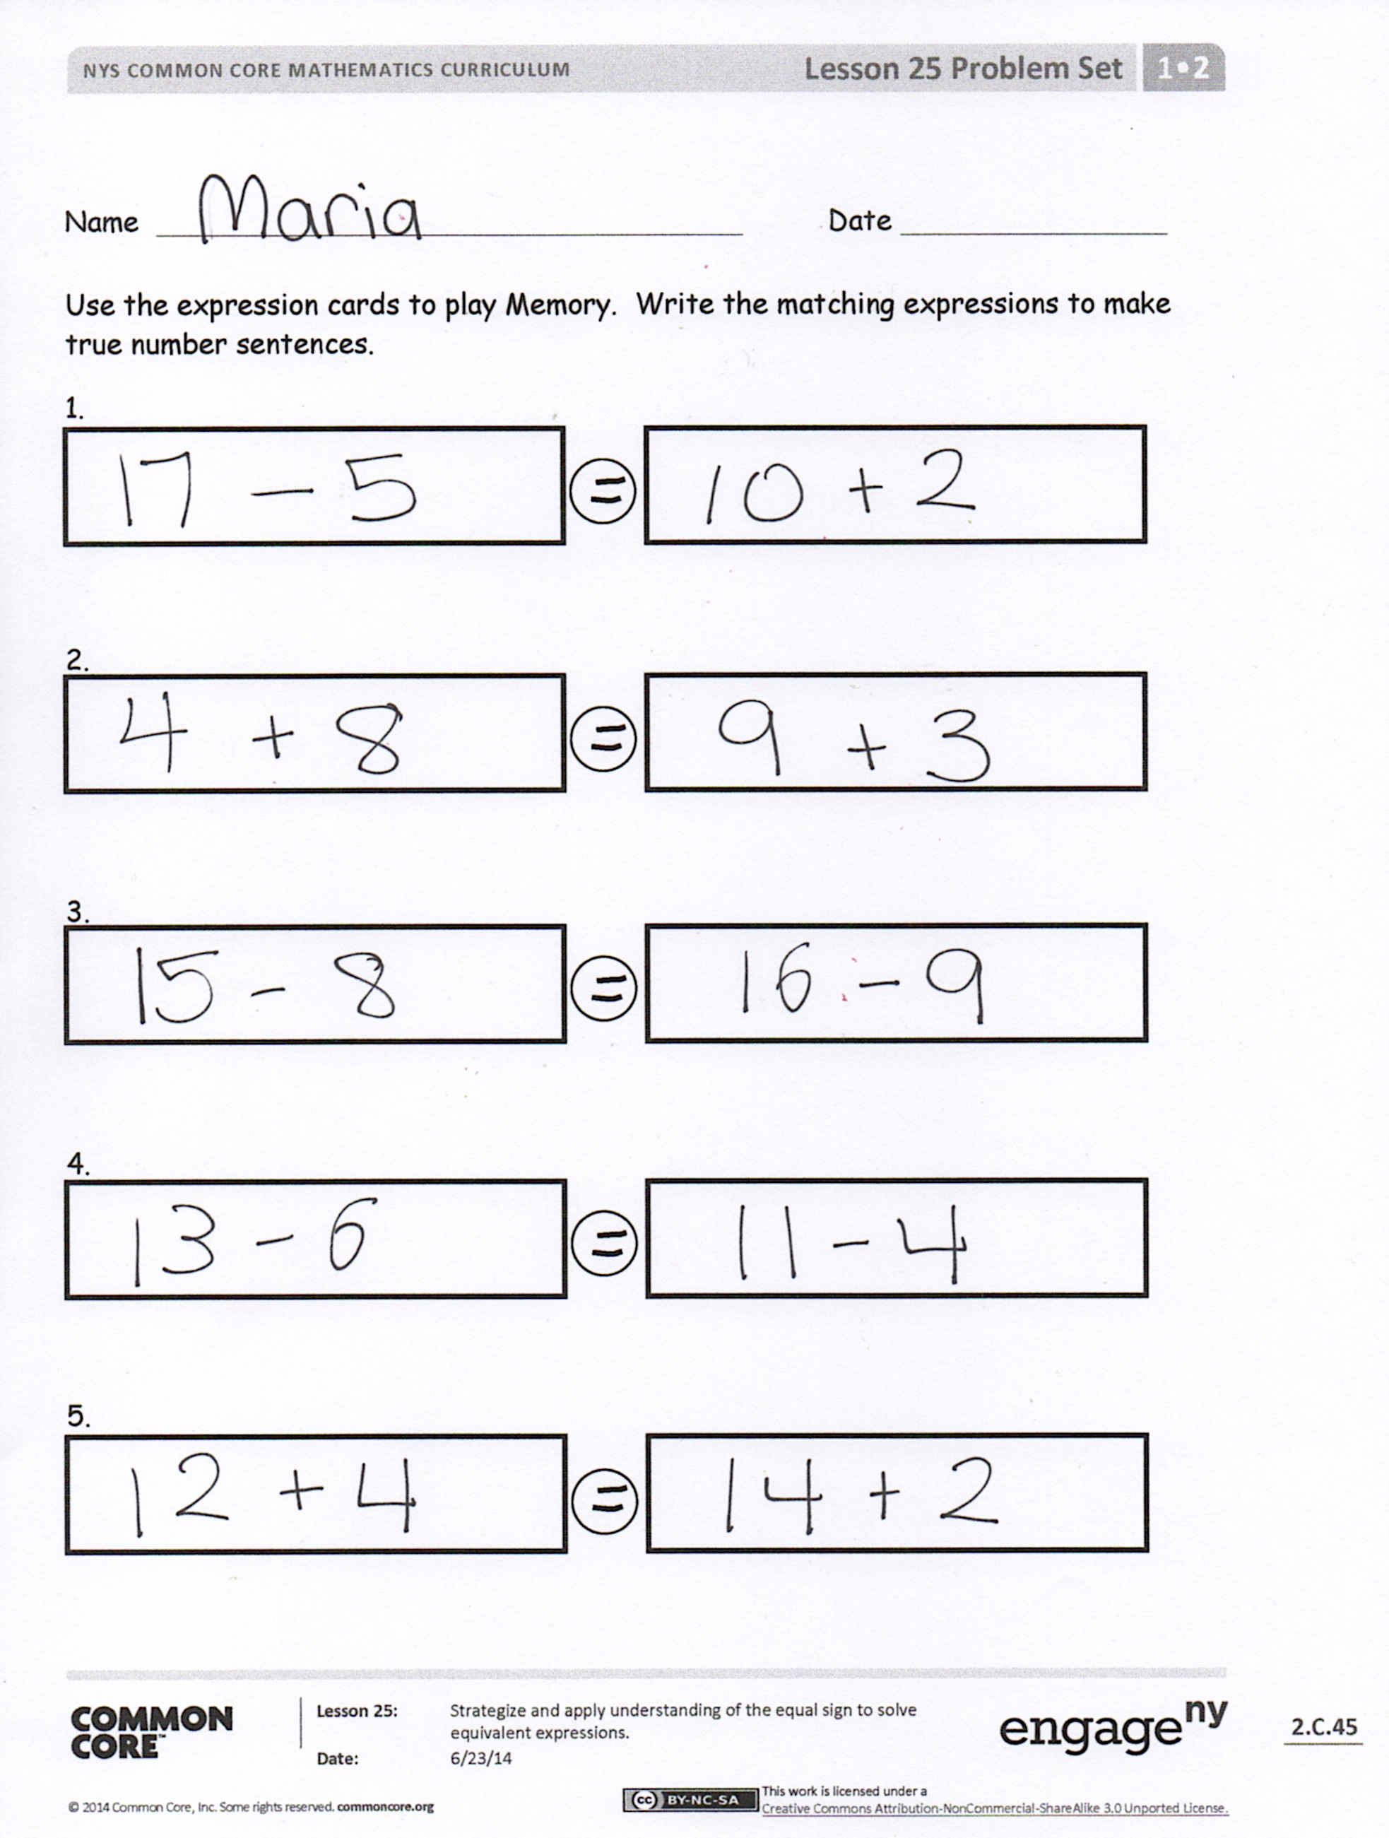
T: There is someone in the room who has the same answer. Find that person, and create a number sentence together to show that your two expressions make equal amounts.
T: What true number sentences did we make?
Problem Set (10 minutes)
Students should do their personal best to complete the Problem Set within the allotted 10 minutes. For some classes, it may be appropriate to modify the assignment by specifying which problems they work on first. Some problems do not specify a method for solving. Students should solve these problems using the RDW approach used for Application Problems.

Student Debrief (10 minutes)
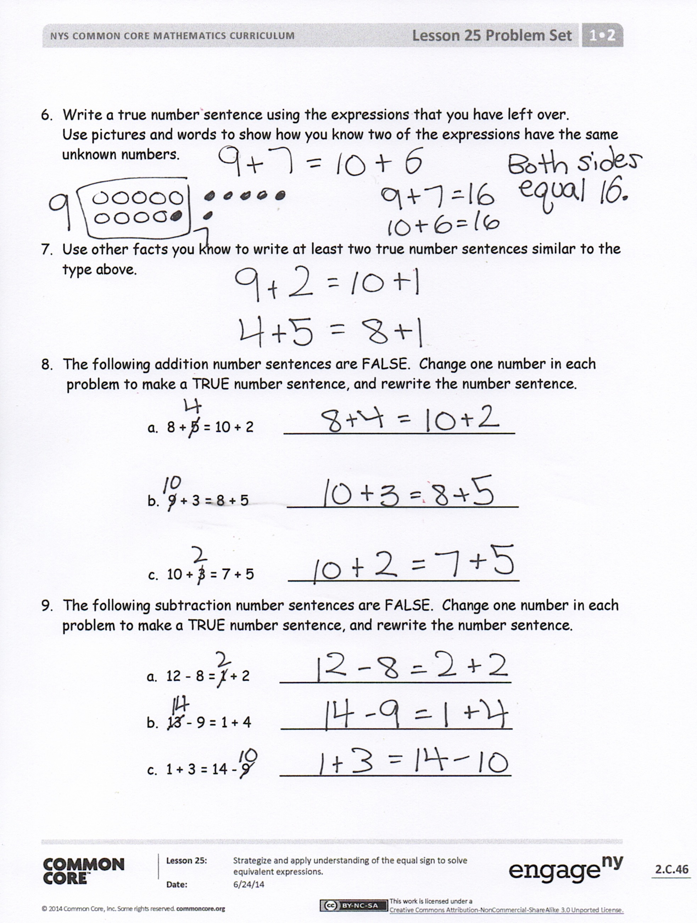
Lesson Objective: Strategize and apply understanding of the equal sign to solve equivalent expressions.
The Student Debrief is intended to invite reflection and active processing of the total lesson experience.
Invite students to review their solutions for the Problem Set. They should check work by comparing answers with a partner before going over answers as a class. Look for misconceptions or misunderstandings that can be addressed in the Debrief. Guide students in a conversation to debrief the Problem Set and process the lesson.
You may choose to use any combination of the questions below to lead the discussion.
- (Write 14 + 2 = 10 + 6 on the board.) Show how you know these are equal expressions. What do you notice about the numbers when you break apart 14?
- (Point to the number sentence written on the board.) Which of the parts of the number sentence are the expression? What does it mean to use “=” between the two expressions? Explain the meaning of equal.
- Look at your Problem Set. Which expressions can you solve in your head? How can they help you solve other expressions that might be harder for you?
- Look at the true number sentences we made during today’s partner activity. What did you notice about the expressions that made these number sentences true?
- Which expressions were missing a part? Which expressions were missing the whole, or total?
- How did the Application Problem connect to today’s lesson?
Exit Ticket (3 minutes)
After the Student Debrief, instruct students to complete the Exit Ticket. A review of their work will help you assess the students’ understanding of the concepts that were presented in the lesson today and plan more effectively for future lessons. You may read the questions aloud to the students.

Name Date
Number correct:
A
*Write the missing number.
1 | ☐ = 4 + 1 |  | 16 | 7 + 3 = 4 + ☐
2 | ☐ = 4 + 2 |  | 17 | 6 + 4 = 5 + ☐
3 | ☐ = 4 + 3 |  | 18 | 5 + 5 = 6 + ☐
4 | ☐ = 5 + 1 |  | 19 | 5 + 3 = ☐ + 1
5 | ☐ = 5 + 2 |  | 20 | 5 + 4 = ☐ + 5
6 | ☐ = 5 + 3 |  | 21 | 4 + 5 = ☐ + 5
7 | ☐ = 6 + 1 |  | 22 | 2 + ☐ = 6 + 2
8 | 8 = 7 + ☐ |  | 23 | 4 + ☐ = 5 + 3
9 | 9 = 8 + ☐ |  | 24 | ☐ + 4 = 5 + 2
10 | 9 = ☐ + 1 |  | 25 | ☐ + 6 = 4 + 3
11 | 9 = ☐ + 9 |  | 26 | 4 + 2 = 1 + ☐
12 | 8 = ☐ + 1 |  | 27 | 3 + 4 = ☐ + 2
13 | ☐ = 7 + 1 |  | 28 | 4 + 4 = 2 + ☐
14 | 10 = 8 + ☐ |  | 29 | 3 + ☐ = 2 + 7
15 | 10 = ☐ + 8 |  | 30 | ☐ + 2 = 2 + 6

Name Date
Number correct:
B
*Write the missing number.
1 | ☐ = 3 + 1 |  | 16 | 5 + 5 = 4 + ☐
2 | ☐ = 3 + 2 |  | 17 | 6 + 4 = 7 + ☐
3 | ☐ = 3 + 3 |  | 18 | 3 + 7 = 8 + ☐
4 | ☐ = 4 + 1 |  | 19 | 5 + 2 = ☐ + 1
5 | ☐ = 4 + 2 |  | 20 | 5 + 3 = ☐ + 5
6 | ☐ = 4 + 3 |  | 21 | 4 + 4 = ☐ + 4
7 | ☐ = 5 + 1 |  | 22 | 3 + ☐ = 6 + 3
8 | 8 = 1 + ☐ |  | 23 | 4 + ☐ = 5 + 4
9 | 9 = 1 + ☐ |  | 24 | ☐ + 4 = 2 + 5
10 | 8 = ☐ + 7 |  | 25 | ☐ + 6 = 3 + 4
11 | 8 = ☐ + 8 |  | 26 | 4 + 3 = 1 + ☐
12 | 7 = ☐ + 1 |  | 27 | 4 + 4 = ☐ + 2
13 | ☐ = 6 + 1 |  | 28 | 4 + 5 = 2 + ☐
14 | 10 = 9 + ☐ |  | 29 | 3 + ☐ = 2 + 6
15 | 10 = ☐ + 9 |  | 30 | ☐ + 2 = 2 + 7

Name Date
Use the expression cards to play Memory. Write the matching expressions to make true number sentences.

- Write a true number sentence using the expressions that you have left over.
Use pictures and words to show how you know two of the expressions have the same unknown numbers.

- Use other facts you know to write at least two true number sentences similar to the type above.

- The following addition number sentences are FALSE. Change one number in each
problem to make a TRUE number sentence, and rewrite the number sentence.
a. 8 + 5 = 10 + 2 __________________________

b. 9 + 3 = 8 + 5 __________________________

c. 10 + 3 = 7 + 5 __________________________

- The following subtraction number sentences are FALSE. Change one number in each problem to make a TRUE number sentence, and rewrite the number sentence.
a. 12 - 8 = 1 + 2 __________________________
b. 13 - 9 = 1 + 4 __________________________
c. 1 + 3 = 14 - 9 __________________________

Name Date
You are given these new expression cards. Write matching expressions to make true number sentences.

2 + 15
19 - 2
12 - 7
8 + 9

3 + 2
10 + 7
14 - 9
1 + 4

Name Date
- Circle “true” or “false.”

Equation | True or False?
- 2 + 3 = 5 + 1 | True / False
- 7 + 9 = 6 + 10 | True / False
- 11 – 8 = 12 – 9 | True / False
- 15 – 4 = 14 – 5 | True / False
- 18 – 6 = 2 + 10 | True / False
- 15 - 8 = 2 + 5 | True / False

- Lola and Charlie are using expression cards to make true number sentences. Use pictures and words to show who is right.

- Lola picked 4 + 8, and Charlie picked 9 + 3. Lola says these expressions are equal, but Charlie disagrees. Who is right? Explain your thinking.

- Charlie picked 11 – 4, and Lola picked 6 + 1. Charlie says these expressions are not equal, but Lola disagrees. Who is right? Use a picture to explain your thinking.

- Lola picked 9 + 7, and Charlie picked 15 – 8. Lola says these expressions are equal but Charlie disagrees. Who is right? Use a picture to explain your thinking.

3. The following addition number sentences are FALSE. Change one number in each
problem to make a TRUE number sentence, and rewrite the number sentence.
a. 10 + 5 = 9 + 5 __________________________

b. 10 + 3 = 8 + 4 __________________________

c. 9 + 3 = 8 + 5 __________________________

12 - 7 | 3 + 2
7 + 8 | 10 + 5

15 – 9 | 1 + 5
6 + 8 | 10 + 4
15 - 8 | 2 + 5
17 - 9 | 1 + 7

11 - 7 | 3 + 1
6 + 7 | 10 + 3
17 – 8 | 2 + 7
4 + 8 | 10 + 2

7 + 9 | 10 + 6
11 - 8 | 2 + 1
8 + 9 | 10 + 7
9 + 9 | 10 + 8
4 + 8 | 10 + 2
17 – 5 | 9 + 3

15 – 8 | 13 – 6
11 – 9 | 1 + 1

12 + 4 | 10 + 6
14 + 2 | 9 + 7

expression cards
expression cards
expression cards
expression cards

