Lesson 23
Objective: Solve add to with change unknown problems, relating varied addition and subtraction strategies.

Suggested Lesson Structure
 Fluency Practice (15 minutes)
 Application Problem (5 minutes)
 Concept Development (30 minutes)
 Student Debrief (10 minutes)
Total Time (60 minutes)
Fluency Practice (15 minutes)
- Subtraction with Partners 1.OA.6 (5 minutes)
- Sprint: Missing Addend Within 10 1.OA.6 (10 minutes)
Subtraction with Partners (5 minutes)
Materials: (S) Personal white board
Note: This fluency activity reviews subtracting 7, 8, and 9 from teen numbers. Allow students who still require pictorial representations to draw 5-groups to solve.
Assign partners of equal ability. Partners assign each other a number from 11 to 17 (e.g., 12). On their personal white boards, they write number sentences with 9, 8, and 7 as the subtrahend and solve them
(e.g., 12 – 9 = 3, 12 – 8 = 4, 12 – 7 = 5). Partners then exchange boards and check each other’s work.
Sprint: Missing Addend Within 10 (10 minutes)
Materials: (S) Missing Addend Within 10 Sprint
Note: This fluency activity is intended to strengthen students’ ability to fluently add and subtract within 10 while preparing students for the problem types that are presented in today’s lesson.

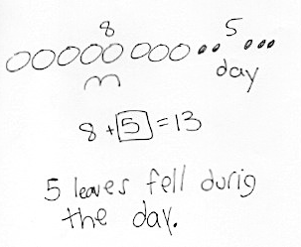
Application Problem (5 minutes)
In the morning, there were 8 leaves on the floor under the ficus tree. During the day, more leaves fell on the floor. Now, there are 13 leaves on the floor. How many leaves fell during the day?
Note: In today’s lesson, students grapple with an add to with change unknown problem. By giving students time to try this problem type independently, teachers have the opportunity to see how students are applying the RDW strategy without direct instruction on a specific method to solve.
Concept Development (30 minutes)
Materials: (S) Personal white board, work from the Application Problem
Students may sit next to their partners in the meeting area or at their seats with their materials.

NOTES ON
MULTIPLE MEANS
OF ACTION AND EXPRESSION:
As students are using the RDW process, some may need help with organizing their work. Not all students use the blank white space well. Drawing lines or a grid for these students to work within helps them be more spatially organized.
T: (Project today’s Application Problem.) Before we share our Application Problem with a partner, let’s walk through the Read and Draw parts of the Read, Draw, Write strategy. We call this RDW. What does RDW stand for?
S: Read, draw, and write.
T: As I read the problem, find the part of your drawing that matches the story.
T: In the morning, there were 8 leaves on the floor. Point to where your drawing shows these 8 leaves on the floor. Do these leaves have a label so you can find them easily?
T: During the day, more leaves fell on the floor. Touch the part of your drawing that shows these leaves. Label this part if you haven’t yet.
T: Now, there are 13 leaves on the floor. Can you find these leaves in your drawing? Is this a part of your leaves or is this the total number of leaves?
S: It’s the total number of leaves. (Touch their drawings to show.)
T: How many leaves fell during the day?
S: 5 leaves!
T: Talk with your partner. How does your drawing help you see the story situation?
S: (Discuss.)
T: (Circulate and take note of students’ language use, including terms such as part, whole, and total.)
T: What was missing, a part or the total number of leaves?
S: A part of the leaves.
T: Now that we know we are missing a part, how could we solve this problem?
S: We can start at 8 and then count on until we get to 13. That would be 5. We can draw all 13 and then cover, or take away, 8. We would have 5 left. We can draw 13 as 10 and 3, so we can quickly cover the 8 without having to recount them. Then, it’s easy to see the 2 and 3 that are left. That’s 5.
T: I saw many of you draw your 8 leaves first and use counting on. How can we use our friendly number 10 to count on in bigger amounts, instead of counting by ones?
S: We can think about how many more we need to get to 10, and then add the rest all at once.
T: Let’s try that here. We have 8 leaves, so how many would we draw to get to 10 leaves?
S: 2 more leaves.
T: From 10 leaves, how many more to get to the total, 13 leaves?
S: 3 leaves!
T: So, how many more leaves did we draw altogether?
S: 5 leaves!
T: Now that it’s later in our Grade 1 year, we can go a little faster by jumping from 8 to 10 and then jumping to the total. Counting on in this way is a little faster.
T: Once we solve the problem, we have to write our number sentence and our statement. Which number sentence best matches what happened in the story? Talk with your partner.

NOTES ON
MULTIPLE MEANS
OF REPRESENTATION:
If students have trouble coming up with the statement, have them re-read the question in the story problem. They can use the question to help write their answer sentence.
S: (Discuss.)
S: 8 + 5 = 13 matches the story best because there were 8 leaves in the morning, and then 5 leaves joined the pile. There were 13 leaves at the end of the story. The part we did not know was the 5.
T: Which number needs a rectangle around it to show it is our answer, or our solution?
S: 5.
T: What is our statement, or our word sentence that tells the answer to the question?
S: 5 leaves fell during the day.
T: Let’s try some more. Remember to think about which number sentence best matches the story.
Present three more add to with change unknown story problems such as those below:
- Eight children were playing on the playground. More children came out to join the 8 children. Now, there are 14 children on the playground. How many children came out to join them on the playground?
- Some new baby ducks hatched at the farm. There were 5 ducks on the farm, and now there are 12 ducks. How many new baby ducks were hatched?
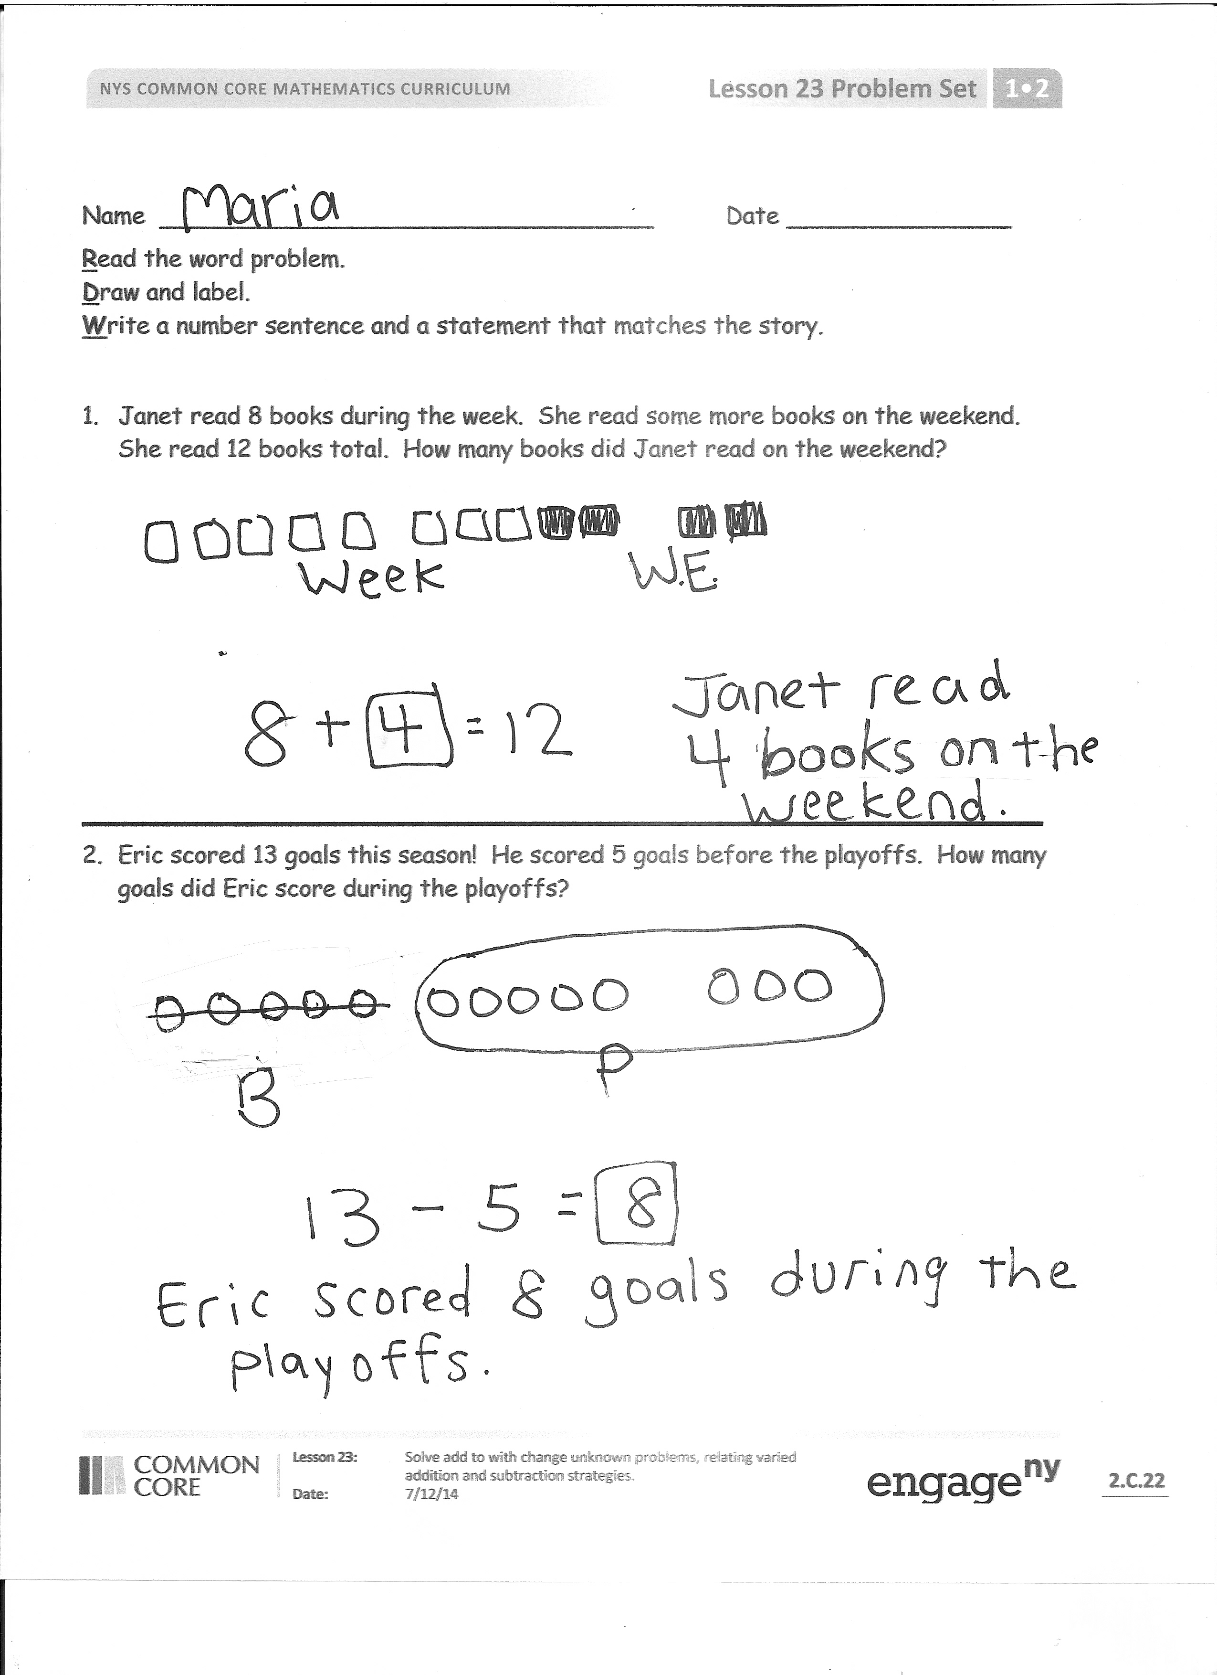
- Thirteen cars are in the parking lot. Six were already there in the morning. The rest of the cars arrived after lunch. How many cars arrived after lunch?
For each story, project the problem and read it aloud. Ask students, “Can you draw something? Listen again and ask yourself, ‘What can I draw?’” Read the problem again to allow students to think about what they can draw from the problem. Encourage the students to use the drawing to help them consider a strategy for solving by asking themselves, “What does my drawing show me?” Remind them to write a number sentence that matches the story and a word sentence, or solution statement, to answer the question. Give students approximately three minutes to work. Share one or two students’ work by drawing it on the board or using a document camera. Have students explain their drawing, share their choices of labels, and explain how their number sentence matches the story.
Problem Set (10 minutes)
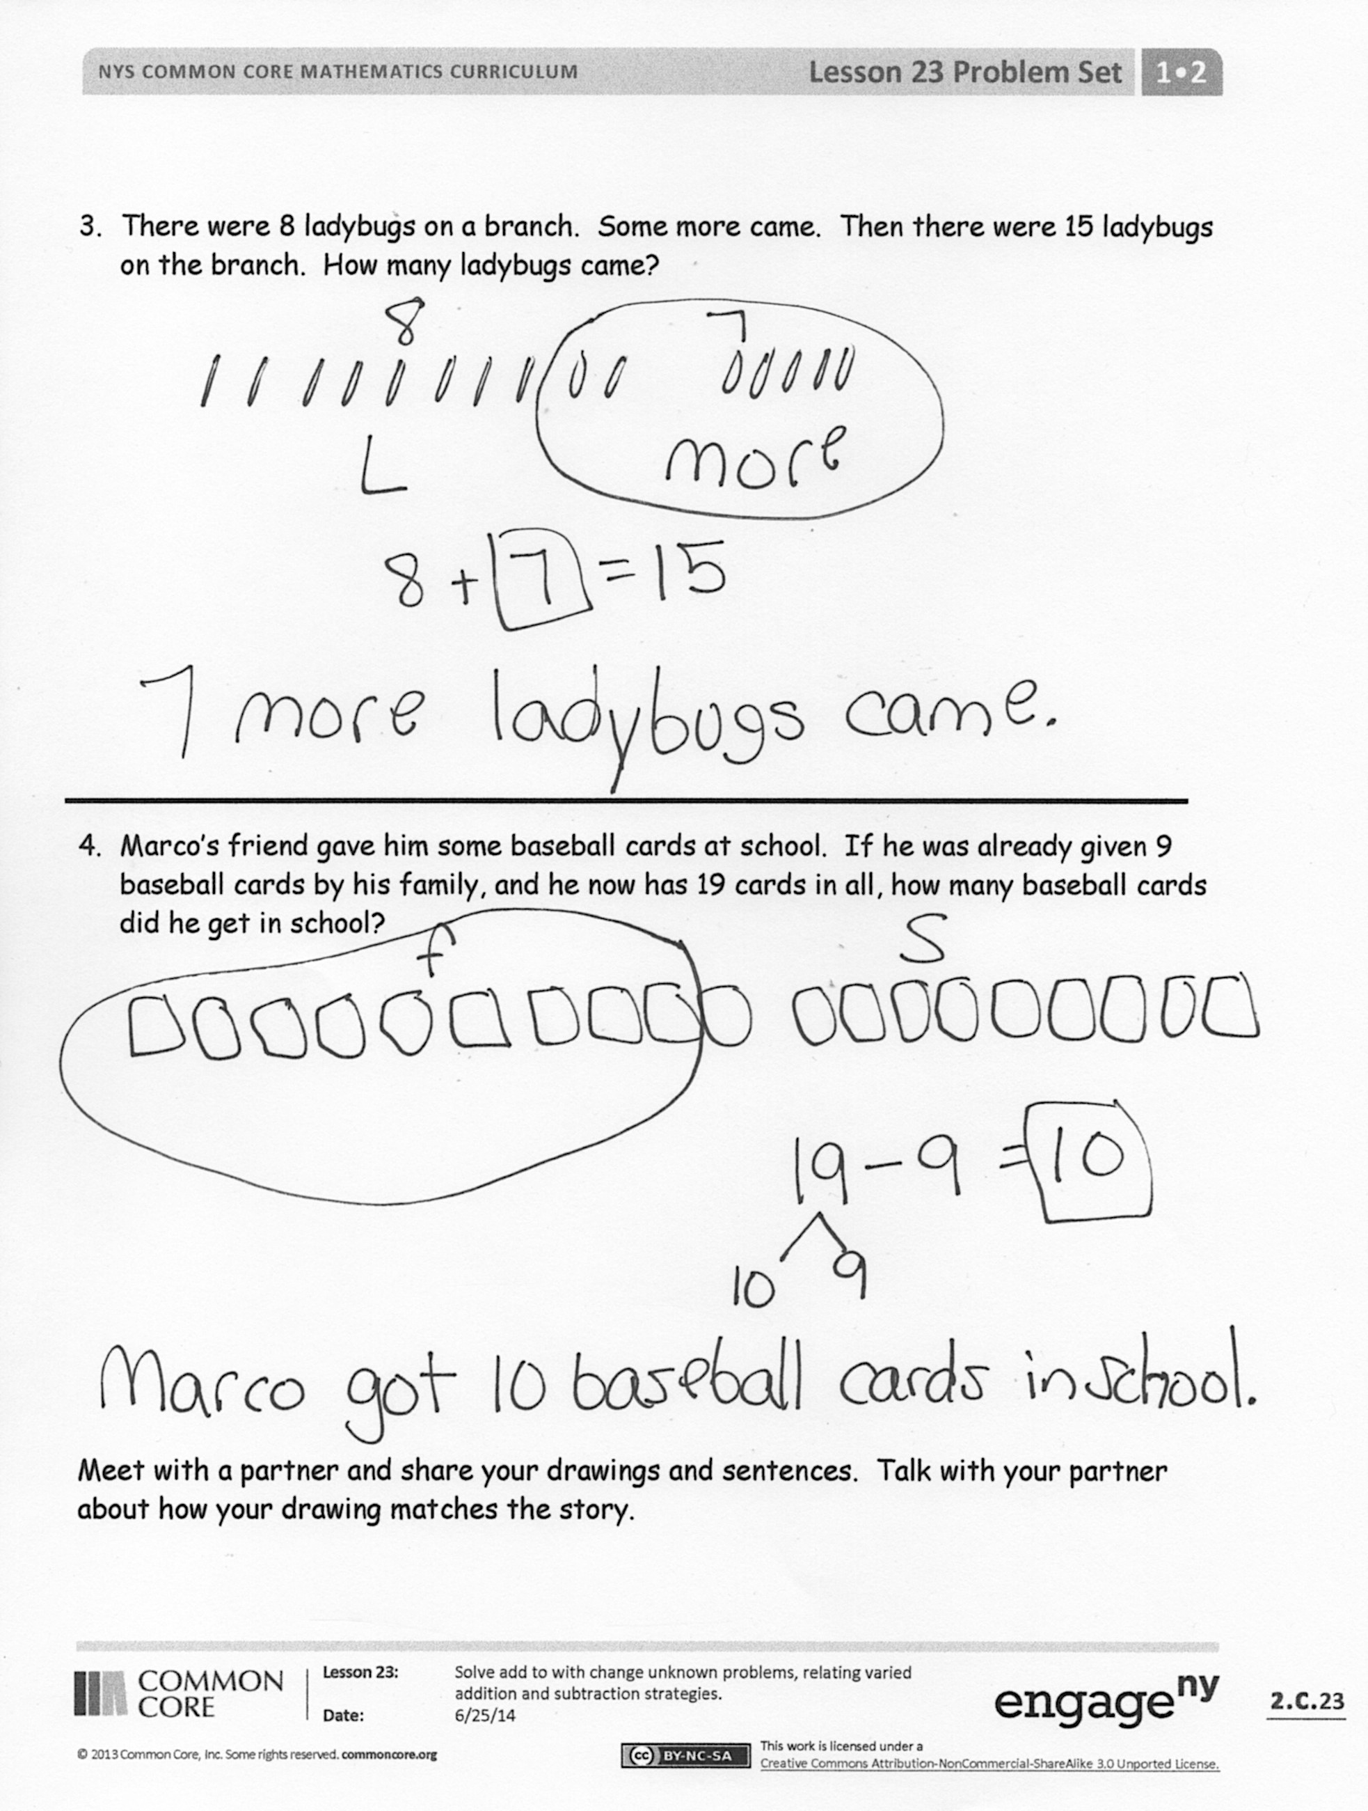
Students should do their personal best to complete the Problem Set within the allotted 10 minutes. For some classes, it may be appropriate to modify the assignment by specifying which problems they work on first. Some problems do not specify a method for solving. Students should solve these problems using the RDW approach used for Application Problems.
Student Debrief (10 minutes)
Lesson Objective: Solve add to with change unknown problems, relating varied addition and subtraction strategies.
The Student Debrief is intended to invite reflection and active processing of the total lesson experience.
Invite students to review their solutions for the Problem Set. They should check work by comparing answers with a partner before going over answers as a class. Look for misconceptions or misunderstandings that can be addressed in the Debrief. Guide students in a conversation to debrief the Problem Set and process the lesson.
You may choose to use any combination of the questions below to lead the discussion.
- Compare the way you solved Problems 1 and 2. How are the strategies you used the same or different?
- What do all of the story problems in the Problem Set have in common? (We always know the total and one of the parts. We had to look for the missing part.)
- Look at Problem 3. How did you use counting on? What did you do? How did that help you solve?
Exit Ticket (3 minutes)
After the Student Debrief, instruct students to complete the Exit Ticket. A review of their work will help you assess the students’ understanding of the concepts that were presented in the lesson today and plan more effectively for future lessons. You may read the questions aloud to the students.

Name Date
Number correct:
A
*Write the missing number.
1 | 2 + ☐ = 3 |  | 16 | 2 + ☐ = 8
2 | 1 + ☐ = 3 |  | 17 | 4 + ☐ = 8
3 | ☐ + 1 = 3 |  | 18 | 8 = ☐ + 6
4 | ☐ + 2 = 4 |  | 19 | 8 = 3 + ☐
5 | 3 + ☐ = 4 |  | 20 | ☐ + 3 = 9
6 | 1 + ☐ = 4 |  | 21 | 2 + ☐ = 9
7 | 1 + ☐ = 5 |  | 22 | 9 = ☐ + 1
8 | 4 + ☐ = 5 |  | 23 | 9 = 4 + ☐
9 | 3 + ☐ = 5 |  | 24 | 2 + 2 + ☐ = 9
10 | 3 + ☐ = 6 |  | 25 | 2 + 2 + ☐ = 8
11 | ☐ + 2 = 6 |  | 26 | 3 + ☐ + 3 = 9
12 | 0 + ☐ = 6 |  | 27 | 3 + ☐ + 2 = 9
13 | 1 + ☐ = 7 |  | 28 | 5 + 3 = ☐ + 4
14 | ☐ + 5 = 7 |  | 29 | ☐ + 4 = 1 + 5
15 | ☐ + 4 = 7 |  | 30 | 3 + ☐ = 2 + 6
Name Date
Number correct:
B
*Write the missing number.
1 | 1 + ☐ = 3 |  | 16 | 3 + ☐ = 8
2 | 0 + ☐ = 3 |  | 17 | 2 + ☐ = 8
3 | ☐ + 3 = 3 |  | 18 | 8 = ☐ + 1
4 | ☐ + 2 = 4 |  | 19 | 8 = 4 + ☐
5 | 3 + ☐ = 4 |  | 20 | ☐ + 2 = 9
6 | 4 + ☐ = 4 |  | 21 | 4 + ☐ = 9
7 | 4 + ☐ = 5 |  | 22 | 9 = ☐ + 5
8 | 1 + ☐ = 5 |  | 23 | 9 = 6 + ☐
9 | 2 + ☐ = 5 |  | 24 | 1 + 5 + ☐ = 9
10 | 4 + ☐ = 6 |  | 25 | 3 + 2 + ☐ = 8
11 | ☐ + 2 = 6 |  | 26 | 2 + ☐ + 6 = 9
12 | 3 + ☐ = 6 |  | 27 | 3 + ☐ + 4 = 9
13 | 3 + ☐ = 7 |  | 28 | 5 + 4 = ☐ + 6
14 | ☐ + 4 = 7 |  | 29 | ☐ + 3 = 6 + 2
15 | ☐ + 5 = 7 |  | 30 | 4 + ☐ = 2 + 7

Name Date
Read the word problem.
Draw and label.
Write a number sentence and a statement that matches the story.

- Janet read 8 books during the week. She read some more books on the weekend. She read 12 books total. How many books did Janet read on the weekend?

- Eric scored 13 goals this season! He scored 5 goals before the playoffs. How many goals did Eric score during the playoffs?

- There were 8 ladybugs on a branch. Some more came. Then, there were 15 ladybugs on the branch. How many ladybugs came?

- Marco’s friend gave him some baseball cards at school. If he was already given 9 baseball cards by his family, and he now has 19 cards in all, how many baseball cards did he get in school?

Meet with a partner and share your drawings and sentences. Talk with your partner about how your drawing matches the story.

Name Date
Read the word problem.
Draw and label.
Write a number sentence and a statement that matches the story.

Shanika ate 7 mini-pretzels in the morning. She ate the rest of her mini-pretzels in the afternoon. She ate 13 mini-pretzels altogether that day. How many mini-pretzels did Shanika eat in the afternoon?

Name Date
Read the word problem.
Draw and label.
Write a number sentence and a statement that matches the story.

- Micah collected 9 pinecones on Friday and some more on Saturday. Micah collected a total of 14 pinecones. How many pinecones did Micah collect on Saturday?

- Giana bought 8 star stickers to add to her collection. Now, she has 17 stickers in all. How many stickers did Giana have at first?

- Samil counted 5 pigeons on the street. Some more pigeons came. There were 13 pigeons in all. How many pigeons came?

- Claire had some eggs in the fridge. She bought 12 more eggs. Now, she has 18 eggs in all. How many eggs did Claire have in the fridge at first?

