Lesson 22
Objective: Solve put together/take apart with addend unknown word problems, and relate counting on to the take from ten strategy.

Suggested Lesson Structure
 Fluency Practice (15 minutes)
 Concept Development (35 minutes)
 Student Debrief (10 minutes)
Total Time (60 minutes)
Fluency Practice (15 minutes)
- Subtraction with Hide Zero Cards 1.OA.6 (3 minutes)
- Count by Fives 1.OA.5 (2 minutes)
- Sprint: Missing Addend Within 10 1.OA.6 (10 minutes)
Subtraction with Hide Zero Cards (3 minutes)
Materials: (T) Hide Zero cards (Lesson 18 Fluency Template 1)
Note: This fluency activity reviews subtracting 7, 8, and 9 using the Hide Zero cards, which helps prepare students to understand ten as a unit by the module’s end. Since this is the second time students are doing this activity, have volunteers describe the steps necessary to apply the take from ten strategy.
T: (Show 15.) What do I need to do if I want to subtract 9?
S: Take apart 15.
T: (Break apart the cards to show 10 and 5.) Now what?
S: Take 9 from 10.
T: 10 – 9 = ?
S: 1.
T: What should I do next?
S Add 1 to the 5.
T: 1 + 5 = ?
S: 6.
T: (Put the cards back together to show 15.) So, 15 – 9 = ?
S: 6.
Continue subtracting 9, 8, and then 7 from teen numbers.
Count by Fives (2 minutes)
Materials: (T) 100-bead Rekenrek
Note: Counting by fives promotes fluency with adding and subtracting 5.
Use the Rekenrek to count up and down by fives within 40. Students say the numbers as you move the beads. This time, count both forward and backward on your way up to 40 (e.g., 5, 10, 5, 10, 15, 20, 15, 20, etc.). Alternate between counting the Say Ten and regular way.
Sprint: Missing Addend Within 10 (10 minutes)
Materials: (S) Missing Addend Within 10 Sprint
Note: This review activity is intended to strengthen students’ ability to fluently add and subtract within 10 while preparing students for the problem types that are presented in today’s lesson.
Concept Development (35 minutes)
Materials: (S) Personal white board
Note: The Application Problem is embedded within the Concept Development since it directly pertains to the objective of today’s lesson.
Students may sit with a partner in the meeting area (or at their seats) with their materials.
T: (Project the following problem: Mark has 14 crayons. Eight of the crayons are on the table, and some more crayons are in the box. How many crayons are in the box?)
S: (Solve and then share work.)
T: (Circulate, noticing students’ accuracy with creating a drawing that matches the story and taking note of the varying ways students solved the problem.)
T: Explain your drawing to your partner, and discuss how you solved the problem.
S: (Share work.)
T: (Continue to circulate and take note of the language students are using to explain their thinking.)
T: (Point to today’s problem.) Step 1: When we want to solve a problem, we read or listen to the problem. Let’s read it together again. (Write on the board: 1. Read.)
S/T: Mark has 14 crayons. Eight of the crayons are on the table, and some more crayons are in the box. How many crayons are in the box?
T: Step 2: Draw as much of the math story as you can. You made some great drawings to match this story. What did you draw? (Write on the board: 2. Draw.)

T: (Project work with a document camera or redraw on the board as students explain their drawings.)

NOTES ON
MULTIPLE MEANS
OF ACTION AND EXPRESSION:
When students are required to draw, remind them to complete math drawings so they do not spend time making beautiful pictures. The use of lines or dots with labels is very efficient.
S: I drew 14 lines in a row, like the 14 crayons in the problem. I circled 8 of them and labeled those with a T to show they were the ones on the table. I started by drawing 8 circles for the 8 crayons on the table. Then, I started drawing dark circles until I got to 14.
T: Everyone look at your work. As I read the story, find the part of your math drawing that matches the sentence.
T: (Read from projection.) Mark has 14 crayons. Does your drawing show Mark has 14 crayons? Point to where your drawing shows the 14 crayons. Circle it with your finger.
T: Eight of the crayons are on the table. Where does your picture show the 8 crayons that are on the table?
T: Are these 8 more crayons, or are they a part of Mark’s 14 crayons?
S: They are a part of Mark’s crayons!
T: How can we tell these crayons from the other crayons in the story?
S: We can make those crayons circles and the other ones dots. We can label these crayons with a T since they are on the table. We can circle them.
MP.2
T: If you didn’t already label them with a T or with the word table, add a label. Let’s put a box around them too, so we can see them together clearly. (Write on the board: and label after 2. Draw.)
T: …and some more crayons are in the box. Can you find these crayons in your drawing? Point to them and circle them with your finger.
T: What could we label this set of crayons?
S: B for box.
T: If you didn’t label these crayons, add B or the word Box to show these are the crayons in the box.
T: Now, we come to the question part of the word problem. How many crayons are in the box? Can we find the answer to this question in our drawing?
S: Yes, 6 crayons!
T: What number sentence would match this story? (Write on the board: 3. Write a number sentence.)
S: 8 + 6 = 14.
T: Which number in the number sentence is the answer, or solution, to the question?
S: 6.
T: We have to make sure we put a rectangle around this number so we know it is the solution. If you didn’t add a box, do that now.
T: What is the answer to our question? (Write: Write or tell a statement of the solution.)
S: There are 6 crayons in the box.

T: When we read the problem and draw the parts of the story, it can help us understand the problem and help us write the number sentence and the answer, or solution, sentence. Let’s try to read, draw, and write (RDW) (point to list of steps now listed on board) to solve more problems.
Use the steps listed on the board as you repeat the process above with three more put together/take apart with addend unknown problems using the suggested sequence of story problems:

NOTES ON
MULTIPLE MEANS
OF REPRESENTATION:
Choose numbers and tasks differentiated for your learners. If students are having difficulty visualizing the story problems, use smaller numbers. For classes of students where they are very successful, use larger numbers within 20.
- There are 12 milk bottles in the crate. Nine are plain milk bottles, and the rest are chocolate milk bottles. How many are chocolate milk bottles?
- Ani puts some pink barrettes in her hair. She already had 7 blue barrettes in her hair. If Ani now has 11 barrettes in her hair, how many pink barrettes did she use?
- Laurie reads 5 books about frogs and then reads some books about toads. Laurie counts and realizes she has just read 13 books! How many books about toads did Laurie read?
Have students project or draw their work on the board as the class shares and discusses each part of the RDW process. Ask students to find in the drawing where they can count on to determine the solution as well as where they can take away, or cover, a part as a method to finding the solution.
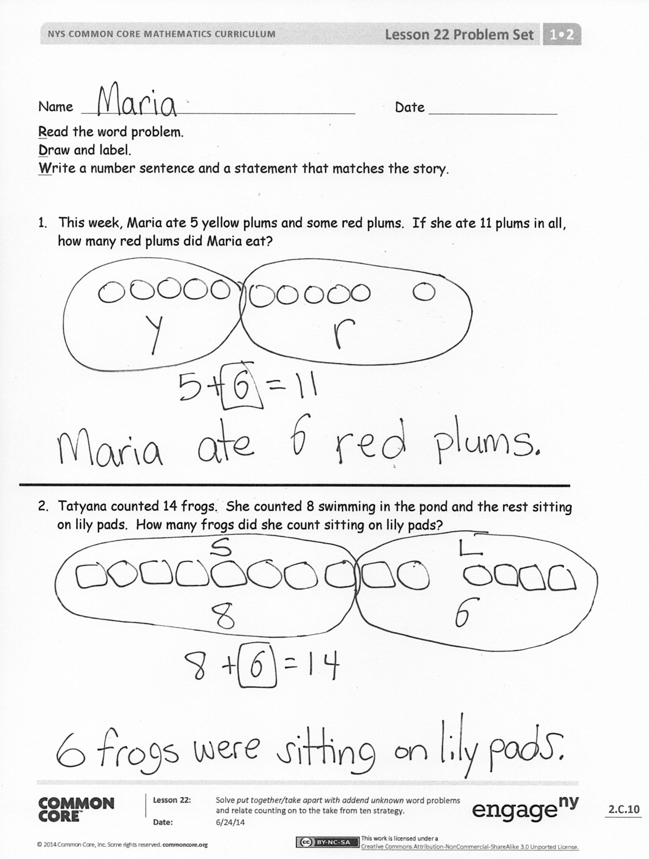
Problem Set (10 minutes)
Students should do their personal best to complete the Problem Set within the allotted 10 minutes. For some classes, it may be appropriate to modify the assignment by specifying which problems they work on first. Some problems do not specify a method for solving. Students should solve these problems using the RDW approach used for Application Problems.
Student Debrief (10 minutes)
Lesson Objective: Solve put together/take apart with addend unknown word problems, and relate counting on to the take from ten strategy.
The Student Debrief is intended to invite reflection and active processing of the total lesson experience.

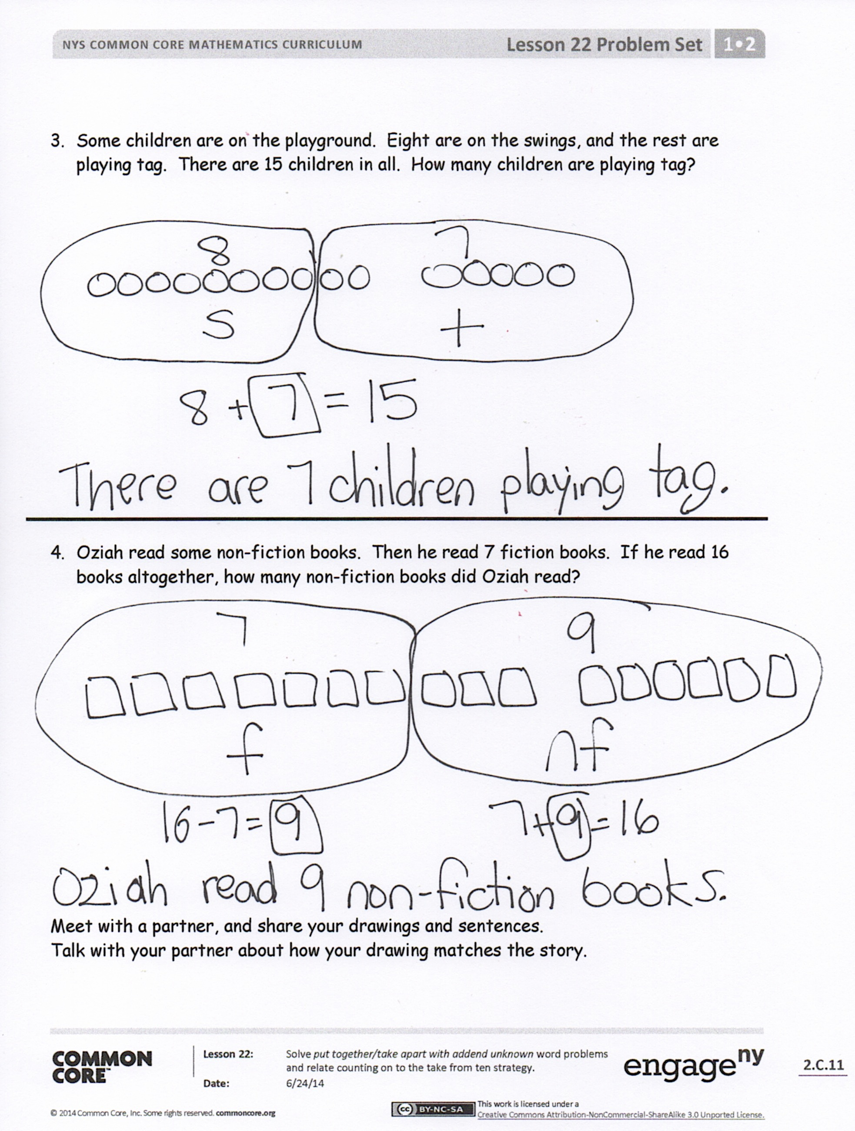
Invite students to review their solutions for the Problem Set. They should check work by comparing answers with a partner before going over answers as a class. Look for misconceptions or misunderstandings that can be addressed in the Debrief. Guide students in a conversation to debrief the Problem Set and process the lesson.
You may choose to use any combination of the questions below to lead the discussion.
- Look at Problems 1 and 2. Did you use the same or different strategy to solve? Explain why you chose to use the strategy (or strategies) you did.
- How did drawing the parts of the story help you solve the story problems?
- What new math strategy did we use today to communicate precisely how we solved the story problem? (RDW.) Explain what it is and how we used it.
Exit Ticket (3 minutes)
After the Student Debrief, instruct students to complete the Exit Ticket. A review of their work will help you assess the students’ understanding of the concepts that were presented in the lesson today and plan more effectively for future lessons. You may read the questions aloud to the students.

Name Date
*Write the missing number.
Number correct:
A
1 | 2 + ☐ = 3 |  | 16 | 2 + ☐ = 8
2 | 1 + ☐ = 3 |  | 17 | 4 + ☐ = 8
3 | ☐ + 1 = 3 |  | 18 | 8 = ☐ + 6
4 | ☐ + 2 = 4 |  | 19 | 8 = 3 + ☐
5 | 3 + ☐ = 4 |  | 20 | ☐ + 3 = 9
6 | 1 + ☐ = 4 |  | 21 | 2 + ☐ = 9
7 | 1 + ☐ = 5 |  | 22 | 9 = ☐ + 1
8 | 4 + ☐ = 5 |  | 23 | 9 = 4 + ☐
9 | 3 + ☐ = 5 |  | 24 | 2 + 2 + ☐ = 9
10 | 3 + ☐ = 6 |  | 25 | 2 + 2 + ☐ = 8
11 | ☐ + 2 = 6 |  | 26 | 3 + ☐ + 3 = 9
12 | 0 + ☐ = 6 |  | 27 | 3 + ☐ + 2 = 9
13 | 1 + ☐ = 7 |  | 28 | 5 + 3 = ☐ + 4
14 | ☐ + 5 = 7 |  | 29 | ☐ + 4 = 1 + 5
15 | ☐ + 4 = 7 |  | 30 | 3 + ☐ = 2 + 6
Name Date
Number correct:
B
*Write the missing number.
1 | 1 + ☐ = 3 |  | 16 | 3 + ☐ = 8
2 | 0 + ☐ = 3 |  | 17 | 2 + ☐ = 8
3 | ☐ + 3 = 3 |  | 18 | 8 = ☐ + 1
4 | ☐ + 2 = 4 |  | 19 | 8 = 4 + ☐
5 | 3 + ☐ = 4 |  | 20 | ☐ + 2 = 9
6 | 4 + ☐ = 4 |  | 21 | 4 + ☐ = 9
7 | 4 + ☐ = 5 |  | 22 | 9 = ☐ + 5
8 | 1 + ☐ = 5 |  | 23 | 9 = 6 + ☐
9 | 2 + ☐ = 5 |  | 24 | 1 + 5 + ☐ = 9
10 | 4 + ☐ = 6 |  | 25 | 3 + 2 + ☐ = 8
11 | ☐ + 2 = 6 |  | 26 | 2 + ☐ + 6 = 9
12 | 3 + ☐ = 6 |  | 27 | 3 + ☐ + 4 = 9
13 | 3 + ☐ = 7 |  | 28 | 5 + 4 = ☐ + 6
14 | ☐ + 4 = 7 |  | 29 | ☐ + 3 = 6 + 2
15 | ☐ + 5 = 7 |  | 30 | 4 + ☐ = 2 + 7

Name Date
Read the word problem.
Draw and label.
Write a number sentence and a statement that matches the story.

- This week, Maria ate 5 yellow plums and some red plums. If she ate 11 plums in all, how many red plums did Maria eat?

- Tatyana counted 14 frogs. She counted 8 swimming in the pond and the rest sitting on lily pads. How many frogs did she count sitting on lily pads?
- Some children are on the playground. Eight are on the swings, and the rest are playing tag. There are 15 children in all. How many children are playing tag?

- Oziah read some non-fiction books. Then, he read 7 fiction books. If he read 16 books altogether, how many non-fiction books did Oziah read?

Meet with a partner, and share your drawings and sentences.
Talk with your partner about how your drawing matches the story.

Name Date
Read the word problem.
Draw and label.
Write a number sentence and a statement that matches the story.
Remember to draw a box around your solution in the number sentence.
- Some students in Mrs. See’s class are walkers. There are 17 students in her class in all. If 8 students ride the bus, how many students are walkers?

- I baked 13 loaves of bread for a party. Some were burnt, so I threw them away. I brought the remaining 8 loaves to the party. How many loaves of bread were burnt?

Name Date
Read the word problem.
Draw and label.
Write a number sentence and a statement that matches the story.
Strategies:
- Take from 10
- Make 10
- Count on
- I just knew
Remember to draw a box around your solution in the number sentence.

- Michael and Anastasia pick 14 flowers for their mom. Michael picks 6 flowers. How many flowers does Anastasia pick?

- Daquan bought 6 toy cars. He also bought some magazines. He bought 15 items in all. How many magazines did Daquan buy?

- Henry and Millie baked 18 cookies. Nine of the cookies were chocolate chip. The rest were oatmeal. How many were oatmeal?

- Felix made 8 birthday invitations with hearts. He made the rest with stars. He made 17 invitations in all. How many invitations had stars?

- Ben and Miguel are having a bowling contest. Ben wins 9 times. They play 17 games in all. There are no tied games. How many times does Miguel win?

- Kenzie went to soccer practice 16 days this month. Only 9 of her practices were on a school day. How many times did she practice on a weekend?

