Lesson 21
Objective: Share and critique peer solution strategies for take from with result unknown and take apart with addend unknown word problems from the teens.

Suggested Lesson Structure
 Fluency Practice (13 minutes)
 Application Problem (5 minutes)
 Concept Development (32 minutes)
 Student Debrief (10 minutes)
Total Time (60 minutes)
Fluency Practice (13 minutes)
- Subtraction with Hide Zero Cards 1.OA.6 (3 minutes)
- Sprint: Subtract 7, 8, 9 1.OA.6 (10 minutes)
Subtraction with Hide Zero Cards (3 minutes)
Materials: (T) Hide Zero cards (Lesson 18 Fluency Template 1)
Note: This fluency activity reviews subtracting 7, 8, and 9 using the Hide Zero cards, which helps prepare students to understand ten as a unit by the module’s end.
T: (Show 15.) Say 15 the Say Ten way.
S: Ten 5.
T: (Break apart the cards to show 10 and 5. Hold up 10.) 10 – 9 = ?
S: 1.
T: (Hold up 5.) 1 + 5 = ?
S: 6.
T: (Put the cards back together to show 15.) So, 15 – 9 = ?
S: 6.
Continue subtracting 9, 8, and then 7, from teen numbers.
Sprint: Subtract 7, 8, 9 (10 minutes)
Materials: (S) Subtract 7, 8, 9 Sprint
Note: Subtracting 7, 8, and 9 from teen numbers allows students to practice the take from ten subtraction strategy.
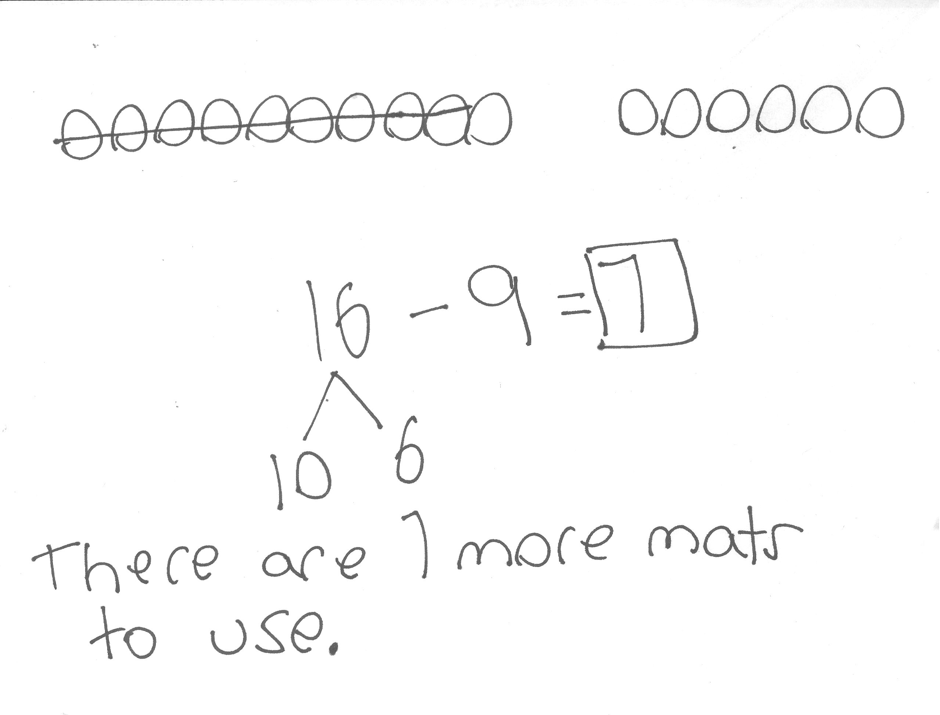
Application Problem (5 minutes)
There are 16 reading mats in the classroom. If 9 reading mats are being used, how many reading mats are still available?
Note: While the Application Problem provides the opportunity to continue exploring subtracting 9 from a teen number, it also directly connects with students’ work during today’s Problem Set. By using the same quantities as the upcoming Problem Set, students have a context for comparing and analyzing other student samples.
Concept Development (32 minutes)
Materials: (T) Student work sample—take from ten strategies (Template) (S) Personal white board
Have students come to the meeting area and sit in a semi-circle.
T: (Project and read.) Colby is reading a book that is 14 pages long. She has already read 8 pages. How many more pages does Colby need to read to finish the book? Turn and talk to your partner about how you would solve this problem.
T: (Project Student A’s sample.) How did Student A solve this problem? Explain to your partner what this student was thinking. What strategy did Student A use?
S: She drew 14 fingers as 10 and 4. She took away 8 fingers from 10 and got 2. She then added 2 and 4 to get 6. She used the take from ten strategy! That’s the right answer!
T: (Label Student A’s work sample Take from Ten Strategy.)
T: Can you think of another good way to make a math drawing?
S: Use a 5-group row drawing. That’s another easy way to see the take from ten strategy.
T: (Project Student B’s sample.) How did Student B solve the problem?
S: He drew a picture, but it’s a little hard to see because the shapes are not organized. He drew 14 circles and took away 8 and circled the left overs. He counted the left overs, 1, 2, 3, 4, 5, 6.
T: (Label Student B’s sample Draw a Picture.)
T: (Project Student C’s sample.) Take a look at Student C’s work. Her answer is 14. Is that correct? Did she do her work correctly? Turn and talk to your partner.
S: No.
T: What do you mean? What did she do wrong here? Well, did she do anything right?
S: She broke apart 14 into 10 and 4. That’s correct. But look at her number sentence. She says 4 – 8 = 4. This is not correct.
T: (Use fingers or the number path to show students her mistake. If she were to take 8 from 4 the answer is less than 0).
S: Her answer is 14. That doesn’t make sense. We started with 14 and took away 8. Her answer has to be 8 less than 14.

NOTES ON
MULTIPLE MEANS
OF ACTION AND EXPRESSION:
Direct students to analyze errors so they understand why they made a mistake. Being able to articulate the mistake helps develop their math comprehension at a deeper level.

T: I love the way you looked at her work so carefully. How can you help her get the correct answer? How would you teach her? What strategy did she try to use? Turn and talk to your partner.
S: I would tell her that you should always check what number you are taking away. In this problem, you have to take away 8. You need to subtract 8 from 10.
T: (Label Student C’s sample work Take from 10.)
Repeat the process and analyze the work samples for Students D and E. Ask students to compare the strategies in these last two samples. Be sure to label the strategy used for each student’s sample work.

T: Except for Student C’s work, do these all show ways to solve the problem correctly? Which way seems like it’s a better shortcut? Turn and talk to your partner.

NOTES ON
MULTIPLE MEANS
OF ENGAGEMENT:
Make sure to validate different accurate and efficient strategies students are using or attempting to use. Be aware that students think in different ways. Encourage and cultivate strategic competence in your classroom by allowing students to explain their thinking. Help them understand their missteps.

S: (Discuss while teacher circulates.)
MP.2
T: (Project and read aloud.) Antalya collected 15 leaves. Nine are yellow. The rest are red. How many leaves are red? Solve this problem by showing your work clearly on your personal white board.

Have student swap boards with their partners and discuss the following:
- Study what strategy your partner used.
- Did you get the same answer?
- Take turns to explain your partner’s strategy.
MP.2
- Are your strategies similar? How? Are they different? How?
- What did your partner do well?
- Was one strategy a better shortcut than the other? Explain.
If time allows, repeat partner work following the suggested sequence: 12 – 7, 18 – 7 (What did you take 7 away from?), and 15 – 9.
Problem Set (10 minutes)
Students should do their personal best to complete the Problem Set within the allotted 10 minutes. For some classes, it may be appropriate to modify the assignment by specifying which problems they work on first. Some problems do not specify a method for solving. Students should solve these problems using the RDW approach used for Application Problems.
Student Debrief (10 minutes)
Lesson Objective: Share and critique peer solution strategies for take from with result unknown and take apart with addend unknown word problems from the teens.
The Student Debrief is intended to invite reflection and active processing of the total lesson experience.
Invite students to review their solutions for the Problem Set. They should check work by comparing answers with a partner before going over answers as a class. Look for misconceptions or misunderstandings that can be addressed in the Debrief. Guide students in a conversation to debrief the Problem Set and process the lesson.
You may choose to use any combination of the questions below to lead the discussion.
- Compare your solution to Problems 2 and 3 with your partner. How is your work similar or different from your partner’s?
- Explain how your partner solved Problem 3.
- Study the ways 16 – 7 was solved. Which solutions seem to be the longest way to solve the problem? Which seem to be the best shortcut?
- (Project Sample C and Problem 1(d).) What have you learned from studying the mistakes from these students’ work?
- Look at your Application Problem with a partner. Did you solve it the same way or a different way? Is your strategy or your partner’s strategy similar to one of the samples in our Problem Set? If so, explain how it is similar. Is your strategy or your partner’s strategy different from all of the samples in the Problem Set? If so, explain your strategy.
Exit Ticket (3 minutes)
After the Student Debrief, instruct students to complete the Exit Ticket. A review of their work will help you assess the students’ understanding of the concepts that were presented in the lesson today and plan more effectively for future lessons. You may read the questions aloud to the students.

Name Date
Number correct:
A
*Write the missing number.
1 | 10 - 9 = ☐ |  | 16 | 12 - 7 = ☐
2 | 11 – 9 = ☐ |  | 17 | 13 - 7 = ☐
3 | 13 - 9 = ☐ |  | 18 | 14 – 7 = ☐
4 | 10 - 8 = ☐ |  | 19 | 15 - 9 = ☐
5 | 11 – 8 = ☐ |  | 20 | 15 - 8 = ☐
6 | 13 - 8 = ☐ |  | 21 | 15 - 7 = ☐
7 | 10 - 7 = ☐ |  | 22 | 17 - 7 = ☐
8 | 11 – 7 = ☐ |  | 23 | 16 - 7 = ☐
9 | 13 - 7 = ☐ |  | 24 | 17 - 7 = ☐
10 | 12 - 9 = ☐ |  | 25 | 16 - ☐ = 9
11 | 13 - 9 = ☐ |  | 26 | 16 - ☐ = 8
12 | 14 - 9 = ☐ |  | 27 | 17 - ☐ = 8
13 | 12 - 8 = ☐ |  | 28 | 17 - ☐ = 9
14 | 13 – 8 = ☐ |  | 29 | 17 - ☐ = 16 - 8
15 | 14 - 8 = ☐ |  | 30 | ☐ - 7 = 17 - 8

Name Date
Number correct:
B
*Write the missing number.
1 | 10 - 9 = ☐ |  | 16 | 11 - 7 = ☐
2 | 11 – 9 = ☐ |  | 17 | 12 - 7 = ☐
3 | 12 - 9 = ☐ |  | 18 | 15 – 7 = ☐
4 | 10 - 8 = ☐ |  | 19 | 15 - 9 = ☐
5 | 11 – 8 = ☐ |  | 20 | 15 - 8 = ☐
6 | 12 - 8 = ☐ |  | 21 | 15 - 7 = ☐
7 | 10 - 7 = ☐ |  | 22 | 15 - 8 = ☐
8 | 11 – 7 = ☐ |  | 23 | 16 - 8 = ☐
9 | 12 - 7 = ☐ |  | 24 | 16 - 7 = ☐
10 | 11 - 9 = ☐ |  | 25 | 16 - ☐ = 9
11 | 12 - 9 = ☐ |  | 26 | 16 - ☐ = 8
12 | 15 - 9 = ☐ |  | 27 | 16 - ☐ = 7
13 | 11 - 8 = ☐ |  | 28 | 16 - ☐ = 9
14 | 12 – 8 = ☐ |  | 29 | 16 - ☐ = 15 - 8

15 | 15 - 8 = ☐ |  | 30 | ☐ - 8 = 15 - 7

Name Date
There were 16 dogs playing at the park. Seven of the dogs went home.
How many of the dogs are still at the park?
- Circle all student work that correctly matches the story.
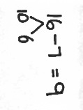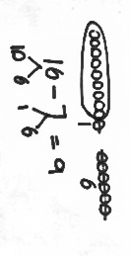a. b. c.
`

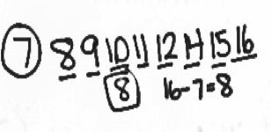
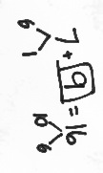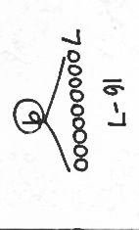d. e. f.

- Fix the work that was incorrect by making a new drawing in the space below with the matching number sentence.
7 + 8 =5

Solve on your own. Show your thinking by drawing or writing.
Write a statement to answer the question.

- There were 12 sugar cookies in the box. My friend and I ate 5 of them. How many cookies are left in the box?

- Megan checked out 17 books from the library. She read 9 of them. How many does she have left to read?

When you are done, share your solutions with a partner. How did your partner solve each problem? Be ready to share how your partner solved the problem.

Name Date
Meg thinks using the take from ten strategy is the best way to solve the following word problem. Bill thinks that solving the problem using the count on strategy is a better way. Solve both ways and explain which strategy you think is best.
Strategies:
- Take from 10
- Make 10
- Count on
- I just knew
Mike and Sally have 6 cats. They have 14 pets in all. How many pets do they have that are not cats?
Meg’s strategy

Bill’s strategy

I think strategy is best because

.

Name Date
Olivia and Jake both solved the word problems.
Write the strategy used under their work.
Check their work. If incorrect, solve correctly.
If solved correctly, solve using a different strategy.
Strategies:
- Take from 10
- Make 10
- Count on
- I just knew

1. A fruit bowl had 13 apples. Mike ate 6 apples from the fruit bowl. How many apples were left?
Olivia’s work Jake’s work

a. Strategy: ______________________ b. Strategy: ____________________

c. Explain your strategy choice below.

2. Drew has 17 baseball cards in a box. He has 8 cards with Red Sox players, and the rest are Yankee players. How many Yankee player cards does Drew have in his box?
Olivia’s work
Jake’s work

- Strategy: _____________________ b. Strategy: ____________________

c. Explain your strategy choice below.

student work samples—take from ten strategies

