Lesson 20
Objective: Subtract 7, 8, and 9 from teen numbers.

Suggested Lesson Structure
 Fluency Practice (18 minutes)
 Application Problems (5 minutes)
 Concept Development (27 minutes)
 Student Debrief (10 minutes)
Total Time (60 minutes)
Fluency Practice (18 minutes)
- Number Path: Get to 10 1.OA.6 (8 minutes)
- Sprint: Subtract 8 1.OA.6 (10 minutes)
Number Path: Get to 10 (8 minutes)
Materials: (T) Subtract 9 flashcards (Lesson 17 Fluency Template), subtract 8 flashcards (Fluency Template) (S) Personal white board, number path 1─20 (Lesson 18 Fluency Template 2)
Note: Using a number path to get to and from 10 reviews Lesson 19, when students were encouraged to relate taking from ten to counting on.
T: (Show the flashcard 15 – 8.)
T: Write 15 ─ 8 as an addition sentence. Use a box for the number we don’t know.
S: (Write 8 + ☐ = 15.)
T: How many spaces do you need to move to land on 10?
S: 2.
T: Hop from 8 to 10. Use your finger if you need help. Were you right?
S: Yes!
T: Now, hop to 15. How many spaces did you move?
S: 5.
T: 2 + 5 = ?
S: 7.
T: So, what is the missing number in your addition sentence?
S: 7.
T: Say the subtraction sentence.
S: 15 – 8 = 7.
Repeat sequence with other flash cards.
Sprint: Subtract 8 (10 minutes)
Materials: (S) Subtract 8 Sprint
Note: This Sprint reviews the take from ten subtraction strategy when the subtrahend is 8.
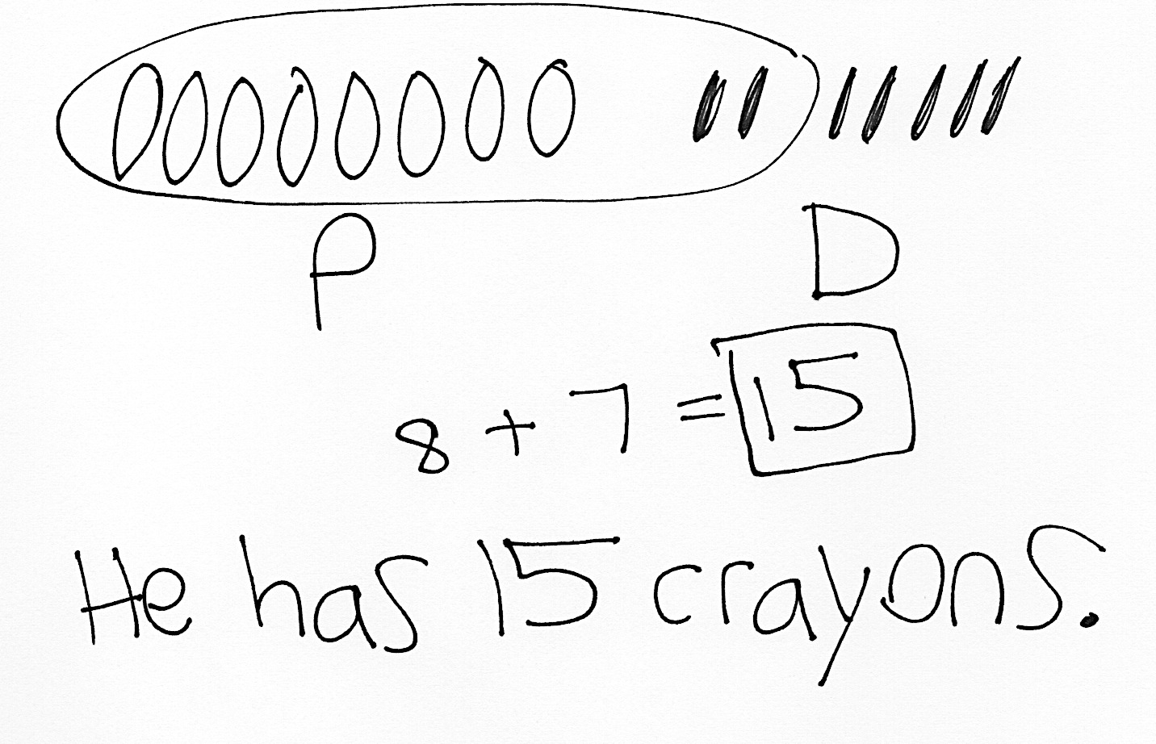
Application Problem (5 minutes)
Imran has 8 crayons in his pencil box and 7 crayons in his desk. How many crayons does Imran have in total?
Note: Because students have been focusing on subtraction, some students may try to subtract 7 from 8 to solve. Look for such misunderstandings that can be addressed through discussion during the Student Debrief or individual support.
Concept Development (27 minutes)
Materials: (S) Personal white board, number path 1–20 (Lesson 18 Fluency Template 2), numeral cards 7–19 and subtraction symbol (Template)
Have students come to the meeting area and sit in a semi-circle with their personal white boards.
T: (Write 13 – 9 = ___.) Solve and share with your partner what you did to get your answer.

NOTES ON
MULTIPLE MEANS
OF ACTION AND EXPRESSION:
To support students who need extra pictorial support, draw a number bond (e.g., 13 decomposed to 10 and 3 circles in 5-group rows) along with the number bond.
S: (Discuss solution and strategies.)
T: Explain what you did to get your answer.
S: We made a 5-group drawing. We used the take from ten strategy using fingers. We made a picture in our minds. We just took away 9 from 10 and did
1 + 3. That’s 4.
T: Everyone, use the number path to show how you can count on to make ten first. Don’t forget to use two arrows to show your thinking.
S: (Solve by starting from 9. Arrows land on 10 and 13.)
T: What addition number sentence helped you to solve 13 – 9?
S: 1 + 3 = 4.
T: How is counting on the number path similar to using our real and imaginary fingers?

S: After we drop 9 fingers, we have 1 more finger left from 10 fingers. We then add 1 to 3 imaginary fingers. This is just like hopping 1 square to get to 10 and 3 more to get to 13. We had to add 1 and 3 both times.
Continue by following the suggested sequence: 13 – 7, 13 – 8, 15 – 9, and 15 – 7. Have Partner A and Partner B alternate between using the number path and their fingers to show their work.
T: (Write 12 – 7 = ___.) Let’s use a number bond to solve 12 – 7. Visualize 5-group rows showing 12. What two parts do you see?
S: 10 and 2.
T: (Make a number bond for 12. Point to – 7.) Where would you take 7 away from?
S: Take 7 away from 10.
T: (Point to 10, then 7 on the board.) Take 7 away in your mind. What is 10 – 7?
S: 3.
T: How many circles are there altogether? What two parts can you picture?
S: There are 5 circles. 2 and 3 make 5.
Continue the process and invite students to solve using a number bond by following the suggested sequence: 11 – 7, 11 – 8, 13 – 9, 12 – 8, 17 – 8, 16 – 7, 19 – 7, and 19 – 8.
T: Now, we are going to play Simple Strategies! (Assign partners based on readiness levels. Instruct each pair to combine their numeral cards and make two piles: digits 11─19 and digits 7─9.) Here’s how you play:
- Partner A picks a card from the teen numbers pile.
- Partners use the 9 card and the subtraction sign to make a subtraction fact. (Put 8 and 7 cards aside for later use.)
- Partner A solves by using any of the strategies from today’s lesson.
- Partner B writes down the addition fact that helped to solve the problem (e.g., for 13 – 9, write 1 + 3).
- Switch roles. Keep the 9 card up each time the partners begin a new expression using a new teen number card.
As students play, the teacher circulates and moves students to working with – 8, then – 7, as appropriate.
Problem Set (10 minutes)
Students should do their personal best to complete the Problem Set within the allotted 10 minutes. For some classes, it may be appropriate to modify the assignment by specifying which problems they work on first. Some problems do not specify a method for solving. Students should solve these problems using the RDW approach used for Application Problems.
Note: Students may use drawings that reflect the strategies they learned from the past few days. For example, they may use 5-group drawings, arrows on a number path, or number bonds.

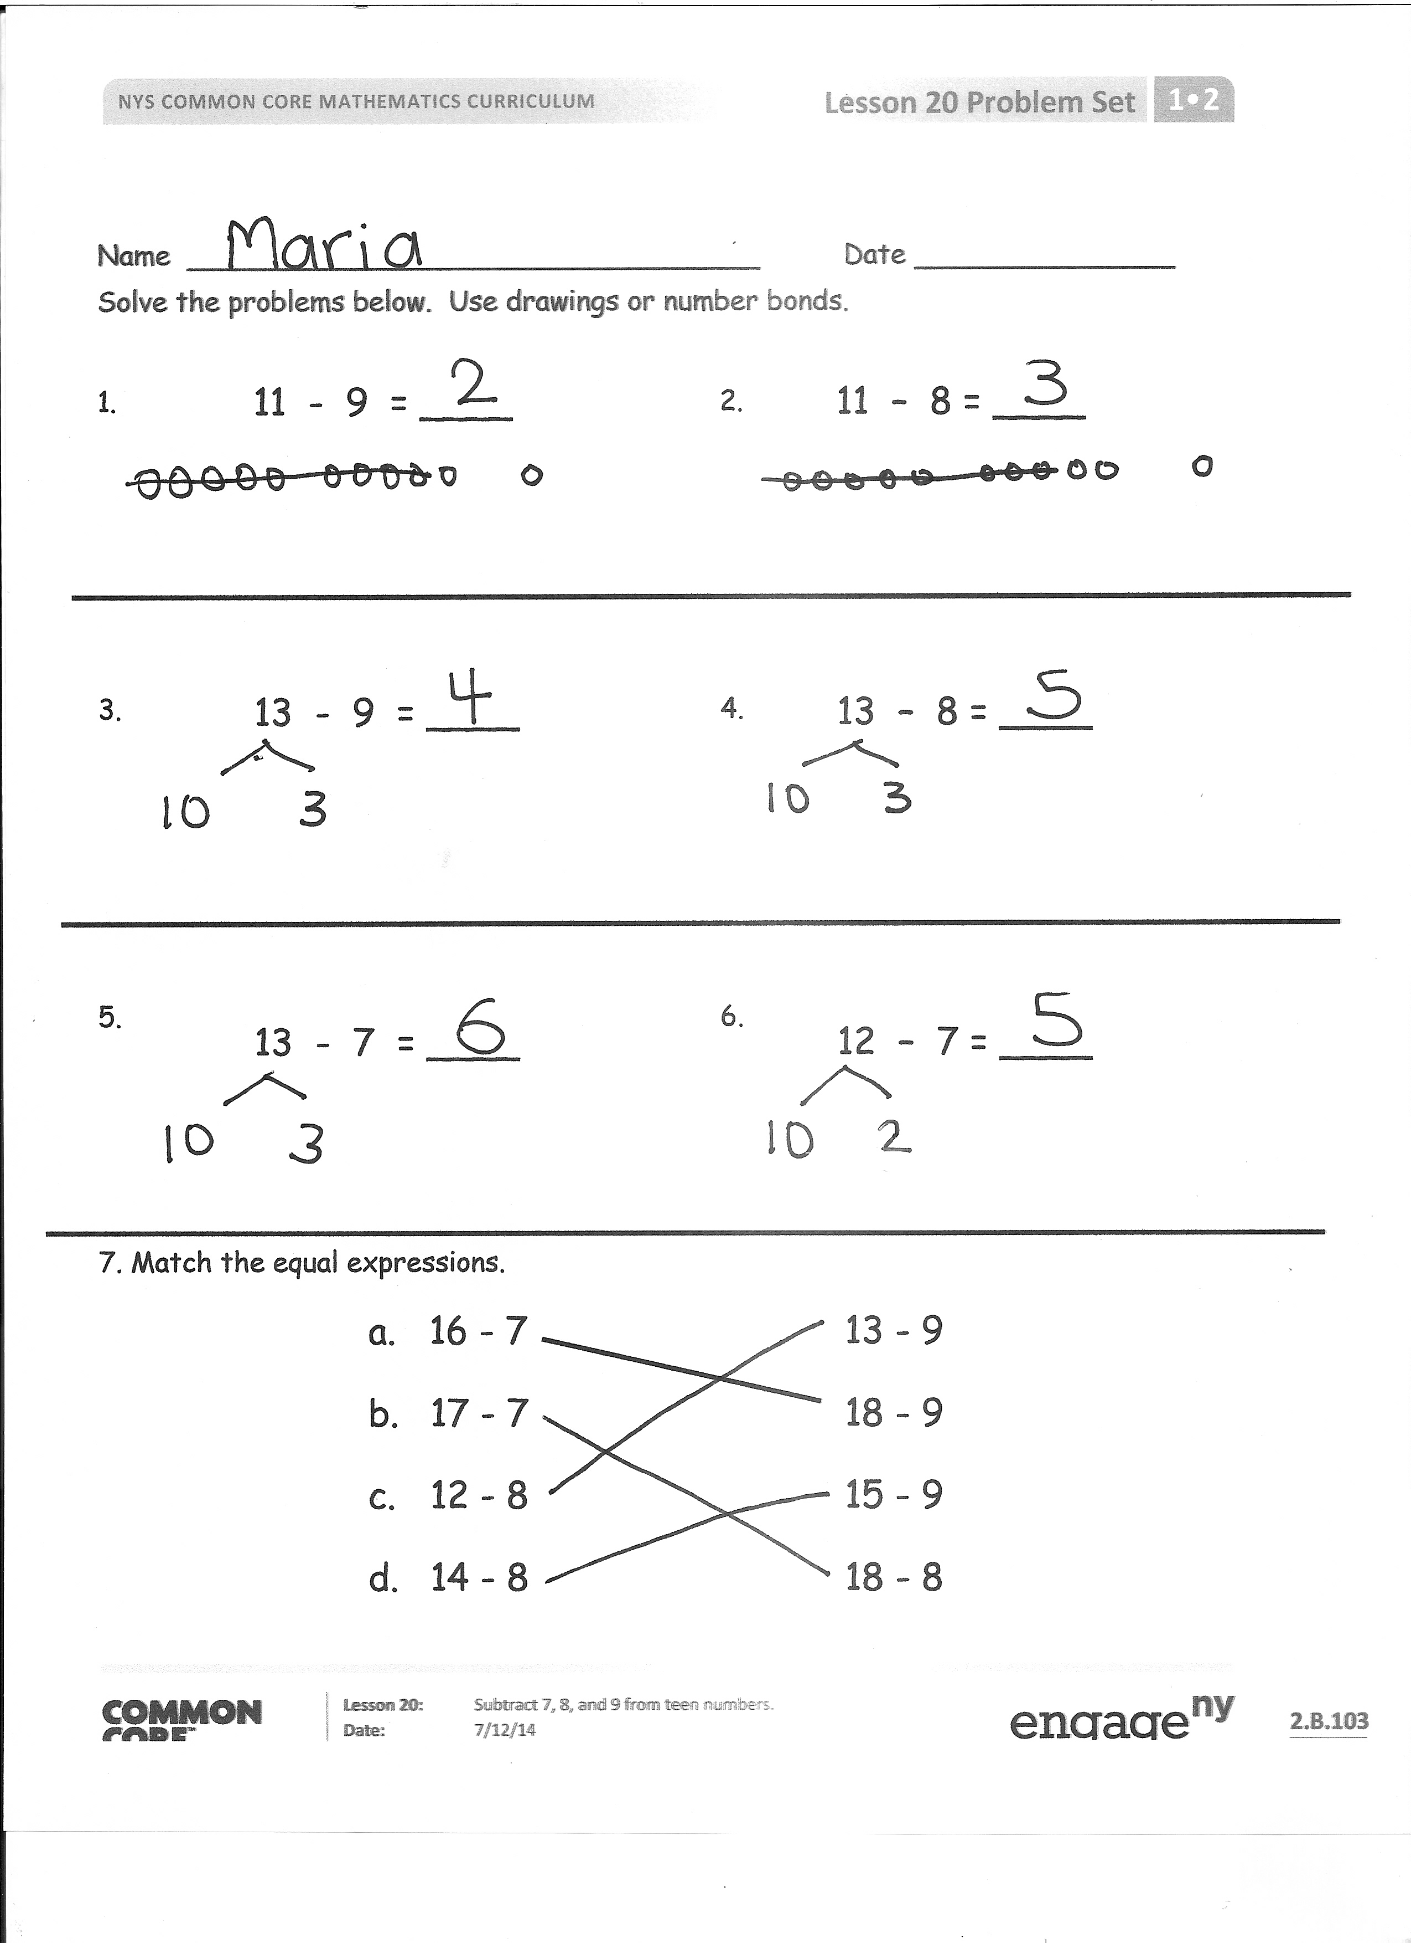
Student Debrief (10 minutes)
Lesson Objective: Subtract 7, 8, and 9 from teen numbers.
The Student Debrief is intended to invite reflection and active processing of the total lesson experience.
Invite students to review their solutions for the Problem Set. They should check work by comparing answers with a partner before going over answers as a class. Look for misconceptions or misunderstandings that can be addressed in the Debrief. Guide students in a conversation to debrief the Problem Set and process the lesson.
You may choose to use any combination of the questions below to lead the discussion.
- Look at your work from Simple Strategies! What did you notice about the addition facts for – 9 problems? – 8 problems? – 7 problems?
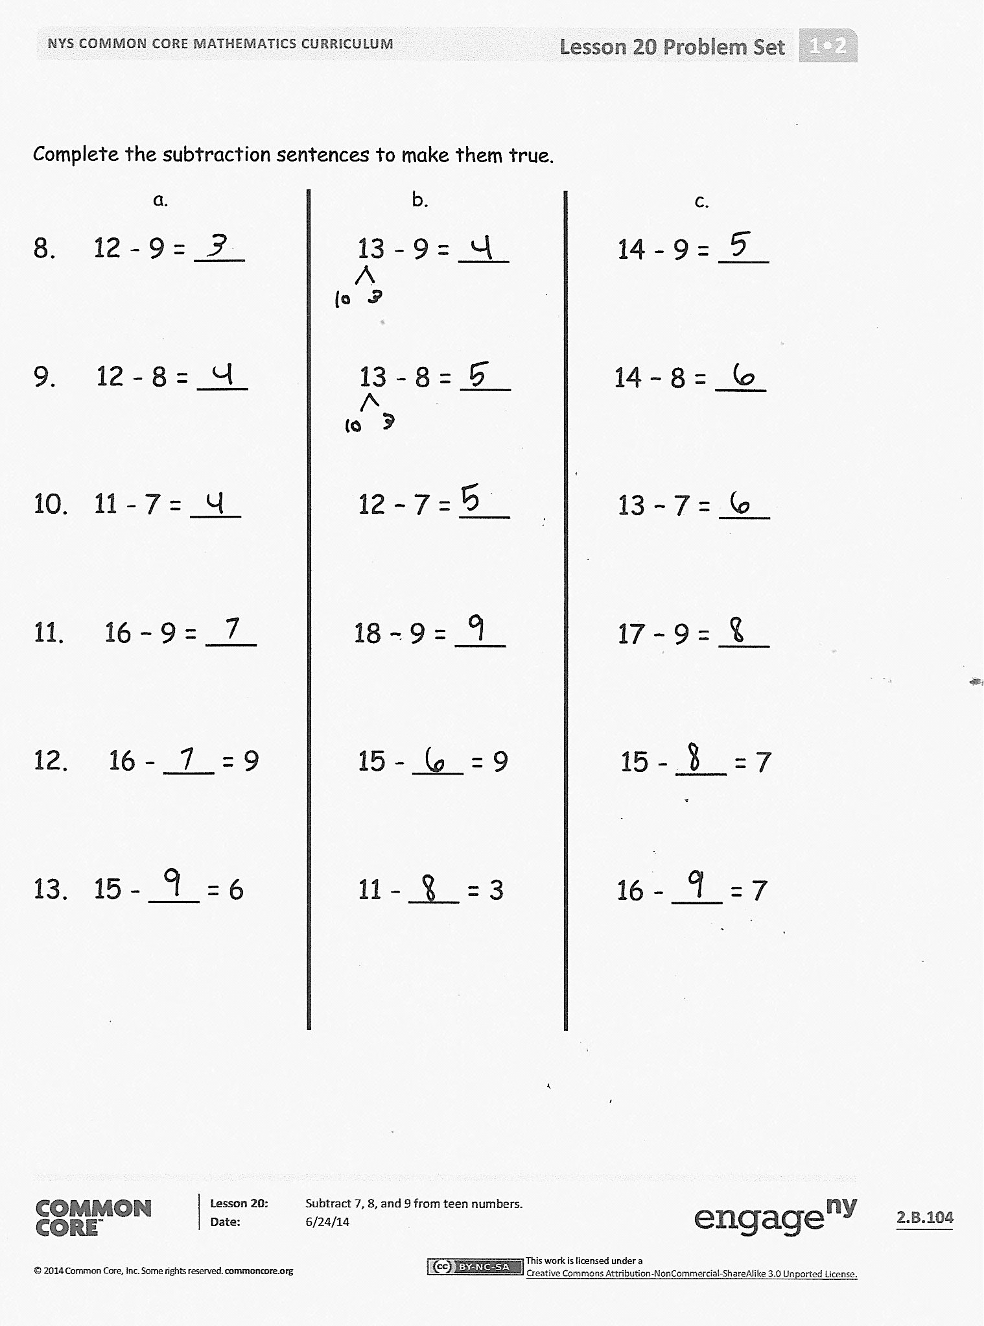
- Look at Problem 8 on your Problem Set. What is happening to the solution as you move from Part (a) to Part (c)? Explain why this is happening.
- Look at Problem 8 and 9. What do you notice? Explain how Problem 8(a) and (b) relate to Problem 9(a) and (b).
- Look at Problems 9 and 10. What do you notice? Explain how the rows are related. If there were a Column (d) here, what might the number sentences be?
- Look at Problem 12. What did you do to solve these? Explain your thinking.
- How could knowing Problem 11(a) help you solve Problem 11(b)?
- Share your Application Problem with a partner. How did you solve it?

Exit Ticket (3 minutes)
After the Student Debrief, instruct students to complete the Exit Ticket. A review of their work will help you assess the students’ understanding of the concepts that were presented in the lesson today and plan more effectively for future lessons. You may read the questions aloud to the students.

Name Date
Number correct:
A
*Write the missing number. Pay attention to the addition or subtraction sign.
1 | 10 - 8 = ☐ |  | 16 | 10 - 8 = ☐
2 | 2 + 2 = ☐ |  | 17 | 11 - 8 = ☐
3 | 10 - 8 = ☐ |  | 18 | 12 – 8 = ☐
4 | 2 + 3 = ☐ |  | 19 | 15 - 8 = ☐
5 | 10 - 8 = ☐ |  | 20 | 14 - 8 = ☐
6 | 2 + 4 = ☐ |  | 21 | 13 - 8 = ☐
7 | 10 - 8 = ☐ |  | 22 | 17 - 8 = ☐
8 | 2 + 1 = ☐ |  | 23 | 18 - 8 = ☐
9 | 11 - 8 = ☐ |  | 24 | 8 + ☐ = 11
10 | 10 - 8 = ☐ |  | 25 | 8 + ☐ = 12
11 | 2 + 2 = ☐ |  | 26 | 8 + ☐ = 15
12 | 12 - 8 = ☐ |  | 27 | 8 + ☐ = 14
13 | 10 - 8 = ☐ |  | 28 | 8 + ☐ = 16
14 | 2 + 5 = ☐ |  | 29 | 8 + ☐ = 17
15 | 15 - 8 = ☐ |  | 30 | 8 + ☐ = 18
Name Date
Number correct:
B
*Write the missing number. Pay attention to the addition or subtraction sign.
1 | 10 - 8 = ☐ |  | 16 | 10 - 8 = ☐
2 | 2 + 1 = ☐ |  | 17 | 11 - 8 = ☐
3 | 10 - 8 = ☐ |  | 18 | 13 – 8 = ☐
4 | 2 + 2 = ☐ |  | 19 | 14 - 8 = ☐
5 | 10 - 8 = ☐ |  | 20 | 13 - 8 = ☐
6 | 2 + 3 = ☐ |  | 21 | 12 - 8 = ☐
7 | 10 - 8 = ☐ |  | 22 | 15 - 8 = ☐
8 | 2 + 2 = ☐ |  | 23 | 16 - 8 = ☐
9 | 12 - 8 = ☐ |  | 24 | 8 + ☐ = 10
10 | 10 - 8 = ☐ |  | 25 | 8 + ☐ = 11
11 | 2 + 3 = ☐ |  | 26 | 8 + ☐ = 13
12 | 13 - 8 = ☐ |  | 27 | 8 + ☐ = 12
13 | 10 - 8 = ☐ |  | 28 | 8 + ☐ = 13
14 | 2 + 2 = ☐ |  | 29 | 8 + ☐ = 15
15 | 12 - 8 = ☐ |  | 30 | 8 + ☐ = 16

Name Date
Solve the problems below. Use drawings or number bonds.
11 – 8 = ____
11 - 9 = ____
1. 2.

13 – 8 = ____

13 - 9 = ____
3. 4.

5. 6.
12 – 7 = ____

13 - 7 = ____

7. Match the equal expressions.
- 16 - 7 13 - 9
- 17 - 7 18 - 9
- 12 - 8 15 - 9
- 14 - 8 18 - 8

Complete the subtraction sentences to make them true.
a. b. c.
8. 12 - 9 = ___ 13 - 9 = ___ 14 - 9 = ___
9. 12 - 8 = ___ 13 - 8 = ___ 14 – 8 = ___
10. 11 - 7 = ___ 12 – 7 = ___ 13 – 7 = ___
11. 16 – 9 = ___ 18 – 9 = ___ 17 – 9 = ___
12. 16 - ___ = 9 15 - ___ = 9 15 - ___ = 7
13. 15 - ___ = 6 11 - ___ = 3 16 - ___ = 7

Name Date
1. Solve the problems below. Use drawings or number bonds.
14 – 8 = ____
14 – 7 = ____
14 - 9 = ____
a. b. c.

16 – 8 = ____
16 – 9 = ____
16 – 7 = ____
d. e. f.

Name Date
Complete the number sentences to make them true.

1. 15 – 9 = ____ 2. 15 – 8 = ____ 3. 15 – 7 = ____

4. 17 – 9 = ____ 5. 17 – 8 = ____ 6. 17 – 7 = ____

7. 16 – 9 = ____ 8. 16 – 8 = ____ 9. 16 – 7 = ____

10. 19 – 9 = ____ 11. 19 – 8 = ____ 12. 19 – 7 = ____

- Match equal expressions.
a. 19 – 9 12 - 7
b. 13 – 8 18 – 8
- Read the math story. Use a drawing or a number bond to show how you know who is right.
- Elsie says that the expressions 17 – 8 and 18 – 9 are equal. John says they are not equal. Who is right?

- John says that the expressions 11 – 8 and 12 – 8 are not equal. Elsie says they are. Who is right?

- Elsie says that to solve 17 – 9, I can take one from 17 and give it to 9 to make 10. So, 17 – 9 is equal to 16 – 10. John thinks Elsie made a mistake. Who is correct?

- John and Elsie are trying to find several subtraction number sentences that start with numbers larger than 10 and have an answer of 7. Help them figure out number sentences. They started the first one.

16 – 9 = ____

10 - 8 = | 11 - 8 =
12 - 8 = | 13 - 8 =
14 - 8 = | 15 - 8 =
16 - 8 = | 17 - 8 =
18 - 8 =
_________________________
numeral cards 7─19 and subtraction symbol
7 | 8 | 9 | 10
11 | 12 | 13 | 14
15 | 16 | 17 | 18
19 | -

numeral cards 7─19 and subtraction symbol

