Lesson 19
Objective: Compare efficiency of counting on and taking from ten.

Suggested Lesson Structure
 Fluency Practice (12 minutes)
 Application Problem (8 minutes)
 Concept Development (30 minutes)
 Student Debrief (10 minutes)
Total Time (60 minutes)
Fluency Practice (12 minutes)
- Subtract 9 and 8 and Relate to Addition 1.OA.6 (6 minutes)
- Say Ten Counting 1.NBT.5 (4 minutes)
- Get to 10 1.OA.6 (2 minutes)
Subtract 9 and 8 and Relate to Addition (6 minutes)
Materials: (S) Personal white board, 5-group row insert (Lesson 12 Fluency Template 2)
Note: When reviewing the take from ten subtraction strategy, remember that the goal is for students to eventually be able to solve these problems mentally. Therefore, for the first two problems, have students cross off the circles. Then, challenge those who are ready to imagine subtracting the circles to solve with their eyes closed.
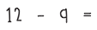
T: Draw more circles to show 12.
T: Say 12 as a number bond, with 10 as a part.
S: 10 and 2 make 12.
T: Turn your circles into a number bond.
S/T: (Draw lines to make a number bond with the numeral 12 on top.)
T: Show me 12 – 9. Think about whether you should subtract from the part with ten or the part with two.
S/T: (Write – 9 after 12, and cross out 9.)
T: Below your circles, write an addition sentence to show what is left.
S: (Write 1 + 2 = 3.)
T: What is 12 – 9?
S: 3.
T: Say 12 – 9 = 3 as a related addition sentence. (Call on a student.)
S: 9 + 3 = 12.
Continue with other numbers between 11 and 20, alternating between subtracting 9 and subtracting 8. As soon as possible, reduce steps (e.g., show me 11 ─ 8).
Say Ten Counting (4 minutes)
Materials: (S) Personal white board
Note: Say Ten counting strengthens understanding of place value. It is used throughout Grade 1 Fluency Practice, beginning in Module 1, Lesson 4. A description of Say Ten counting, as shared with children in Kindergarten, can be found in GK–M5–Lesson 4.
Practice Say Ten counting from 0 to 40 and back. Count for two minutes. Then, have students see how many numbers they can write from 10 to 40 in two minutes.
Get to 10 (2 minutes)
Materials: (T) 20-bead Rekenrek
Note: Practice with getting to 10 from single-digit and teen numbers prepares students for today’s lesson as they are encouraged to count on or back strategically, stopping at 10 and continuing to the desired number.
T: (Show 8 on the Rekenrek.) What number do you see?
S: 8.
T: How can I get to 10?
S: Add 2.
T: (Move 2 beads to make ten.) Good.
T: (Show 12.) What number do you see?
S: 12.
Continue with other numbers within 20.
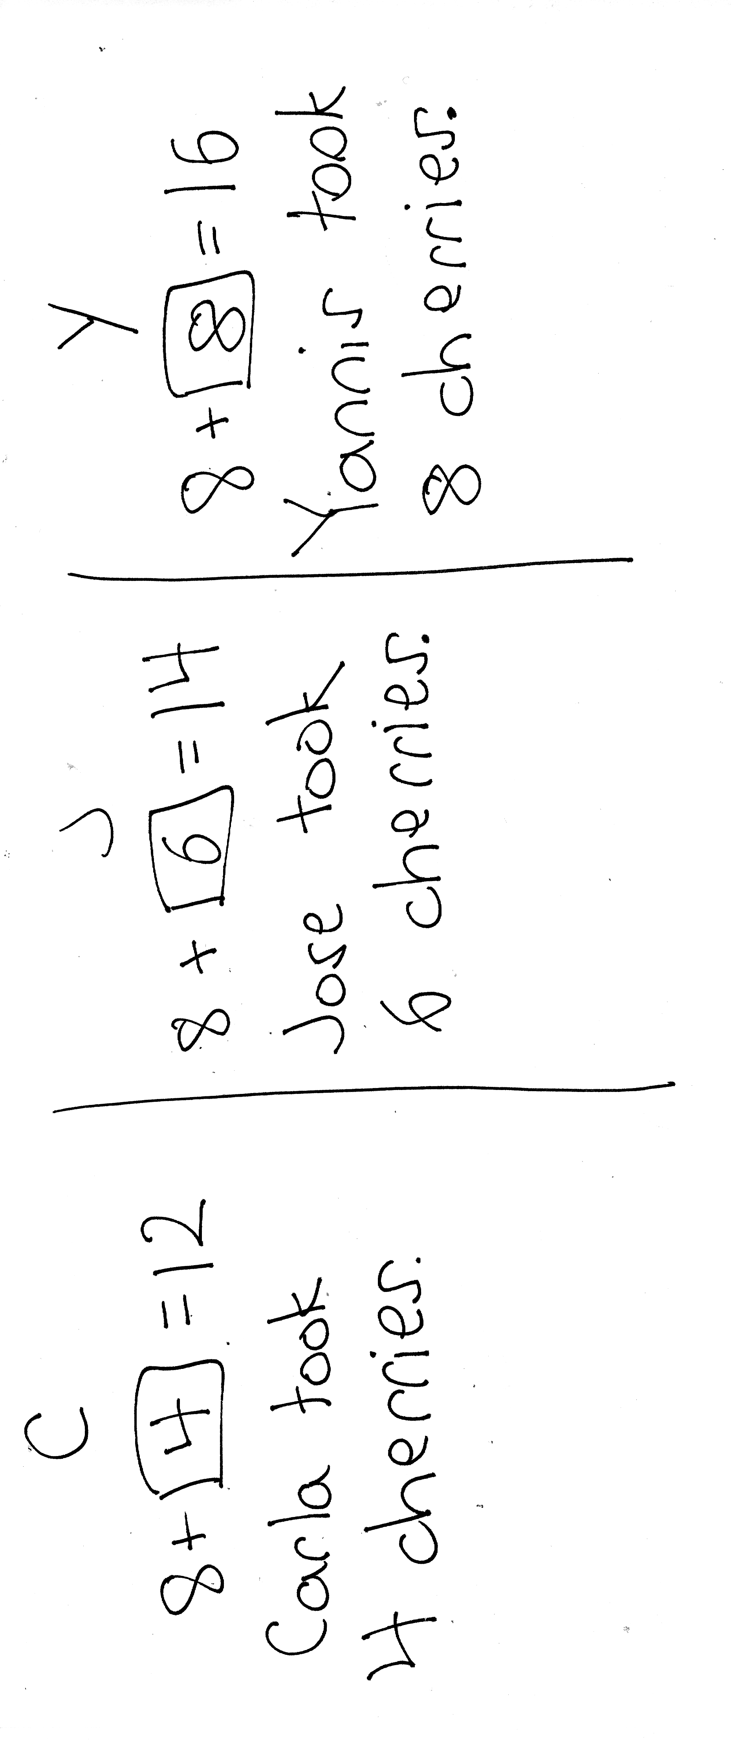
Application Problem (8 minutes)
Carla, Jose, and Yannis each have 8 cherries. They all get more cherries to put in their bowls. Now, Carla has 12 cherries, Jose has 14 cherries, and Yannis has 16 cherries. How many more cherries did each child put in his or her bowl? Write a number sentence for each answer.
Note: This Application Problem enables students to consider three different missing addends all starting from 8. Consider adjusting the story to include only Carla or only Carla and Jose, depending on student need. During the Debrief, students connect their solutions to one child’s quantity of cherries as a possible stepping stone for solving the other children’s quantity of cherries.
Concept Development (30 minutes)
Materials: (T) Number path 1─20 (Lesson 18 Fluency Template 2) (S) Personal white board, number path 1─20 (Lesson 18 Fluency Template 2)
Have students come to the meeting area and sit in a semi-circle with their materials.
T: (Write 13 – 8 = ___.) Let’s count on by tracking on our fingers to solve 13 – 8.
S: Eiiight, 9, 10, 11, 12, 13. (Put up a finger for each number starting with 9.)
T: What is 13 – 8?
S: 5.
T: Let’s count on using a more efficient strategy. You are an expert at making ten, so let’s count on from 8 to 13, this time by making ten. Show me 8 fingers.
S: (Extend 8 fingers.)
T: How many fingers do we need to pop up to make ten? Show me.
S: 2. (Extend the rest of the fingers.)
T: We need to now imagine more fingers popping up. How many more imaginary fingers do we need to get to 13?
S: 3.
T: How many more fingers, real and imaginary, did we need to get from 8 to 13?
S: 5.
T: Let’s use the number path to show what we did with our fingers.

T: (Project number path.) Let’s see what counting up by making ten looks like on the number path. How many do we need to get from 8 to 10?
S: 2.
T: I can just jump 2 squares to get to 10 from 8. (Draw a curved arrow from 8 to 10, and write +2.)
T: I need to get to 13. What is 13 the Say Ten way?
S: Ten 3.
T: How many do we need to get from 10 to 13?
S: 3.
T: I don’t need to count on tennnn, 11, 12, 13. I can just jump 3 squares to get to 13 from 10. (Draw a curved arrow from 10 to 13, and write + 3.)
T: How many squares did we jump in all from 8 to 13? How many do we need to get from 8 to 13?

NOTES ON
MULTIPLE MEANS
OF REPRESENTATION:
Teachers feel a sense of pride as their students use strategies to make math easy. It is exciting when students are able to explain how they are thinking and relate counting on to make ten and take from ten. Use these students to show others who may want or need some extra help.
S: 5.
T: How did you know so quickly?
S: 2 and 3 is 5. 2 + 3 = 5.
T: Great job counting on to make ten first.
T: Let’s check this work using the take from ten strategy using our fingers and a number bond. Put up 13 fingers. How many real and imaginary fingers are up?
MP.4
S: 10 fingers and 3 imaginary ones.
T: (Write the number bond for 13.) Subtract 8 fingers all at once.
S: (Show 2 fingers.)
T: Where did you take away the 8 from?
S: From the 10 fingers.
T: What is 10 – 8? (Point to 10 in the number bond and 8 in the expression.)
S: 2.
T: How many more imaginary fingers do you have?
S: 3.
T: (Point to 3 in the number bond.) What is 2 and 3?
S: 5.
T: So, what is 13 – 8? Say the number sentence.
S: 13 – 8 = 5.
Repeat the process using the number path and the take from ten strategy following the suggested sequence: 11 – 8, 14 – 8, 15 – 8, 12 – 8, 17 – 8, and 16 – 8. When it seems appropriate, encourage students to imagine using their fingers and move towards using only the number bond to solve. This is an opportunity for partner work. After a few modeled problems, allow students to work in partnerships with Partner A solving and Partner B checking, then changing roles.

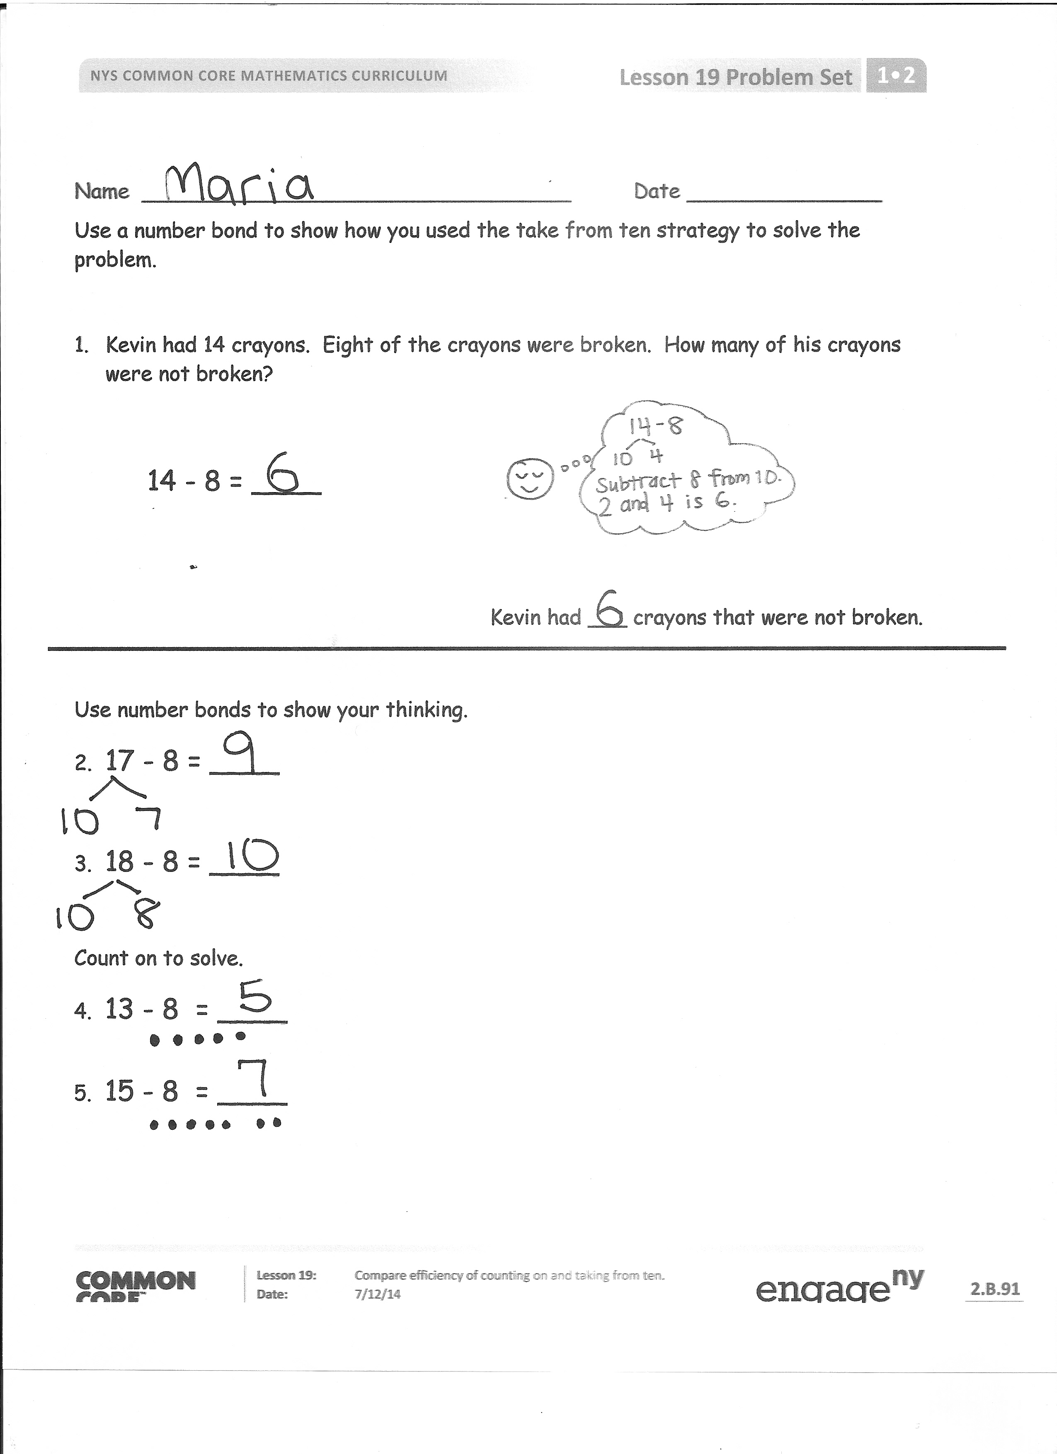
Problem Set (10 minutes)
Note: If needed, allow students to use their personal white boards with the number path insert to help them complete the Problem Set.
Students should do their personal best to complete the Problem Set within the allotted 10 minutes. For some classes, it may be appropriate to modify the assignment by specifying which problems they work on first. Some problems do not specify a method for solving. Students should solve these problems using the RDW approach used for Application Problems.
Student Debrief (10 minutes)
Lesson Objective: Compare efficiency of counting on and taking from ten.
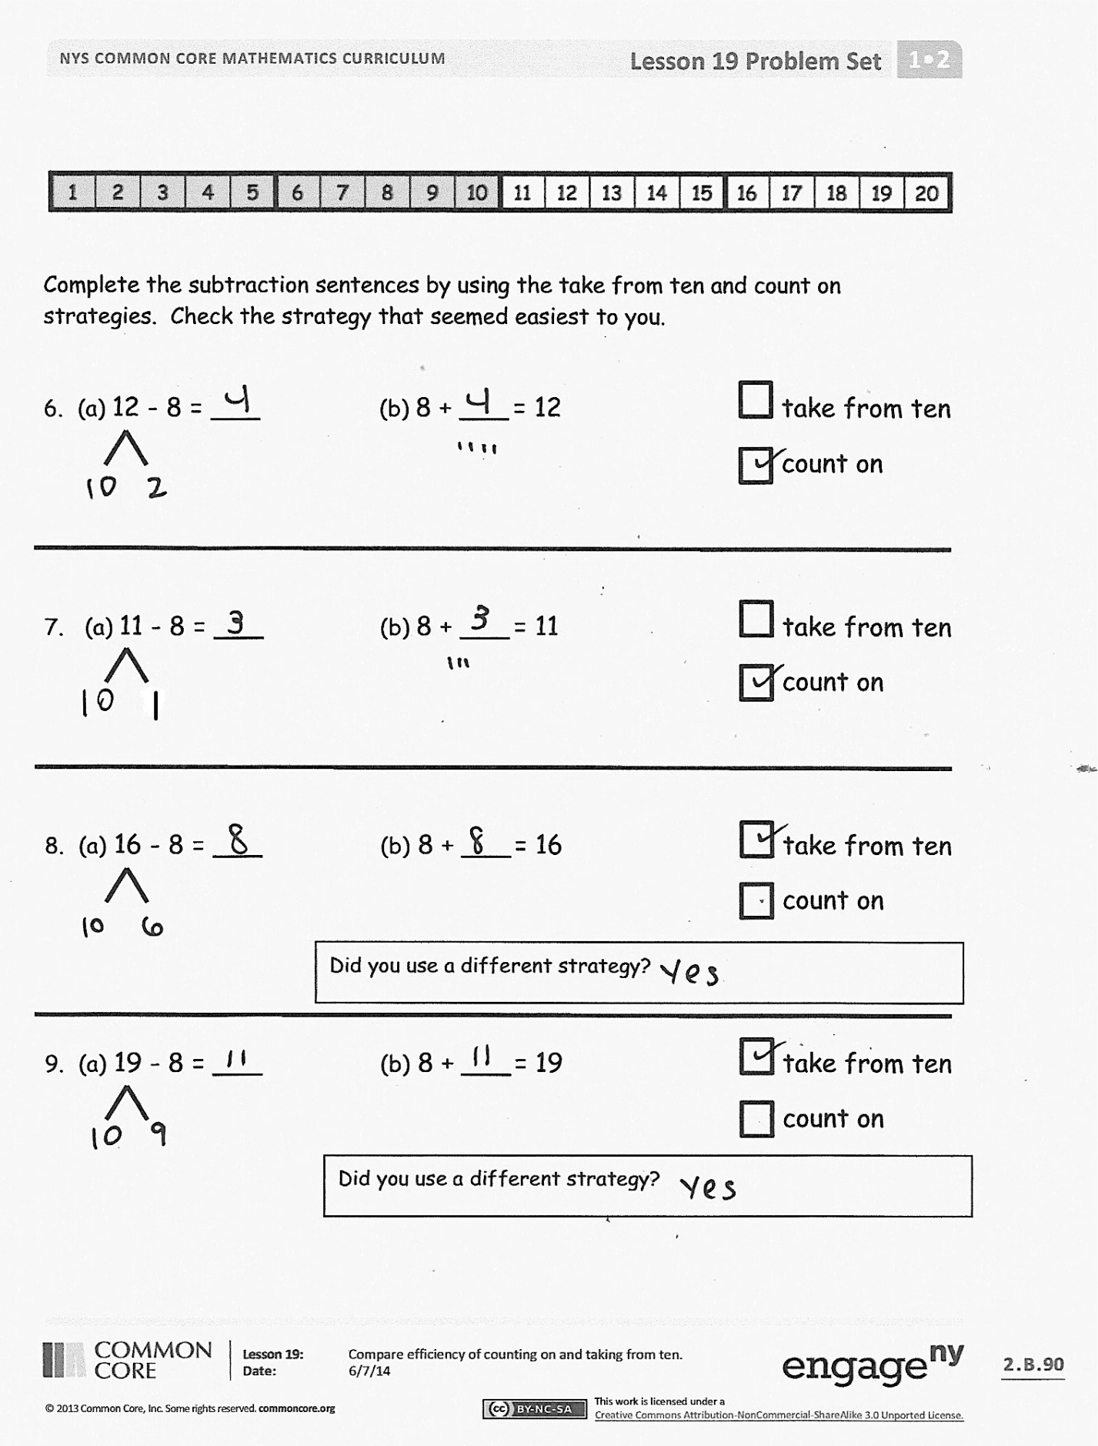
The Student Debrief is intended to invite reflection and active processing of the total lesson experience.
Invite students to review their solutions for the Problem Set. They should check work by comparing answers with a partner before going over answers as a class. Look for misconceptions or misunderstandings that can be addressed in the Debrief. Guide students in a conversation to debrief the Problem Set and process the lesson.
You may choose to use any combination of the questions below to lead the discussion.
- Look at Problems 6 through 9. Which strategy do you prefer, counting on or the take from ten strategy? (It is important to emphasize that they are both good shortcuts rather than discussing which strategy is more efficient.) Why?
- How are these two strategies, counting on to make ten and take from ten, similar to each other? Use 15 – 8 and turn and talk to your partner. (For both of them, we do 2 + 5. For counting on, we are adding 2 to 8 to get to 10 and then adding 5 to get to 15. In the take from ten strategy, you take 8 from 10 and get 2. You add 2 to 5 that’s still left and get 7.)
- Explain to your partner how counting on to make ten is related to taking from ten.
- What new math tool did we use today to show counting on to make ten? (Using the number path to count on by using 2 hops to get to 10 and then adding the hops used to get to the teen number.)
- Look at the Application Problem. How did you solve it? How could we use today’s strategies to solve the problem? How could knowing how many cherries Carla took help you solve how many cherries the other children took?
Exit Ticket (3 minutes)
After the Student Debrief, instruct students to complete the Exit Ticket. A review of their work will help you assess the students’ understanding of the concepts that were presented in the lesson today and plan more effectively for future lessons. You may read the questions aloud to the students.

Name Date
Use a number bond to show how you used the take from ten strategy to solve the problem.

- Kevin had 14 crayons. Eight of the crayons were broken. How many of his crayons were not broken?

14 - 8 = ____
Kevin had ___ crayons that were not broken.

Use number bonds to show your thinking.
- 17 - 8 = ____

- 18 - 8 = ____

Count on to solve.
- 13 - 8 = ____

- 15 - 8 = ____

Complete the subtraction sentences by using the take from ten and count on strategies. Check the strategy that seemed easiest to you.

- a. 12 - 8 = ___ b. 8 + ___ = 12 take from ten
count on
- a. 11 - 8 = ___ b. 8 + ___ = 11 take from ten
count on
- a. 16 - 8 = ___ b. 8 + ___ = 16 take from ten
count on
Did you use a different strategy?

- a. 19 - 8 = ___ b. 8 + ___ = 19 take from ten
count on
Did you use a different strategy?

Name Date
Complete the subtraction sentences by using the take from ten strategy and count on.

- a. 11 - 8 = ___ b. 8 + ___ = 11

- a. 15 - 8 = ___ b. 8 + ___ = 15

Name Date
Complete the subtraction sentences by using the take from ten strategy and count on.

- a. 12 - 8 = ___ b. 8 + ___ = 12

- a. 15 - 8 = ___ b. 8 + ___ = 15

Choose the count on strategy or the take from ten strategy to solve.
- 11 - 8 = ___

- 17 - 8 = ___

Use a number bond to show how you solved using the take from ten strategy.
- Elise counted 16 worms on the pavement. Eight worms crawled into the dirt. How many worms did Elise still see on the pavement?
16 - 8 = ____

Elise still saw ____ worms on the pavement.

- John ate 8 orange slices. If he started with 13, how many orange slices does he have left?
John has ____ orange slices left.

- Match the addition number sentence to the subtraction number sentence. Fill in the missing numbers.
8 + _____ = 11
- 12 – 8 = _____
8 + _____ = 18
- 15 – 8 = _____

- 18 - 8 = _____
8 + _____ = 12

- 11 – 8 =_____
8 + _____ = 15

