Lesson 18
Objective: Model subtraction of 8 from teen numbers.

Suggested Lesson Structure
 Fluency Practice (12 minutes)
 Application Problem (5 minutes)
 Concept Development (33 minutes)
 Student Debrief (10 minutes)
Total Time (60 minutes)
Fluency Practice (12 minutes)
- Cold Call: Subtract 9 1.OA.6 (4 minutes)
- Hide Zero Number Sentences 1.NBT.2 (2 minutes)
- Number Path 1.OA.6 (6 minutes)
Cold Call: Subtract 9 (4 minutes)
Materials: (T) Subtract 9 flashcards (Lesson 17 Fluency Template)
Note: This fluency activity reviews the take from ten subtraction strategy when the subtrahend is 9.
Show a subtract 9 flashcard (e.g., 12 – 9). Play Cold Call, where you flash a card and then call on a student or group of students to answer. Students do not raise their hands to be chosen. If students continue to need help subtracting 9, use the following vignette.
T: Say 12 the Say Ten way.
S: Ten 2.
T: 10 – 9 is…?
S: 1.
T: 1 + 2 is…? (Point to the 2.)
S: 3.
T: So, 12 – 9 is?
S: 3.

Hide Zero Number Sentences (2 minutes)
Materials: (S) Hide Zero cards (Fluency Template 1)
Note: This fluency activity strengthens the understanding of place value and prepares students to understand ten as a unit by the module’s end.
Show students numbers from 10 to 19 with Hide Zero cards (e.g., 15). Students say an addition sentence with 10 as an addend (e.g., 10 + 5 = 15). As students say the sentence, break apart the Hide Zero cards to model the equation. Students can also say the numbers the Say Ten way and the regular way.
Number Path (6 minutes)
Materials: (T/S) Personal white board, number path 1–20 (Fluency Template 2), counter
Note: Using a number path to get to and from 10 prepares students to relate counting on and taking from ten in Lesson 19.
T: Put your counter on 8.
S: (Place counter on 8.)
T: How many spaces do you need to move to land on 10? (Pause to provide thinking time.)
S: 2.
T: Let’s check. Move your counter to 10.
S (Move counter to 10.)
T: Were you right?
S: Yes!
T: Write an equation to show what you did.
S: (Write 8 + 2 = 10.)
Continue moving to and from 10 within 10. Next, start at 10 and move counters to and from teen numbers. Ask questions about how students determined the number of spaces they moved. Did they count each space, or did they “just know”?
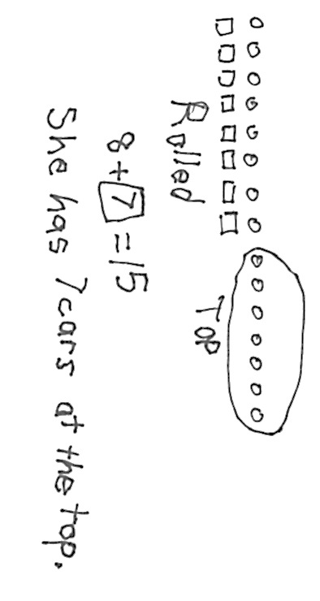
Application Problem (5 minutes)
Juliana rolls 8 cars down a ramp. If she started with 15 cars at the top of the ramp, how many cars does Juliana still have at the top of the ramp?
Note: This Application Problem provides another context for students to subtract 8 from a teen number. While it is still a take from with result unknown problem type, the problem is somewhat more complex based on the order of the sentences within the story. In this story, the quantity being subtracted is given first.
Concept Development (33 minutes)
Materials: (S) Personal white board
Have students gather in the meeting area with their personal white boards.
T: (Project 15 – 8 = ___.) Show me 15 fingers. How many imaginary fingers are up?
S: (Show 10 fingers.) 5.
T: Take away 8 all at once. How many fingers, real and imaginary, are there now?
S: 7.
T: What addition sentence helped you solve 15 – 8?
S: 2 + 5 = 7.
T: Let’s use 5-group drawings to show how we used our fingers. How did we show 15 with our fingers?
S: We used 10 real fingers and 5 imaginary fingers.
T: (Decompose 15 by drawing a 5-group row on the board. Leave extra space between the first 10 circles and the last 5 circles.)
T: (Draw a frame around 10 circles.) This is so everyone can see 10 and 5 more easily, just like how we’ve framed 10 objects together in the past.
T: How did you take away 8 all at once using your fingers? How can we show that in our drawing?
S: We took down 8 real fingers, so cross off 8 from the ten. We can just hide 8 circles from the ten.
T: If we cross off or hide 8 circles from 10, how many circles would that leave us in the frame?
S: 2.

NOTES ON
MULTIPLE MEANS
OF ENGAGEMENT:
Having students work in partners frequently develops their cooperative learning skills. Some students have trouble working together with a partner while others shine through as leaders. Be sure to talk about how to work well in a team if you see any problems develop.
T: Great. (Hide 8 circles.) How many circles do you see now?
MP.4
S: 7.
T: What addition sentence do you see in your picture?
S: 2 + 5 = 7.
Repeat the process above with the following sequence: 11 – 8, 16 – 8, 13 – 8, 17 – 8, 12 – 8, 14 – 8, 18 – 8, and 19 – 8. Invite students to draw 5-group rows on their personal white boards. After solving a few problems using both strategies as a whole class, have students work with their partners. Alternate having Student A solve the problem using real and imaginary fingers while Student B shows her work with 5-group row drawings.
When it seems appropriate, ask students to close their eyes to see if they can visualize what is happening when they subtract 8, encouraging them to move away from using their fingers or drawings and work instead towards using mental math. Encourage students to share what they are picturing in their minds as they are solving.

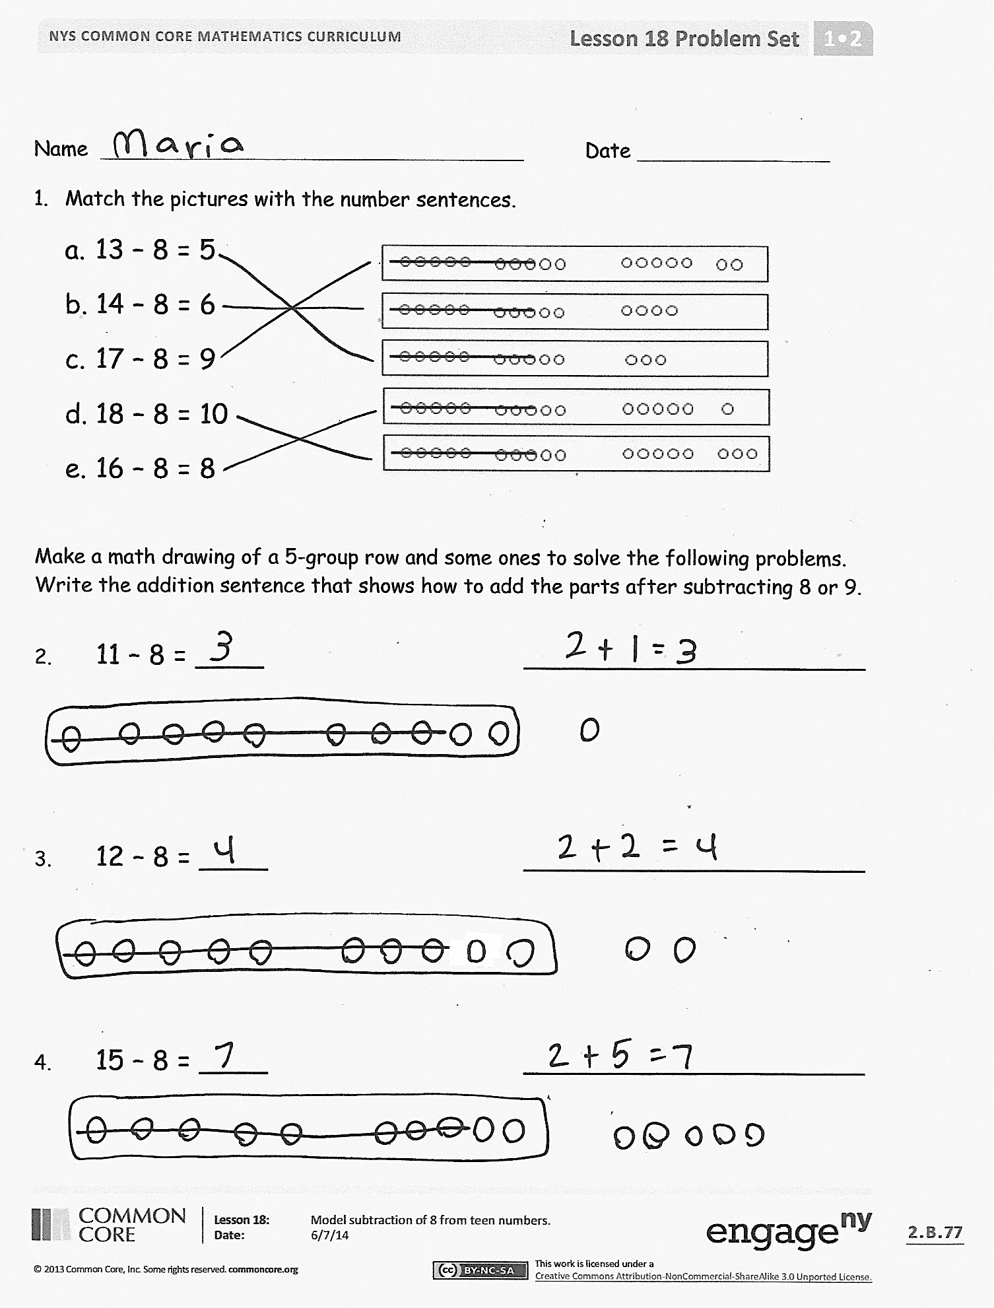
Problem Set (10 minutes)
Students should do their personal best to complete the Problem Set within the allotted 10 minutes. For some classes, it may be appropriate to modify the assignment by specifying which problems they work on first. Some problems do not specify a method for solving. Students should solve these problems using the RDW approach used for Application Problems.
Student Debrief (10 minutes)
Lesson Objective: Model subtraction of 8 from teen numbers.
The Student Debrief is intended to invite reflection and active processing of the total lesson experience.
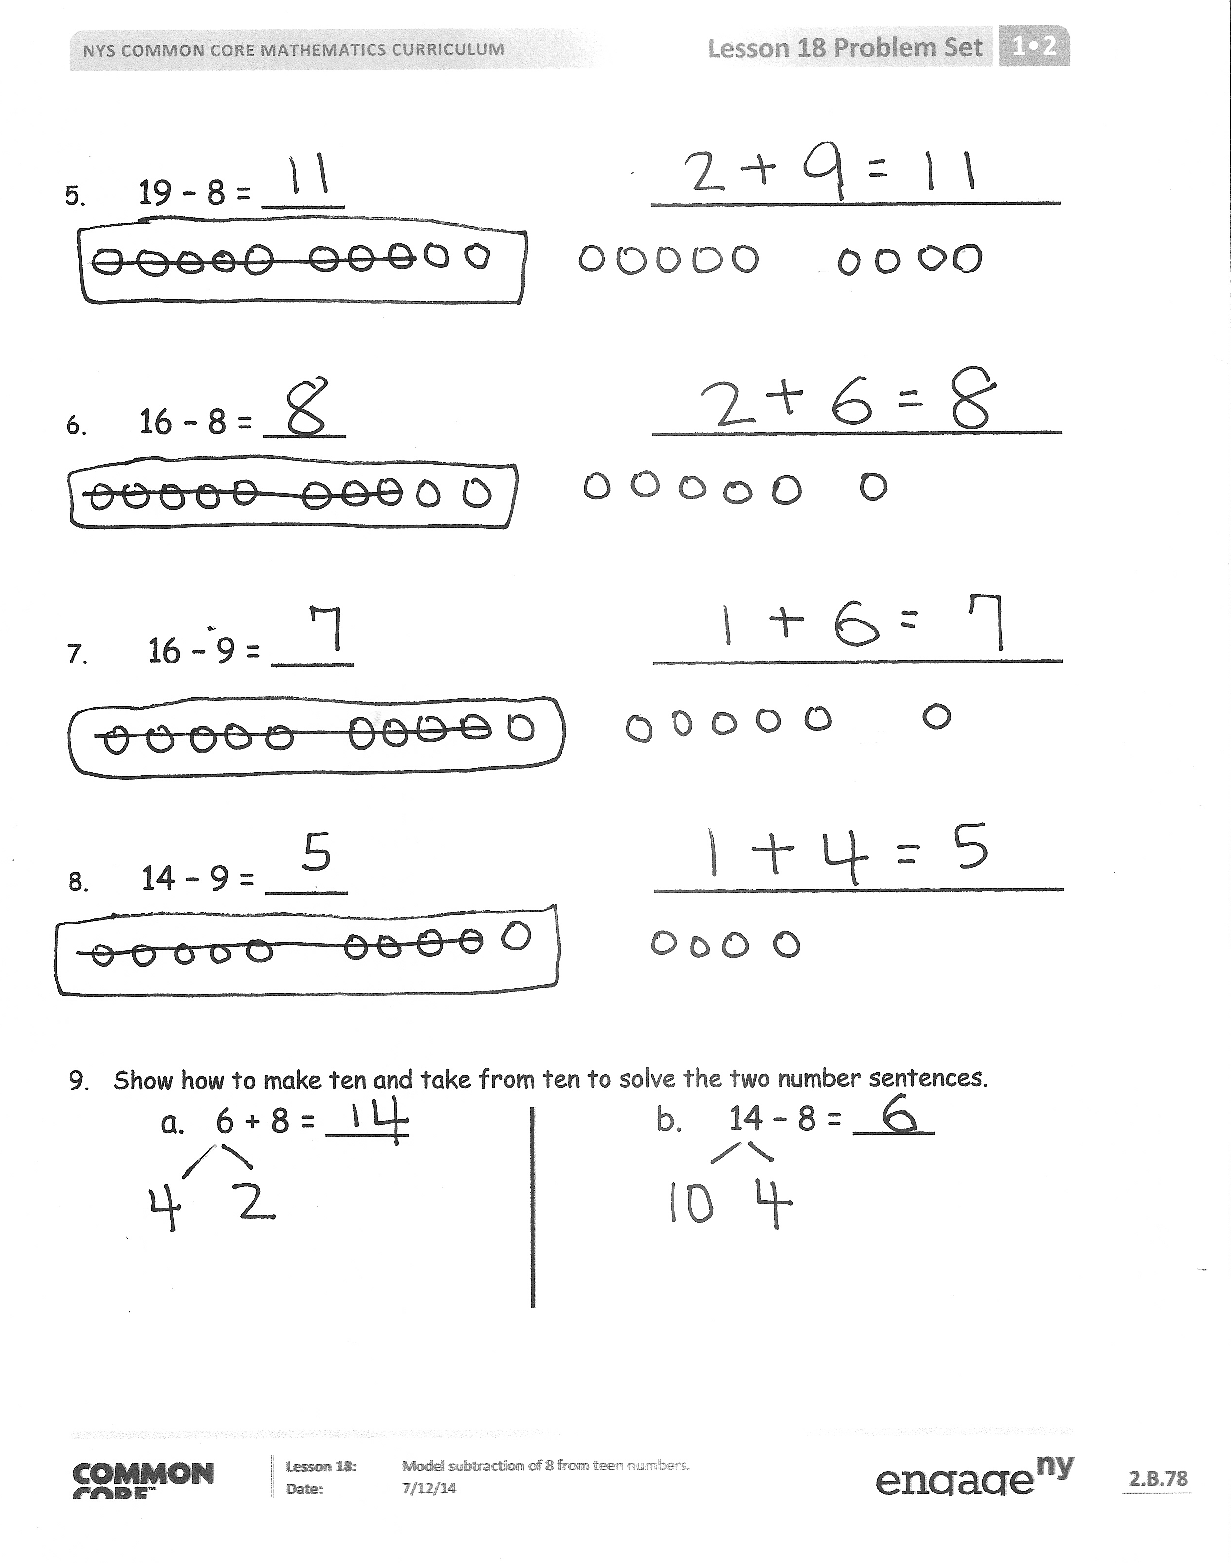
Invite students to review their solutions for the Problem Set. They should check work by comparing answers with a partner before going over answers as a class. Look for misconceptions or misunderstandings that can be addressed in the Debrief. Guide students in a conversation to debrief the Problem Set and process the lesson.
You may choose to use any combination of the questions below to lead the discussion.
- What pattern did you notice every time we took away 8 from a teen number?
- How did you solve 18 – 8 and 19 – 8? How is solving these problems different than solving the other – 8 problems?
- How did solving Problem 7 help you solve Problem 8?
- Look at Problem 9. How are (a) and (b) related? Using these examples, explain how the make ten strategy is related to the take from ten strategy.
- How can we use what we learned about taking away 8 from a teen number to solve a – 7 problem?
- What tools did we use today to help us subtract 8 from a teen number? (Our fingers and 5-group drawings.) How did they help us?
- How is the way you subtract 8 from a teen number different from the way you subtract 9?
- Look at the Application Problem. How did you choose to solve it? Explain your thinking. How could the strategies discussed today be used to solve this problem?
Exit Ticket (3 minutes)
After the Student Debrief, instruct students to complete the Exit Ticket. A review of their work will help you assess the students’ understanding of the concepts that were presented in the lesson today and plan more effectively for future lessons. You may read the questions aloud to the students.

Name Date
- Match the pictures with the number sentences.
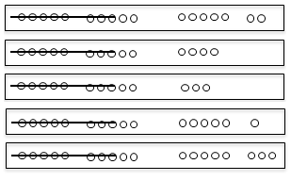
a. 13 – 8 = 5
b. 14 – 8 = 6
c. 17 – 8 = 9
d. 18 – 8 = 10
e. 16 – 8 = 8

Make a math drawing of a 5-group row and some ones to solve the following problems. Write the addition sentence that shows how to add the parts after subtracting 8 or 9.

- 11 – 8 = ____ ____________________

- 12 – 8 = ____ ____________________

- 15 – 8 = ____ ____________________

- 19 – 8 = ____ ____________________

6. 16 – 8 = ____ ____________________

7. 16 – 9 = ____ ____________________

8. 14 – 9 = ____ ____________________

- Show how to make ten and take from ten to solve the two number sentences.
a. 6 + 8 = ____ b. 14 – 8 = ____

Name Date
Draw 5-group rows and cross out to solve. Complete the number sentences. Write the 2+ addition sentence that helped you add the two parts.
- 14 – 8 = ____

2 + ____ = ____

- 17 – 8 = ____

2 + ____ = ____

Name Date
Draw 5-group rows and cross out to solve. Write the 2+ addition sentence that helped you add the two parts.
- Annabelle had 13 goldfish. Eight goldfish ate fish food. How many goldfish did not eat fish food?

____ goldfish did not eat fish food.

- Sam collected 15 buckets of rain water. He used 8 buckets to water his plants. How many buckets of rain water does Sam have left?

Sam has ____ buckets of rain water left.

- There were 19 turtles swimming in the pond. Some turtles climbed up onto the dry rocks, and now there are only 8 turtles swimming. How many turtles are on the dry rocks?

There are ____ turtles on the dry rocks.
Show making ten or taking from ten to solve the number sentences.
5. 15 – 8 = _____
4. 7 + 8 = _____

Find the missing number by drawing 5-group rows.

6. 11 – 9 = _____ 7. 14 – 9 = _____

- Draw 5-group rows to show the story. Cross out or use number bonds to solve. Write a number sentence to show how you solved the problem.

There were 14 people at home. Ten people were watching a football game. Four people were playing a board game. Eight people left. How many people stayed?

______ people stayed at home.

1 | 0 | 2 | 0
0 | 1 | 2 | 3
4 | 5 | 6 | 7
8 | 9

hide zero cards, numeral side (copy double-sided with next page)
hide zero cards, dot side (copy double-sided with previous page)
number path 1–20

