Lesson 16
Objective: Relate counting on to making ten and taking from ten.

Suggested Lesson Structure
 Fluency Practice (14 minutes)
 Application Problem (5 minutes)
 Concept Development (31 minutes)
 Student Debrief (10 minutes)
Total Time (60 minutes)
Fluency Practice (14 minutes)
- Subtract 9 1.OA.6 (10 minutes)
- 5 and 4 Less 1.OA.6 (2 minutes)
- Happy Counting by Twos: Odd Numbers 1.OA.5 (2 minutes)
Subtract 9 (10 minutes)
Materials: (S) Personal white board, 5-group row insert (Lesson 12 Fluency Template 2)
Note: This fluency activity reviews the take from ten subtraction strategy. The goal is for students to be able to use this strategy as mental math. For the first two problems, have students cross off the circles to show their subtraction. Then, have students cover the circles and imagine subtracting them.
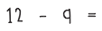
T: Look at your 5-group row insert. Draw more circles to the right of your 5-group to show a total of 12.
S: (Draw 2 more circles).
T: Say 12 as a number bond, with 10 as a part.
S: 10 and 2 make 12.
T: Turn your circles into a number bond.
S/T: (Draw lines to make a number bond with the numeral 12 on top.)
T: Show me 12 – 9. Think about whether you should subtract from the part with ten or the part with two.
S/T: (Write – 9 after 12 and cross out 9 circles.)
T: Below your circles, write an addition sentence to show what is left.
S: (Write 1 + 2 = 3.)
T: What is 12 – 9?
S: 3.
Continue with other numbers between 11 and 20. As soon as possible, reduce the number of steps (e.g., show me 14 ─ 9).
5 and 4 Less (2 minutes)
Materials: (T) 5-group row cards (Lesson 12 Fluency Template 1)
Note: This activity supports Grade 1’s core fluency standard of adding and subtracting within 10 and helps students to see 4 less as related to 5 less (take out the five except for 1). Lead struggling students to visualize 5 less by hiding a 5-group. Make the connection to seeing the number on their fingers and hiding one hand.
Flash a card for two to three seconds. Students say the number that is 5 less and then 4 less.
Happy Counting by Twos: Odd Numbers (2 minutes)
Note: Review of counting on allows students to maintain fluency with adding and subtracting 2.
Repeat the Happy Counting activity from Lesson 4, counting by twos from 1 to 19 and back. This range may be adjusted to meet the needs of students.
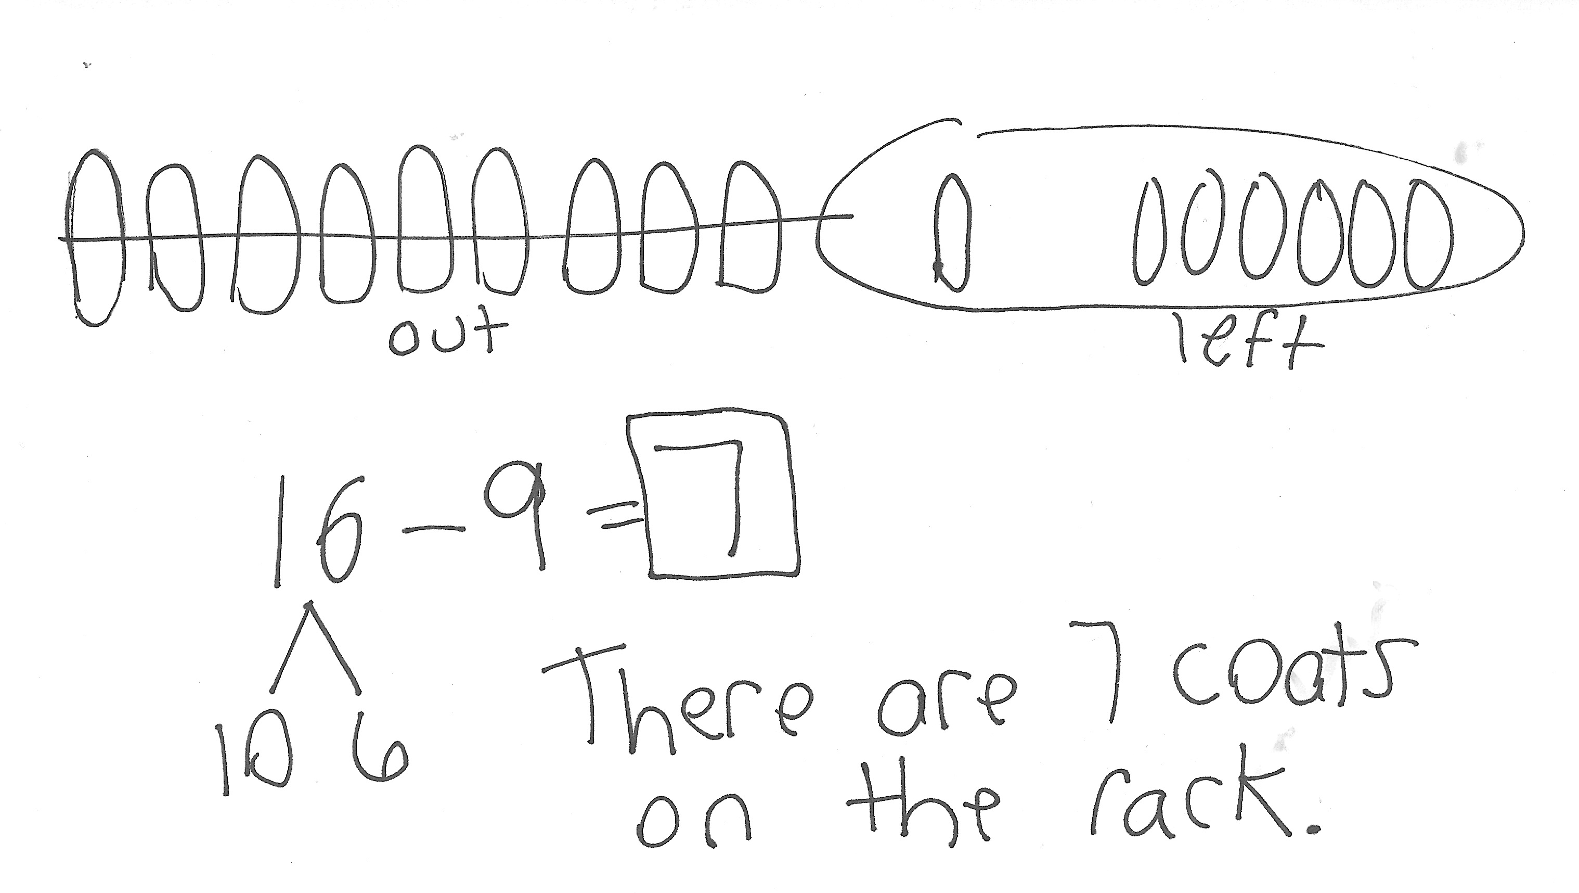
Application Problem (5 minutes)
There were 16 coats on the rack. Nine students took their coats to go outside. How many coats were still on the rack?
Extension: If 4 more students take their coat to go outside, how many coats will still be hanging?
Note: In this problem, students may use the take from ten strategy or count on strategy. While circulating, look for students who used these strategies and ask them to share during the Debrief.
Concept Development (31 minutes)
Materials: (S) Personal white board
Have students sit in a semi-circle in the meeting area with their personal white boards.
T: (Write 11 – 9 = ___.) Solve 11 – 9 on your personal white board.
S: (Solve on personal white board as the teacher circulates and selects two students, one who is using the count on strategy and another using the take from ten strategy.)
S: I started with 9 and counted on. Niiiine, 10, 11. Two fingers are up.
T: Let’s all try counting on.
T/S: Niiiine, 10, 11. (Put up a finger for each count after 9.)
T: (Ask the second student.) How did you solve 11 – 9?
S: I took 9 from 10 and did 1 + 1 and got 2.
T: Let’s all use the take from ten strategy to solve on our personal white boards.
S: (Show a number bond to break apart 11 to solve.)
T: What did you do?
S: 10 – 9 is 1; 1 + 1 is 2.
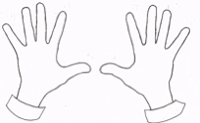
T: Everyone, let’s use the take from ten strategy using our fingers to check! Start by showing 11 fingers.
real fingers
imaginary finger

S: We can’t! We only have 10 fingers!
T: Oh boy, we can’t quite do that, can we? We’ll just have to use our imagination. First, put up your 10 fingers.
S: (Show 10 fingers.)
MP.4
T: How many more fingers do we need to imagine?
S: 1.
T: Visualize, or picture in your mind, 1 more finger next to your 10. Now, take away 9, all at once.

NOTES ON
MULTIPLE MEANS
OF REPRESENTATION:
Sharing strategies is important for students to articulate the way they chose to solve a problem. Other students hear how their classmates are thinking and this may guide them in understanding the strategies at a deeper level. As the teacher, you can see who is using Level 1, Level 2, or Level 3 strategies in your classroom.
S: (Hold 1 finger up.)
T: How many fingers do you have up?
S: 1.
T: How many imaginary fingers are still up?
S: 1.
T: So, how many fingers are there altogether, real and imaginary? Let’s count. Nod your head when you count your imaginary fingers so we are sure we counted them.
S/T: Ooone, 2. (Nod head while saying 2.)
T: What is 11 – 9?
S: 2.
T: Which strategy was easier for you? Turn and talk to your partner.
S: (Discuss.)
T: I heard many students say that they were all easy. They took about the same amount of time. Let’s try another problem to see if one strategy is a better shortcut than the other.
Invite all students to solve 17 – 9 using the two strategies (take from ten, modeled with a number bond and with imaginary fingers, and counting on). This allows students to experience that the take from ten strategy is more efficient. Generate a discussion about the difficulty of trying to count 7 imaginary fingers since they are hard to keep track of. Repeat the process subtracting 9 from 12 to 18 out of sequence so that students have a chance to practice the take from ten strategy. A suggested sequence is 13 – 9, 17 – 9, 15 – 9, 12 – 9, etc. Discuss the increased efficiency of taking from ten as the minuend, or total, gets bigger when subtracting 9, gradually abandoning the counting on strategy and exclusively using the take from ten strategy.
For 14 – 9 and on, use the following paradigm to demonstrate a more efficient way to count on when using imaginary fingers. Students find that trying to keep track of more than 3 imaginary fingers through head nodding becomes difficult.
T: Let’s try 14 – 9. Show 10 fingers and imagine 4 more.
S: (Show 10 fingers.)
T: Now, take away 9, all at once. How many fingers do you have up?
S: 1.
T: How many imaginary fingers are still up?
S: 4.
T: Instead of nodding our heads 4 times to count on, can you see how many fingers there are altogether?
S: Yes. We can just add 1 and 4. That’s 5.
As the strategy becomes more familiar, invite students to visualize the entire process instead of using their fingers.
Note: Although using the take from ten strategy is more efficient than counting on one at a time, starting with 13 – 9, some students may find counting on by keeping track on their fingers easier (e.g., niiine, 10, 11, 12, 13, as they put up a finger for each number) because they have not yet mastered the take from ten strategy. It is not wrong for students to say counting on is easier, but with continued practice, they may embrace the Level 3 strategy of taking from ten.

NOTES ON
MULTIPLE MEANS
OF REPRESENTATION:
When using word problems in class or sending them home as homework, be sure to provide help for your non-readers. Tell parents they can read the problems to their child since you want to focus on the students’ problem solving skills and not their reading ability.

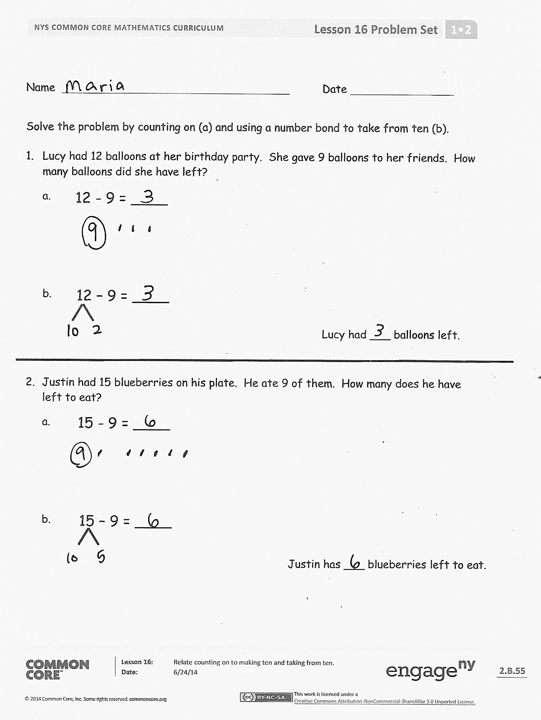
Problem Set (10 minutes)
Students should do their personal best to complete the Problem Set within the allotted 10 minutes. For some classes, it may be appropriate to modify the assignment by specifying which problems they work on first. Some problems do not specify a method for solving. Students should solve these problems using the RDW approach used for Application Problems.
Student Debrief (10 minutes)
Lesson Objective: Relate counting on to making ten and taking from ten.
The Student Debrief is intended to invite reflection and active processing of the total lesson experience.
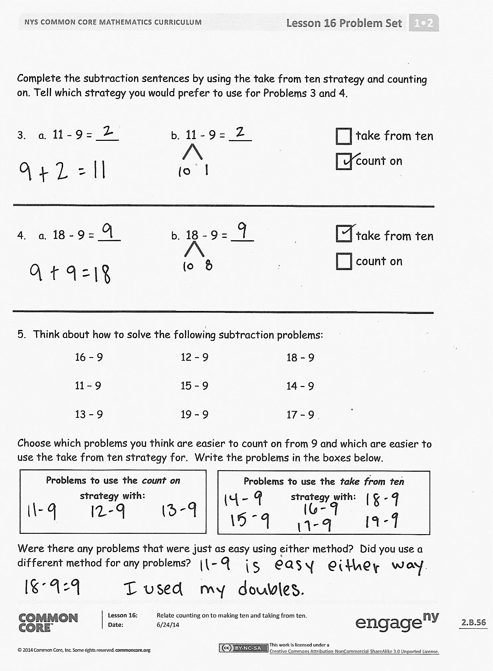
Invite students to review their solutions for the Problem Set. They should check work by comparing answers with a partner before going over answers as a class. Look for misconceptions or misunderstandings that can be addressed in the Debrief. Guide students in a conversation to debrief the Problem Set and process the lesson.
You may choose to use any combination of the questions below to lead the discussion.
- In Problem 3, how is the take from ten strategy similar to counting on?
- We found that counting on from 9 took different amounts of time, depending on what number we were subtracting from. Is this also true when using the take from ten strategy? Does it take longer to take from ten when the starting number is larger? Explain your reasoning.
- We used our imaginary fingers to show the take from ten strategy. (Model 12 – 9.) How is this like counting on? What did we do to make our count on strategy more efficient? Look at Problem 5. Which strategy did you choose for each problem? Explain your reasoning.
  - Guide students to see that counting on one at a time becomes less efficient as the difference becomes larger.
  - As time allows, expand the discussion to point out that the modifications to counting on (mentioned in the previous bullet) do make it more efficient and on par with the take from ten strategy.
  - What new math strategy did we use today to solve subtraction problems more efficiently? (Taking from ten using fingers.)
  - Look at your Application Problem. How did you choose to solve it? Explain your thinking. How could the strategies discussed today be used to solve this problem?
Exit Ticket (3 minutes)
After the Student Debrief, instruct students to complete the Exit Ticket. A review of their work will help you assess the students’ understanding of the concepts that were presented in the lesson today and plan more effectively for future lessons. You may read the questions aloud to the students.

Name Date
Solve the problem by counting on (a) and using a number bond to take from ten (b).

- Lucy had 12 balloons at her birthday party. She gave 9 balloons to her friends. How many balloons did she have left?
12 - 9 = ____
a.

12 – 9 = ____
b.
Lucy had ___ balloons left.

- Justin had 15 blueberries on his plate. He ate 9 of them. How many does he have left to eat?
15 - 9 = ____
a.

15 – 9 = ____
b.
Justin has ___ blueberries left to eat.
Complete the subtraction sentences by using the take from ten strategy and counting on. Tell which strategy you would prefer to use for Problems 3 and 4.

- a. 11 - 9 = ___ b. 11 - 9 = ___ take from ten
count on
- a. 18 - 9 = ___ b. 18 - 9 = ___ take from ten
count on

- Think about how to solve the following subtraction problems:
16 – 9  11 – 9  13 – 9 | 12 – 9  15 – 9  19 – 9 | 18 – 9  14 – 9  17 – 9
Choose which problems you think are easier to count on from 9 and which are easier to use the take from ten strategy for. Write the problems in the boxes below.
Problems to use the count on strategy with:
Problems to use the take from ten strategy with:

Were there any problems that were just as easy using either method? Did you use a different method for any problems?
Name Date
Complete the subtraction sentences by using both the count on and take from ten strategies.

- a. 13 - 9 = ___ b. 13 - 9 = ___

- a. 17 - 9 = ___ b. 17 - 9 = ___

Name Date
Complete the subtraction sentences by using either the count on or take from ten strategy. Tell which strategy you used.
- 17 - 9 = ___ take from ten
count on

- 12 - 9 = ___ take from ten
count on

- 16 - 9 = ___ take from ten
count on

- 11 - 9 = ___ take from ten
count on

- Nicholas collected 14 leaves. He pasted 9 into his notebook. How many of his leaves were not pasted into his notebook? Choose the count on or take from ten strategy to solve.

I chose this strategy:
take from ten
count on

- Sheila had 17 oranges. She gave 9 oranges to her friends. How many oranges does Sheila have left? Choose the count on or take from ten strategy to solve.

I chose this strategy:
take from ten
count on

- Paul has 12 marbles. Lisa has 18 marbles. They each rolled 9 marbles down a hill. How many marbles did each student have left? Tell which strategy you chose for each student.

Paul has ____ marbles left. Lisa has ____ marbles left.
- Just as you did today in class, think about how to solve the following problems and talk to your parent or caregiver about your ideas.
15 – 9  18 – 9  11 – 9 | 13 – 9  19 – 9  14 – 9 | 17 – 9  12 – 9  16 – 9
Circle the problems you think are easier to solve by counting on from 9. Put a rectangle around those that are easier to solve using the take from ten strategy. Remember, some might be just as easy using either method.
Numbers to use the count on strategy with:
Numbers to use the take from ten strategy with:

