Lesson 15
Objective: Model subtraction of 9 from teen numbers.

Suggested Lesson Structure
 Fluency Practice (10 minutes)
 Application Problem (7 minutes)
 Concept Development (33 minutes)
 Student Debrief (10 minutes)
Total Time (60 minutes)
Fluency Practice (10 minutes)
- 5-Group Flash: 5 Less and 4 Less 1.OA.6 (2 minutes)
- Make It Equal: Subtraction Expressions 1.OA.6 (5 minutes)
- Partners to Ten 1.OA.6 (3 minutes)
5-Group Flash: 5 Less and 4 Less (2 minutes)
Materials: (T) 5-group row cards (Lesson 12 Fluency Template 1)
Note: This activity supports Grade 1’s core fluency standard of adding and subtracting within 10 and helps students to see the relationship with 5 less (easy, one 5-group less) to 4 less (take out the five except for 1). For struggling students, lead them to visualize 5 less by hiding a 5-group. Make the connection to seeing the number on their fingers and hiding one hand.
Flash a card for two to three seconds. Students say the number that is 5 less and then 4 less.
Make It Equal: Subtraction Expressions (5 minutes)
Materials: (S) 5-group cards (Lesson 1 Fluency Template), minus and equal symbol cards, one = card and
two – cards per set of partners (Fluency Template)
Note: This activity builds fluency for subtraction within 10 and promotes an understanding of equality.
Assign students partners of similar skill level. Students arrange 5-group cards from 0 to 10, including the extra 5, and place the "=″ card between them. Write four numbers on the board (e.g., 10, 9, 2, 1). Partners take the 5-group cards that match the numbers written to make two equivalent subtraction expressions (e.g., 10 – 9 = 2 – 1). Students can be encouraged to make another sentence of equivalent expressions for the same set of cards as well.
Suggested sequence: 10, 9, 2, 1 10, 3, 9, 2 10, 4, 5, 9 10, 8, 7, 9 10, 7, 9, 6 10, 8, 4, 2
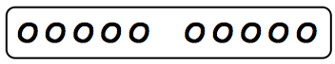
Partners to Ten (3 minutes)
Materials: (S) Personal white board with 5-group row insert (Lesson 12 Fluency Template 1)
Note: This maintenance fluency with partners to ten facilitates the take from ten subtraction strategy.
Say a number between 0 and 10 (e.g., 9). Students cross off the number from the 5-group row insert and write the corresponding subtraction sentence.

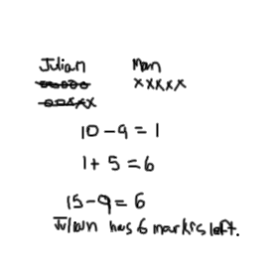
Application Problem (7 minutes)
Julian has 7 markers. His mother gives him 8 more. He loses 9 markers. How many does he have left?
Note: In the Student Debrief, students can discuss their drawings and number sentences and share various strategies, one of which may be decomposing 15 into 10 and 5 and taking 9 from 10. Though it is covered formally in a later lesson, teachers might also choose to encourage students to see that the expressions 15 – 9 and 1 + 5 are equivalent.
Concept Development (33 minutes)
Materials: (S) Personal white board
T: (Project 15 – 9 = ___.) With a partner, solve this on your personal white board. Use words or a drawing to show how you know.

NOTES ON
MULTIPLE MEANS
OF ACTION AND EXPRESSION:
Some students may have trouble organizing their dots in a row with spaces in the correct places. Be sure to accommodate these students and set up a way for them to be successful with their drawings. Avoiding a frustration like drawing keeps students focused on the math or task at hand.
S: (Discuss and solve with partner as teacher circulates and notices the solution strategies students are using independently.)
T: What is the unknown number in this number sentence?
S: 6!
T: How did you solve that?
S: I started at 9 and counted on until I got to 15. That took 6 fingers. I took 9 away from 15 and had 6 left. I know 15 is made of 10 and 5, so I took 9 from 10 and then saw that I had 6 left.

T: I noticed that many of you used drawings on your personal white boards. How can we draw 15 so that we can tell how many we have when we look quickly?
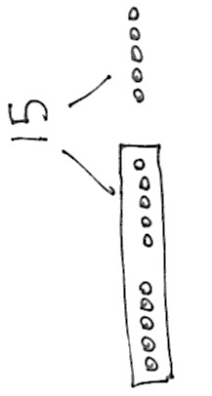
S: Use 5-group pictures!
T: Let’s use 5-groups in one long row, like we did during Fluency today. (On the board, draw a 5-group row to show 15. Leave extra space between the first 10 circles and the last 5 circles.)
T: Let’s frame the 10 circles we have so we can see 10 and 5 more easily. (Draw a rectangle around the first 10 circles.)
T: Now we can see 15 as 10 and 5. (Add the number 15 and the bond lines above as shown.)
T: If we want to take 9 out of 15, how can this drawing help us find a quick and easy place to take the 9 from?
S: The group of 10 inside the frame!
T: Hmm, if I take 9 out of 10, how much would that leave me in the frame?
S: Just one!
T: How much do we have when we take 9 out of 15?

NOTES ON
MULTIPLE MEANS
OF ENGAGEMENT:
For those students that can fluently solve math facts within 20, cultivate excitement by connecting on-level math to higher math, presenting numbers to 100. If they can solve
15 – 9 with ease present problems
such as 25 – 9 or 35 – 9.
S: 6! There is 1 left in the frame and 5 left on the other side, so that’s 6.
T: (Project 14 – 9 = ___.) Let’s all make 5-group drawings like that last one as we solve for the unknown number.
Repeat the process above with the following sequence: 16 – 9,
13 – 9, 17 – 9, etc. Support students in drawing 5-group rows so that they can see the ten and the additional circles easily. Circulate and encourage students to share where they can find 9 quickly and easily.
Suggest students cover the 9 to help them move away from counting all and move towards visualizing and mental math.
After two problems, ask students to close their eyes and see if they can visualize or see in their mind’s eye what is happening in the story when they subtract 9.
Have students draw the problem using 5-group drawings. Before they cross out the 9, ask them to visualize what the picture will look like once it is crossed out and determine how many will not be crossed out. Then have students cross out the 9 and see if their picture matches what they visualized.
Problem Set (10 minutes)
Students should do their personal best to complete the Problem Set within the allotted 10 minutes. For some classes, it may be appropriate to modify the assignment by specifying which problems they work on first. Some problems do not specify a method for solving. Students should solve these problems using the RDW approach used for Application Problems.

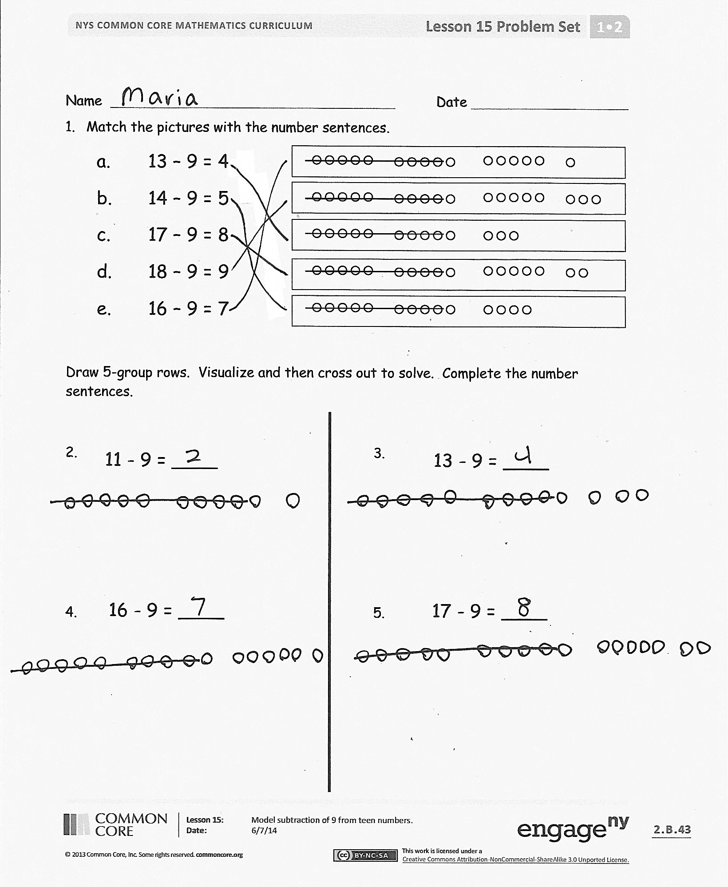
Student Debrief (10 minutes)
Lesson Objective: Model subtraction of 9 from teen numbers.
The Student Debrief is intended to invite reflection and active processing of the total lesson experience.
Invite students to review their solutions for the Problem Set. They should check work by comparing answers with a partner before going over answers as a class. Look for misconceptions or misunderstandings that can be addressed in the Debrief. Guide students in a conversation to debrief the Problem Set and process the lesson.
You may choose to use any combination of the questions below to lead the discussion.
- Look at your Problem Set. How did you find an easy way to take 9 out of the teen numbers?
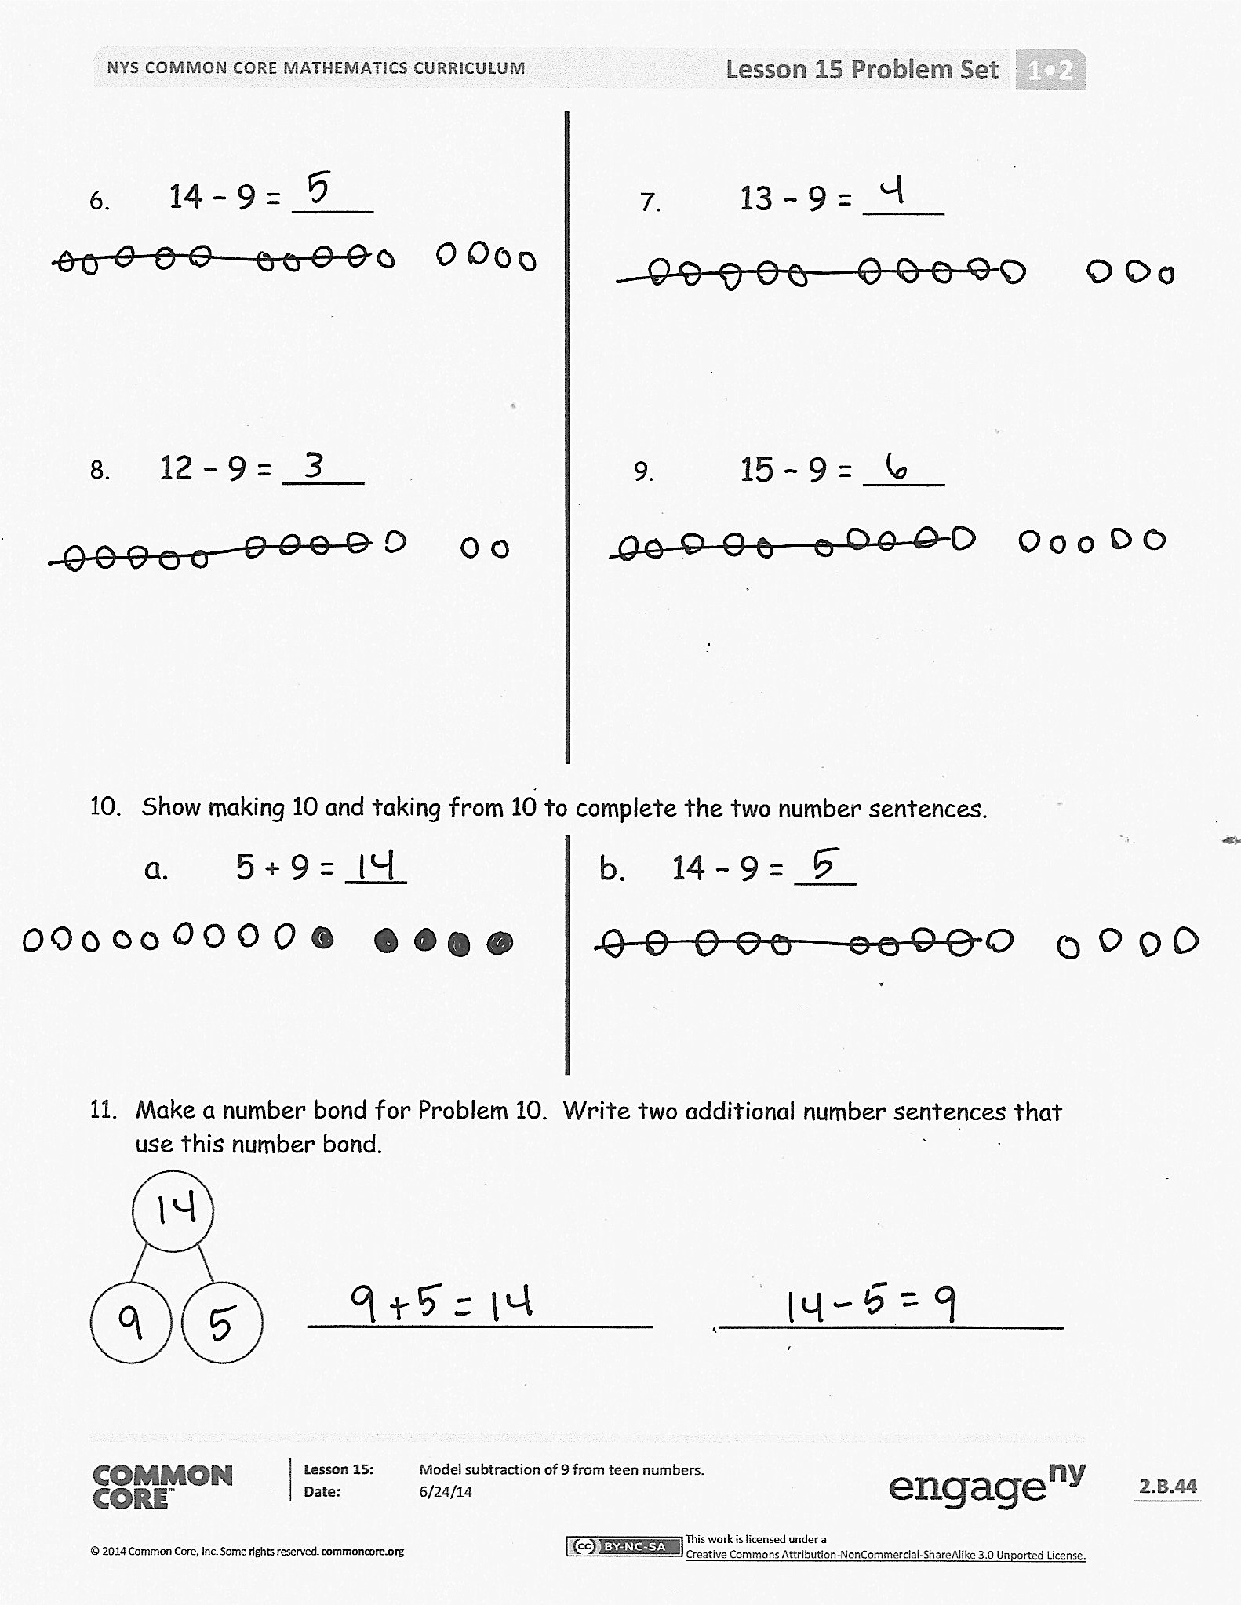
- Look at Problems 6–8. What do you notice is similar about the pictures in these problems? What do you notice about the numbers in these problems? If this pattern continued, what problem would come next? How can the problems help us solve 11 – 9?
- Look at Problem 10. How are the two number sentences related? What was the same or different about your drawings?
- Look at your Application Problem. How does the problem connect to today’s lesson? How would you change or add to your work?
Exit Ticket (3 minutes)
After the Student Debrief, instruct students to complete the Exit Ticket. A review of their work will help you assess the students’ understanding of the concepts that were presented in the lesson today and plan more effectively for future lessons. You may read the questions aloud to the students.

Name Date
- Match the pictures with the number sentences.
a. 13 – 9 = 4
b. 14 – 9 = 5
c. 17 – 9 = 8
d. 18 – 9 = 9
e. 16 – 9 = 7

Draw 5-group rows. Visualize and then cross out to solve. Complete the number sentences.
13 - 9 = ____
11 - 9 = ____
- 3.

17 - 9 = ____
- 5.
16 - 9 = ____

14 – 9 = ____
- 7.
13 – 9 = ____

15 – 9 = ____
12 – 9 = ____
- 9.

- Show making 10 and taking from 10 to complete the two number sentences.
a. 5 + 9 = ___ b. 14 – 9 = ___

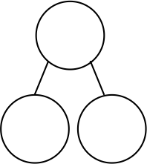
- Make a number bond for Problem 10. Write two additional number sentences that use this number bond.

_________________ _________________
Name Date
Draw 5-group rows and cross out to solve. Complete the number sentences.
- 17 – 9 = ___ 2. 19 – 9 = ___

Name Date
Write the number sentence for each 5-group row drawing.
- 13 – 9 = 4
________________

________________

________________
________________
________________

________________

Draw 5-groups to complete the number bond and write the 9– number sentence.
15
9

17
9
3.

4.
16
9

Draw 5-groups to show making ten and taking from ten to solve the two number sentences. Make a number bond and write two additional number sentences that would have this number bond.
5. 8 + 9 = ___ 6. 17 – 9 = ___

_________________ _________________ _________________ _________________

= | - | -
= | - | -
= | - | -
= | - | -

minus and equal symbol cards

