Lesson 14
Objective: Model subtraction of 9 from teen numbers.

Suggested Lesson Structure
 Fluency Practice (12 minutes)
 Application Problem (5 minutes)
 Concept Development (33 minutes)
 Student Debrief (10 minutes)
Total Time (60 minutes)
Fluency Practice (12 minutes)
- 5-Group Flash: Partners to Ten 1.OA.6 (2 minutes)
- Sprint: Subtraction Within 10 1.OA.6 (10 minutes)
5-Group Flash: Partners to Ten (2 minutes)
Materials: (T) 5-group row cards (Lesson 12 Fluency Template 1)
Note: This activity supports Grade 1’s core fluency standard of adding and subtracting within 10.
Flash a card for two to three seconds. Signal students to say the number. Signal again for students to say the partner to ten.
Sprint: Subtraction Within 10 (10 minutes)
Materials: (S) Subtraction Within 10 Sprint
Note: This Sprint reviews subtracting from ten, along with other subtraction facts within the Grade 1 core fluency objective of adding and subtracting within 10.
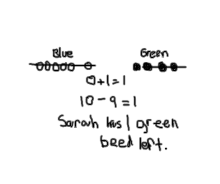
Application Problem (5 minutes)
Sarah has 6 blue beads in her bag and 4 green beads in her pocket. She gives away the 6 blue beads and 3 green beads. How many beads does she have left?

Note: This problem again asks students to subtract 9 from 10, but from two different places: some from the green bead group and some from the blue bead group. Using numbers within 10, students can explore how it is sometimes more efficient to take from a particular group(s) when subtracting. During the Student Debrief, students have the opportunity to share their strategies.
Concept Development (33 minutes)

NOTES ON
MULTIPLE MEANS
OF ENGAGEMENT:
Be aware of the different learning needs in your class and adjust the lesson as necessary. Since some students may need to work at the concrete level for a longer period of time, allow access to manipulatives. Other students may grasp the take from ten strategy quickly and be able to do mental math for some number sentences.

Materials: (T) Linking cubes (S) Personal white board, linking cubes (optional)
Students sit in a semi-circle in the meeting area with their personal white boards.
T: (Project and read aloud.) Shayan has 12 eggs.
He uses nine of them to make breakfast for his family. How many eggs are left?
T: How would you solve this problem? Use your personal white board to show your work.
S: (Solve as teacher circulates.)
T: How did you solve this problem?
S: I drew 12 eggs. I crossed off 9 and I had 3 eggs left. I counted on from 9 (9, 10, 11, 12). I have 3 fingers up, too. I used the strategy from yesterday. I saw that I can take apart 12 as 10 and 2.
I took away 9 from 10 and did 1 + 2 = 3. Three eggs.
T: No matter which strategies these students used, did they get the same answer?
S: Yes!
T: Here is a stick of 12 linking cubes to show how many eggs Shayan had in the beginning. Just like what we practiced yesterday, let’s break it off into 10 and 2. (Break off and separate into two sticks.) We need to take away…
S: 9 eggs.

NOTES ON
MULTIPLE MEANS
OF ACTION AND EXPRESSION:
It is important to guide students to evaluate their thinking, as well as their partner’s, during the turn and talks. This provides students an opportunity to evaluate their process and analyze errors.
T: Where should I take 9 from? Turn and talk to your partner.
S: Take from 2 and then more from 10. Take 9 from 10.
T: (Model taking away from 2.) Do I have enough?
I need to take away more from 10. Help me count until we take away 9. (Count and take away 7 more.)
How many do we have left?
MP.7
S: 3.
T: (Model taking away from 10.) Taking away 9 from 10 will first leave us with…?
(Break off 9 and show 1.)
S: 1.
T: 1 and 2 make…?
S: 3.
T: Turn and talk to your partner. Which was more efficient, simpler? Taking 9 from 10 or taking away the 2 and then some more from 10?
S: Taking 9 from 10.
MP.7
T: I agree. Let’s try more.
Repeat the process using the following suggested sequence: 11 – 9, 14 – 9, and 17 – 9. For each story problem, ask students which number 9 should be taken from.
T: Most of these are examples of 10 being a friendly number. When we take a number away from 10, we’ll call it the take from ten strategy.
T: On your personal white board, draw a picture to show how we took 9 away from 10 to solve 17 – 9.
S: (Draw as teacher circulates and supports students.)
T: Let’s do just a few more. This time, you can use drawings or the linking cubes to show how we use the take from ten strategy to solve.
Repeat with 15 – 9, 18 – 9, and 19 – 9.
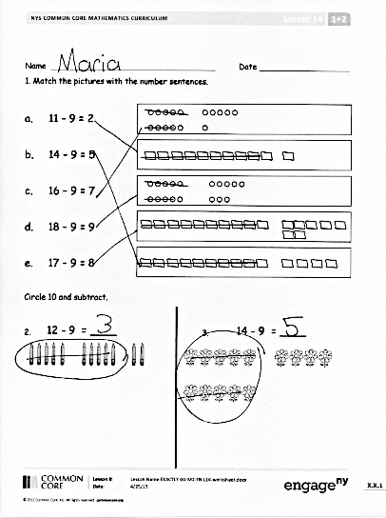
Problem Set (10 minutes)
Students should do their personal best to complete the Problem Set within the allotted 10 minutes. For some classes, it may be appropriate to modify the assignment by specifying which problems they work on first. Some problems do not specify a method for solving. Students should solve these problems using the RDW approach used for Application Problems.
Student Debrief (10 minutes)
Lesson Objective: Model subtraction of 9 from teen numbers.
The Student Debrief is intended to invite reflection and active processing of the total lesson experience.
Invite students to review their solutions for the Problem Set. They should check work by comparing answers with a partner before going over answers as a class. Look for misconceptions or misunderstandings that can be addressed in the Debrief. Guide students in a conversation to debrief the Problem Set and process the lesson.

You may choose to use any combination of the questions below to lead the discussion.
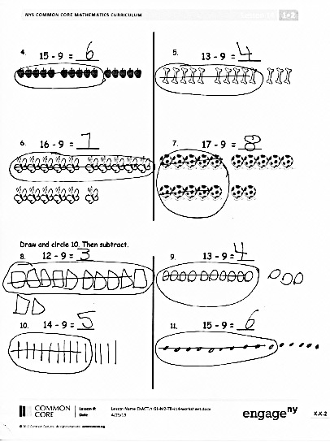
- Look at Problems 8–10. What is happening with the difference in each of these problems? If the pattern continued, what would be the next problem? What problem would come before the first problem?
- When solving 19 – 9, where can you take 9 from? Explain your answer.
- A student says, “Taking away 9 is like adding 1 to the part that is not 10 from the number bond. To solve 17 – 9, you can do 1 + 7.” Is she correct? Explain your answer.
- What new strategy did we learn to solve our problems today? (Take from ten strategy.) Explain to your partner why it’s an efficient strategy.
- Look at your Application Problem. How did you solve it? Do you have to add the blue beads and the green beads together to solve this problem? Why or why not? How is it like our lesson today? How is it different?
Exit Ticket (3 minutes)
After the Student Debrief, instruct students to complete the Exit Ticket. A review of their work will help you assess the students’ understanding of the concepts that were presented in the lesson today and plan more effectively for future lessons. You may read the questions aloud to the students.

Name Date
Number correct:
A
*Write the missing number.
1 | 10 - 9 = ☐ |  | 16 | 10 - ☐ = 5
2 | 10 - 8 = ☐ |  | 17 | 9 - ☐ = 5
3 | 10 - 6 = ☐ |  | 18 | 8 - ☐ = 5
4 | 10 - 7 = ☐ |  | 19 | 10 - ☐ = 3
5 | 10 - 6 = ☐ |  | 20 | 9 - ☐ = 3
6 | 10 - 5 = ☐ |  | 21 | 8 - ☐ = 3
7 | 10 - 6 = ☐ |  | 22 | ☐ - 6 = 4
8 | 10 - 4 = ☐ |  | 23 | ☐ - 6 = 3
9 | 10 - 3 = ☐ |  | 24 | ☐ - 6 = 2
10 | 10 - 7 = ☐ |  | 25 | 10 - 4 = 9 - ☐
11 | 10 - 8 = ☐ |  | 26 | 8 - 2 = 10 - ☐
12 | 10 - 2 = ☐ |  | 27 | 8 - ☐ = 10 - 3
13 | 10 - 1 = ☐ |  | 28 | 9 - ☐ = 10 - 3
14 | 10 - 9 = ☐ |  | 29 | 10 - 4 = 9 - ☐
15 | 10 - 10 = ☐ |  | 30 | ☐ - 2 = 10 - 4
Name Date
Number correct:
B
*Write the missing number.
1 | 10 - 8 = ☐ |  | 16 | 10 - ☐ = 0
2 | 10 - 9 = ☐ |  | 17 | 9 - ☐ = 0
3 | 10 - 8 = ☐ |  | 18 | 8 - ☐ = 0
4 | 10 - 9 = ☐ |  | 19 | 10 - ☐ = 1
5 | 10 - 7 = ☐ |  | 20 | 9 - ☐ = 1
6 | 10 - 9 = ☐ |  | 21 | 8 - ☐ = 1
7 | 10 - 8 = ☐ |  | 22 | ☐ - 5 = 5
8 | 10 - 7 = ☐ |  | 23 | ☐ - 5 = 4
9 | 10 - 3 = ☐ |  | 24 | ☐ - 5 = 3
10 | 10 - 7 = ☐ |  | 25 | 10 - 8 = 9 - ☐
11 | 10 - 6 = ☐ |  | 26 | 8 - 6 = 10 - ☐
12 | 10 - 4 = ☐ |  | 27 | 8 - ☐ = 10 - 2
13 | 10 - 3 = ☐ |  | 28 | 9 - ☐ = 10 - 2
14 | 10 - 7 = ☐ |  | 29 | 10 - 3 = 9 - ☐
15 | 10 - 5 = ☐ |  | 30 | ☐ - 1 = 10 - 3
Name Date
- Match the pictures with the number sentences.

a. 11 – 9 = 2
b. 14 – 9 = 5
c. 16 – 9 = 7
d. 18 – 9 = 9
e. 17 – 9 = 8
Circle 10 and subtract.
14 - 9 = ____
12 - 9 = ____
- 3.

- 5.
13 - 9 = ____
15 - 9 = ____

17 - 9 = ____
16 - 9 = ____
- 7.

Draw and circle 10. Then subtract.

- 12 – 9 = ___ 9. 13 – 9 = ___

- 14 – 9 = ___ 11. 15 – 9 = ___

Name Date
Draw and circle 10. Solve and make a number bond.
- 17 – 9 = ____ 2. 14 – 9 = ____

- 15 – 9 = ___ 4. 18 – 9 = ___

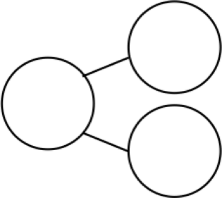
Name Date
12
9
Circle 10 and subtract. Make a number bond.

- 15 – 9 = ___

Draw and circle 10. Subtract and make a number bond.

- 14 – 9 = ___ 3. 12 – 9 = ___

- 13 – 9 = ___ 5. 16 – 9 = ___

6. Complete the number bond and write the number sentence that helped you.
12
9
________________________________
16
9
15
9
________________________________
14
9
13
9
________________________________

________________________________

7. Make the number bond that would come next and write a number sentence that matches.

