Lesson 13
Objective: Solve word problems with subtraction of 9 from 10.

Suggested Lesson Structure
 Fluency Practice (13 minutes)
 Application Problem (7 minutes)
 Concept Development (30 minutes)
 Student Debrief (10 minutes)
Total Time (60 minutes)
Fluency Practice (13 minutes)
- 2, 3, 5 Less 1.OA.6 (3 minutes)
- Subtraction with Cards 1.OA.6 (5 minutes)
- 5-Group Flash: Take from Ten 1.OA.6 (5 minutes)
2, 3, 5 Less (3 minutes)
Note: This activity supports Grade 1’s core fluency standard of adding and subtracting within 10.
T: On my signal, say the number that is 2 less.
T: 5.
S: 3.
Continue with numbers between 4 and 10. Then review 3 less and 5 less.
Subtraction with Cards (5 minutes)
Materials: (S) 1 deck of numeral cards with 2 extra tens for each pair of students (Lesson 1 Fluency Template, numeral side only), counters (if needed)
Note: Reviewing subtraction facts supports Grade 1’s core fluency standard of adding and subtracting within 10. Provide number bond template for students who need extra support. Students can place the larger number as the whole and the smaller as a part to figure out the missing part.
Students place the deck of cards face down between them. Each partner flips over two cards and subtracts the smaller number from the larger number. The partner with the smaller difference keeps the cards played by both players that round. The player with the most cards at the end of the game wins.
5-Group Flash: Take From Ten (5 minutes)
Materials: (T) 5-group row cards (Lesson 12 Fluency Template 1) (S) Personal white board with 5-group row insert (Lesson 12 Fluency Template 2)
Note: This maintenance fluency with partners to ten facilitates the take from ten subtraction strategy that students are learning.
Flash a card (e.g., 9) for one to three seconds. Students cross off the number flashed from the 5-group row insert and write the corresponding subtraction sentence.
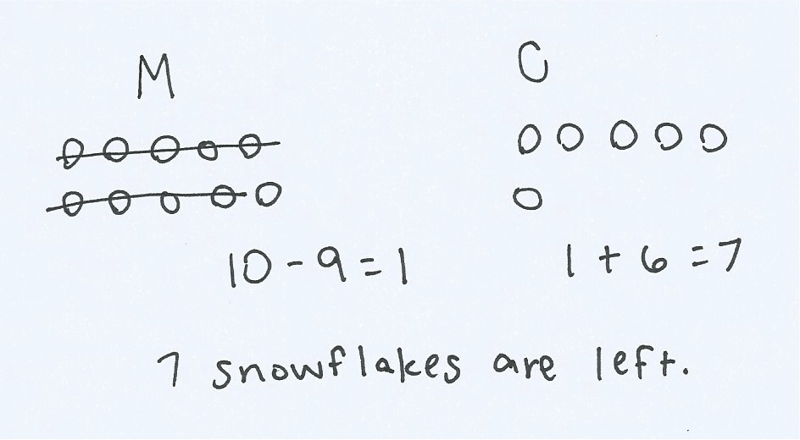
Application Problem (7 minutes)
Ten snowflakes fell on Sam’s mitten and 6 fell on his coat. Nine of the snowflakes on Sam’s mitten melted. How many snowflakes are left? Write a subtraction sentence to show how many snowflakes are left.
Note: This problem continues the work started in Lesson 12, asking students to subtract 9 from 10.
Concept Development (30 minutes)
Materials: (T) Image of 5-group rows (Lesson 12 Fluency Template 1) (S) Personal white board with 5-group rows insert (Lesson 12 Fluency Template 2)
Have students come to the meeting area with their personal boards and sit in a semi-circle.
T: (Project and read aloud.) There were 10 ants on the picnic blanket and 4 ants on the grass. Nine ants from the picnic blanket went into the anthill with a breadcrumb. How many ants are not in the anthill?
T: Show me a number bond that shows how many ants were around at the beginning of the story.
S: (Write 14, 10, and 4.)
T: Using the picture from our fluency activity, I’ll make a math drawing to show the parts. (Model drawing a
5-group row of 10 that is framed and labeled as 10 and 4 dark circles to the right, labeled as 4.)

NOTES ON
MULTIPLE MEANS
OF REPRESENTATION:
Reading aloud word problems facilitates problem solving for those students who have difficulty reading the text within the problems. Hearing the word problem also helps students who are auditory learners.

T: Talk with a partner. If 9 ants left the blanket to go into the anthill, how many ants are not in the anthill?
S: (Discuss with a partner and solve.)
T: How many ants are not in the anthill?
S: 5!
T: Use my math drawing to show me how you know.
S: These 10 circles are the ants from the blanket. If I cross off 9 of them, I have 1 here (point to framed 5-group row) and 4 more here (point to 4 dark circles next to frame). If we start from the 9 we had, we can count up. (Point to 5-group picture, starting at last circle in framed 5-group row.)
1 more to get to 10, and then 4 more to get to 14. I knew that we had 4 black circles and I added 1 more. That’s 5.
T: Which strategy is more efficient?

NOTES ON
MULTIPLE MEANS
OF ACTION AND EXPRESSION:
In this lesson, students are transitioning from drawing 5-groups to drawing 5-group rows. Some students may need some time to make the transition and complete the drawings the new way.

S: Adding 1 to the other part.
T: Turn and talk to you partner and write the number sentence that shows how we solved this problem. Explain your thinking.
S: We took away 9 ants from the 10 ants on the blanket. There was 1 ant left, plus there were 4 ants still on the grass. So, 10 – 9 = 1 and then 4 + 1 = 5. I can write 14 – 9 = 5. In the beginning, there were 14 ants.
Then 9 ants went into the anthill, so I took 9 away. There are 5 ants left.
T: Let’s take a look at the math drawing. Do these 10 open circles remind you of any other drawings?
S: They look like 5-groups, except they are all in a line. We used to make them with 5 on top and 5 on the bottom.
T: You are right! Since these are all in a row, we’ll call them a 5-group row. There is a space to separate 5 circles from the other 5.
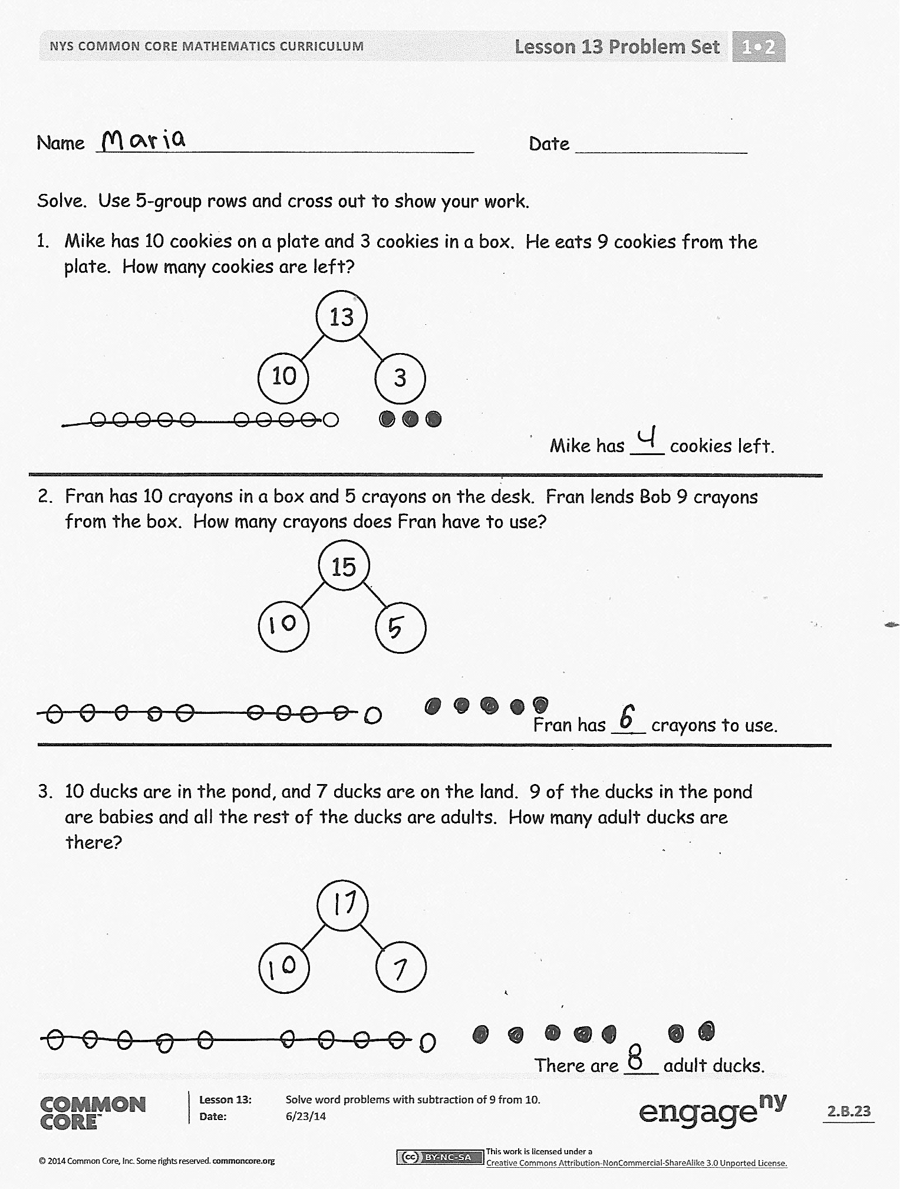
Repeat the process by having students write the number bond, draw the picture, and write the number sentence using the following suggested sequence: 13 – 9, 15 – 9,
16 – 9, 17 – 9, and 18 – 9. For the first few problems, use the 5-group rows template (with the group of 10 framed), revisiting the fluency activities from yesterday and today’s lessons. Then leave the last couple of problems for students to draw their 5-group rows (with or without frames) independently.
Problem Set (10 minutes)
Students should do their personal best to complete the Problem Set within the allotted 10 minutes. For some classes, it may be appropriate to modify the assignment by specifying which problems they work on first. Some problems do not specify a method for solving. Students should solve these problems using the RDW approach used for Application Problems.
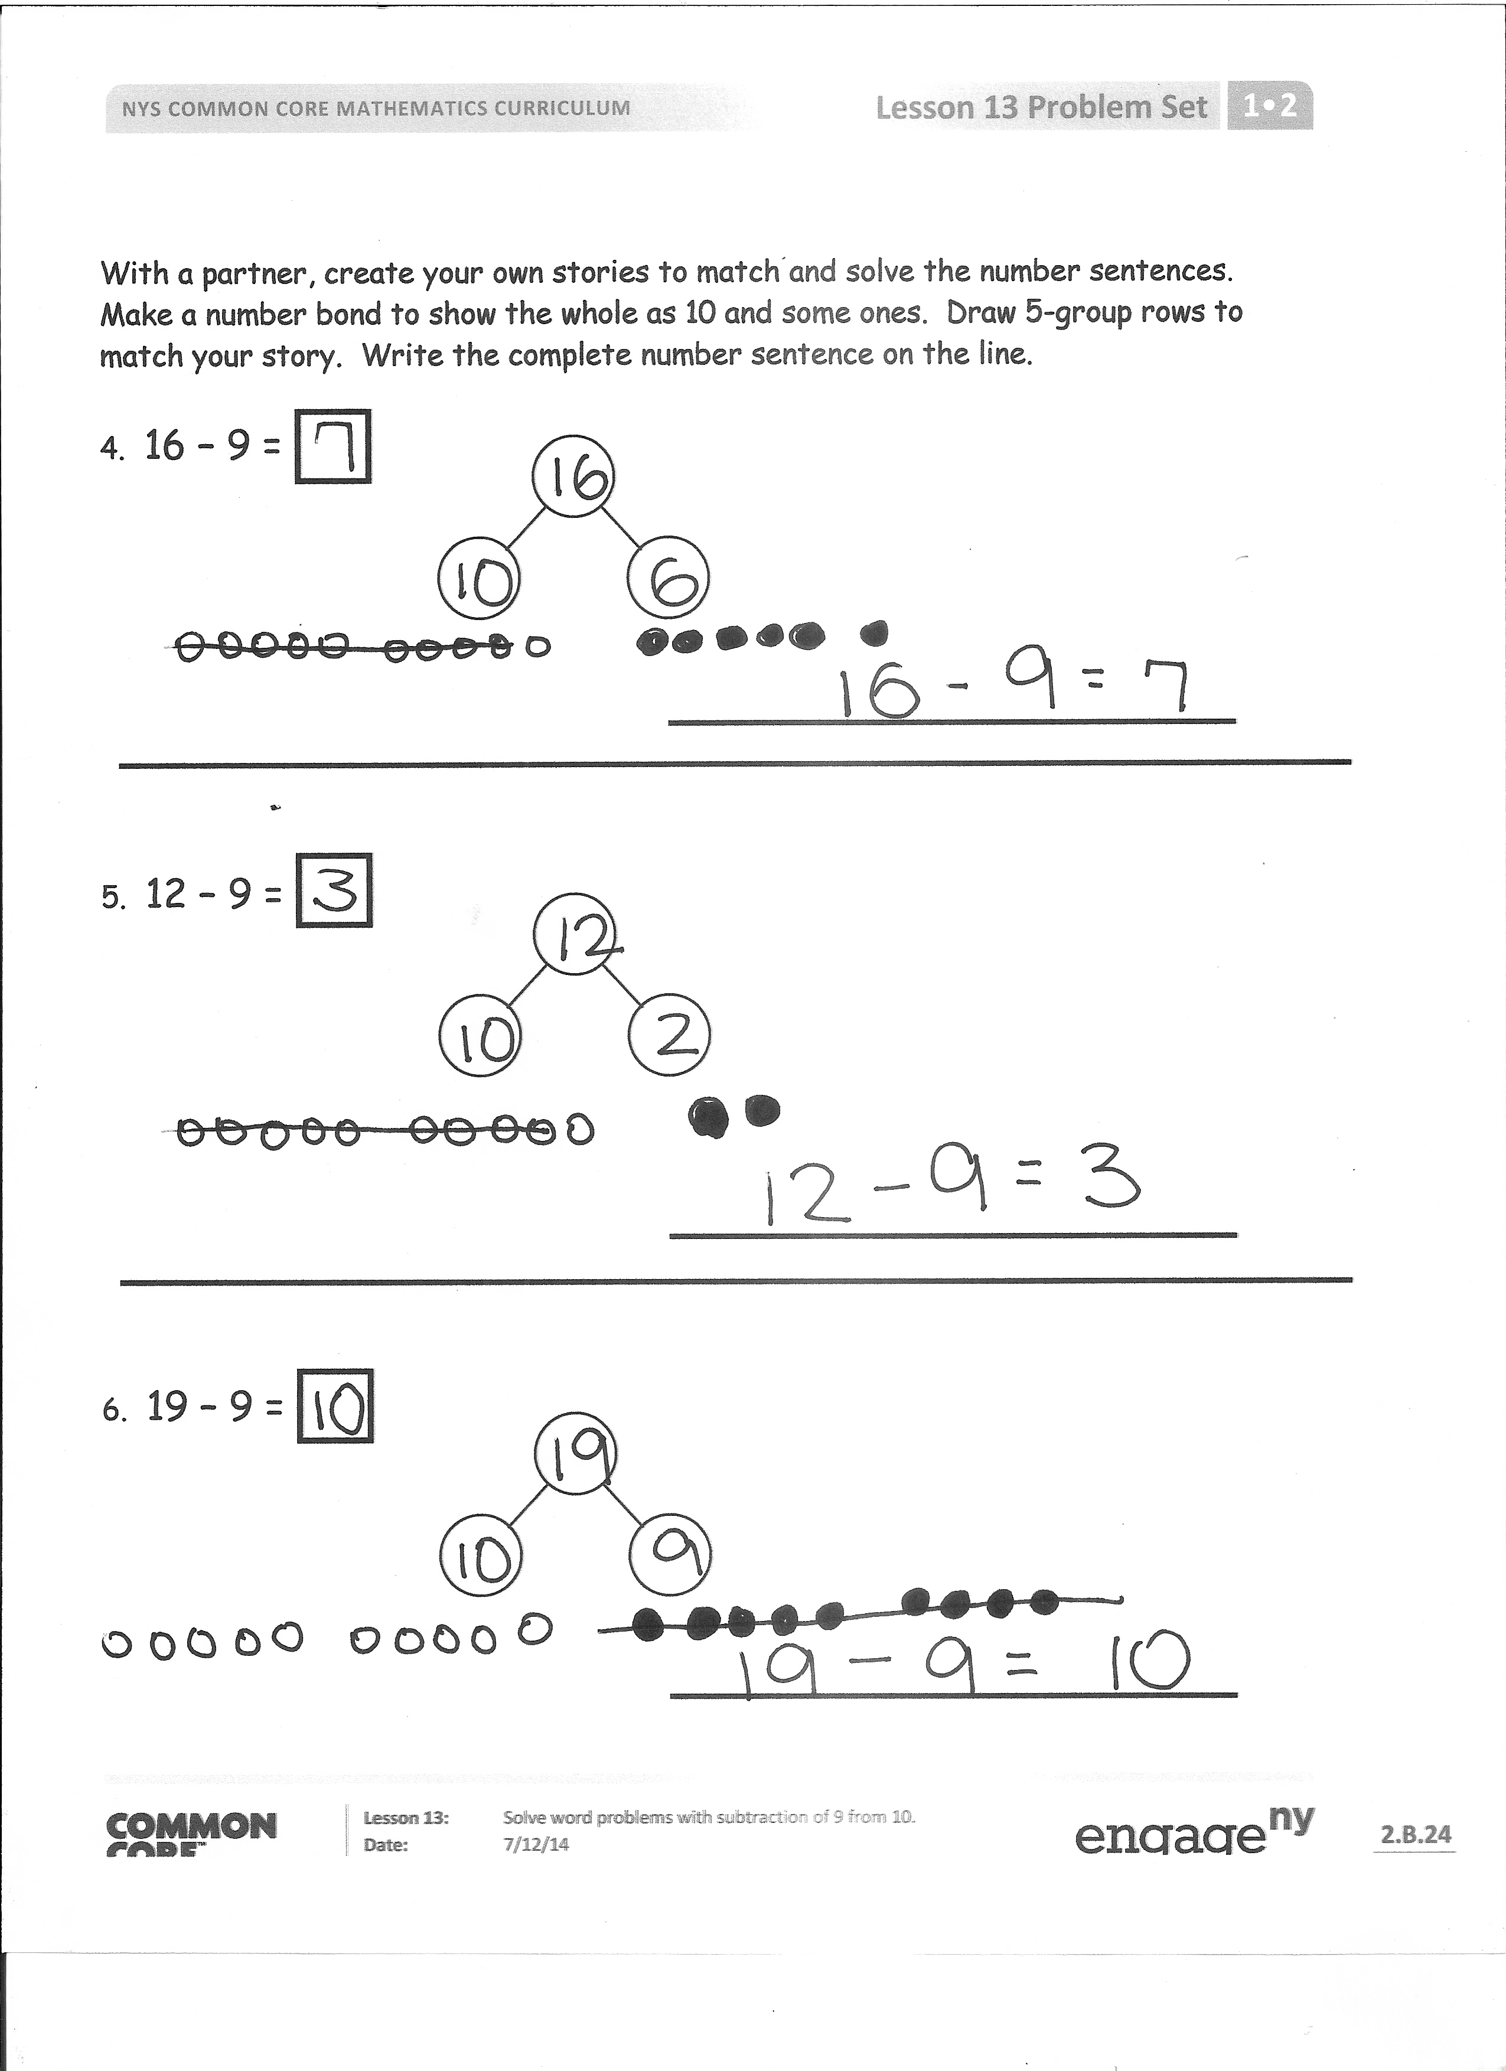
Student Debrief (10 minutes)
Lesson Objective: Solve word problems with subtraction of 9 from 10.
The Student Debrief is intended to invite reflection and active processing of the total lesson experience.
Invite students to review their solutions for the Problem Set. They should check work by comparing answers with a partner before going over answers as a class. Look for misconceptions or misunderstandings that can be addressed in the Debrief. Guide students in a conversation to debrief the Problem Set and process the lesson.
You may choose to use any combination of the questions below to lead the discussion.
- What pattern did you notice about how we solved –9 problems? (We always took away 9 from 10. The answer is always the other part plus 1 because taking away 9 from 10 always leaves you with 1.)
- How can Problem 2 help you solve Problem 4?
- Look at Problem 6. Which part did you take the 9 from? Why? Explain your thinking.
- What new math drawing did we use today to solve subtraction problems? (5-group rows.)
How is this drawing helpful?
- Look at your Application Problem. Where did you take your 9 from? Share your strategy.
- How can we use what we learned today to solve the Application Problem?
Exit Ticket (3 minutes)
After the Student Debrief, instruct students to complete the Exit Ticket. A review of their work will help you assess the students’ understanding of the concepts that were presented in the lesson today and plan more effectively for future lessons. You may read the questions aloud to the students.

Name Date
Solve. Use 5-group rows and cross out to show your work.
- Mike has 10 cookies on a plate and 3 cookies in a box. He eats 9 cookies from the plate. How many cookies are left?
10

3

13

Mike has ___ cookies left.

- Fran has 10 crayons in a box and 5 crayons on the desk. Fran lends Bob 9 crayons from the box. How many crayons does Fran have to use?
15

Fran has ___ crayons to use.

- 10 ducks are in the pond, and 7 ducks are on the land. 9 of the ducks in the pond are babies and all the rest of the ducks are adults. How many adult ducks are there?

With a partner, create your own stories to match and solve the number sentences.
There are ___ adult ducks.
Make a number bond to show the whole as 10 and some ones. Draw 5-group rows to match your story. Write the complete number sentence on the line.

- 16 – 9 =

- 12 – 9 =

- 19 – 9 =

Name Date
Solve. Fill in the number bond. Use 5-group rows and cross out to show your work.
Gabriela has 4 hair clips in her hair and 10 hair clips in her bedroom. She gives 9 of the hair clips in her room to her sister. How many hair clips does Gabriela have now?

Gabriela has ___ hair clips.

Name Date
Solve. Use 5-group rows and cross out to show your work. Write number sentences.

- In a park, 10 dogs are running on the grass and 1 dog is sleeping under the tree.
9 of the running dogs leave the park. How many dogs are left in the park?
10
1

There are ___ dogs left in the park.

- Alejandro had 9 rocks in his yard and 10 rocks in his room. 9 of the rocks in his room are gray rocks and the rest of the rocks are white. How many white rocks does Alejandro have?

Alejandro has ___ white rocks.

- Sophia has 8 toy cars in the kitchen and 10 toy cars in her bedroom. 9 of the toy cars in the bedroom are blue. The rest of her cars are red. How many red cars does Sophia have?

Sophia has ___ red cars.

- Complete the number bond, and fill in the math story. Use 5-group rows and cross out to show your work. Write number sentences.
10

4

There were ____ birds splashing in a puddle and ____ birds walking on the dry grass.
9 of the splashing birds flew away. How many birds are left?

There are ___ birds left.

