Lesson 12
Objective: Solve word problems with subtraction of 9 from 10.

Suggested Lesson Structure
 Fluency Practice (11 minutes)
 Application Problem (6 minutes)
 Concept Development (33 minutes)
 Student Debrief (10 minutes)
Total Time (60 minutes)
Fluency Practice (11 minutes)
- Rewrite Expressions as 10+ Sentences 1.OA.6 (5 minutes)
- 5-Group Flash: Partners to Ten 1.OA.6 (2 minutes)
- Teen Number Bonds 1.NBT.2 (4 minutes)
Rewrite Expressions as 10+ Sentences (5 minutes)
Materials: (S) Personal white board
Note: This review fluency reinforces the make ten addition strategy where students mentally decompose numbers to create equivalent but easier number sentences.
Write addition sentences with 9, 8, or 7 as an addend. Tell students to rewrite the sentence with 10 as an addend (e.g., write 9 + 2 and students write 10 + 1 = 11). Suggested sequence: 9 + 1, 9 + 2, 9 + 3, 9 + 5, 9 + 6, 8 + 2, 8 + 3, 8 + 5, 8 + 6, 7 + 3, etc.
5-Group Flash: Partners to Ten (2 minutes)

NOTES ON
MULTIPLE MEANS
OF ENGAGEMENT:
Certain fluency games that you play in class are good to play at home. Send home directions to the games so that parents can play with their child. Suggest ways parents can use different numbers to challenge their child and extend their learning during the games.

Materials: (T) 5-group row cards (Fluency Template 1)
Note: This activity supports Grade 1’s core fluency standard of adding and subtracting within 10. Notice the shift in visual representation of ten which transitions students into seeing ten as a single unit by the module’s end.
This fluency activity focuses on the partners to ten.
Flash a card for two to three seconds. Snap. Students say the number. Snap again. Students say the partner to ten.
Teen Number Bonds (4 minutes)
Materials: (S) Personal white board with 5-group row insert (Fluency Template 2)
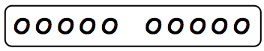
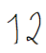
Note: Composing teen numbers as 10 ones and some more ones prepares students for the take from ten subtraction strategy.
T: Draw more circles to show a total of 12.
S: (Draw 2 more circles.)
T: Say 12 as a number bond with 10 as a part.
S: 10 and 2 make 12.
T: Draw lines to show the total of 12 from your circles.
S: (Draw lines to make a number bond with the numeral 12 on top.)
Continue with other numbers between 11 and 20.
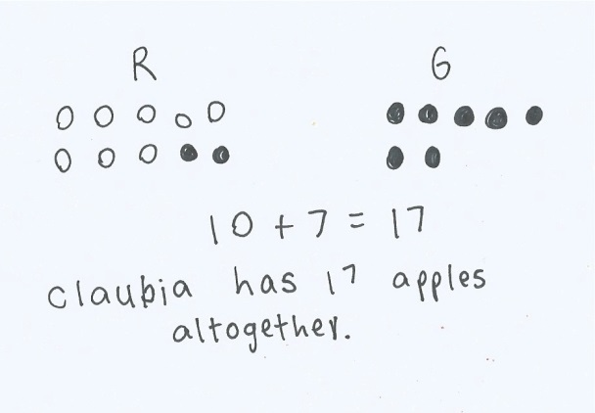
Application Problem (6 minutes)
Claudia bought 8 red apples and 9 green apples. How many apples does Claudia have altogether? Make a math drawing, number sentence, and statement to show your thinking.
Extension: Claudia ate 3 red apples and her friend ate 4 green apples. How many apples does Claudia have now?
Note: This problem revisits the make ten strategy introduced in Topic A. It provides a foundation for today’s work of solving word problems with subtraction of 9 from 10 using the same numbers and story problem character.
Concept Development (33 minutes)
Materials: (T) Chart paper (S) Personal white board
Have students sit at their tables with the personal white boards.
T: (Project and read aloud.) When Claudia brought home her 17 apples, she put 10 in a bowl and 7 on the table. Then, she decided to give 9 apples to her babysitter. How many apples did Claudia have left? (Pause.) Solve the problem on your personal board, and talk with your partner about how you solved it.
S: (Solve the problem and discuss strategies as the teacher circulates.)
T: What strategies did you use?
S: I drew all of the apples and then crossed off the ones on the table and 2 more. I counted the ones that were left. 8! I drew 10 circles for the bowl and 7 for the table. Then I took 9 from the 10 in the bowl. 7 and 1 is 8!
T: Let’s all try another. (Project and read aloud, “Bailey Bunny had 10 carrots in a basket and 5 on a plate. She ate 9 carrots from the basket. How many carrots were left?”)
T: On your personal white board, draw how many carrots Bailey Bunny had in the basket and label it.
S: (Draw 10 circles and write B or basket.)
T: In the next row, draw the carrots that were on the plate and label it.
S: (Draw 5 circles and write P or plate.)
T: The problem says that she ate 9 carrots from the basket. What should we do?
S: Cross off 9!

NOTES ON
MULTIPLE MEANS
OF EXPRESSION:
At this time, students may be working at varying stages of subtracting, as depicted in the image below. As we praise students for accurate solutions, we want to encourage them to move to the next level strategy. If they are counting all, they should be encouraged to make the connection to counting on. If students are counting on, they should be encouraged towards taking from ten.

T: From where?
S: From the basket, from 10.
T: Show on your personal white board.
S: (Cross off 9 circles from 10.)
T: How many carrots are left in the basket?
S: 1 carrot!
T: How many are left on the plate?
S: 5 carrots.
T: Then how many carrots are left in all?
S: 6 carrots.
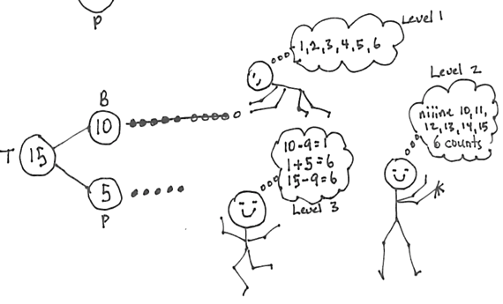
Repeat the process using the suggested sequence:
11 – 9, 12 – 9, and 14 – 9, recording the work on a
chart paper for the Debrief.
T: Let’s record how we solved our story problem with a number bond. (Read the story again.)
Draw a number bond to show Bailey Bunny’s total number of carrots, the part in the basket, and
the part on the plate.
S: (Draw.)
T: Draw circles to show the different parts.
S: (Draw.)
T: What did we do next? Show in your picture.
S: (Cross off 9 circles.) We took away 9 carrots from the basket. We took away 9 from 10.
T: Turn and talk to your partner about how you can find how many carrots are left.
S: I counted 1, 2, 3, 4, 5, 6. I didn’t use the picture. I counted on, niiine, 10, 11, 12, 13, 14, 15. That is 6 counts. I added 1 and 5. That’s 6 carrots.
Repeat the process using the following suggested sequence: 16 – 9, 17 – 9, and 18 – 9, recording the work on chart paper for the Debrief.
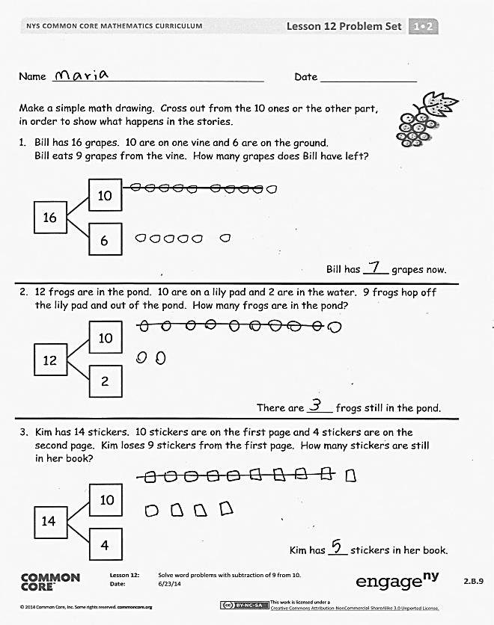
Problem Set (10 minutes)
Students should do their personal best to complete the Problem Set within the allotted 10 minutes. For some classes, it may be appropriate to modify the assignment by specifying which problems they work on first. Some problems do not specify a method for solving. Students should solve these problems using the RDW approach used for Application Problems.
Student Debrief (10 minutes)
Lesson Objective: Solve word problems with subtraction of 9 from 10.
The Student Debrief is intended to invite reflection and active processing of the total lesson experience.
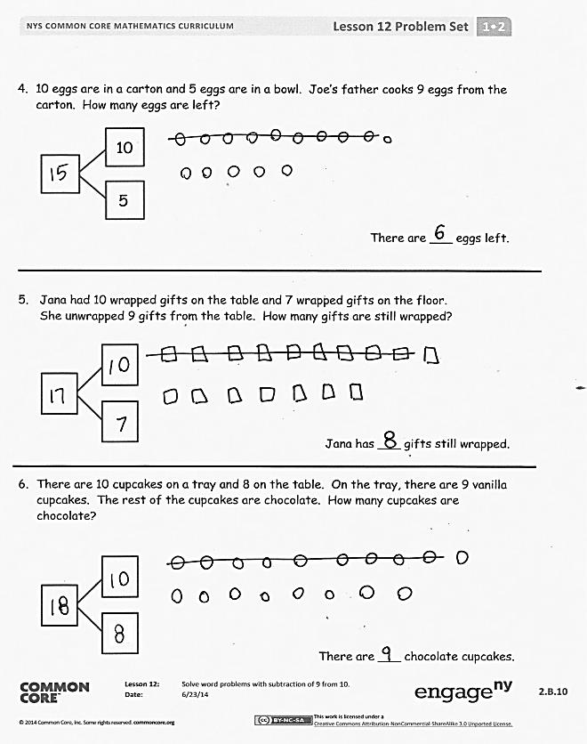
Invite students to review their solutions for the Problem Set. They should check work by comparing answers with a partner before going over answers as a class. Look for misconceptions or misunderstandings that can be addressed in the Debrief. Guide students in a conversation to debrief the Problem Set and process the lesson.
You may choose to use any combination of the questions below to lead the discussion.
- Look at your drawings on your Problem Set. What did you notice when we took away 9 for each problem?
- Look at the chart of work from the Concept Development. What do you notice about the answers to each of these questions?
(The answer is always 1 more than the second part of the number bond.) Why do you think this is?
How can solving Problem 3 help you solve Problem 4?
- After taking 9 from 10, how did you find the total amount left over? Which is the most efficient way to find out how many are left? Explain your thinking.
- Look at your Application Problem and think about what Claudia did with the apples once she got home (model this problem again). How are these problems similar? How are they different?
Exit Ticket (3 minutes)
After the Student Debrief, instruct students to complete the Exit Ticket. A review of their work will help you assess the students’ understanding of the concepts that were presented in the lesson today and plan more effectively for future lessons. You may read the questions aloud to the students.

Name Date
Make a simple math drawing. Cross out from the 10 ones or the other part, in order to show what happens in the stories.
- Bill has 16 grapes. 10 are on one vine and 6 are on the ground.
Bill eats 9 grapes from the vine. How many grapes does Bill have left?
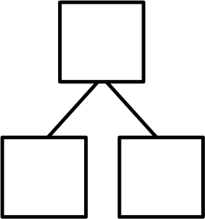
16
10
6
Bill has ____ grapes now.

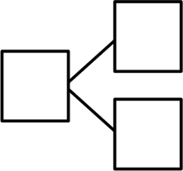
- 12 frogs are in the pond. 10 are on a lily pad and 2 are in the water. 9 frogs hop off the lily pad and out of the pond. How many frogs are in the pond?
12
10
2

There are ____ frogs still in the pond.

- Kim has 14 stickers. 10 stickers are on the first page and 4 stickers are on the second page. Kim loses 9 stickers from the first page. How many stickers are still in her book?
Kim has ____ stickers in her book.
14
10
4
- 10 eggs are in a carton and 5 eggs are in a bowl. Joe’s father cooks 9 eggs from the carton. How many eggs are left?

There are ___ eggs left.

10
5

- Jana had 10 wrapped gifts on the table and 7 wrapped gifts on the floor.
She unwrapped 9 gifts from the table. How many gifts are still wrapped?
Jana has ___ gifts still wrapped.

- There are 10 cupcakes on a tray and 8 on the table. On the tray, there are 9 vanilla cupcakes. The rest of the cupcakes are chocolate. How many cupcakes are chocolate?

There are ___ chocolate cupcakes.

Name Date
Make a simple math drawing. Cross out from the 10 ones to show what happens in the story.
There were 16 books on the table. 10 books were about dinosaurs. 6 books were about fish. A student took 9 of the dinosaur books. How many books were left on the table?

There were ____ books left on the table.

Name Date
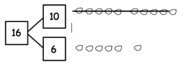
Make a simple math drawing. Cross out from the 10 ones to show what happens in the stories.
I had 16 grapes. I ate 9 grapes.
How many grapes do I have now?
Now I have 7 grapes.

- There were 15 squirrels by a tree. 10 of them were eating nuts. 5 squirrels were playing. A loud noise scared away 9 of the squirrels eating nuts. How many squirrels were left by the tree?

There were ___ squirrels left by the tree.

- There are 17 ladybugs on the plant. 10 of them are on a leaf, and 7 of them are on the stem. 9 of the ladybugs on the leaf crawled away. How many ladybugs are still on the plant?

There are ___ ladybugs on the plant.
- Use the number bond to fill in the math story. Make a simple math drawing.
Cross out from 10 ones or some ones to show what happens in the stories.
There were ____ ants in the ant hill.
10 of the ants are sleeping and ____ of them are awake. 9 of the sleeping ants woke up.
How many ants are awake now?
13
3
10

Math drawing:

There are ____ ants awake now.

- Use the number bond below to come up with your own math story. Include a simple math drawing. Cross out from 10 ones to show what happens.
Math drawing:

14
4
10

Number sentences:

Statement:

ooooo ooooo

5-group row cards
5-group row insert

