Lesson 11
Objective: Share and critique peer solution strategies for put together with total unknown word problems.

Suggested Lesson Structure
 Fluency Practice (13 minutes)
 Application Problem (6 minutes)
 Concept Development (31 minutes)
 Student Debrief (10 minutes)
Total Time (60 minutes)
Fluency Practice (13 minutes)
- Sprint: Adding Across Ten 1.OA.6 (10 minutes)
- Rekenrek: Ten Less 1.NBT.5 (3 minutes)
Sprint: Adding Across Ten (10 minutes)
Materials: (S) Sprint: Adding Across Ten
Note: This Sprint reviews the make ten addition strategy.
Rekenrek: Ten Less (3 minutes)
Materials: (T) Rekenrek
Note: This is an anticipatory fluency for the take from ten subtraction strategy in Topic B where students need to decompose numbers by taking out a ten.
T: (Show 14 on the Rekenrek). Say the number.
S: 14.
T: Say it the Say Ten way.
S: Ten 4.
T: What will my number be if I take out ten ones?
S: 4.
T: Let’s check. (Take out ten.) Yes!
Continue with other teen numbers.
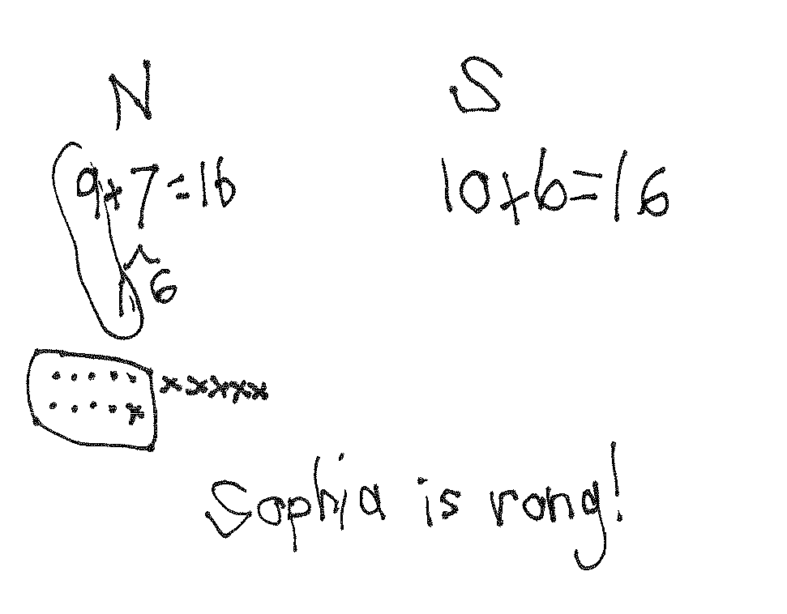
Application Problem (6 minutes)
Nicholas bought 9 green apples and 7 red apples. Sofia bought 10 red apples and 6 green apples. Sofia thinks she has more apples than Nicholas. Is she right? Choose a strategy you have learned to show your work. Then, write number sentences to show how many apples Nicholas and Sofia each have.
Note: This problem allows students to revisit equivalent expressions as they work with 9 + 7 and 10 + 6. The teacher can extend this thinking by either showing 9 + 7 = 10 + 6 or having students write the true number sentence themselves, then asking students to explain how they know.
Concept Development (31 minutes)
Materials: (T) Student work samples- make ten strategies (Template) (S) Personal white board
Have students come to the meeting area and sit in a semi-circle.
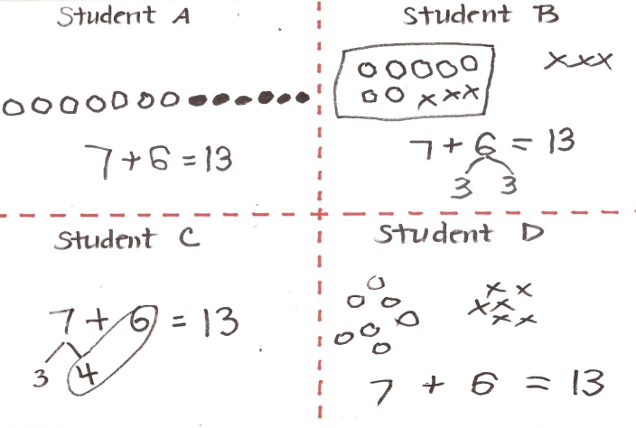
T: (Project and read.) Louie made 7 puppets out of paper bags. Roberto made 6 puppets out of socks. How many puppets did the boys make? (Pause.) Turn and talk to your partner about how you would solve this problem.
S: (Discuss as teacher circulates and listens.)
T: (Project Student A sample.) How did Student A solve this problem? Explain to your partner what this student was thinking.
S: She counted all the circles starting with 1.
Maybe she used counting on. Seeeven, 8, 9, 10, 11, 12, 13.
T: (Project Student B sample.) How did Student B solve this problem? Can you explain his thinking? Turn and talk to your partner.
S: He drew his shapes in 5-groups. When he made ten starting with 7, he drew a frame around it so you can see 10 and 3. His strategy was to make ten from 7 by breaking 6 into 3 and 3.
T: (Project Student C sample.) How did Student C solve this problem? How is it similar and different from Student B’s work?
S: She didn’t need to make a picture. She used the make ten strategy. But instead of making ten with 7, she made ten with 6 and broke apart 7 into 4 and 3.
T: (Project Student D sample.) How did Student D solve the problem?
S: He drew a picture, but it’s a little hard to count because the shapes are not organized. He probably had to count all of them, starting with 1. Or maybe he counted on from 7. Seeeven, 8, 9, 10, 11, 12, 13.
T: Do these all show ways to solve the problem? Which way seems like it’s a better shortcut? Turn and talk to your partner.
S: (Discuss as teacher circulates and listens.)
T: Oh, I found one more! Actually, I did this one. Ta-dah! Pretend you are my teacher and take a look at my work. What are your thoughts? (Project teacher work.)
S: Your picture is organized. I like the way you drew your circles in a 5-group. But you didn’t solve it right. The picture doesn’t make sense.
T: What do you mean? With your partner, draw a picture that will help me see how I can make this better.
S: (Discuss as teacher circulates and listens.)

NOTES ON
MULTIPLE MEANS
OF ENGAGEMENT:
Make sure to validate the different strategies students are using to solve so no one feels they have completed the work incorrectly. Be sensitive to students thinking in different ways and encourage and cultivate healthy competition in your classroom.

T: How can you help me get the correct answer? What did I do wrong?
S: You need to make ten by taking apart 3 from 6. You just added 10 and 6 here. Not 10 and 3.
T: Good work! Let’s try another problem!
T: (Project and read aloud.) Louie glued on 5 pieces of brown yarn for his puppet’s hair. He then glued on 8 pieces of red yarn for more hair. How many pieces of yarn did Louie use? (Pause.) Solve this problem by showing your work clearly on your personal white board.
S: (Solve.)
Have students swap personal white boards with their partners and discuss the following:

NOTES ON
MULTIPLE MEANS
OF ENGAGEMENT:
As students compare their strategies, be sure to listen to their conversations.
By having these discussions with one another, you are facilitating students’ reflection and ability to actively process what they are learning.

- Study what strategy your partner used.
- Did you get the same answer?
- Take turns to explain your partner’s strategy.
- Are your strategies similar? How? Are they different? How?
- What did your partner do well?
- Which strategy is more efficient?
If time allows, repeat partner work following the suggested sequence: 9 + 7, 8 + 6, and 7 + 7.

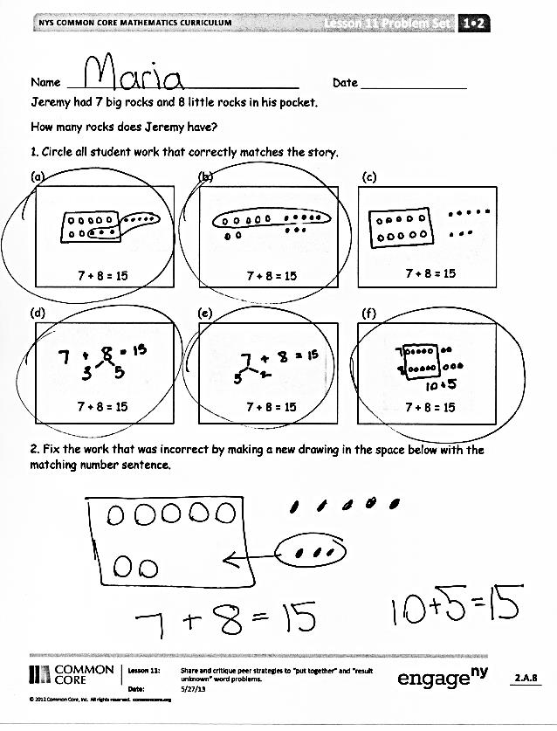
Problem Set (10 minutes)
Students should do their personal best to complete the Problem Set within the allotted 10 minutes. For some classes, it may be appropriate to modify the assignment by specifying which problems they work on first.
Some problems do not specify a method for solving. Students should solve these problems using the RDW approach used for Application Problems.
Student Debrief (10 minutes)
Lesson Objective: Share and critique peer solution strategies for put together with total unknown word problems.
The Student Debrief is intended to invite reflection and active processing of the total lesson experience.
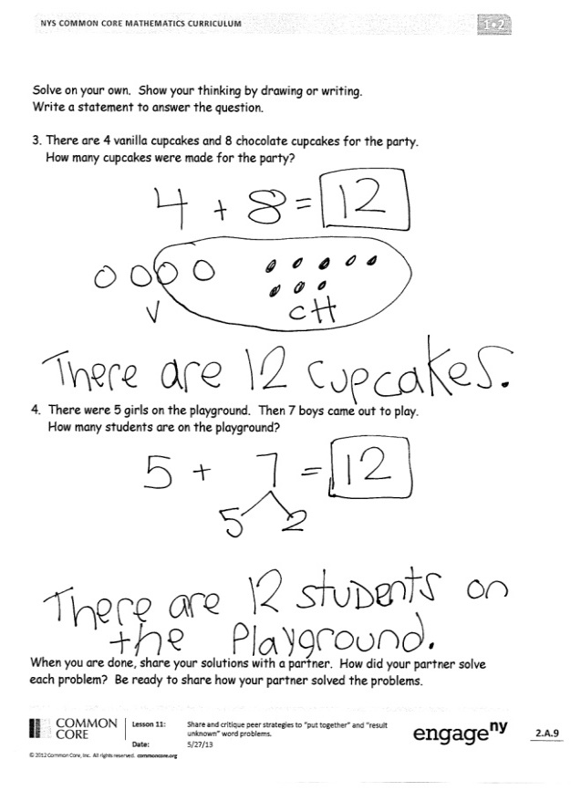
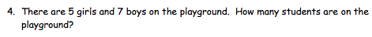
Invite students to review their solutions for the Problem Set. They should check work by comparing answers with a partner before going over answers as a class. Look for misconceptions or misunderstandings that can be addressed in the Debrief. Guide students in a conversation to debrief the Problem Set and process the lesson. You may choose to use any combination of the questions below to lead the discussion.
- Compare Problem 3 to Problem 4 with your partner. How are your strategies similar and different?
- Look at Problem 1(b). How did this student solve his problem? How is it similar and different from the way we use the make ten strategy?
- Which samples use similar strategies? Explain your thinking.
- Which sample seems like it could be the most efficient strategy once you became an expert with it?
Exit Ticket (3 minutes)
After the Student Debrief, instruct students to complete the Exit Ticket. A review of their work will help you assess the students’ understanding of the concepts that were presented in the lesson today and plan more effectively for future lessons. You may read the questions aloud to the students.
Name Date
Number correct:
A
*Write the missing number.
1 | 9 + 2 = ☐ |  | 16 | 4 + 8 = ☐
2 | 9 + 3 = ☐ |  | 17 | 8 + 4 = ☐
3 | 9 + 5 = ☐ |  | 18 | 7 + 4 = ☐
4 | 9 + 4 = ☐ |  | 19 | 7 + 5 = ☐
5 | 8 + 2 = ☐ |  | 20 | 7 + 6 = ☐
6 | 8 + 3 = ☐ |  | 21 | 6 + 7 = ☐
7 | 8 + 5 = ☐ |  | 22 | 9 + 9 = ☐
8 | 8 + 4 = ☐ |  | 23 | 9 + ☐ = 18
9 | 9 + 4 = ☐ |  | 24 | ☐ + 4 = 13
10 | 8 + 5 = ☐ |  | 25 | ☐ + 4 = 12
11 | 9 + 5 = ☐ |  | 26 | 12 = 3 + ☐
12 | 8 + 6 = ☐ |  | 27 | 16 = 8 + ☐
13 | 9 + 6 = ☐ |  | 28 | 9 + 4 = 8 + ☐
14 | 6 + 9 = ☐ |  | 29 | 9 + 3 = 5 + ☐
15 | 9 + 6 = ☐ |  | 30 | ☐ + 7 = 8 + 6
Name Date
Number correct:
B
*Write the missing number.

1 | 9 + 1 = ☐ |  | 16 | 3 + 8 = ☐
2 | 9 + 2 = ☐ |  | 17 | 8 + 3 = ☐
3 | 9 + 4 = ☐ |  | 18 | 7 + 3 = ☐
4 | 9 + 3 = ☐ |  | 19 | 7 + 4 = ☐
5 | 8 + 2 = ☐ |  | 20 | 7 + 5 = ☐
6 | 8 + 3 = ☐ |  | 21 | 5 + 7 = ☐
7 | 8 + 5 = ☐ |  | 22 | 8 + 8 = ☐
8 | 8 + 4 = ☐ |  | 23 | 8 + ☐ = 16
9 | 9 + 4 = ☐ |  | 24 | ☐ + 3 = 12
10 | 8 + 5 = ☐ |  | 25 | ☐ + 4 = 12
11 | 9 + 5 = ☐ |  | 26 | 12 = 3 + ☐
12 | 8 + 7 = ☐ |  | 27 | 14 = 7 + ☐
13 | 9 + 7 = ☐ |  | 28 | 9 + 3 = 8 + ☐
14 | 7 + 9 = ☐ |  | 29 | 9 + 3 = 5 + ☐
15 | 9 + 7 = ☐ |  | 30 | ☐ + 7 = 8 + 5
Name Date
Jeremy had 7 big rocks and 8 little rocks in his pocket.
How many rocks does Jeremy have?
- Circle all student work that correctly matches the story.
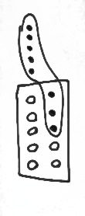
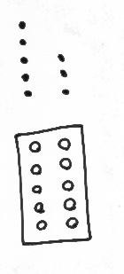
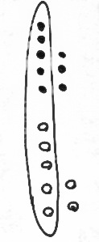
a. b. c.
7 + 8 = 15
7 + 8 = 15
7 + 8 = 15

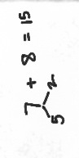
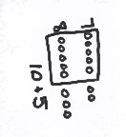
d. e. f.
7 + 8 = 15
7 + 8 = 15
7 + 8 = 15

- Fix the work that was incorrect by making a new drawing in the space below with the matching number sentence.
7 + 8 =5

Solve on your own. Show your thinking by drawing or writing. Write a statement to answer the question.

- There are 4 vanilla cupcakes and 8 chocolate cupcakes for the party. How many cupcakes were made for the party?

_________________________________________________________________

- There are 5 girls and 7 boys on the playground. How many students are on the playground?

_________________________________________________________________
When you are done, share your solutions with a partner. How did your partner solve each problem? Be ready to share how your partner solved the problems.
Name Date
John thinks the problem below should be solved using 5-group drawings, and Sue thinks it should be solved using a number bond. Solve both ways and circle the strategy you think is the more efficient.
- Kim scores 5 goals in her soccer game and 8 runs in her softball game. How many points does she score altogether?
John’s work Sue’s work

Name Date
Look at the student work. Correct the work. If the answer is incorrect, show a correct solution in the space below the student work.
- Todd has 9 red cars and 7 blue cars. How many cars does he have altogether?
Mary’s work Joe’s work Len’s work
9 + 7 = 16
9 + 7 = 16
9 + 7 = 15

- Jill has 8 beta fish and 5 goldfish. How many fish does she have in total?
Frank’s work Lori’s work Mike’s work
8 + 5 = 13
8 + 5 = 13
8 + 5 = 14

- Dad baked 7 chocolate and 6 vanilla cupcakes. How many cupcakes did he bake in all?
Mary’s work Joe’s work Lori’s work
7 + 6= 13
10 + 3 = 13 13
13 = 7 + 6

- Mom caught 9 fireflies and Sue caught 8 fireflies. How many fireflies did they catch altogether?
Mike’s work Len’s work Frank’s work
10 + 7 = 17
18 = 9 + 8
17 = 9 + 8

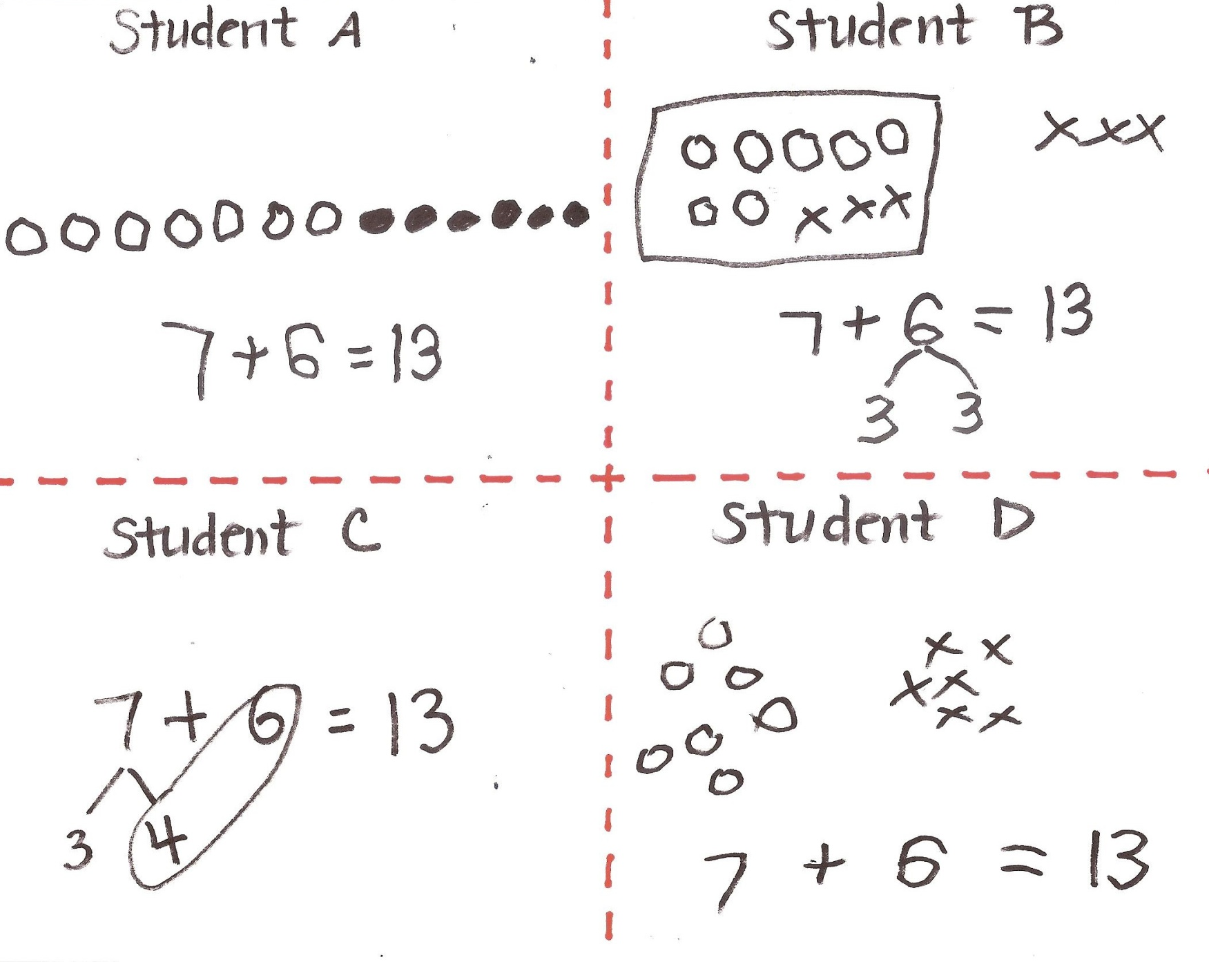

student work samples- make ten strategies

