Lesson 10
Objective: Solve problems with addends of 7, 8, and 9.

Suggested Lesson Structure
 Fluency Practice (10 minutes)
 Application Problem (6 minutes)
 Concept Development (30 minutes)
 Student Debrief (14 minutes)
Total Time (60 minutes)
Fluency Practice (10 minutes)
- 1, 2, and 3 Less 1.OA.6 (3 minutes)
- Decomposing Addition Sentences 1.OA.6 (5 minutes)
- Happy Counting by Threes 1.OA.5 (2 minutes)
1, 2, and 3 Less (3 minutes)
Note: This fluency activity prepares students for today’s lesson as students decompose numbers to make ten with addends of 7, 8, and 9.
T: On my signal, say the number that is 1 less.
T: 3.
S: 2.
Continue with all numbers within 10. Then repeat with 2 less and 3 less.
Decomposing Addition Sentences (5 minutes)
Note: This activity reviews how to decompose numbers to make ten, creating equivalent but easier number sentences.
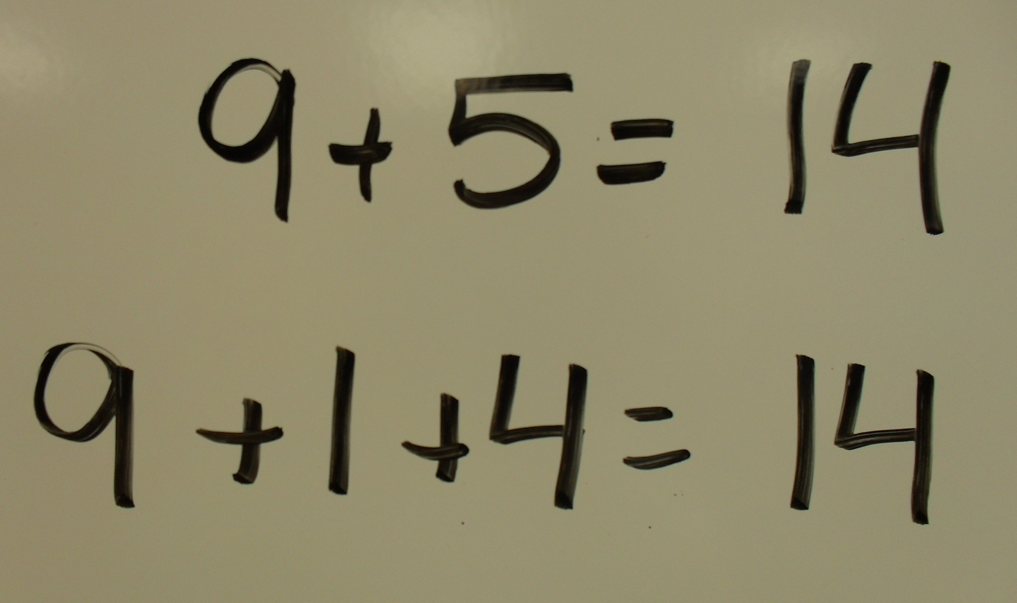
Write number sentences on the board to model how to decompose number sentences into three addends.
T: (Write 9 + 5 = ___ on the board.) What does 9 need to make ten?
S: 1.
T: (Write 9 + 1 below 9 + 5 = ___.)
T: (Point to the 5.) If we take 1 from 5 to make ten, what part is left?
S: 4.
T: (Add + 4 after 9 + 1.) Say the number sentence with the answer.
S: 9 + 1 + 4 = 14.
T: (Write 14 to complete 9 + 1 + 4 = ___.) 9 + 1 + 4 = 14. 9 + 5 is…?
S: 14.
T: (Write 14 to complete 9 + 5 = ___.)
Continue with other 9 + n and 8 + n addition sentences. If students are ready, have them use their boards to independently decompose addition sentences into three parts.

NOTES ON
MULTIPLE MEANS
OF ENGAGEMENT:
Maintain student attention with short fluency games that are energetically presented.

Happy Counting by Threes (2 minutes)
Note: Review of counting on and back allows students to maintain fluency with adding and subtracting 3.
Repeat the Happy Counting activity from Lesson 4, counting by threes from 0 to 12 and back.
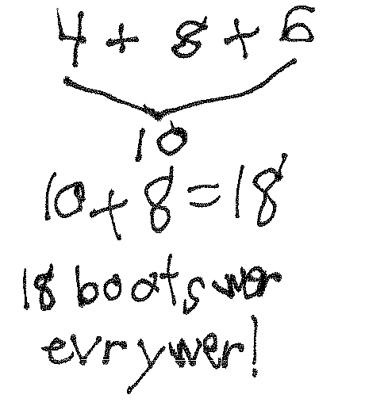
Application Problem (6 minutes)
There were 4 boots by the classroom door, 8 boots in the hallway, and 6 boots by the teacher’s desk. How many boots were there altogether?
Extension: How many pairs of boots were there in all?
Note: In this problem, the numbers 4, 8, and 6 are used as addends. To solve, students may choose to make ten by adding (4 + 6) + 8, or they may choose to decompose either the 4 or 6 to make ten with 8. During the Debrief, students have the opportunity to share work and notice how peers are using Level 3 strategies such as making ten to solve.
Concept Development (30 minutes)
Materials: (S) Personal white board, numeral cards or 5-group cards, one + card for each student, and
one "=″ card for each pair of students (Lesson 1 Fluency Template)
Have students come to the meeting area with their personal white boards and sit in a semi-circle.
T: (Write 9 + 6 = ___ on the board.) Using an organized math drawing or a number bond, solve 9 + 6. Think about the equal 10+ fact, and write a true number sentence using two expressions.
S: (Solve by drawing or using a number bond as teacher circulates.)
T: (Choose one student to share the use of counting on and another student to share the use of making ten.) When there is a 9 as an addend, what could you do to the other addend?
S: Get the 1 out! Break apart 6 into 1 and 5 as parts.
Repeat the process with 4 + 8. Begin by asking students which number they should make ten with to solve more efficiently.
T: (Write 7 + 6 = ___ on the board.) Turn and talk to your partner. How might you solve this problem using what you already know about the make ten strategy?

NOTES ON
MULTIPLE MEANS
OF ACTION AND EXPRESSION:
Before sharing as a class, have students share their strategies with a partner. Hearing how problems were solved more than once helps those students who are still learning the process and your English language learners.

T: Which number should we make ten with? Why?
S: Make ten with 7 because it’s only 3 away from 10. 6 is 4 away from 10. It’s easier for me to get the missing part from 7 than 6.
T: With your partner, use a number bond to solve this problem.
T: Look at your picture. What expression is 7 + 6 the same as?
S: 10 + 3!
T: Write that as a true number sentence.
S: (Write 7 + 6 = 10 + 3 or 10 + 3 = 7 + 6.)
T: What is 10 + 3?
S: 13.
T: So, what is 7 + 6? Say the number sentence.
S: 7 + 6 = 13.
Repeat the process with 4 + 7, 7 + 5, and 7 + 7.
T: When 7 is the bigger addend, what could you do to the other addend?
S: Get the 3 out! Make 3 as a part.
T: Now, we are going to play Simple Strategies! (Assign partners. Instruct each pair to combine their numeral cards and make two piles: digits 1–6 and digits 7–9, placing the 9 card on top of the second pile.) Here’s how you play:
- Partner A picks a card from the first pile (digits 1–6).
MP.8
MP.7
- Using the 9 card from the second pile and the card picked by Partner A, Partner B writes an addition expression (e.g., 6 + 9).
- Partners use counting on and then use making ten to solve the expression.
MP.7
- After using the make ten strategy, Partner A writes down the equal 10 + ___ fact.
- Partners place the equal sign card between the boards to make a true number sentence.
- Switch roles. Keep the 9 card up each time you begin a new expression.
As students play, the teacher circulates and moves students to replacing the 9 card with the 8 card and then the 7 card, as appropriate.
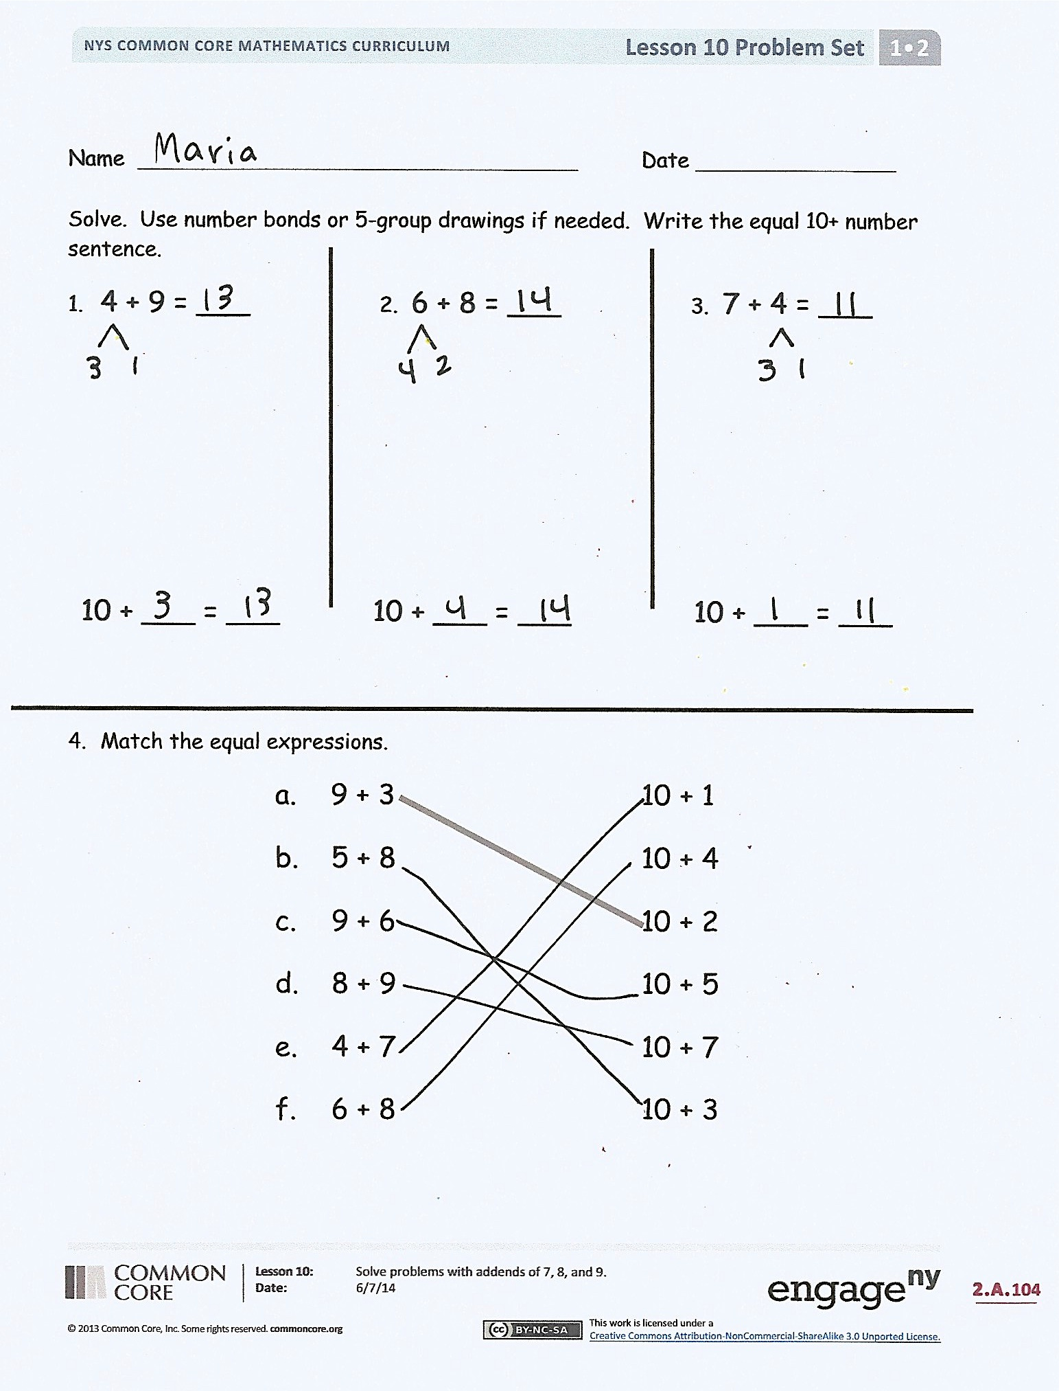
Problem Set (10 minutes)
Students should do their personal best to complete the Problem Set within the allotted 10 minutes. For some classes, it may be appropriate to modify the assignment by specifying which problems they work on first. Some problems do not specify a method for solving. Students should solve these problems using the RDW approach used for Application Problems.
Student Debrief (14 minutes)
Lesson Objective: Solve problems with addends of 7, 8, and 9.
The Student Debrief is intended to invite reflection and active processing of the total lesson experience.
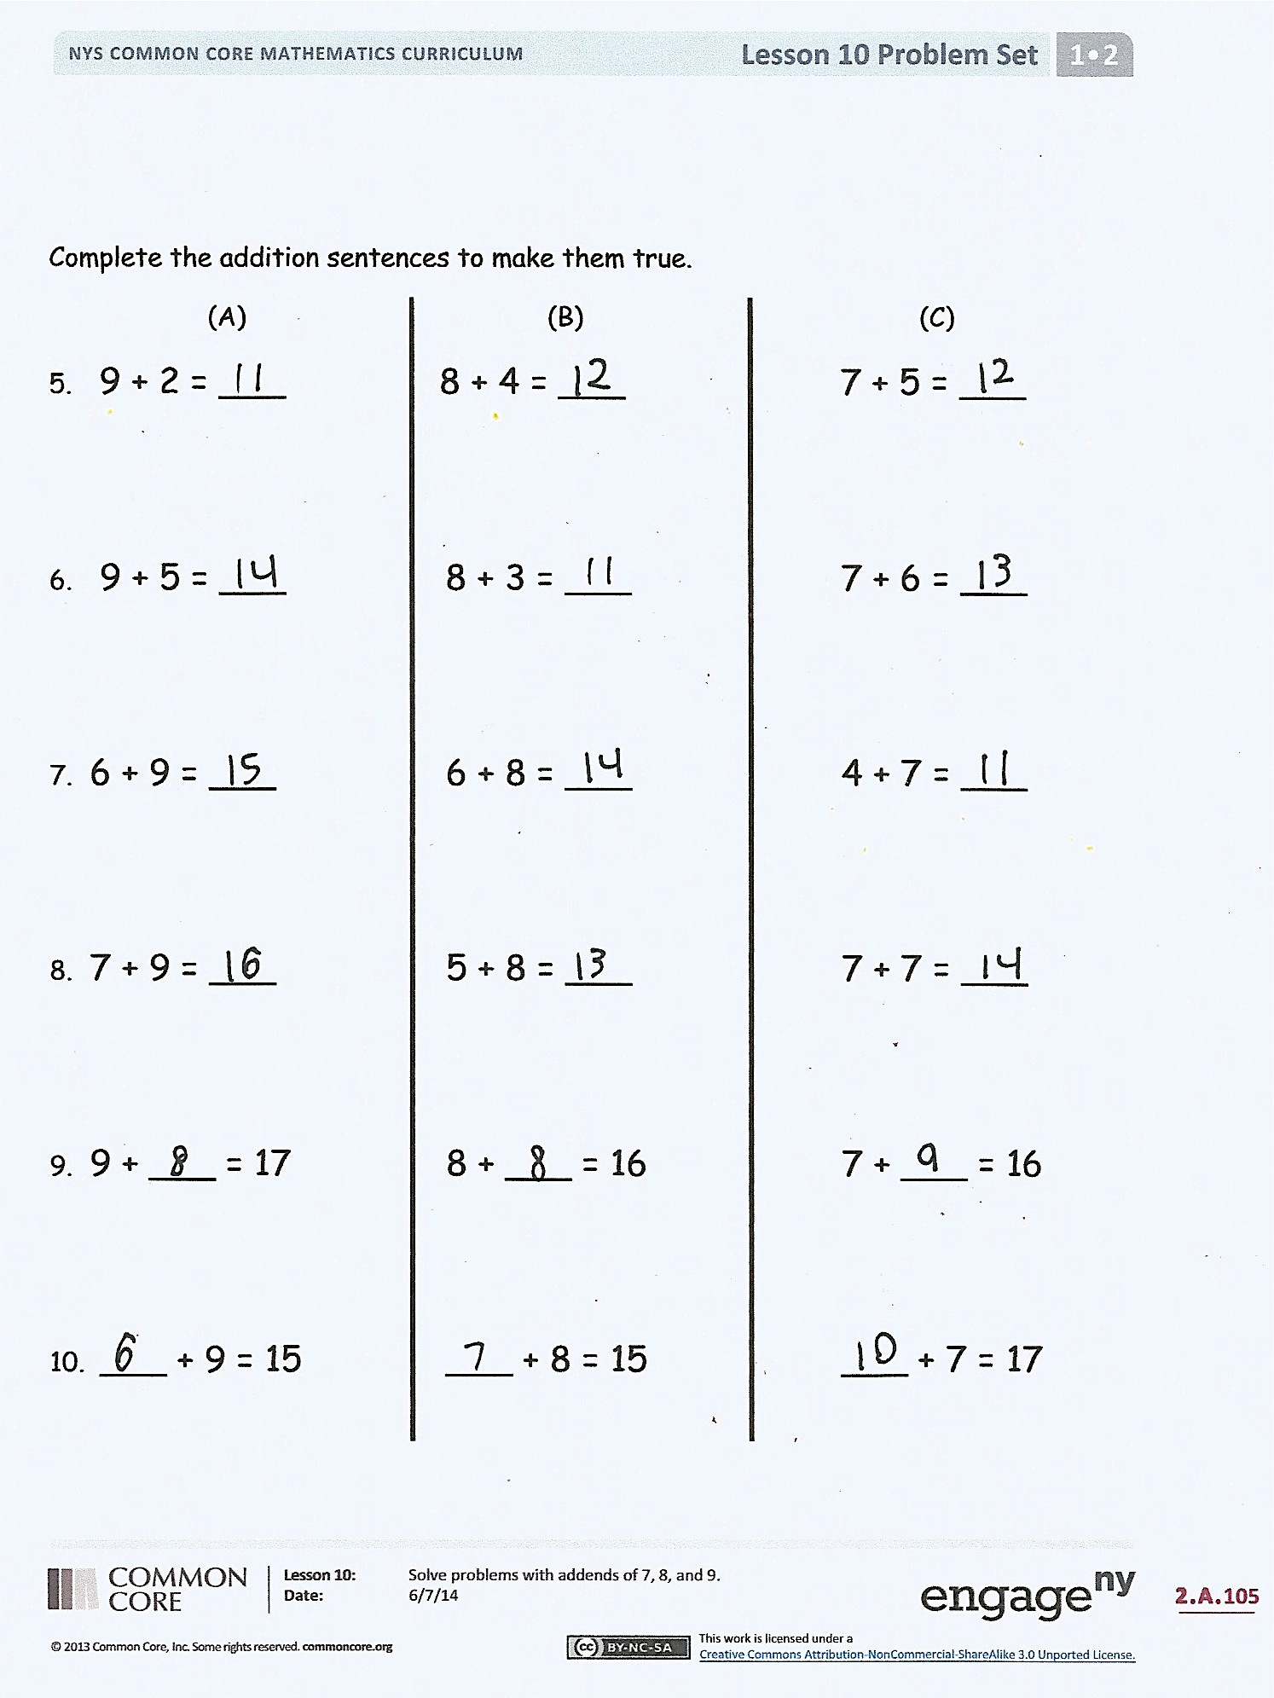
Invite students to review their solutions for the Problem Set. They should check work by comparing answers with a partner before going over answers as a class. Look for misconceptions or misunderstandings that can be addressed in the Debrief. Guide students in a conversation to debrief the Problem Set and process the lesson.
You may choose to use any combination of the questions below to lead the discussion.
- Look at Problems 8–10. Can you find number sentences that have the same total? What are the number sentences? How are they related?
- Why is it efficient to start with a larger addend when you add? Give an example.
- Solve 9 + 6 = ___, 8 + 6 = ___, 7 + 6 = ___. What patterns do you notice? Look at how you broke apart the second addend. What patterns do you see there? How did this breaking apart affect your totals? (When you take out 1 more from the second addend, your total is 1 less.)
- Which is easiest for you to use? Counting on, making ten, or just knowing? Why?

Exit Ticket (3 minutes)
After the Student Debrief, instruct students to complete the Exit Ticket. A review of their work will help you assess the students’ understanding of the concepts that were presented in the lesson today and plan more effectively for future lessons. You may read the questions aloud to the students.

Name Date
Solve. Use number bonds or 5-group drawings if needed. Write the equal 10+ number sentence.

- 4 + 9 = ___
- 6 + 8 = ___
- 7 + 4 = ___

10 + ___ = ___
10 + ___ = ___
10 + ___ = ___

- Match the equal expressions.
a. 9 + 3 10 + 1
b. 5 + 8 10 + 4
c. 9 + 6 10 + 2
d. 8 + 9 10 + 5
e. 4 + 7 10 + 7
f. 6 + 8 10 + 3

Complete the addition sentences to make them true.
(A) (B) (C)
- 9 + 2 = ___ 8 + 4 = ___ 7 + 5 = ___
- 9 + 5 = ___ 8 + 3 = ___ 7 + 6 = ___
- 6 + 9 = ___ 6 + 8 = ___ 4 + 7 = ___
- 7 + 9 = ___ 5 + 8 = ___ 7 + 7 = ___
- 9 + ___ = 17 8 + ___ = 16 7 + ___ = 16
- ___ + 9 = 15 ___ + 8 = 15 ___ + 7 = 17
Name Date
Solve. Use number bonds or 5-group drawings if needed. Write the equal 10+ number sentence.
c.
b.
a.
9 + 5 = ___ 8 + 4 = ___ 7 + 6 = ___

10 + ___ = ___ 10 + ___ = ___ 10 + ___ = ___

Name Date
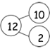
Solve. Match the number sentence to the 10+ number bond that helped you solve the problem. Write the 10+ number sentence.
1 2
9 + 3 = ___
__ + __ = ___
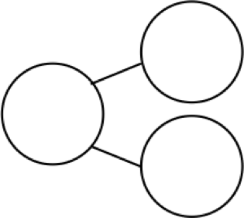
11
10
1
1. 8 + 6 = ___ ___ + ___ = ____
15
10
5
2. 7 + 5 = ___ ___ + ___ = ____
12
10
2
3. 5 + 8 = ___ ___ + ___ = ____
14
10
4
4. 4 + 7 = ___ ___ + ___ = ____
13
10
3
5. 6 + 9 = ___ ___ + ___ = ____
Complete the number sentences so they equal the given number bond.
6. 7. 8.
13
10
3
14
10
4

10
2

9 + ___ = 12 9 + ___ = 13 9 + ___ = 14
8 + ___ = 12 8 + ___ = 13 8 + ___ = 14
7 + ___ = 12 7 + ___ = 13 7 + ___ = 14
9. 10. 11.

10
7
16
10
6

10
5

15 = 9 + ___ 16 = 9 + ___ ___ = 9 + 8
___ = 8 + ___ ___ = 8 + ___ ___ = 8 + ___
___ = 7 + ___ 7 + ___ = ___ ___ = 7 + ___

