Lesson 9
Objective: Compare efficiency of counting on and making ten when one addend is 8.

Suggested Lesson Structure
 Fluency Practice (12 minutes)
 Application Problem (8 minutes)
 Concept Development (30 minutes)
 Student Debrief (10 minutes)
Total Time (60 minutes)
Fluency Practice (12 minutes)
- Decompose Addition Sentences into Three Parts 1.OA.6 (5 minutes)
- Cold Call: Break Apart Numbers 1.OA.6 (2 minutes)
- Make It Equal 1.OA.6 (5 minutes)
Decompose Addition Sentences into Three Parts (5 minutes)
Note: This fluency activity reviews adding three numbers and making ten when one addend is 8.
Decompose addition sentences into three addends that are more efficient to add.
T: (Write 8 + 3.) How many do we need from 3 to make ten?
S: 2.
T: Say 3 as an addition expression, starting with 2.
S: 2 + 1.
T: (Write 2 + 1 below the 3, showing the decomposition of 3.) Say 8 + 3 as a three-part addition sentence.
S: 8 + 2 + 1 = 11.
Repeat process for other problems.

Cold Call: Break Apart Numbers (2 minutes)
Note: This is an anticipatory fluency for making ten when one addend is 7 since 7 needs 3 to make ten.
Say a number between 3 and 10. Tell students you will cold call them to say the number bond with 3 as a part. Alternate between calling on individual students, the whole class, and groups of students (e.g., only boys, only girls). Use the example below as a reference.
T: 4. (Pause to provide thinking time.) Everybody.
S: 3 and 1.
T: 6. (Pause.) Boys.
S: (Only boys.) 3 and 3.
Repeat with numbers 3 through 10.
Make It Equal (5 minutes)
Materials: (S) 5-group cards, one = card, and two + cards (Lesson 1 Fluency Template) per set of partners
Note: This activity reinforces the make ten addition strategy as students relate 10 + n addition sentences to an equivalent sentence with an addend of 8 or 9. Students ready to use the numeral side of the 5-group cards should be encouraged to do so.
Assign students partners of equal ability. Students arrange 5-group cards from 0 to 10, including the extra 5, and place the "=″ card between them.
Write four numbers on the board (e.g., 10, 9, 1, and 2). Partners take the 5-group cards that match the numbers written to make two equivalent expressions (e.g., 10 + 1 = 9 + 2).
Suggested sequence: 10, 9, 1, 2; 10, 3, 9, 2; 10, 4, 5, 9; 10, 8, 1, 3; 10, 8, 4, 2; etc.
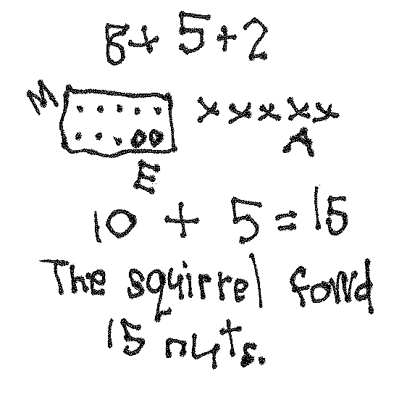
Application Problem (8 minutes)
A squirrel found 8 nuts in the morning, 5 nuts in the afternoon, and 2 nuts in the evening. How many nuts did the squirrel find in all?
Extension: The next day, the squirrel found 3 more nuts in the morning, 1 more in the afternoon, and 1 more in the evening. How many did he collect over the two days?
Note: This problem uses three addends, revisiting the associative and commutative properties from earlier in this topic. During the Debrief, students who used making ten as a strategy to solve share their work, supporting students’ development toward independent use of the strategy.
Concept Development (30 minutes)
Materials: (S) Personal white board
Have students sit at their desks or the meeting area with their personal white boards.
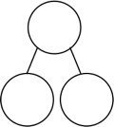
T: (Project or write the two number bonds shown here.) Which number bond are you able to solve faster?
8
6
10
4
S: 10 and 4!
T: (Write 10 + 4 = ___.) 10 + 4 is?
S: 14!
T: (Record the solution.) How did you know that so quickly?
S: Because we know our 10+ facts. Because 10 is a friendly number.
T: (Write 8 + 6 = ___.) Let’s count on to solve 8 + 6.
T/S: Eeeiiiight, 9, 10, 11, 12, 13, 14. 14!
T: (Record the solution.)
T: (On another line, write 8 + 6 = ___.) What expression is equal to 8 + 6?

NOTES ON
MULTIPLE MEANS
FOR ENGAGEMENT:
Students enjoy the use of interactive technology in the classroom. Do an Internet search of make ten or something similar. This provides some websites for use during independent time or if you have the means to use the website with the entire class.

S: 10 + 4!
T: (Record this to make the true number sentence
8 + 6 = 10 + 4.) Use your personal white board to show how you can solve 8 + 6 by making ten to be sure that this is a true number sentence.
S: (Solve by making ten with 8, taking apart 6 into 2 and 4, etc.)
T: (Read aloud.) Our friends Sergio and Lila are back again! They were getting ready to go to P.E. They both had to solve 8 + 7. The first one to solve it got to go to P.E. first! Sergio decided he was going to count on to solve it again. (Pause.) Was there another way to solve 8 + 7 that Sergio could have used?
15
8 7
S: (Discuss, as teacher circulates and listens.) Make ten! Take 2 from 7 to make ten with 8.
T: Some of you said that you would make ten. Well, that is just what Lila decided to do again. (Assign partners.) Partner A, explain to your partner how Sergio solved 8 + 7 by counting on. Partner B, explain to your partner how Lila solved
8 + 7 by making ten. Use your personal white board if it helps you share your thoughts.
15
10 5
S: (Discuss, as teacher circulates and listens.)

NOTES ON
MULTIPLE MEANS
OF ACTION AND EXPRESSION:
While encouraging students to use the most efficient strategy when solving number sentences, some may be able to use different number combinations as efficiently. For example, some might see 7 + 8 as 7 + 7 + 1 or 8 + 8 – 1, and some may already know 7 + 8 but benefit from the strategy discussion. Use this opportunity to show students how we all think differently. Have the students communicate their mathematical thinking to the class.

T: Help me make a number bond to show what Sergio did. What were the parts that Sergio used?
S: 8 and 7! (Write the bond.)
T: What was the whole?
S: 15. (Complete the bond.)
T: Help me make a number bond to show what Lila did. What were the parts that Lila used?
S: 10 and 5! (Write the bond.)
T: What was the whole?
S: 15. (Complete the bond.)
T: Which number bond will help you solve more efficiently?
S: 10 and 5.
T: So, based on these number bonds, and the work you and your partner just did, who do you think got to go to P.E. first?
S: Lila!
T: Again, you’re right! Since Lila really knows how to use the make ten strategy, she was able to solve for the unknown very quickly or efficiently. Sometimes it takes practice before we can use a strategy quickly. When a strategy is new to us, it can take longer for us to use it until we get better at it. Let’s keep practicing.
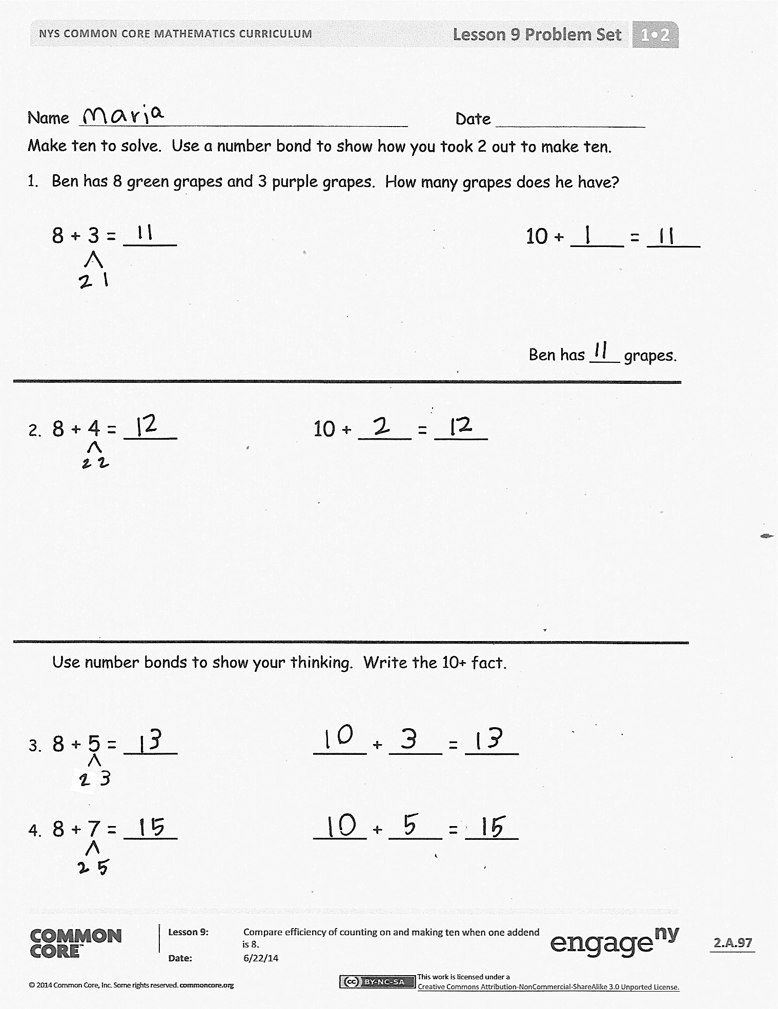
Continue with partners solving each problem, showing how to solve using counting on and making ten. The following is a suggested sequence of problems: 8 + 5, 8 + 4, 8 + 8, 8 + 3 (counting on may actually be more efficient here), and 8 + 9.
Problem Set (10 minutes)
Students should do their personal best to complete the Problem Set within the allotted 10 minutes. For some classes, it may be appropriate to modify the assignment by specifying which problems they work on first. Some problems do not specify a method for solving. Students should solve these problems using the RDW approach used for Application Problems.

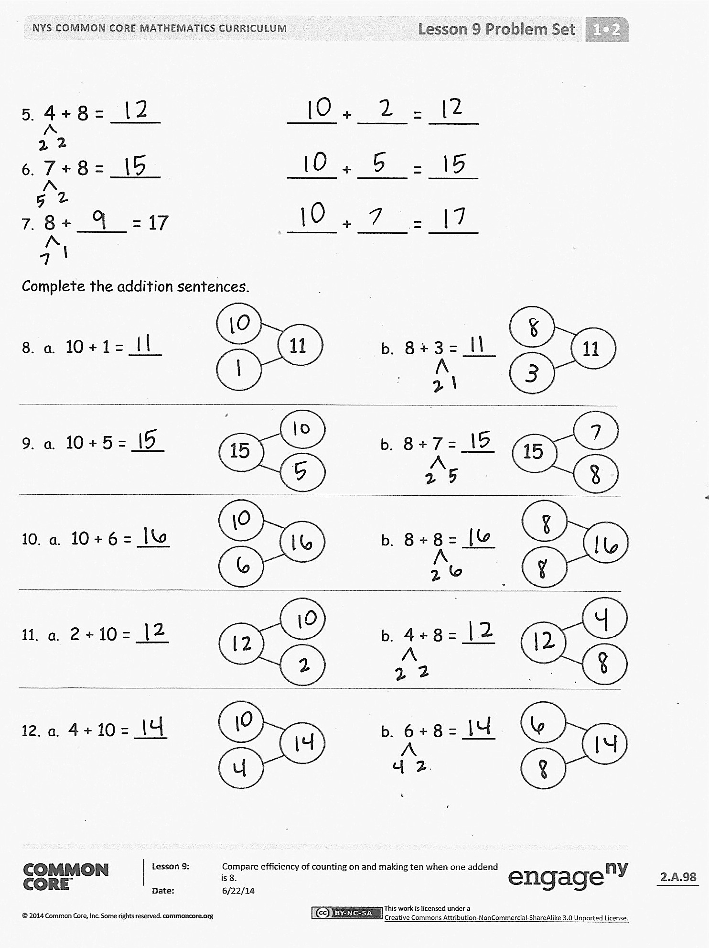
Student Debrief (10 minutes)
Lesson Objective: Compare efficiency of counting on and making ten when one addend is 8.
Note: Distribute student Problem Set from Lesson 5 for comparing with today’s Problem Set.
The Student Debrief is intended to invite reflection and active processing of the total lesson experience.
Invite students to review their solutions for the Problem Set. They should check work by comparing answers with a partner before going over answers as a class. Look for misconceptions or misunderstandings that can be addressed in the Debrief. Guide students in a conversation to debrief the Problem Set and process the lesson.
You may choose to use any combination of the questions below to lead the discussion.
- Look at Problem 1 and Problem 2. How are your bonds different? How can Problem 1 help you solve Problem 2?
- Look at Problems 8–10. What do you notice about the number bonds? How does knowing your 10+ facts help you with your 8+ facts?
- Look at Problem 5 and Problem 8. Do you think counting on or making ten was more efficient to solve these? Why?
- Look at your Problem Set from a few days ago. What do you notice about the answers when you have 9 as an addend compared to 8 as an addend? Why do you think this is?
- Look at your Application Problem. Would counting on or making ten help you solve this problem most efficiently? If you used making ten to solve this, share your work and explain your thinking.
- One first grader I know makes ten for some of her 8+ facts and counts on to solve others. Sometimes she just knows the solution. Is that true for any of you? Which 8+ facts do you use a particular strategy to help you solve? Why?
Exit Ticket (3 minutes)
After the Student Debrief, instruct students to complete the Exit Ticket. A review of their work will help you assess the students’ understanding of the concepts that were presented in the lesson today and plan more effectively for future lessons. You may read the questions aloud to the students.

Name Date
Make ten to solve. Use a number bond to show how you took 2 out to make ten.
- Ben has 8 green grapes and 3 purple grapes. How many grapes does he have?
10 + ____ = ____
8 + 3 = ____
Ben has ___ grapes.

- 8 + 4 = ____ 10 + ____ = ____

Use number bonds to show your thinking. Write the 10+ fact.
- 8 + 5 = ____ ____ + ____ = ____
- 8 + 7 = ____ ____ + ____ = ____
- 4 + 8 = ____ ____ + ____ = ____
- 7 + 8 = ____ ____ + ____ = ____
- 8 + ____ = 17 ____ + ____ = ____
Complete the addition sentences.
11
11

- a. 10 + 1 = ___ b. 8 + 3 = ___
15
15
- a. 10 + 5 = ___ b. 8 + 7 = ___
- a. 10 + 6 = ___ b. 8 + 8 = ___
- a. 2 + 10 = ___ b. 4 + 8 = ___
- a. 4 + 10 = ___ b. 6 + 8 = ___

Name Date
- Seyla has 3 stamps in her collection. Her father gives her 8 more stamps. How many stamps does she have now? Show how you make ten and write the 10+ fact.

3 + 8 = ____ 10 + ____ = ____

- Complete the addition sentences and the number bonds.

  - 8 + 6 = ___
- 10 + ___ = 14

Name Date
Use number bonds to show your thinking. Write the 10+ fact.
- 8 + 3 = ____ 10 + ____ = ____

- 6 + 8 = ____ ____ + 10 = ____

- ____ = 8 + 8 ____ = 10 + ____

- ____ = 5 + 8 ____ = 10 + ____

Complete the addition sentences.
15

- a. 7 + 8 = ___ b. 10 + 5 = ___
- a. 16 = ___ + 8 b. 10 + 6 = ___
- a. ___ = 9 + 8 b. 10 + 7 = ___
Draw a line to the matching number sentence. You may use a number bond or 5-group drawing to help you.

- 11 = 8 + 3
8 + 6 = 14

10 + 1 = 11
- Lisa had 5 red rocks and 8 white rocks. How many rocks did she have?
13 = 10 + 3
14
10
4

