Lesson 8
Objective: Make ten when one addend is 8.

Suggested Lesson Structure
 Fluency Practice (15 minutes)
 Application Problem (5 minutes)
 Concept Development (30 minutes)
 Student Debrief (10 minutes)
Total Time (60 minutes)
Fluency Practice (15 minutes)
- Sprint: 9 + n 1.OA.6 (10 minutes)
- Happy Counting by Twos 1.OA.5 (2 minutes)
- Take Out 2: Addition Sentences 1.OA.6 (3 minutes)
Sprint: 9 + n (10 minutes)
Materials: (S) 9 + n Sprint
Note: This Sprint provides practice with the make ten addition strategy, when one addend is 9.
Happy Counting by Twos (2 minutes)
Note: This reviewing of counting on allows students to maintain fluency with adding and subtracting 2.
Repeat the Happy Counting activity from Lesson 4, counting by twos from 0 to 20 and back (this range may be adjusted to meet the needs of students). As students strengthen their skills, start with other numbers such as 1, 7, 11, or 8.
Take Out 2: Addition Sentences (3 minutes)
Note: This activity supports the make ten addition strategy when one addend is 8 since 8 needs 2 to make ten.
Say a number between 2 and 10 (e.g., 3). Students say an addition sentence beginning with 2 (e.g., 2 + 1 = 3).

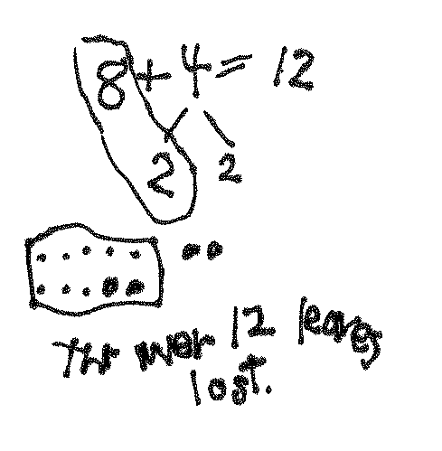
Application Problem (5 minutes)
A tree lost 8 leaves one day and 4 leaves the next. How many leaves did the tree lose at the end of the two days? Use a number bond, a number sentence, and a statement to match the story.
Extension: On the third day, the tree lost 6 leaves. How many leaves did it lose by the end of the third day?
Note: This problem revisits the idea of making ten when one addend is 8. It also challenges students to use addition, although the leaves are being lost.
Concept Development (30 minutes)
Materials: (T) 10 blue and 10 yellow linking cubes, ten-frame border (S) Personal white board
Have students come to the meeting area with their personal white boards.
T: (Project and read aloud.) Amy wrote 8 letters to her friends. Peter wrote 3 to his friends. How many letters did they write? (Pause.) What is the expression to solve this story?
S: 8 + 3.
T: How many blue cubes do I need to represent the number of letters Amy wrote? How should I arrange it?
S: 8 cubes. Put them in a 5-group.
T: Why should I organize them in 5-group?
S: It’s easy for everyone to see that there are 8 instead of counting the cubes.
T: With your partner, figure out how many letters Amy and Peter wrote. Use your personal white boards to record your work.
S: (Discuss and solve problem while teacher circulates and listens.)
T: How many letters did Amy and Peter write?
S: 11 letters!
T: How did you solve the problem?
S: I counted on from 8. Eiiight, 9, 10, 11. I put 2 cubes with the 8 blue ones and had 1 cube left. That made 11. I broke apart the 3 into 2 and 1 to make 10 and 1.
T: Let’s all try using this last strategy of making ten to solve this problem.
T: (Lay out 8 blue cubes.) How many yellow cubes do I need to represent the number of letters Peter wrote?
S: 3 cubes.
T: (Lay out 3 yellow cubes as a separate pile.) What should we do to add 8 and 3 efficiently?
S: Make ten!
T: How many does 8 need to make ten?
S: 2.

NOTES ON
MULTIPLE MEANS
OF ENGAGEMENT:
Adjust lesson structure to suit specific learning needs remembering that some students may need to keep practicing with their linking cubes as they complete problems.

T: (Place 2 yellow cubes into 5-group arrangement.)
T: Now that we have 10 here, we can put a frame around it. (Frame it.) Look at the new piles. What expression is 8 + 3 equal to?
S: 10 + 1.
T: Let’s write a true number sentence using these expressions. (Write 8 + 3 = 10 + 1.)
T: What’s 10 + 1?
S: 11.
T: (Write 10 + 1 = 11). So, what is 8 + 3? Say the number sentence.
S: 8 + 3 = 11.
T: (Write 8 + 3 = 11.) How many letters did Amy and Peter write?
S: 11 letters.
T: Show me on your board how we solved 8 + 3. Remember, it’s easy to show how we are solving 8 + 3 if we organize our math drawings just like the way we organized the cubes. Use empty circles to represent 8 and dark circles to represent 3. Don’t forget to put a frame around the 10 cubes!
S: (Draw.)

T: Where is the 3 in your picture?
S: (Point to 2 and 1.)
T: You are pointing to two different places. Why?
S: We broke 3 apart into 2 and 1.
T: Let’s use a number bond to show how we broke apart 3.

NOTES ON
MULTIPLE MEANS
OF ENGAGEMENT:
Offer opportunities for student leadership as “teacher.” Have students demonstrate for the class how they are breaking apart and joining their linking cubes. Listen for accurate use of math vocabulary in their descriptions. Math language in this lesson includes expression, organize, join, break apart, and frame.

T: Just like we framed the ten in our picture, we’ll frame the numbers that make ten. (Ring 8 and 2.)
T: 8 and 2 make?
S: 10.
T: 10 and 1 make?
S: 11.
T: So, 8 plus 3 equals?
S: 11!

Repeat the process adding the numbers 4–9 in order as time allows, alternating 8 as the first and the second addend. For the first example, use linking cubes to illustrate what the math drawings should look like. For the remainder of the examples, move towards having students draw without the visual aid. Before students add dark circles to their math drawing, ask them, "How many does 8 need to make ten?" and "How many do you have when you take away 2 from [the other addend]?" to guide how they can decompose the addend when drawing.
Be sure to have students make ten with 8, reinforcing the concept of commutativity for efficient problem solving. Be sure that they also write two number sentences (8 + 6 = 14, 10 + 4 = 14) and the equivalent expression (8 + 6 = 10 + 4).
Problem Set (10 minutes)
Students should do their personal best to complete the Problem Set within the allotted 10 minutes. For some classes, it may be appropriate to modify the assignment by specifying which problems they work on first. Some problems do not specify a method for solving. Students should solve these problems using the RDW approach used for Application Problems.
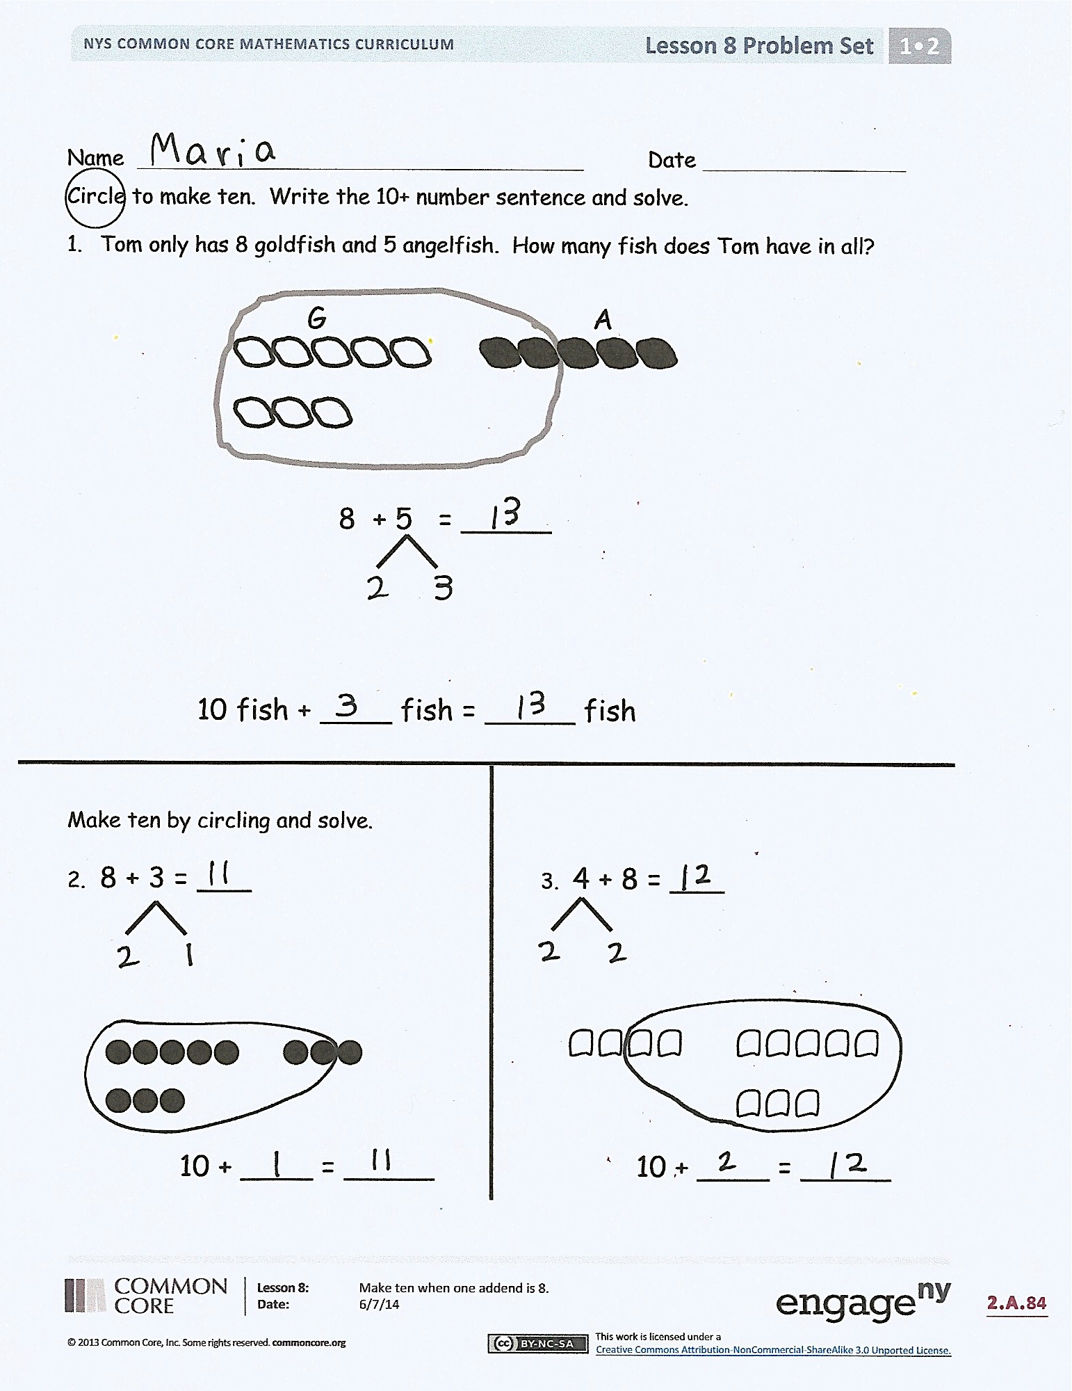
Student Debrief (10 minutes)
Lesson Objective: Make ten when one addend is 8.
Note: Distribute student Problem Set from Lesson 4 for comparing with today’s Problem Set.
The Student Debrief is intended to invite reflection and active processing of the total lesson experience.
Invite students to review their solutions for the Problem Set. They should check work by comparing answers with a partner before going over answers as a class. Look for misconceptions or misunderstandings that can be addressed in the Debrief. Guide students in a conversation to debrief the Problem Set and process the lesson.
You may choose to use any combination of the questions below to lead the discussion.
- Look at Problem 1 and Problem 6. How are your drawings different? Which drawing shows how you solved 8 + 5 more easily?
- What did you notice about having 8 as an addend? What happens to the other addend when it gets broken apart?
- How did Problem 6 help you solve Problem 7?
- Look at your Problem Set from a few days ago. What do you notice about the answers when you have 9 as an addend compared to 8 as an addend? Why do you think this is?
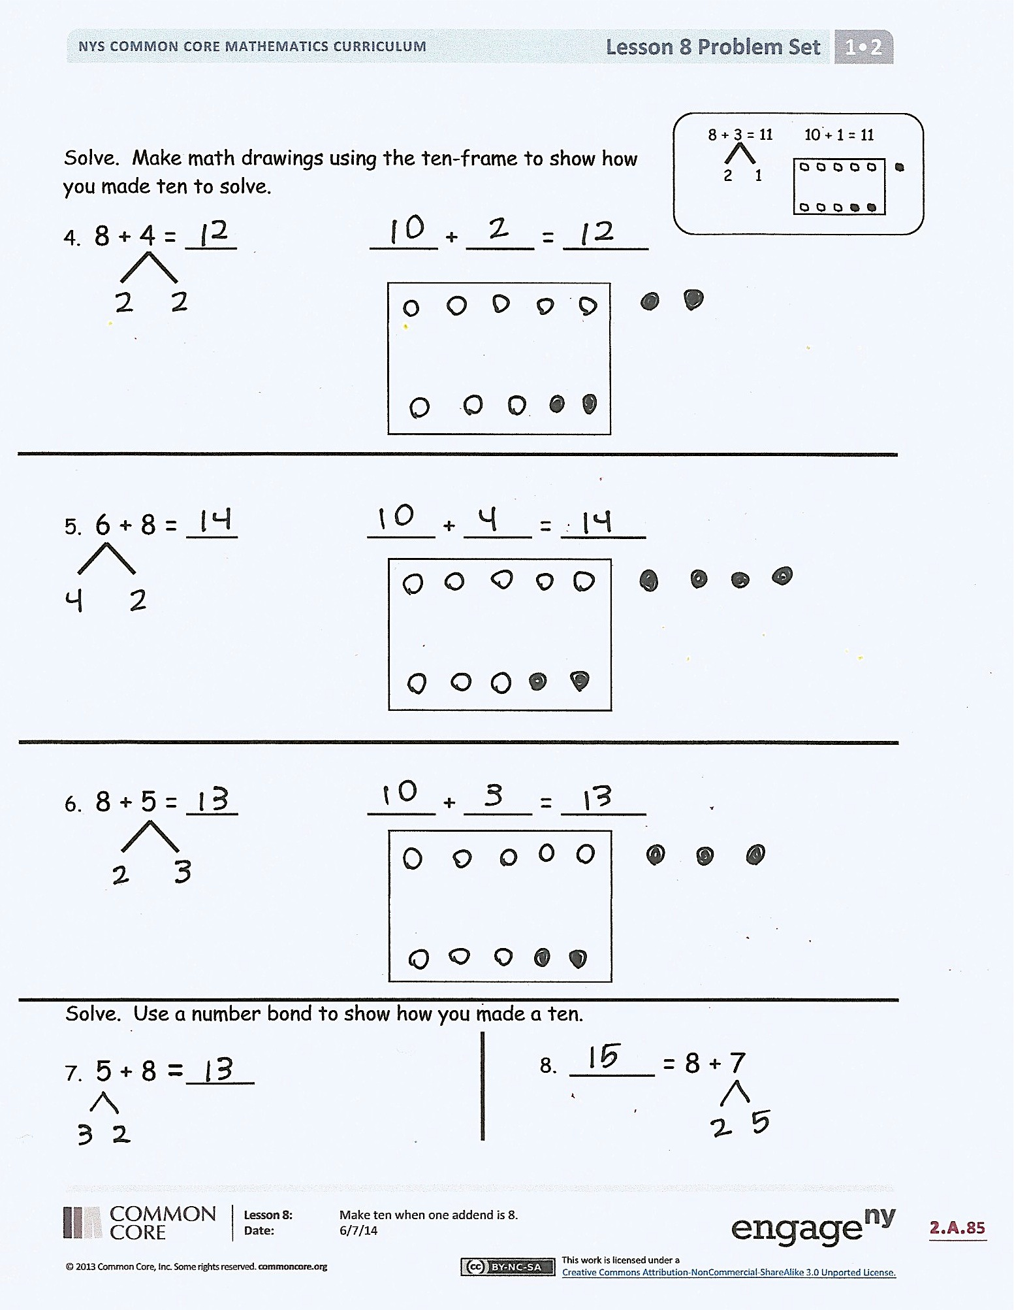
- How would you solve 8 + 9? Turn and talk to your partner. Explain your strategy.
- Why is it important to make our math drawings in an organized way?
- Look at your Application Problem. Draw an organized picture to show how you can solve this problem.
Exit Ticket (3 minutes)
After the Student Debrief, instruct students to complete the Exit Ticket. A review of their work will help you assess the students’ understanding of the concepts that were presented in the lesson today and plan more effectively for future lessons. You may read the questions aloud to the students.

Name Date
Number correct:
A
*Write the missing number.
1 | 9 + 1 = ☐ |  | 16 | 9 + 5 = ☐
2 | 10 + 1 = ☐ |  | 17 | 9 + 6 = ☐
3 | 9 + 2 = ☐ |  | 18 | 6 + 9 = ☐
4 | 9 + 1 = ☐ |  | 19 | 9 + 4 = ☐
5 | 10 + 2 = ☐ |  | 20 | 4 + 9 = ☐
6 | 9 + 3 = ☐ |  | 21 | 9 + 8 = ☐
7 | 9 + 1 = ☐ |  | 22 | 9 + 9 = ☐
8 | 10 + 4 = ☐ |  | 23 | 9 + ☐ = 18
9 | 9 + 5 = ☐ |  | 24 | ☐ + 6 = 15
10 | 9 + 1 = ☐ |  | 25 | ☐ + 6 = 16
11 | 10 + 6 = ☐ |  | 26 | 13 = 9 + ☐
12 | 9 + 7 = ☐ |  | 27 | 17 = 8 + ☐
13 | 9 + 1 = ☐ |  | 28 | 10 + 2 = 9 + ☐
14 | 10 + 8 = ☐ |  | 29 | 9 + 5 = 10 + ☐
15 | 9 + 9 = ☐ |  | 30 | ☐ + 7 = 8 + 9
Name Date
Number correct:
B
1 | 9 + 1 = ☐ |  | 16 | 5 + 9 = ☐
2 | 10 + 2 = ☐ |  | 17 | 6 + 9 = ☐
3 | 9 + 3 = ☐ |  | 18 | 9 + 6 = ☐
4 | 9 + 1 = ☐ |  | 19 | 9 + 7 = ☐
5 | 10 + 1 = ☐ |  | 20 | 7 + 9 = ☐
6 | 9 + 2 = ☐ |  | 21 | 9 + 8 = ☐
7 | 9 + 1 = ☐ |  | 22 | 9 + 9 = ☐
8 | 10 + 3 = ☐ |  | 23 | 9 + ☐ = 17
9 | 9 + 4 = ☐ |  | 24 | ☐ + 5 = 14
10 | 9 + 1 = ☐ |  | 25 | ☐ + 4 = 14
11 | 10 + 5 = ☐ |  | 26 | 15 = 9 + ☐
12 | 9 + 6 = ☐ |  | 27 | 16 = 7 + ☐
13 | 9 + 1 = ☐ |  | 28 | 10 + 4 = 9 + ☐
14 | 10 + 4 = ☐ |  | 29 | 9 + 6 = 10 + ☐
15 | 9 + 5 = ☐ |  | 30 | ☐ + 6 = 7 + 9
*Write the missing number.

Name Date
Circle to make ten. Write the 10+ number sentence and solve.
- Tom only has 8 goldfish and 5 angelfish. How many fish does Tom have in all?
Angelfish
Goldfish

8 + 5 = _____

10 fish + ____ fish = _____ fish

Make ten by circling and solve.

- 8 + 3 = ___
- 4 + 8 = ___

10 + ____ = _____
10 + ____ = _____
Solve. Make math drawings using the ten-frame to show how you made ten to solve.
8 + 3 = 11 10 + 1 = 11
2 1
- 8 + 4 = ___ ____ + ____ = _____

- 6 + 8 = ___ ____ + ____ = _____

- 8 + 5 = ___ ____ + ____ = _____

Solve. Use a number bond to show how you made a ten.

- 5 + 8 = ____
- _____ = 8 + 7

Name Date
Make math drawings using the ten-frame to solve. Rewrite as a 10+ number sentence.

- 6 + 8 = ___
- ___ = 4 + 8

10 + ___ = ___ ___ + ___ = ___

Name Date
Solve. Make math drawings using the ten-frame to show how you made ten to solve.
8 + 3 = 11 10 + 1 = 11
2 1

- 8 + 4 = ___ ____ + ____ = _____

- 8 + 6 = ___ ____ + ____ = _____

- 7 + 8 = ___ ____ + ____ = _____

4. Make math drawings using ten-frames to solve. Circle the true number sentences.
Write an X to show number sentences that are not true.

- 8 + 4 = 10 + 2
- 10 + 6 = 8 + 8
- 7 + 8 = 10 + 6

- 5 + 10 = 5 + 8
- 2 + 10 = 8 + 3
- 8 + 9 = 10 + 7

