Lesson 7
Objective: Make ten when one addend is 8.

Suggested Lesson Structure
 Fluency Practice (13 minutes)
 Application Problem (7 minutes)
 Concept Development (30 minutes)
 Student Debrief (10 minutes)
Total Time (60 minutes)
Fluency Practice (13 minutes)
- Add to 9 1.OA.6 (5 minutes)
- Friendly Fact Go Around: Make it Equal 1.OA.6 (5 minutes)
- Take Out 2: Addition Sentences 1.OA.6 (3 minutes)
Add to 9 (5 minutes)
Materials: (T) 9 + n addition cards (Fluency Template 1) (S) Personal white board
Note: This activity supports the make ten addition strategy as students need to fluently decompose an addend in order to make ten.
Show an addition flashcard (e.g., 9 + 3). Students write the three-addend equation (9 + 1 + 2 = 12).
Friendly Fact Go Around: Make it Equal (5 minutes)
Materials: (T) Friendly Fact Go Around: Make it Equal (Fluency Template 2)
Note: This activity reinforces the make ten adding strategy and promotes an understanding of equality.
Project the Friendly Fact Go Around: Make it Equal (or make and display a poster). Point to a problem and call on a student: 9 + 6 = 10 + . The student answers “five.” The class says the number sentence aloud with the answer, “9 + 6 = 10 + 5.” If a student gives an incorrect answer, he then repeats the correct equation that the class has given. The teacher can adapt the problem to individual children, pointing to easier problems for children who are less fluent.

Take Out 2: Addition Sentences (3 minutes)
Note: This activity supports the make ten addition strategy when one addend is 8, since 8 needs 2 to make ten.
Say a number between 2 and 10 (e.g., 3). Students say an addition sentence beginning with 2 (e.g., 2 + 1 = 3).
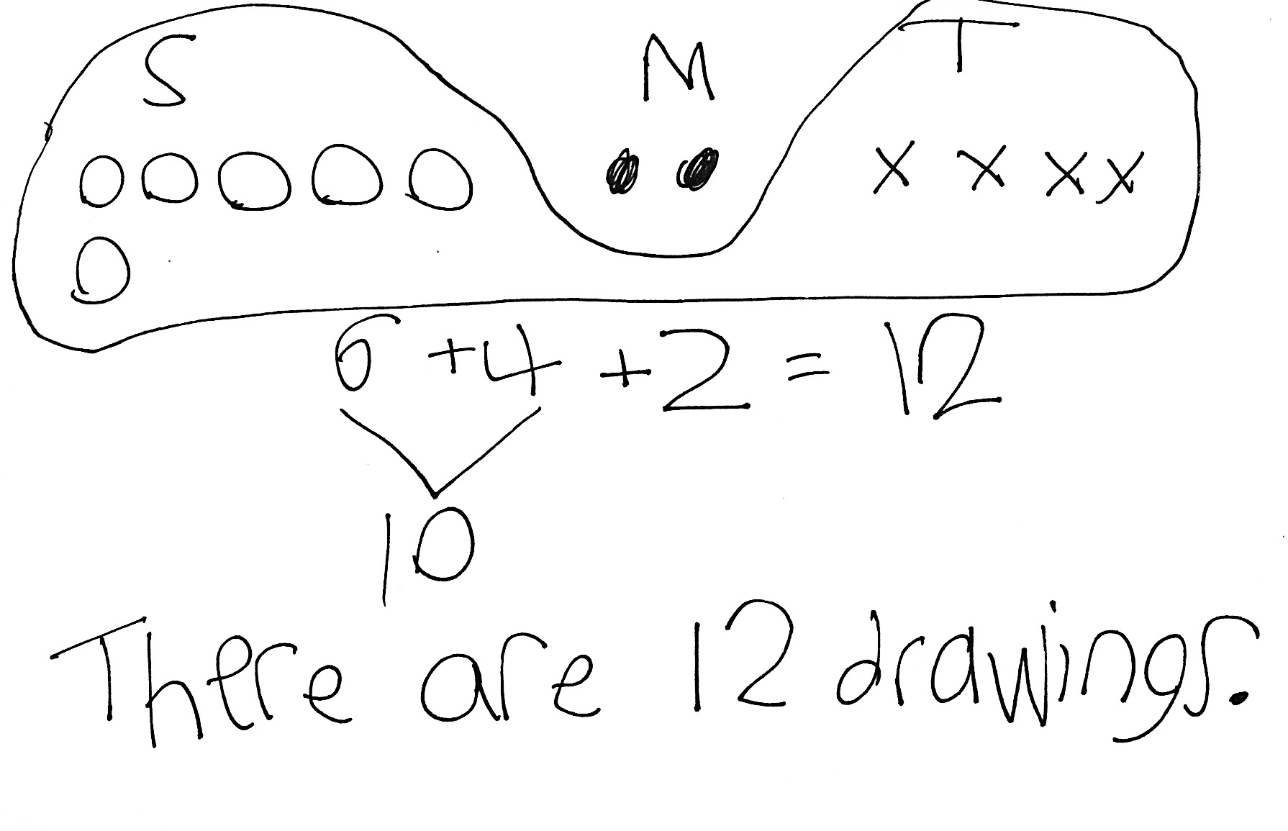
Application Problem (7 minutes)
Stacy made 6 drawings. Matthew made 2 drawings. Tim made 4 drawings. How many drawings did they make altogether? Use a drawing, a number sentence, and a statement to match the story.
Note: Some students may actually create detailed drawings. Continue discussing how simple shapes, such as squares or circles, can be used to efficiently represent the story’s drawings rather than spending time and thought on elaborate pictures.
Concept Development (30 minutes)

NOTES ON
MULTIPLE MEANS
OF REPRESENTATION:
When using colors in lessons, be sensitive to those students who have difficulty seeing certain colors. If you have these students in your classroom, use primary colors and typically sharp contrast, like green (or red) and yellow that can be distinguished by these students. Be sure to adjust the color names to align when implementing the Concept Development.

Materials: (T) 10 blue and 10 yellow linking cubes, a ten-frame border (S) 10 blue and 10 yellow linking cubes, personal white board
Have students sit at their seats with materials.
T: (Project and read aloud.) Peter has 8 books and Willie has 5. How many books do they have altogether?
T: What is the expression to solve this problem?
S: 8 + 5.
T: On your personal white boards, use your blue linking cubes in 5-groups to show how many books Peter has.
S: (Organize 8 blue linking cubes.)
T: Use your yellow cubes to show how many books Willie has. Put them in a line of five next to your board.
S: (Organize 5 yellow linking cubes.)
T: What are the different ways we can solve 8 + 5?
S: Count on! Make ten with 5! Make ten with 8!
T: (Call on students to demonstrate each of these strategies, saving making 10 with 8 for the end. As a student volunteer makes ten, use the ten-frame border to physically group the ten.)
MP.7
T: Let’s use the last strategy to solve 8 + 5. Everyone, make ten with 8!
S: (Move 2 yellow cubes to the blue pile.)
T: With your marker, draw a frame around your 10 cubes.
S: (Frame 10 cubes.)
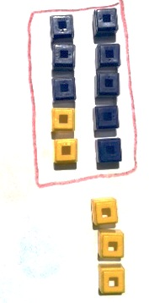
T: We have 10 here. (Gesture to the 10.) What do we have left here? (Point to the other pile.)
S: 3.
T: Look at your new groups. What is our new number sentence?
S: 10 + 3 = 13!
T: (Write 10 + 3 = 13 on the board.) Did we change the number of linking cubes we have?
MP.7
S: No.
T: So, 8 + 5 is the same as what addition expression?
S: 10 + 3.
T: (Write 8 + 5 = 10 + 3.)
T: What is 10 + 3?
S: 13.
T: What is 8 + 5? Say the number sentence.
S: 8 + 5 = 13.
T: How many books do Peter and Willie have?
S: 13 books.
Repeat the process with the following suggested sequence: 8 + 3, 8 + 6, 4 + 8, 8 + 7, 8 + 8, etc. Be sure to have students make ten with 8, reinforcing the concept of commutativity for efficient problem solving. Write both number sentences (8 + 6 = 14, 10 + 4 = 14) and a number sentence equating the equivalent expressions (8 + 6 = 10 + 4).
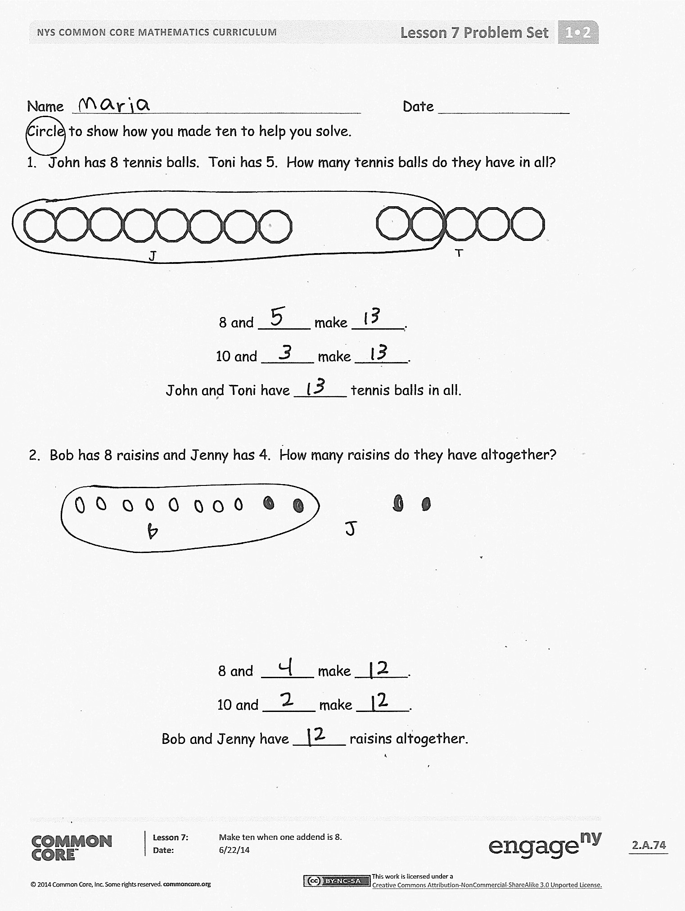
Problem Set (10 minutes)
Students should do their personal best to complete the Problem Set within the allotted 10 minutes. For some classes, it may be appropriate to modify the assignment by specifying which problems they work on first. Some problems do not specify a method for solving. Students should solve these problems using the RDW approach used for Application Problems.

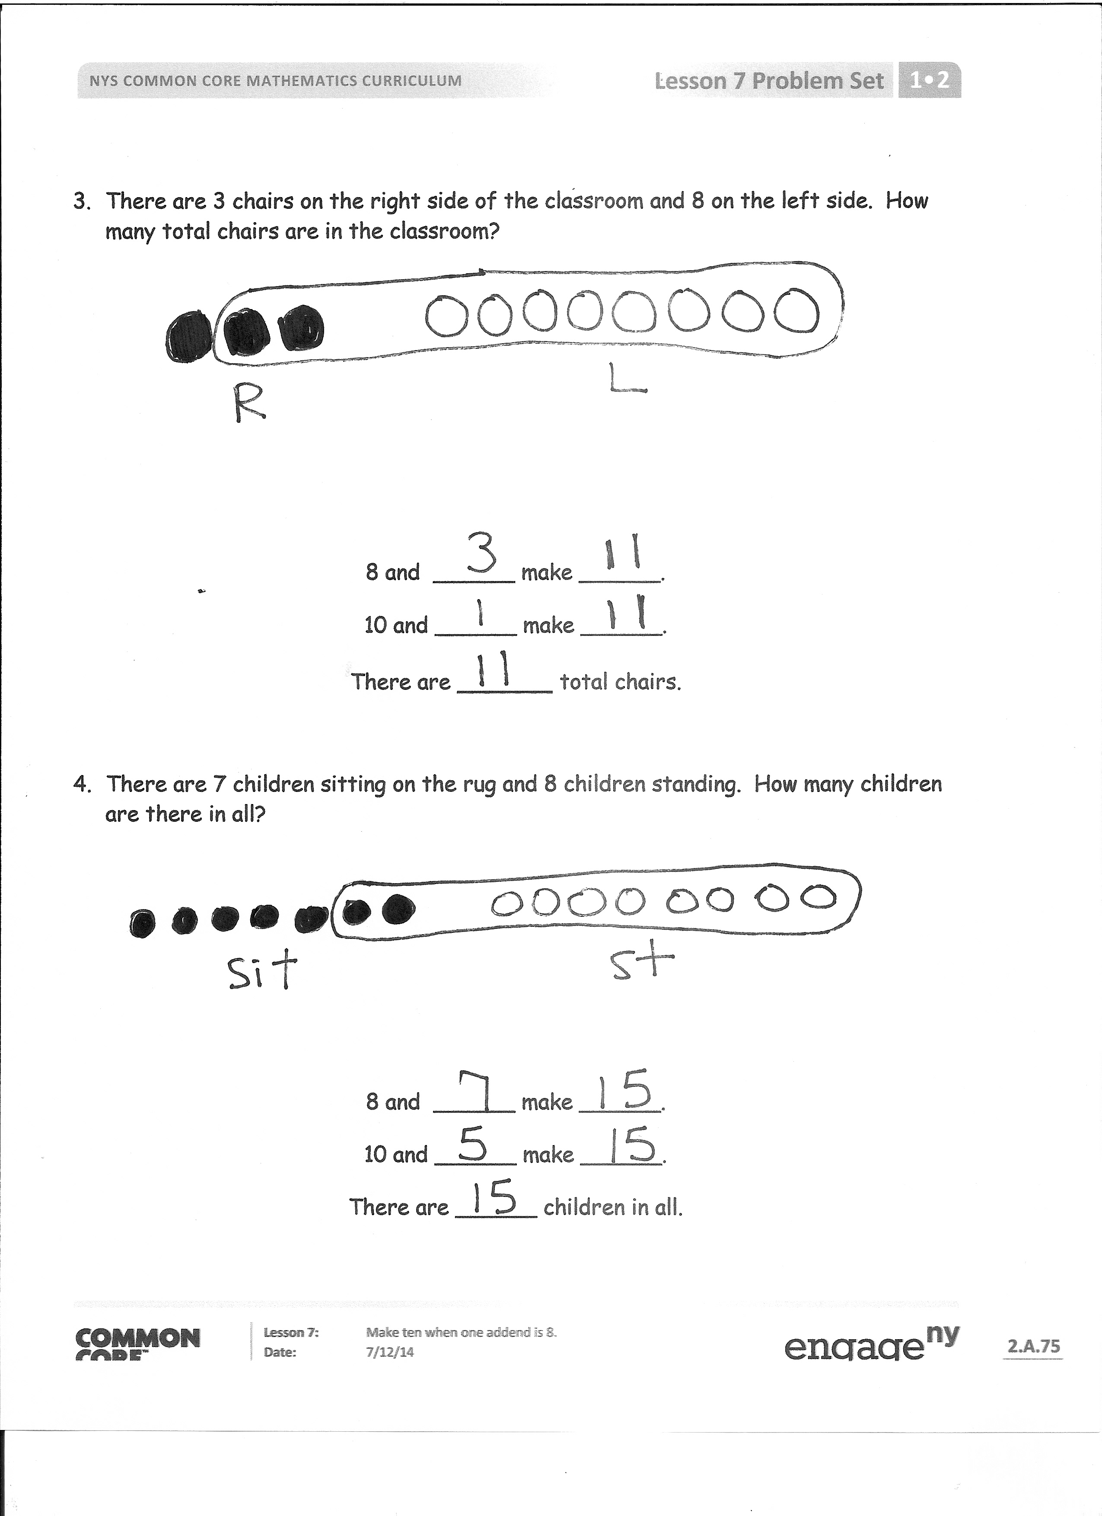
Student Debrief (10 minutes)
Lesson Objective: Make ten when one addend is 8.
Note: Distribute the student Problem Set from Lesson 3 or Lesson 4 for comparing with today’s Problem Set.
The Student Debrief is intended to invite reflection and active processing of the total lesson experience.
Invite students to review their solutions for the Problem Set. They should check work by comparing answers with a partner before going over answers as a class. Look for misconceptions or misunderstandings that can be addressed in the Debrief. Guide students in a conversation to debrief the Problem Set and process the lesson.
You may choose to use any combination of the questions below to lead the discussion.
- Look at Problem 1. What are the two number sentences that match the statements? (Repeat with other problems as necessary.)
- (Write 8 + 5 = 13 and 10 + 3 = 13 on the board.) How can you make one true number sentence from the two number sentences on the board? (8 + 5 = 10 + 3)
- When you had 8 as an addend, how many objects did you circle from the other addend?
- Look at your Problem Set from Lesson 3 or Lesson 4. How are these problems similar to today’s Problem Set? How are they different? What do you notice about the answers when you have 9 as an addend compared to 8 as an addend? Why do you think this is?
- Look at the Application Problem. What did you add first? Why? (Some students may have added 6 + 4 because it is an efficient way to make ten. Some students may still be adding the numbers in order. If students added 6 + 2 first, ask them to use today’s lesson to show making ten to solve.)
Exit Ticket (3 minutes)
After the Student Debrief, instruct students to complete the Exit Ticket. A review of their work will help you assess the students’ understanding of the concepts that were presented in the lesson today and plan more effectively for future lessons. You may read the questions aloud to the students.

Name Date
Circle to show how you made ten to help you solve.
- John has 8 tennis balls. Toni has 5. How many tennis balls do they have in all?
John
Toni

8 and ______ make ______.
10 and ______ make ______.
John and Toni have ______ tennis balls in all.

- Bob has 8 raisins and Jenny has 4. How many raisins do they have altogether?

8 and ______ make ______.
10 and ______ make ______.
Bob and Jenny have ______ raisins altogether.
- There are 3 chairs on the right side of the classroom and 8 on the left side. How many total chairs are in the classroom?

8 and ______ make ______.
10 and ______ make ______.
There are ______ total chairs.

- There are 7 children sitting on the rug and 8 children standing. How many children are there in all?

8 and ______ make ______.
10 and ______ make ______.
There are ______ children in all.
Name Date
Draw, label, and circle to show how you made ten to help you solve.
Write the number sentences you used to solve.
- Nick picks some peppers. He picks 5 green peppers and 8 red peppers. How many peppers does he pick in all?

8 and ______ make ______.
10 and ______ make ______.
Nick picks ____ peppers.

Name Date

Draw, label, and circle to show how you made ten to help you solve.
Write the number sentences you used to solve.
- Meg gets 8 toy animals and 4 toy cars at a party. How many toys does Meg get in all?

8 + 4 = ____
10 + ____ = ____ Meg gets _____ toys.

- John makes 6 baskets in his first basketball game and 8 baskets in his second. How many baskets does he make altogether?

____ + ____ = ____
____ + ____ = ____ John makes _____ baskets.
- May has a party. She invites 7 girls and 8 boys. How many friends does she invite in all?

____ + ____ = ____
____ + ____ = ____ May invites _____ friends.

- Alec collects baseball hats. He has 9 Mets hats and 8 Yankee hats. How many hats are in his collection?

____ + ____ = ____
____ + ____ = ____ Alec has _____ hats.

9 + 2 = | 3 + 9 =
9 + 4 = | 5 + 9 =
9 + 6 = | 7 + 9 =
9 + 8 = | 9 + 9 =

Friendly Fact Go Around: Make it Equal

9 + 1 = 10 + ☐ 9 + 3 = 10 + ☐ 9 + 5 = 10 + ☐

9 + 4 = 10 + ☐ 9 + 7 = 10 + ☐ 9 + 6 = 10 + ☐

3 + 9 = 10 + ☐ 2 + 9 = 10 + ☐ 8 + 9 = 10 + ☐

5 + 9 = 10 + ☐ 4 + 9 = 10 + ☐ 9 + 9 = 10 + ☐

9 + 4 = ☐ + 10 9 + 6 = ☐ + 10 9 + 5 = ☐ + 10

9 + 2 = ☐ + 10 9 + 7 = ☐ + 10 9 + 9 = ☐ + 10

9 + ☐ = 10 + 5 9 + ☐ = 10 + 7 9 + ☐ = 10 + 8
9 + ☐ = 10 + 3 9 + ☐ = 10 + 4 9 + ☐ = 10 + 6

9 + n addition cards, print on cardstock and cut
friendly fact go around: make it equal

