Lesson 6
Objective: Use the commutative property to make ten.

Suggested Lesson Structure
 Fluency Practice (10 minutes)
 Application Problem (5 minutes)
 Concept Development (35 minutes)
 Student Debrief (10 minutes)
Total Time (60 minutes)
Fluency Practice (10 minutes)
- Happy Counting by Twos 1.OA.5 (2 minutes)
- Take Out 2: Number Bonds 1.OA.6 (4 minutes)
- Decompose Addition Sentences into Three Parts 1.OA.6 (4 minutes)
Happy Counting by Twos (2 minutes)
Materials: (T) Rekenrek, if available
Note: Reviewing counting on allows students to maintain fluency with adding and subtracting 2.
Repeat the Happy Counting activity from G1–M1–Lesson 3, counting by twos from 0 to 20 and back.
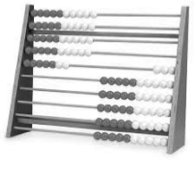
Note: As it relates to addition and subtraction, counting forward and backward by twos affords students review with this strategy. This fluency may be challenging for students at first. A Rekenrek helps students visualize numbers and makes it easier for students to change direction as they count. Rekenreks can be made simply and inexpensively with cardboard, elastic, and beads. If this is not available to you, there are also interactive Rekenreks online: http://www.ictgames.com/brilliant_beadstring_with_colour.html or http://maine.edc.org/file.php/1/tools/ArithmeticRack1.html
Rekenrek
Move the beads on the Rekenrek to model counting forward and backward by twos within twenty. Students count along with the beads (e.g., 2, 4, 6, 8, 10, 8, 6, 4, etc.).
When students are ready, put the Rekenrek away and tell students to look at your thumb to count forward and backward by twos. When your thumb points and motions up, students count up. When your thumb is to the side, students stop. When your thumb points and motions down, students count down (see illustration on the next page).

T:
T/S: 2 4 6 (pause) 4 2 (pause) 4 6 8

Take Out 2: Number Bonds (4 minutes)
Materials: (S) Personal white board
Note: This is an anticipatory fluency for the make ten addition strategy when one addend is 8.
Say a number within 10. Students quickly write a number bond for the number said, using 2 as a part, and hold up their boards when finished.
Decompose Addition Sentences into Three Parts (4 minutes)
Note: This fluency activity reviews adding three numbers and making ten when one addend is 9.
Decompose addition sentences into three steps.
T: (Write 9 + 3.) Say 3 as an addition sentence starting with 1.
S: 1 + 2.
T: (Write 1 + 2 below 3.) Say 9 + 3 as a three-part addition sentence.
S: 9 + 1 + 2 = 12.
Write out the equation for students to see if necessary. Repeat process for other problems.
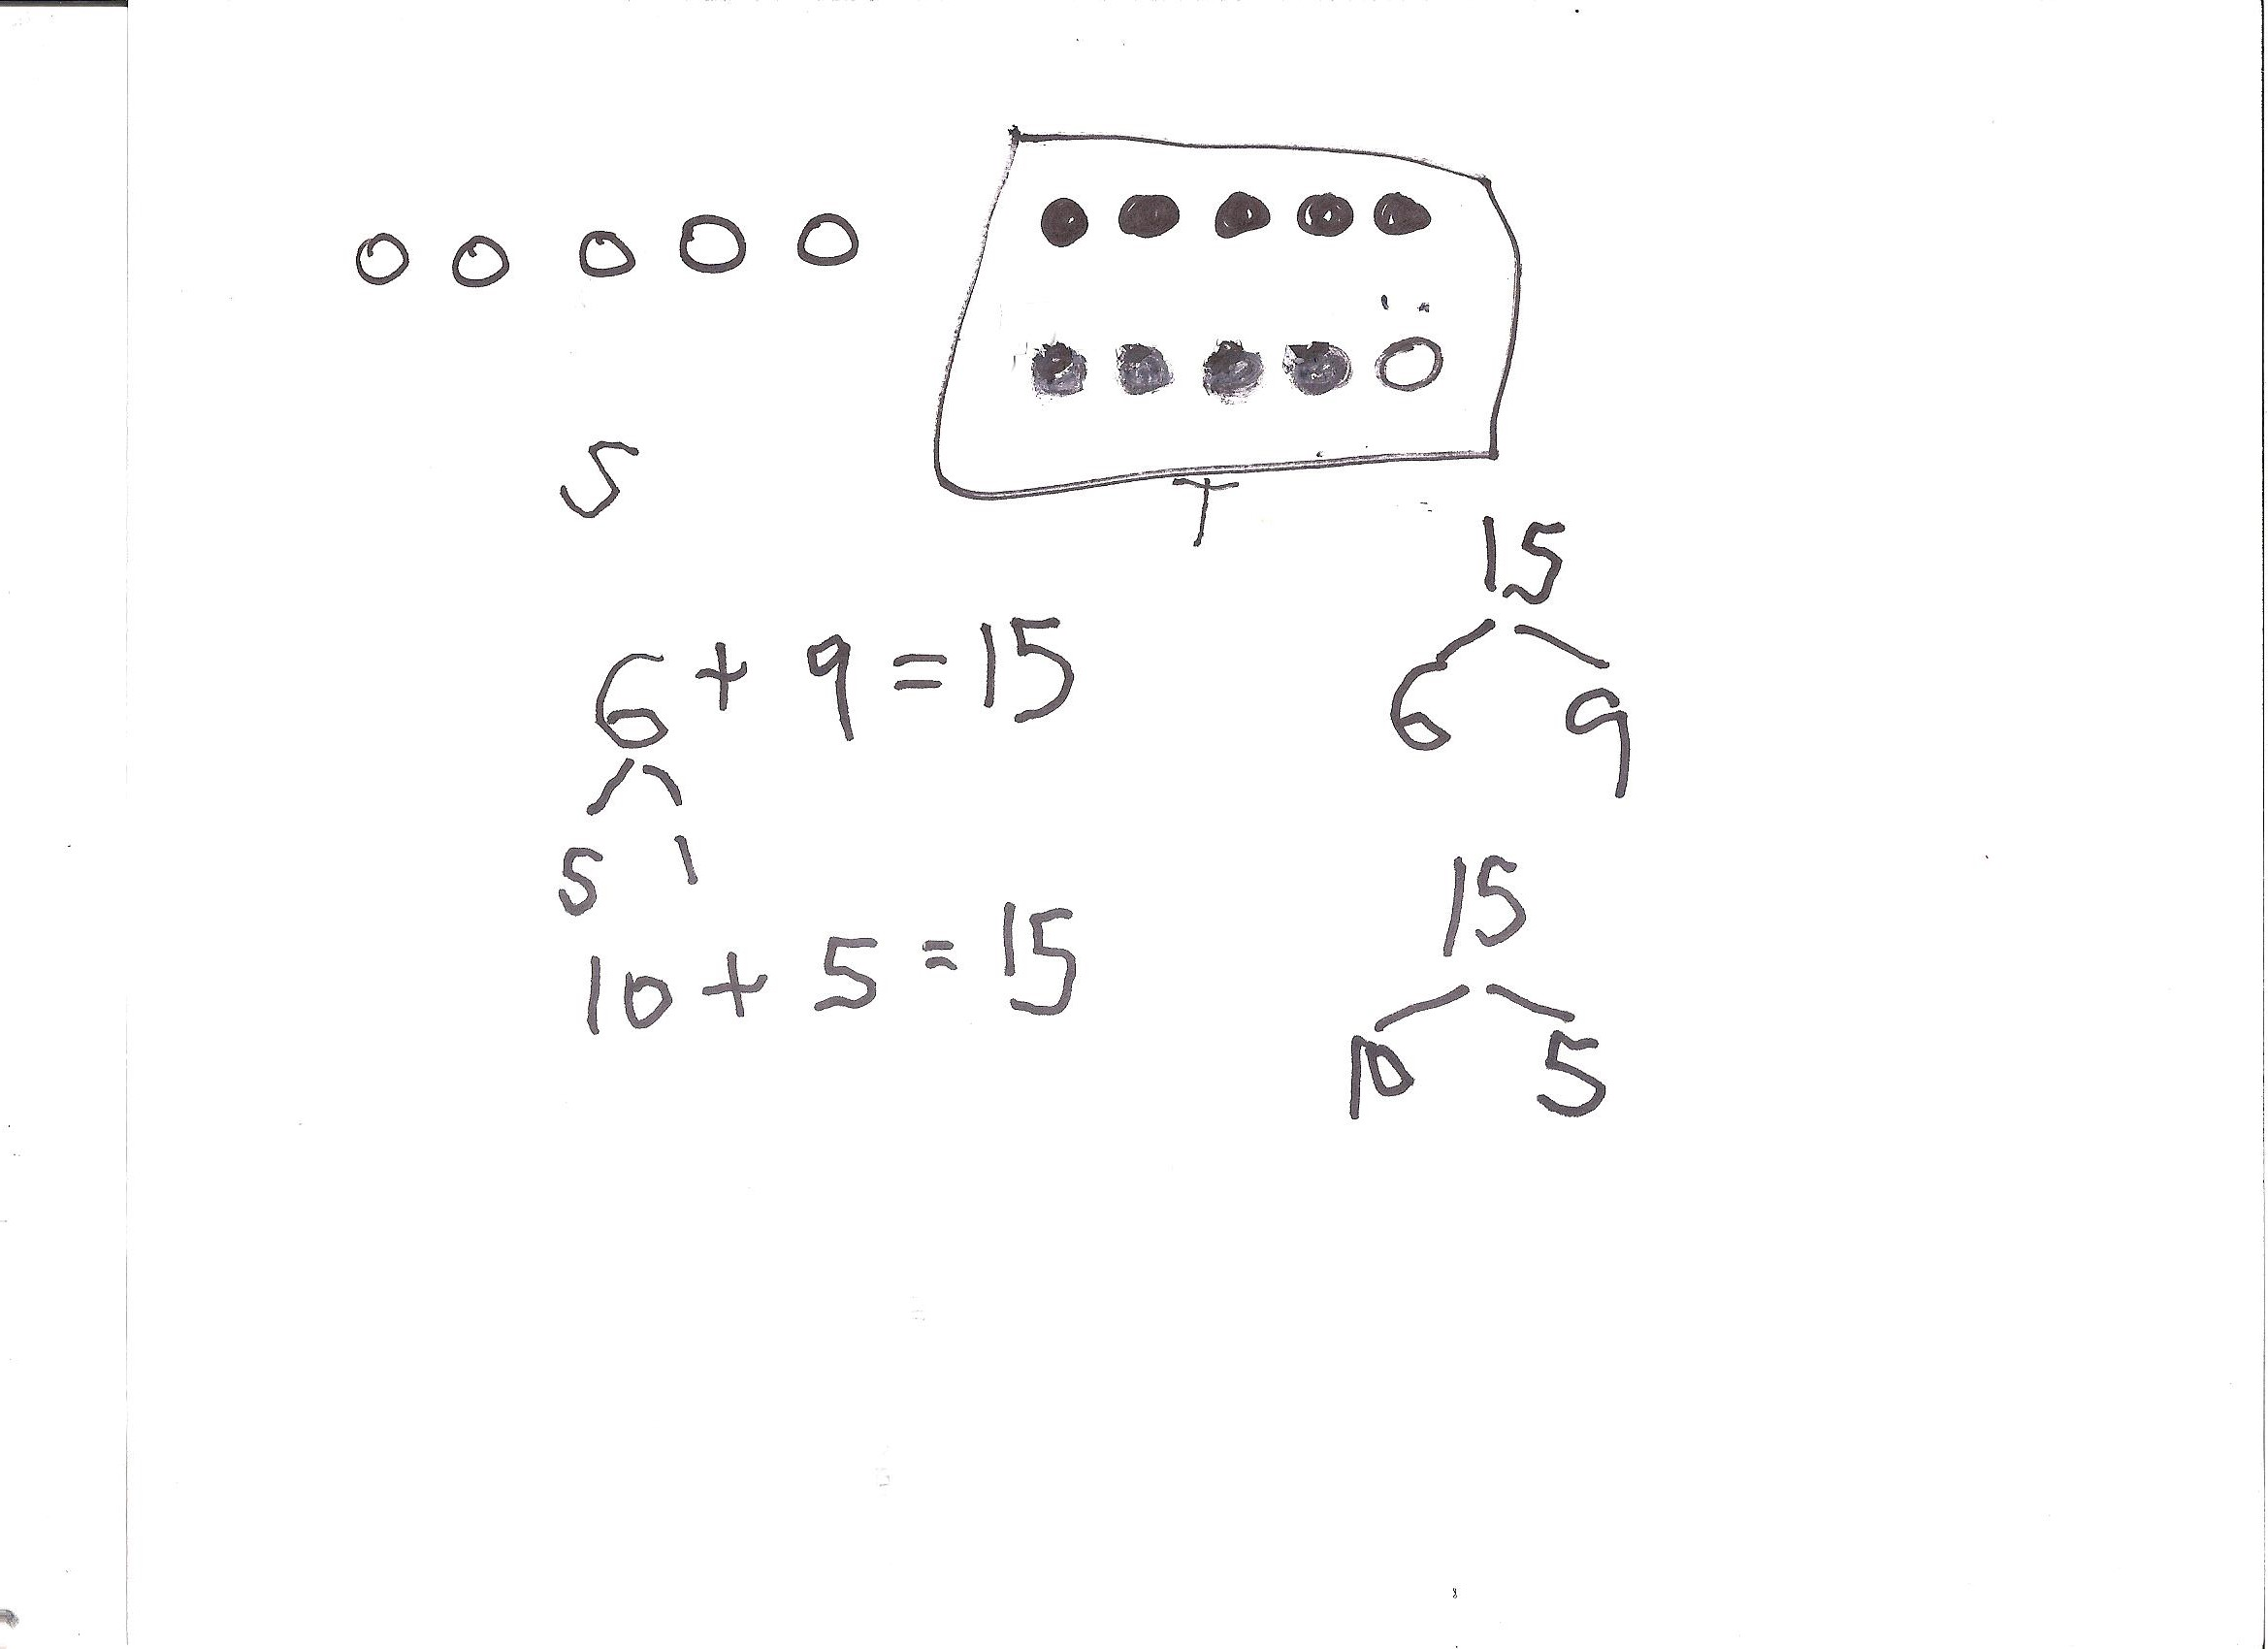
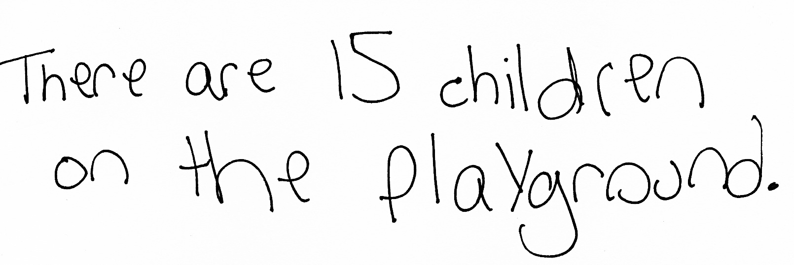
Application Problem (5 minutes)
There are 6 children on the swings and 9 children playing tag. How many children are playing on the playground? Make ten to solve. Create a drawing, number bond, and number sentence along with your statement.
Note: This problem gives students the chance to apply learning from Lessons 3, 4, and 5 as they solve problems with 9 as an addend. During the Debrief, discuss how the commutative property is applied to solve the problem efficiently.
Concept Development (35 minutes)

NOTES ON
MULTIPLE MEANS
OF ENGAGEMENT:
Some students are ready for more challenging numbers. Adjust lesson structure as appropriate by providing just right numbers, such as 13 and 9, where students can continue to apply the making ten strategy in a more complex way.
Materials: (S) Personal white board
Students sit in partnerships at tables or in the meeting area.
T: (Write 5 + 9 = on the board.) Turn and talk to your partner. What strategy should we use to solve efficiently?
S: Make ten.
T: Should we make ten with 5 or with 9? Let’s have each partner try it a different way. Partner A, solve this by making ten with 5. Partner B, solve this by making ten with 9.
S: (Solve on personal white boards as the teacher circulates.)
T: Share your solution with your partner. Did you get the same total or a different total? Discuss how you solved it.
S: (Share solutions and how they broke apart the numbers.)
T: How much is 5 + 9?
S: 14!
T: Did you solve for the total using the same way? How did you and your partner solve this?
S: We used different ways. I broke apart the 9 into 5 and 4 so I could make ten with 5 + 5, and my partner broke apart the 5 into 4 and 1 so she could make ten with 9 + 1.
T: (Write the students’ solutions on the board, including bonds.) So Partner A added 5 + 9 using
5 + 5 + 4. (Point to number bond.) You’re saying that this is the same as Partner B’s work where she added 5 + 9 using 9 + 1 + 4. (Point to number bond.) So 5 + 5 + 4 is the same as 9 + 1 + 4? (Point to number bonds.)
S: Yes!
T: Which way did you prefer? Why?
S: I know 9 is made from 5 and 4, so taking apart 9 was fast for me. Making 10 with 9 was fast and easy for me. It’s just 1 away from 10. It’s easy to take away 1 from a number.
T: Do we always have to start with the first addend when we are adding?
S: No. We can add in any order, as long as we add all of the parts.
T: (Project 3 + 9.) Which number should we start with?
S: 9, because all we have to do is take the 1 out of 3 to make ten.
T: On your personal white board, find the total and show your bonds.
S: (Write 3 + 9 = 12, showing bonds of 2 and 1 under 3.)
T: What is the related 10+ fact to help you solve 3 + 9?
S: 10 + 2 = 12.
T: So what is 3 + 9? Say the number sentence.
S: 3 + 9 = 12.
T: (Write 9 + 4 = on the board.) Which number should we make ten with?
S: 9.
T: Which number should we break apart?
S: 4.
T/S: (Repeat the process to find the sum.)
Repeat the process using the suggested sequence: 9 + 6, 8 + 9, and 7 + 9. For each problem, have students make ten to solve and alternate writing the related 10+ fact as a number bond and a number sentence.
Problem Set (10 minutes)
Students should do their personal best to complete the Problem Set within the allotted 10 minutes. For some classes, it may be appropriate to modify the assignment by specifying which problems they work on first. Some problems do not specify a method for solving. Students should solve these problems using the RDW approach used for Application Problems.
Note: Students should save the Problem Set so it is available as a comparison during debriefs focusing on making ten when one addend is 8.
Student Debrief (10 minutes)
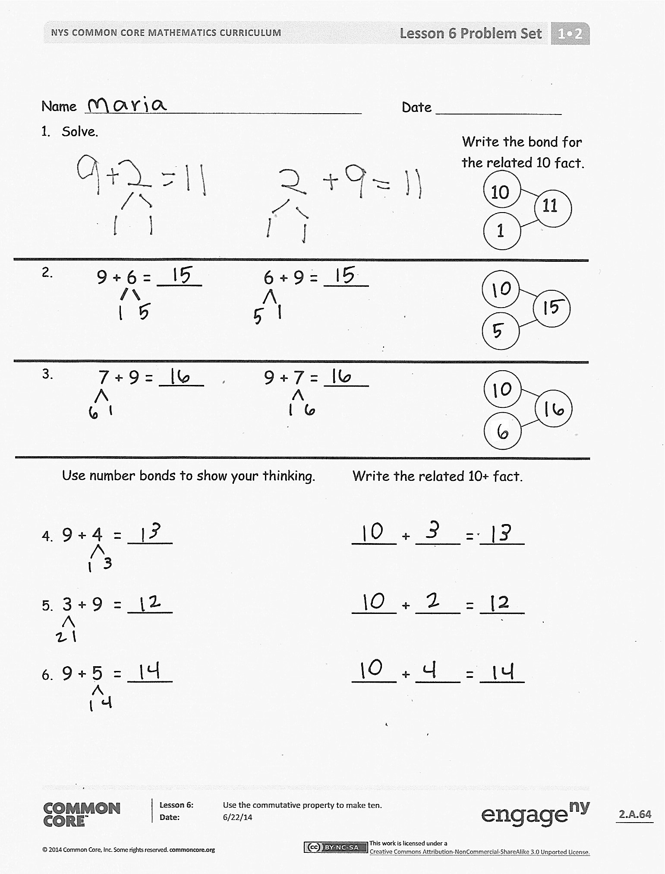
Lesson Objective: Use the commutative property to make ten.
The Student Debrief is intended to invite reflection and active processing of the total lesson experience.
Invite students to review their solutions for the Problem Set. They should check work by comparing answers with a partner before going over answers as a class. Look for misconceptions or misunderstandings that can be addressed in the Debrief. Guide students in a conversation to debrief the Problem Set and process the lesson.
You may choose to use any combination of the questions below to lead the discussion.
- Look at Problem 8. Find as many related equal equations as you can.
- Look at Problem 8. In which problem can you use your doubles + 1 fact to help you solve?
- How did we apply the make ten strategy today to solve addition problems efficiently?
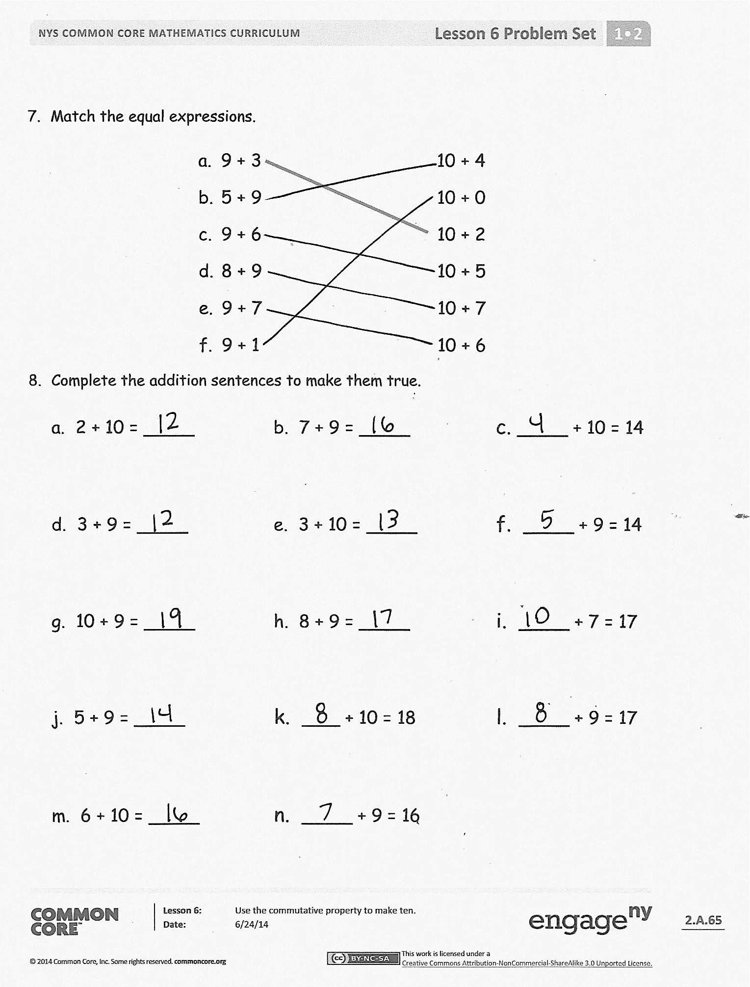
- To solve 3 + 9, which addend should we make ten with? Why?
- Look at your Application Problem. Turn and talk to your partner about which addend we should break apart to solve the problem more efficiently.
Exit Ticket (3 minutes)
After the Student Debrief, instruct students to complete the Exit Ticket. A review of their work will help you assess the students’ understanding of the concepts that were presented in the lesson today and plan more effectively for future lessons. You may read the questions aloud to the students.

Name Date
Write the bond for the related 10 fact.
- Solve.
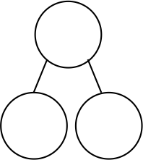
1
10
11
6 + 9 = ____
9 + 6 = ____

7 + 9 = ____
9 + 7 = ____
3.

Use number bonds to show your thinking. Write the related 10+ fact.

- 9 + 4 = ____ ____ + ____ = ____
- 3 + 9 = ____ ____ + ____ = ____
- 9 + 5 = ____ ____ + ____ = ____

- Match the equal expressions.
- 9 + 3 10 + 4
- 5 + 9 10 + 0
- 9 + 6 10 + 2
- 8 + 9 10 + 5
- 9 + 7 10 + 7
- 9 + 1 10 + 6
- Complete the addition sentences to make them true.

a. 2 + 10 = ____
d. 3 + 9 = ____
g. 10 + 9 = ____
j. 5 + 9 = ____
m. 6 + 10 = ____
b. 7 + 9 = ____
e. 3 + 10 = ____
h. 8 + 9 = ____
k. ___ + 10 = 18
n. ____ + 9 = 16
c. ____ + 10 = 14
f. ____ + 9 = 14
i. ____ + 7 = 17
l. ____ + 9 = 17

Name Date
Solve. Use number bonds to show your thinking. Write the bond for the related 10 fact.
9 + 5 = ____
10
5 + 9 = ____

- Solve. Draw a line to match the related facts. Write the related 10+ fact.
a.
9 + 7 = ____
8 + 9 = ____
____ = 6 + 9 ____
7 + 9 = ____
____ = 9 + 8 ____
9 + 6 = ____
b.

c.

Name Date
- Solve. Use your number bonds. Draw a line to match the related facts. Write the related 10+ fact.
a.
9 + 6 = ____
___ = 9 + 5
____ = 3 + 9 ____
8 + 9 = ____
9 + 7 = ____
____ = 7 + 9
____ = 9 + 8 ____
6 + 9 = ____
9 + 3 = ____
5 + 9 = ____

b.

c.

d.

e.

- Complete the addition sentences to make them true.

- 3 + 10 = ___
- 4 + 9 = ___
- 10 + 5 = ___
- 9 + 6 = ___
- 7 + 10 = ___
- ___ = 7 + 9
- 10 + ___ = 18
- 9 + 8 = ___
- ___ + 9 = 19
- 5 + 9 = ___

- Find and color the expression that is equal to the expression on the snowman’s hat. Write the true number sentence below.
6 + 9
9 + 4
9 + 3
10 + 3
b.
a.
8 + 7
9 + 5
7 + 9
10 + 6

7. Match the equal expressions.

=
=
2 + 9
9 + 9
8 + 9
10 + 8

8 + 9
8 + 8
9 + 5
10 + 7
c.
d.

=
=

