Lesson 5
Objective: Compare efficiency of counting on and making ten when one addend is 9.

Suggested Lesson Structure
 Fluency Practice (13 minutes)
 Application Problem (5 minutes)
 Concept Development (32 minutes)
 Student Debrief (10 minutes)
Total Time (60 minutes)
Fluency Practice (13 minutes)
- Partners to Ten 1.OA.6 (5 minutes)
- Add Partners of Ten First 1.OA.6 (4 minutes)
- Take Out 2 1.OA.6 (4 minutes)
Partners to Ten (5 minutes)
Materials: (S) Numeral cards (Lesson 1 Fluency Template 5-group cards with numeral-side only copied), personal white board
Note: This fluency activity provides maintenance with partners to ten while applying the commutative property.
Students put 5-group cards face down and write 10 on their boards. Each partner takes a 5-group card, and then draws a number bond without bubbles using the selected card as one part. Students write two addition sentences for the number bond and check each other’s work.
Add Partners of Ten First (4 minutes)
Note: This activity reviews adding three numbers and prepares students for the make ten addition strategy when one addend is 9.
Conduct the activity as outlined in Lesson 3.

Take Out 2 (4 minutes)
Note: This is an anticipatory fluency for making ten when one addend is 8 since 8 needs 2 to make ten.

NOTES ON
MULTIPLE MEANS
OF ENGAGEMENT:
Fluency games and activities provide most students the opportunity to gain math confidence by experiencing daily math success. Be sure to highlight students’ math successes frequently in order to facilitate continued effort and persistence.

T: Take out 2 on my signal. For example, if I say 5, you say 2 and 3.
T: 3.
S: 2 and 1.
T: 10.
S: 2 and 8.
Continue with all numbers within 10 for about a minute, and then give students about 30 seconds of practice with a partner. Repeat the set as a whole class and celebrate improvement.
Application Problem (5 minutes)
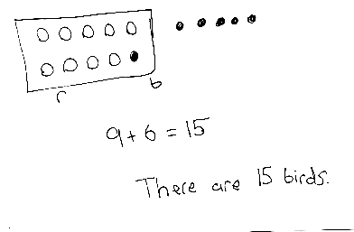
There are 9 red birds and 6 blue birds in a tree. How many birds are in the tree? Use a ten-frame drawing and a number sentence. Write a number bond to match the story and a number bond to show the matching 10+ fact. Write a statement.
Note: This problem continues to provide contextual practice of solving addition situations where one addend is 9. By drawing a number bond to match the story and drawing a number bond to match the ten-frame drawing, students continue to relate the addition facts of 9 with the addition facts of 10. Students consider the problem’s relationship to today’s lesson during the Debrief.
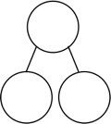
Concept Development (32 minutes)
9
6
10
5
Materials: (S) Personal white board
Have students sit at their desks or the meeting area.
T: (Project or write the two number bonds shown here.) Which number bond is easier to solve?
S: 10 and 5!
T: (Write 10 + 5 = .) 10 + 5 = …?
S: 15!
T: (Record the solution.) How did you know that so quickly?
S: Because we know our 10+ facts. Because 10 is a friendly number.
T: (Write 9 + 6 = .) Now let’s count on to solve 9 + 6.

NOTES ON
MULTIPLE MEANS
OF ENGAGEMENT:
It is important to partner important vocabulary with captions or pictorial representations for all students. It is especially beneficial to English language learners and students with hearing impairments. Have students model or demonstrate their understanding of more difficult vocabulary such as efficient.

T/S: Niiiine, 10, 11, 12, 13, 14, 15. 15!
T: (Record the solution.) Wait, 9 + 6 is equal to 10 + 5?
S: Yes!
T: Both number bonds have the same total, but when one part is 10, our solution came to us automatically.
T: (Read aloud.) Sergio and Lila were getting ready to go to recess. They both had to solve 9 + 8. The first one to solve it got to go to recess first! Sergio decided he was going to count on to solve it. (Pause.) Was there another way to solve 9 + 8 that Sergio could have used? (Circulate and listen.)
S: (Discuss.) Make ten! Take 1 out from 8 and give it to the 9, in order to make ten.
T: Some of you said that you would make ten. Well, that is just what Lila decided to do. (Assign partners.) Partner A, use your personal white board to show how Sergio solved 9 + 8 by counting on. Partner B, show how Lila solved 9 + 8 by making ten.
S: (Solve 9 + 8 using counting on or making ten.)
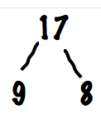
T: Talk to your partner about the strategy you used to solve 9 + 8.
S: (Discuss and share as the teacher circulates.)
T: Help me make a number bond to show what Sergio did. What were the parts that Sergio used?
S: 9 and 8!
T: (Write the bond.) What was the total?
S: 17.
T: (Complete the bond.) Help me make a number bond to show what Lila did. What were the parts that Lila used?
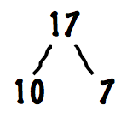
S: 10 and 7!
T: (Write the bond.) What was the total?
S: 17.
T: (Complete the bond.) Which number bond will help you solve more efficiently or quickly?
S: 10 and 7.
T: So, based on these number bonds, and the work you and your partner just did, who do you think got to go to recess first?
S: Lila!
T: You’re right! By using the make ten strategy, she was able to solve for the unknown quickly or efficiently.
Continue with partners solving each problem, showing how to solve using counting on and making ten: 9 + 6, 9 + 5, 9 + 2 (counting on may actually be more efficient here), and 9 + 9.
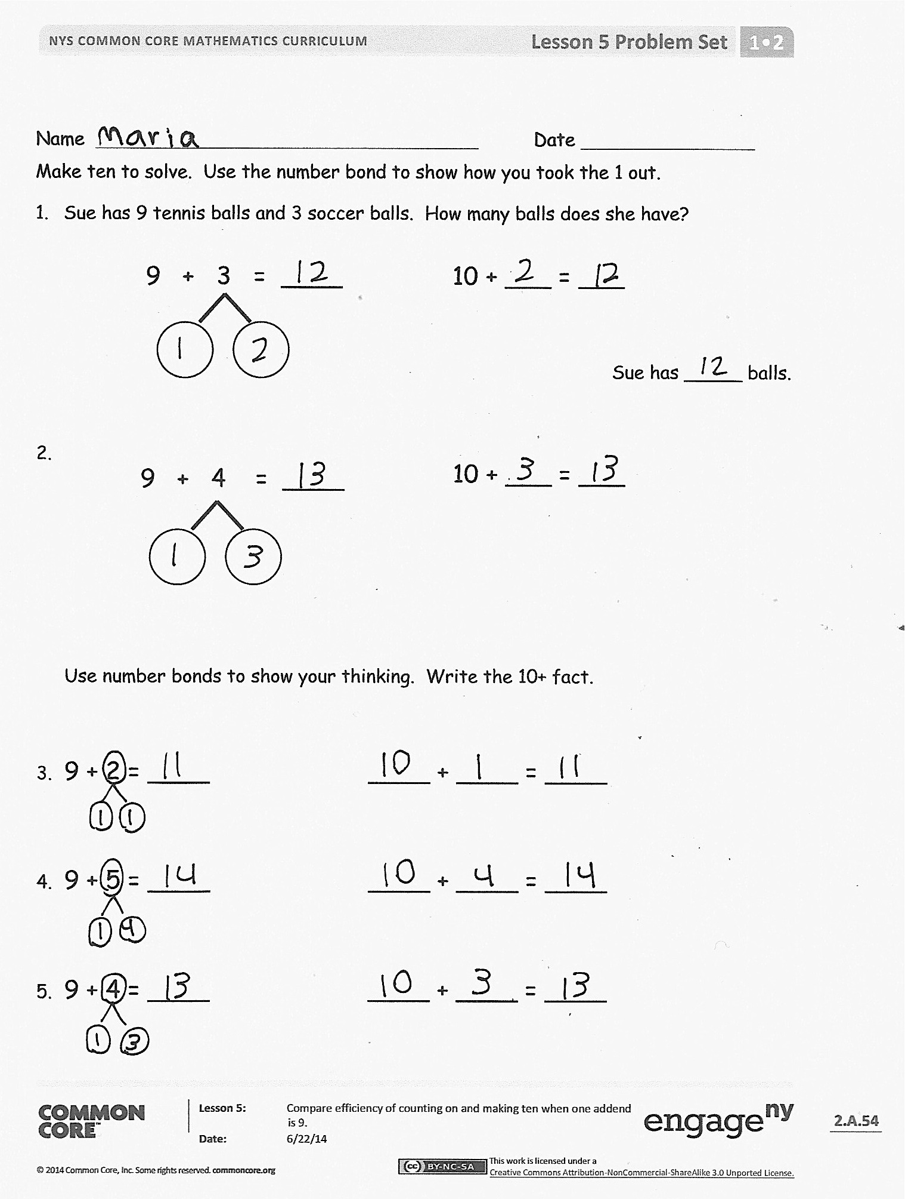
Problem Set (10 minutes)
Students should do their personal best to complete the Problem Set within the allotted 10 minutes. For some classes, it may be appropriate to modify the assignment by specifying which problems they work on first. Some problems do not specify a method for solving. Students should solve these problems using the RDW approach used for Application Problems.
Note: Students should save the Problem Set to provide the opportunity to compare making ten when adding 8.
Student Debrief (10 minutes)
Lesson Objective: Compare efficiency of counting on and making ten when one addend is 9.
The Student Debrief is intended to invite reflection and active processing of the total lesson experience.
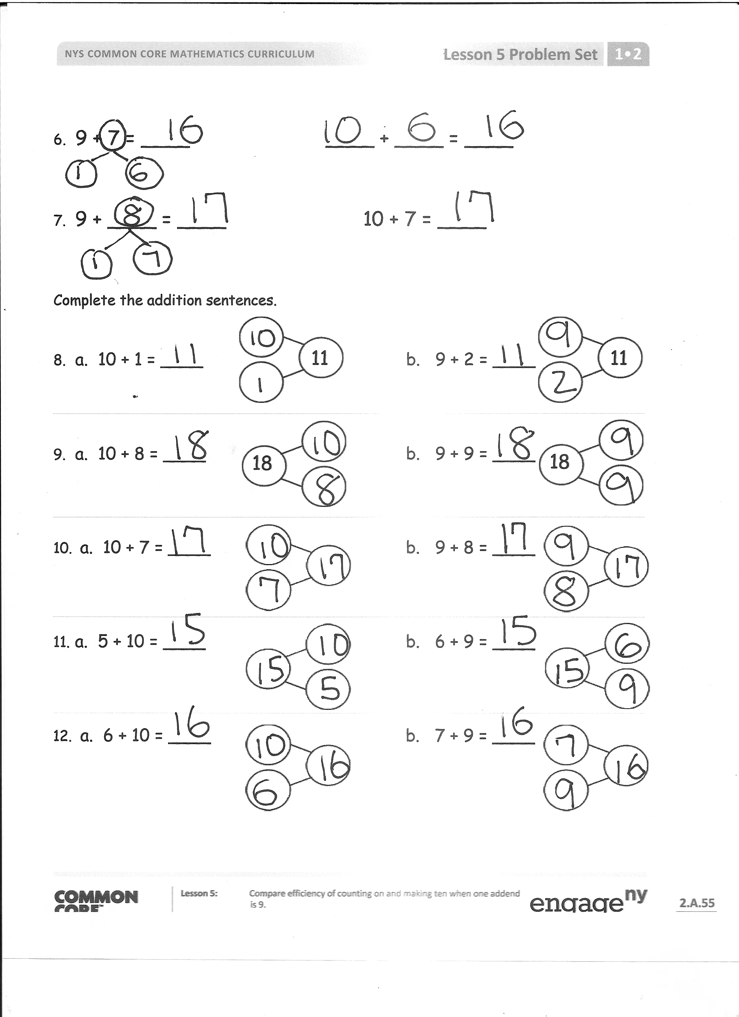
Invite students to review their solutions for the Problem Set. They should check work by comparing answers with a partner before going over answers as a class. Look for misconceptions or misunderstandings that can be addressed in the Debrief. Guide students in a conversation to debrief the Problem Set and process the lesson.
You may choose to use any combination of the questions below to lead the discussion.
- Which problems could you solve more efficiently by making ten?
- Why was that a more efficient way to solve?
- Were there any problems that you think could have been solved more efficiently using counting on? Why?
- Look at Problems 8–10. What do you notice about the number bonds? How does knowing your 10+ facts help you with your 9+ facts?
- Look at your Application Problem. What is the related 10+ fact for this problem? How does your drawing show both the 9+ fact and the related 10+ fact?
- Look at Problems 3–6. Think about these statements: 9 and _____ make _____ and 10 and _____ make _____. (For example, 9 and 2 make 11 and 10 and 1 make 11.) What pattern do you notice?
Exit Ticket (3 minutes)
After the Student Debrief, instruct students to complete the Exit Ticket. A review of their work will help you assess the students’ understanding of the concepts that were presented in the lesson today and plan more effectively for future lessons. You may read the questions aloud to the students.

Name Date
Make ten to solve. Use the number bond to show how you took the 1 out.
- Sue has 9 tennis balls and 3 soccer balls. How many balls does she have?
9 + 3 = ____
10 + ___ = ___
Sue has _____ balls.
10 + ___ = ___

9 + 4 = ____

Use number bonds to show your thinking. Write the 10+ fact.

- 9 + 2 = ____ ____ + ____ = ____

- 9 + 5 = ____ ____ + ____ = ____

- 9 + 4 = ____ ____ + ____ = ____
- 9 + 7 = ____ ____ + ____ = ____

- 9 + ____ = ____ 10 + 7 = ____

Complete the addition sentences.
11
11

- a. 10 + 1 = ____ b. 9 + 2 = ____
18
18
- a. 10 + 8 = ____ b. 9 + 9 = ____
- a. 10 + 7 = ____ b. 9 + 8 = ____
- a. 5 + 10 = ____ b. 6 + 9 = ____
- a. 6 + 10 = ____ b. 7 + 9 = ____

Name Date
Complete the number sentence.
Use an efficient strategy to solve the number sentences.

- 9 + 2 = ___
- 7 + 9 = ___
- ___ = 9 + 5

Name Date
Solve the number sentences. Use number bonds to show your thinking. Write the 10+ fact and new number bond.
- 9 + 6 = ____ 10 + ____ = ____

- 9 + 8 = ____ ____ + ____ = ____

- 5 + 9 = ____ ____ + ____ = ____

- 7 + 9 = ____ ____ + ____ = ____

- Solve. Match the number sentence to the 10+ number bond.
- 9 + 5 = ____ b. 9 + 6 = ____ c. 9 + 8 = ____

7
17
10
14
10
15
10
4
5

Use an efficient strategy to solve the number sentences.

- 9 + 7 = ____

- 8 + 9 = ____
- 9 + 2 = ____

- 4 + 9 = ____
- 9 + 1 = ____

- 9 + 9 = ____

