Lesson 4
Objective: Make ten when one addend is 9.

Suggested Lesson Structure
 Fluency Practice (12 minutes)
 Application Problem (5 minutes)
 Concept Development (33 minutes)
 Student Debrief (10 minutes)
Total Time (60 minutes)
Fluency Practice (12 minutes)
- Happy Counting the Say Ten Way 1.NBT.2 (2 minutes)
- Sprint: Add Three Numbers 1.OA.3 (10 minutes)
Happy Counting the Say Ten Way (2 minutes)
Note: Say Ten counting strengthens student understanding of place value.
Tell students to look at your thumb and count up and down between 10 and 120 the Say Ten way. When your thumb points and motions up, the students count up. When your thumb is to the side, students stop. When your thumb points and motions down, the students count down (see example below).
T:
T/S: 4 ten 4 ten 1 4 ten 2 (pause) 4 ten 1 4 ten (pause) 4 ten 1 4 ten 2 4 ten 3
Choose numbers based on student skill level. If students are very proficient up to 40, start at 40 and quickly go up to 80. If they are proficient between 40 and 80, Happy Count between 80 and 120. Alternate at times between regular and Say Ten counting, too.
Sprint: Add Three Numbers (10 minutes)
Note: This Sprint provides practice with adding three numbers by making ten first.
Materials: (S) Add Three Numbers Sprint

Application Problem (5 minutes)
Michael plants 9 flowers in the morning. He then plants 4 flowers in the afternoon. How many flowers did he plant by the end of the day? Make a drawing, number bond, and a statement.
Note: Students can apply the make ten strategy from Lesson 3 as they solve this problem. During the Debrief, the teacher discusses how using rows to show the plants can create a clear and quick visual for identifying the compositions and decompositions needed to apply the make ten strategy.
Concept Development (33 minutes)
Materials: (T) 10 green and 10 red linking cubes, a ten-frame border (S) 10 green and 10 red linking cubes, personal white board
Have students come to the meeting area with linking cubes and personal white boards.
T: (Project and read aloud.) Maria has 9 green cubes. Tony has 3 red cubes. How many cubes do Maria and Tony have?
T: What is the expression to solve this story problem?
S: 9 + 3.
T: (Show two piles: 9 scattered green cubes and 3 scattered red cubes.)
T: How can you check that I have the correct number of cubes representing Maria’s cubes?
S: We can count, one at a time.

NOTES ON
MULTIPLE MEANS
OF REPRESENTATION:
It is important to make the connection between concrete math and math models. This helps English language learners and struggling learners understand the math without getting bogged down with language acquisition.

T: Okay, but that’s not very efficient. Is there a way to organize my green cubes so we can tell there are 9 cubes faster?
S: Put them in a 5-group!
T: Great idea. When we arrange or draw things in a
5-group, we are all going to follow these steps. Just like reading, we’ll start with the top row and from the left. (Place 5 green cubes in a row.)
T: We start in the next line with 6 and try to match it up to the top as closely as we can. (Place 4 in the bottom row.)
MP.4
T: Now, can you see we have 9 cubes right away?
S: Yes!
T: (Arrange the 3 red cubes in a 5 group on the other side.) The red cubes are also organized.
T: What do we do to solve 9 + 3?
S: Make ten.
T: (Circle the 9 green cubes and 1 red cube with finger.)
T: Here’s another way to show ten. (Move 1 red cube to add to 9 green cubes.)
ten-frame
T: (Place a red cube in the tenth slot.) We made ten!
T: I’m going to put a frame around it. (Place the frame around ten.) We are going to call this a ten-frame. It looks just like our 5-group drawings but now that we are making ten, we can call it a ten-frame. Whenever we make ten, we make or draw a frame around it. That way, we can see ten right away.
MP.4
T: Look at the new piles. What new expression do you see?
S: 10 + 2.
T: So, 9 + 3 is the same as?

NOTES ON
MULTIPLE MEANS
OF REPRESENTATION:
Be aware of the different learning needs in your class and adjust the lesson as necessary. As some students may need to work at the concrete level for a longer period of time, allow students access to manipulatives.

S: 10 + 2.
T: (Write 9 + 3 = 10 + 2.)
T: What is 10 + 2?
S: 12.
T: What is 9 + 3?
S: 12.
T: How many cubes do Maria and Tony have?
S: 12 cubes.
T: Where are the 9 green cubes? Point to them.
S: (Point to 9.)
T: Where are the 3 red cubes? Point to them.
S: (Point to 1 and 2.)
T: You are pointing to two different places. Why?

S: We broke 3 apart into 1 and 2.
T: Let’s use a number bond to show how we broke apart 3.
T: Just like we framed the ten in our picture, we’ll frame the numbers that make ten. (Circle 9 and 1.)
T: 9 and 1 make?
S: 10.
T: 10 and 2 make?
S: 12.
T: So, 9 plus 3 equals?
9 + 2 = 11 10 + 1 = 11
1
1
S: 12!
Repeat the process by having students work with cubes. Be sure to guide students when organizing their cubes into a ten-frame. The following is a suggested sequence: 9 + 2 (pictured to the right), 4 + 9, and 5 + 9. Note that the smaller addend sometimes appears first. Guide students to realize that they can still compose ten from the 9 for efficiency during the last two problems.
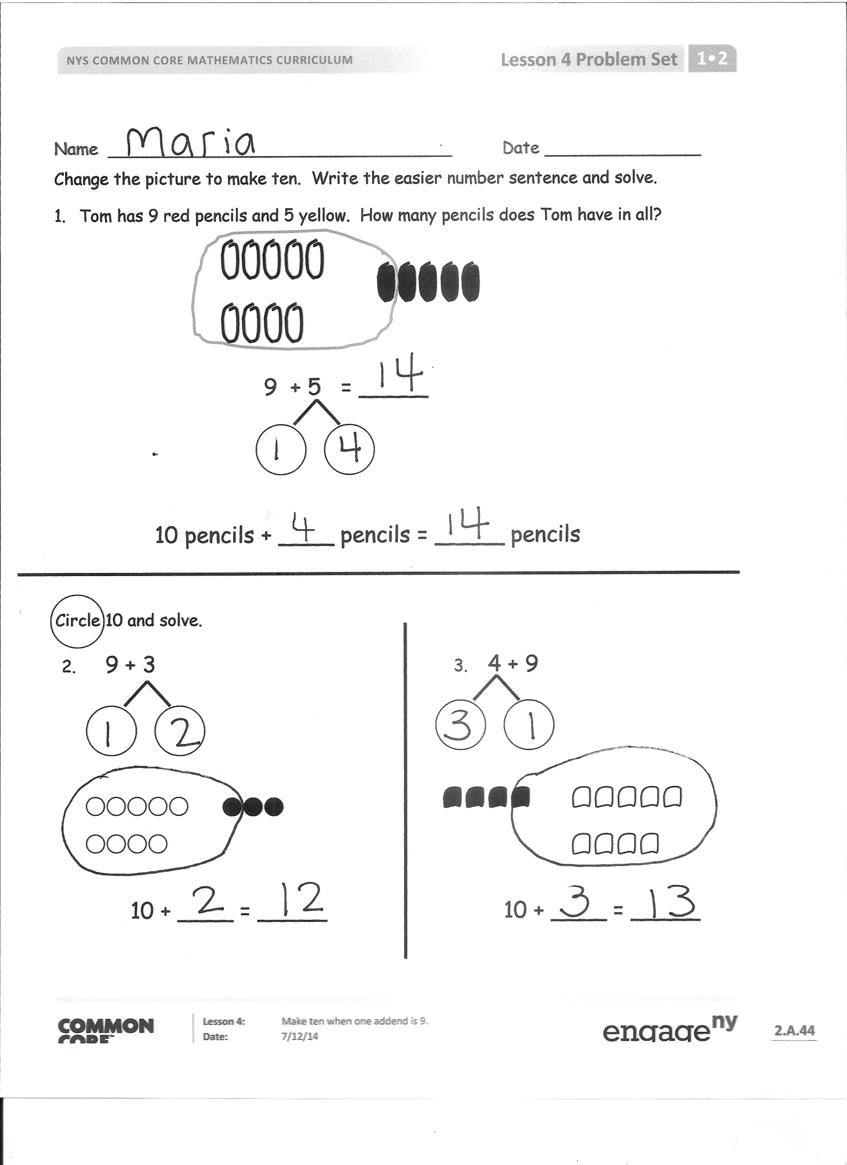
Next, repeat the process by having students use math drawings to solve the following in this suggested sequence: 9 + 6, 3 + 9, and 7 + 9. The 9 should be drawn with open circles. The other addend should be drawn with filled-in circles. Before students add dark circles to their math drawing, ask them, "How many does 9 need to make ten?" and "How many do you have when you take away 1 from [the other addend]?" to guide how they decompose the addend. Additionally, encourage students to place the 1 closer to the 9 as they write the number bond below the other addend, making it easier to make ten with 9.
Problem Set (10 minutes)
Students should do their personal best to complete the Problem Set within the allotted 10 minutes. For some classes, it may be appropriate to modify the assignment by specifying which problems they work on first. Some problems do not specify a method for solving. Students should solve these problems using the RDW approach used for Application Problems.
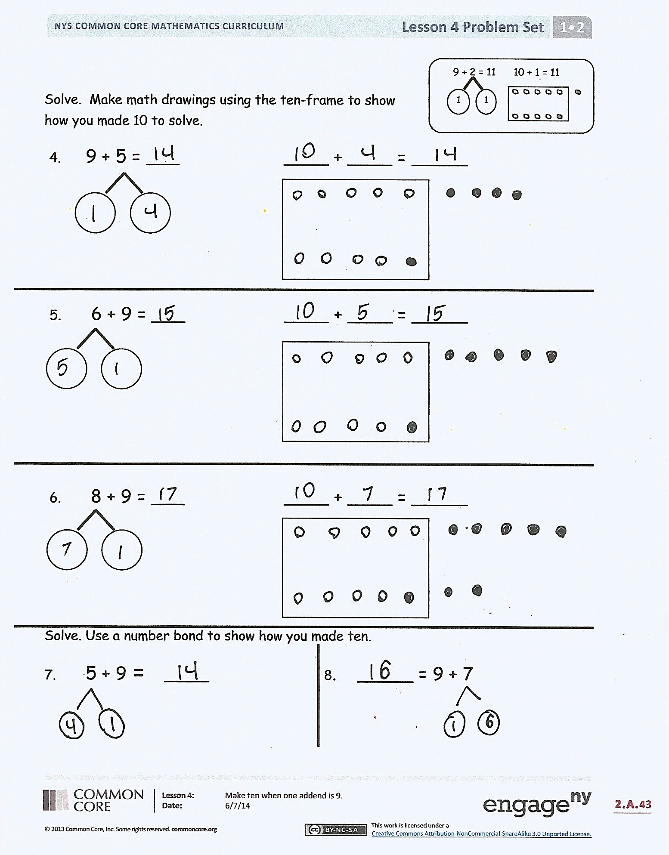
Student Debrief (10 minutes)
Lesson Objective: Make ten when one addend is 9.
The Student Debrief is intended to invite reflection and active processing of the total lesson experience.
Invite students to review their solutions for the Problem Set. They should check work by comparing answers with a partner before going over answers as a class. Look for misconceptions or misunderstandings that can be addressed in the Debrief. Guide students in a conversation to debrief the Problem Set and process the lesson.
You may choose to use any combination of the questions below to lead the discussion.
- How did solving Problem 4 help you solve Problem 5?
- What new (or significant) math vocabulary did we use today to make our pictures precise?
- What were some strategies we learned today to solve addition problems efficiently? (Organizing materials and drawings in ten-frame, making ten, starting with the 9 to add.)
- Look at your Problem Set. What pattern did you notice when adding 9 to a number? Why is it always a ten and the number that is 1 less than the other addend?
- Look at the Application Problem. Share your drawing with a partner. How could you use the ten-frame to show your work? How does the ten-frame help you see your total amount?
Exit Ticket (3 minutes)
After the Student Debrief, instruct students to complete the Exit Ticket. A review of their work will help you assess the students’ understanding of the concepts that were presented in the lesson today and plan more effectively for future lessons. You may read the questions aloud to the students.

Name Date
Number correct:
A
*Make a ten to add.
1 | 9 + 1 + 3 = ☐ |  | 16 | 6 + 4 + 5 = ☐
2 | 9 + 1 + 5 = ☐ |  | 17 | 6 + 4 + 6 = ☐
3 | 1 + 9 + 5 = ☐ |  | 18 | 4 + 6 + 6 = ☐
4 | 1 + 9 + 1 = ☐ |  | 19 | 4 + 6 + 5 = ☐
5 | 5 + 5 + 4 = ☐ |  | 20 | 4 + 5 + 6 = ☐
6 | 5 + 5 + 6 = ☐ |  | 21 | 5 + 3 + 5 = ☐
7 | 5 + 5 + 5 = ☐ |  | 22 | 6 + 5 + 5 = ☐
8 | 8 + 2 + 1 = ☐ |  | 23 | 1 + 4 + 9 = ☐
9 | 8 + 2 + 3 = ☐ |  | 24 | 9 + 1 + ☐ = 14
10 | 8 + 2 + 7 = ☐ |  | 25 | 8 + 2 + ☐ = 11
11 | 2 + 8 + 7 = ☐ |  | 26 | ☐ + 3 + 4 = 13
12 | 7 + 3 + 3 = ☐ |  | 27 | 2 + ☐ + 6 = 16
13 | 7 + 3 + 6 = ☐ |  | 28 | 1 + 1 + ☐ = 11
14 | 7 + 3 + 7 = ☐ |  | 29 | 19 = 5 + ☐ + 9
15 | 3 + 7 + 7 = ☐ |  | 30 | 18 = 2 + ☐ + 6
Name Date
Number correct:
B
*Make a ten to add.
1 | 5 + 5 + 4 = ☐ |  | 16 | 6 + 4 + 2 = ☐
2 | 5 + 5 + 6 = ☐ |  | 17 | 6 + 4 + 3 = ☐
3 | 5 + 5 + 5 = ☐ |  | 18 | 4 + 6 + 3 = ☐
4 | 9 + 1 + 1 = ☐ |  | 19 | 4 + 6 + 6 = ☐
5 | 9 + 1 + 2 = ☐ |  | 20 | 4 + 7 + 6 = ☐
6 | 9 + 1 + 5 = ☐ |  | 21 | 5 + 4 + 5 = ☐
7 | 1 + 9 + 5 = ☐ |  | 22 | 8 + 5 + 5 = ☐
8 | 1 + 9 + 6 = ☐ |  | 23 | 1 + 7 + 9 = ☐
9 | 8 + 2 + 4 = ☐ |  | 24 | 9 + 1 + ☐ = 11
10 | 8 + 2 + 7 = ☐ |  | 25 | 8 + 2 + ☐ = 12
11 | 2 + 8 + 7 = ☐ |  | 26 | ☐ + 3 + 4 = 14
12 | 7 + 3 + 7 = ☐ |  | 27 | 3 + ☐ + 7 = 20
13 | 7 + 3 + 8 = ☐ |  | 28 | 7 + 8 + ☐ = 17
14 | 7 + 3 + 9 = ☐ |  | 29 | 16 = 3 + ☐ + 6
15 | 3 + 7 + 9 = ☐ |  | 30 | 19 = 2 + ☐ + 7

Name Date
Change the picture to make ten. Write the easier number sentence and solve.
- Tom has 9 red pencils and 5 yellow. How many pencils does Tom have in all?

9 + 5 = _____

10 pencils + ____ pencils = _____ pencils

Circle 10 and solve.
- 9 + 3 3. 4 + 9

10 + ____ = _____ 10 + ____ = _____
Solve. Make math drawings using the ten-frame to show how you made 10 to solve.
9 + 2 = 11 10 + 1 = 11
1
1
- 9 + 5 = ___ ____ + ____ = _____

- 6 + 9 = ___ ____ + ____ = _____

- 8 + 9 = ___ ____ + ____ = _____

Solve. Use a number bond to show how you made ten.
- 5 + 9 = ____ 8. _____ = 9 + 7

Name Date
9 + 2 = 11

10 + 1 = 11
1
1
Solve.
Make math drawings using the ten-frame to show how you made 10 to solve.

- 6 + 9 = ___ 2. ___ = 4 + 9

10 + ___ = ___ ___ + ___ = ___

Name Date
Solve. Make math drawings using the ten-frame to show how you made 10 to solve.
9 + 2 = 11 10 + 1 = 11
1
1

- 9 + 3 = ___ ____ + ____ = _____

- 9 + 6 = ___ ____ + ____ = _____

- 7 + 9 = ___ ____ + ____ = _____

4. Match the number sentences to the bonds you used to help you make ten.

7
1
- 9 + 8 = ___
1
6

- __ = 9 + 6
5
1
- 7 + 9 =___
5. Show how the expressions are equal.
Use numbers bonds to make ten in the 9+ fact expression within the true number sentence. Draw to show the total.

a. 9 + 2 = 10 + 1 b. 10 + 3 = 9 + 4 c. 5 + 10 = 6 + 9

