Lesson 3
Objective: Make ten when one addend is 9.

Suggested Lesson Structure
 Fluency Practice (10 minutes)
 Application Problem (5 minutes)
 Concept Development (35 minutes)
 Student Debrief (10 minutes)
Total Time (60 minutes)
Fluency Practice (10 minutes)
- Take Out 1 1.OA.6 (1 minute)
- Break Apart 10 1.OA.6 (5 minutes)
- Add Partners of Ten First 1.OA.3 (4 minutes)
Take Out 1 (1 minute)
Materials: (S) Personal white board
Note: This is an anticipatory fluency for the make ten addition strategy, as students need to fluently take 1 out of the second addend when adding to 9.
Make the pace quicker now that students have done this for a few days. Celebrate their improvement.
Say a number between 1 and 9. Students say the number decomposed with one part as one.
Break Apart 10 (5 minutes)
Materials: (T) 5-group cards (Lesson 1 Fluency Template) (S) Personal white board
Students write the numeral 10 on their personal white boards. Flash a 5-group card. Students break apart 10 using the number flashed as a part, without making bubbles or boxes around the numerals.

Add Partners of Ten First (4 minutes)
Note: This activity reviews adding three numbers and prepares students for the make ten addition strategy when one addend is 9.
Build towards three addends. Begin with 9 + 1.
T: 9 + 1.
S: 10.
T: 10 + 5
S: 15.
T: 9 + 1 (pause) + 5 is?
S: 15.
Continue with the following suggested sequence: 9 + 1 + 6, 9 + 1 + 4, 9 + 1 + 3, 9 + 1 + 7, 8 + 2 + 7, etc.
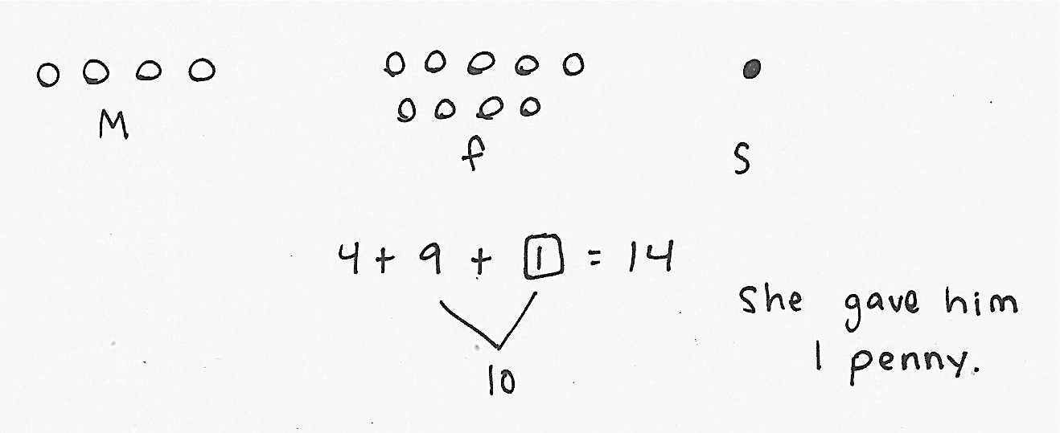
Application Problem (5 minutes)
Tom’s mother gave him 4 pennies. His father gave him 9 pennies. His sister gave him enough pennies so that he now has a total of 14. How many pennies did his sister give him? Use a drawing, number sentence, and a statement.
Extension: How many more would he need to have 19 pennies?
Note: This application problem challenges students to consider finding an unknown addend within a context with three addends. Students may add 4 and 9 together first noticing that they need 1 more penny to make 14. Other students may recognize that 14 is made of 10 and 4, and realize that they are looking for the partner for 9 when making ten. During the Debrief, students explore how they could use making ten as a quick strategy to add the sets of pennies that Tom’s parents gave him (9 pennies and 4 pennies).
Concept Development (35 minutes)
Materials: (T) 10 red and 10 green linking cubes (S) 10 red and 10 green linking cubes, personal white board

NOTES ON
MULTIPLE MEANS
OF REPRESENTATION:
While some students are experts at solving 10+ number sentences, others may need pictorial support such as ten- frames (rather than numerals) to help develop mental calculations.

Have students sit at their seats with materials.
T: (Project and read aloud.) Maria has 9 snowballs and Tony has 3. How many do they have altogether?
T: What is the expression to solve this problem?
S: 9 + 3.
T: Use your green linking cubes to show how many snowballs Maria has.
S: (Lay out 9 green linking cubes.)
T: Using the red cubes, show how many snowballs Tony has. Put them in a separate pile.
S: (Lay out 3 linking cubes.)
T: How would you solve this problem?

NOTES ON
MULTIPLE MEANS
OF REPRESENTATION:
For those students who can fluently solve math facts within 20, cultivate excitement by connecting on-level math to higher math, presenting numbers to 100.
(29 + 3 or 39 + 13)

S: Count on!
T/S: Niiiine, 10, 11, 12.
T: (Complete the equation 9 + 3 = 12.)
T: Is there a way to make ten with the amounts we have in front of us? Turn and talk to your partner.
S: (Discuss while the teacher circulates.)
T: (Choose a student who used the strategy below.)
S: I made ten by moving 1 red cube to the green pile, I had 9 cubes in that pile but now I have 10.
T: You made ten! Everyone make ten.
S: (Move 1 red cube to the green pile.)
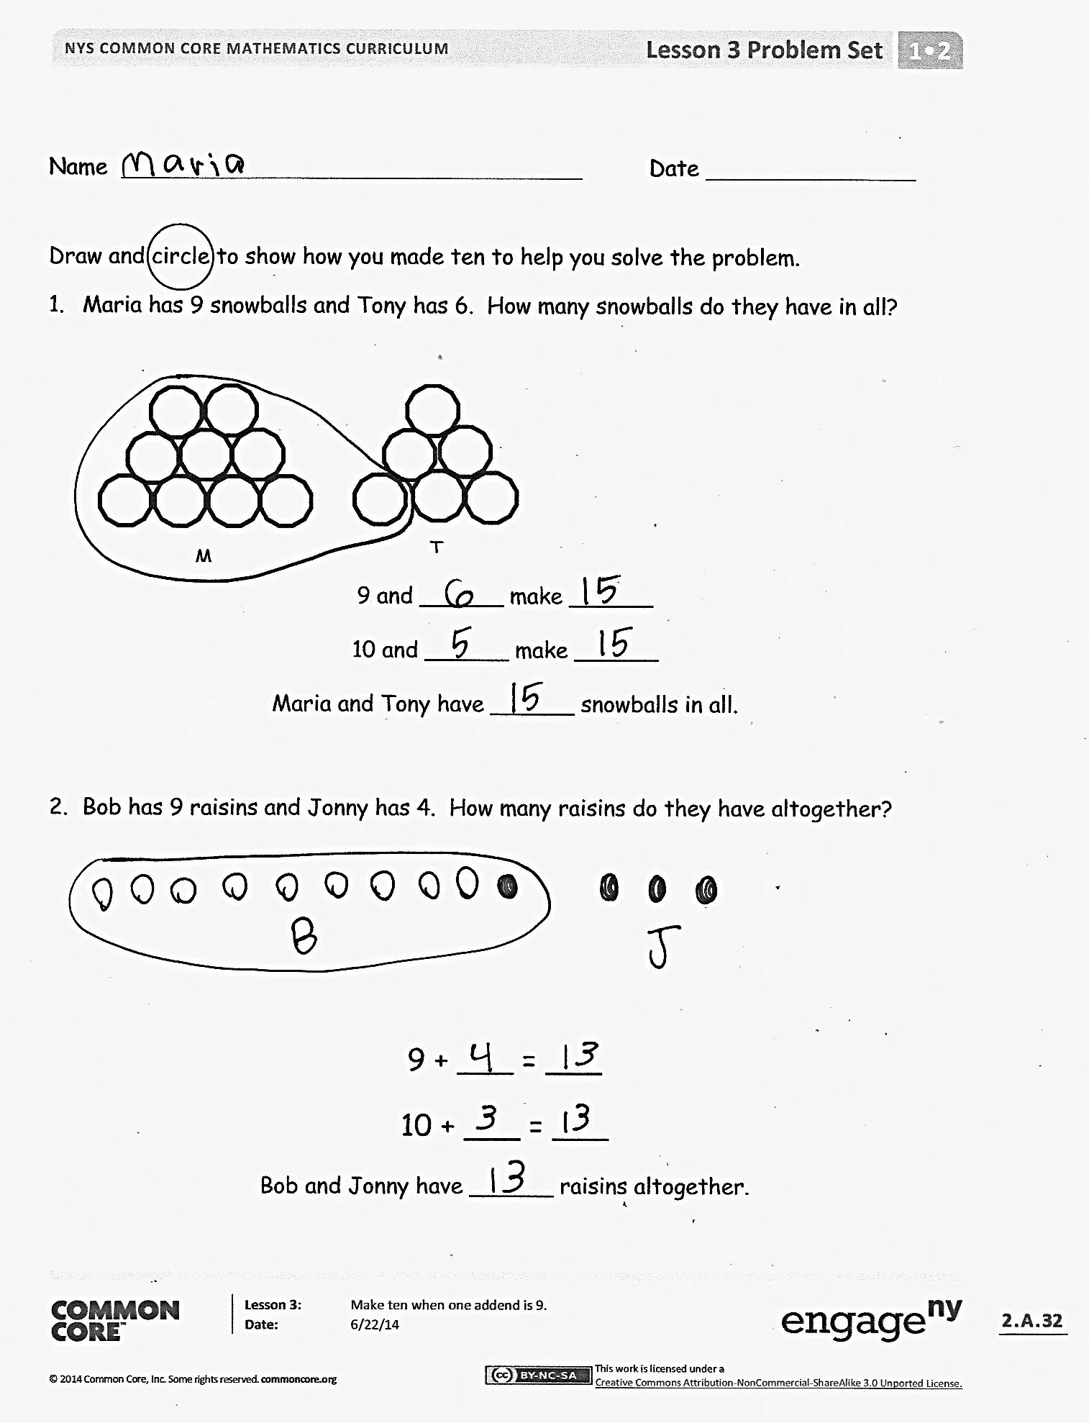
T: Now, we have 10 here. (Gesture to the pile of 10.) What do we have left here? (Point to the other pile.)
S: 2.
T: Look at your new piles. What is our new number sentence?
S: 10 + 2 = 12!
T: (Write 10 + 2 = 12 on the board.) Did we change the amount of linking cubes we have?
S: No.
T: So, 9 + 3 is the same as what addition expression?
S: 10 + 2.
T: (Write 9 + 3 = 10 + 2.)
T: What is 10 + 2?
S: 12.
T: What is 9 + 3? Say the number sentence.
S: 9 + 3 = 12.
T: How many snowballs do Maria and Tony have?
S: 12 snowballs.
Repeat the process with snowball situations for 9 + 2 and 9 + 4. Then, change to 5-group drawings instead of cubes. Continue to repeat the process with the following suggested sequence: 9 + 5, 9 + 8, and 9 + 7. Create different story situations for 9 + 6, 8 + 9, and 9 + 9. Be sure to have students label their pictures, circle 10, and write three number sentences (e.g., 9 + 6 = 15, 10 + 5 = 15, 9 + 6 = 10 + 5).
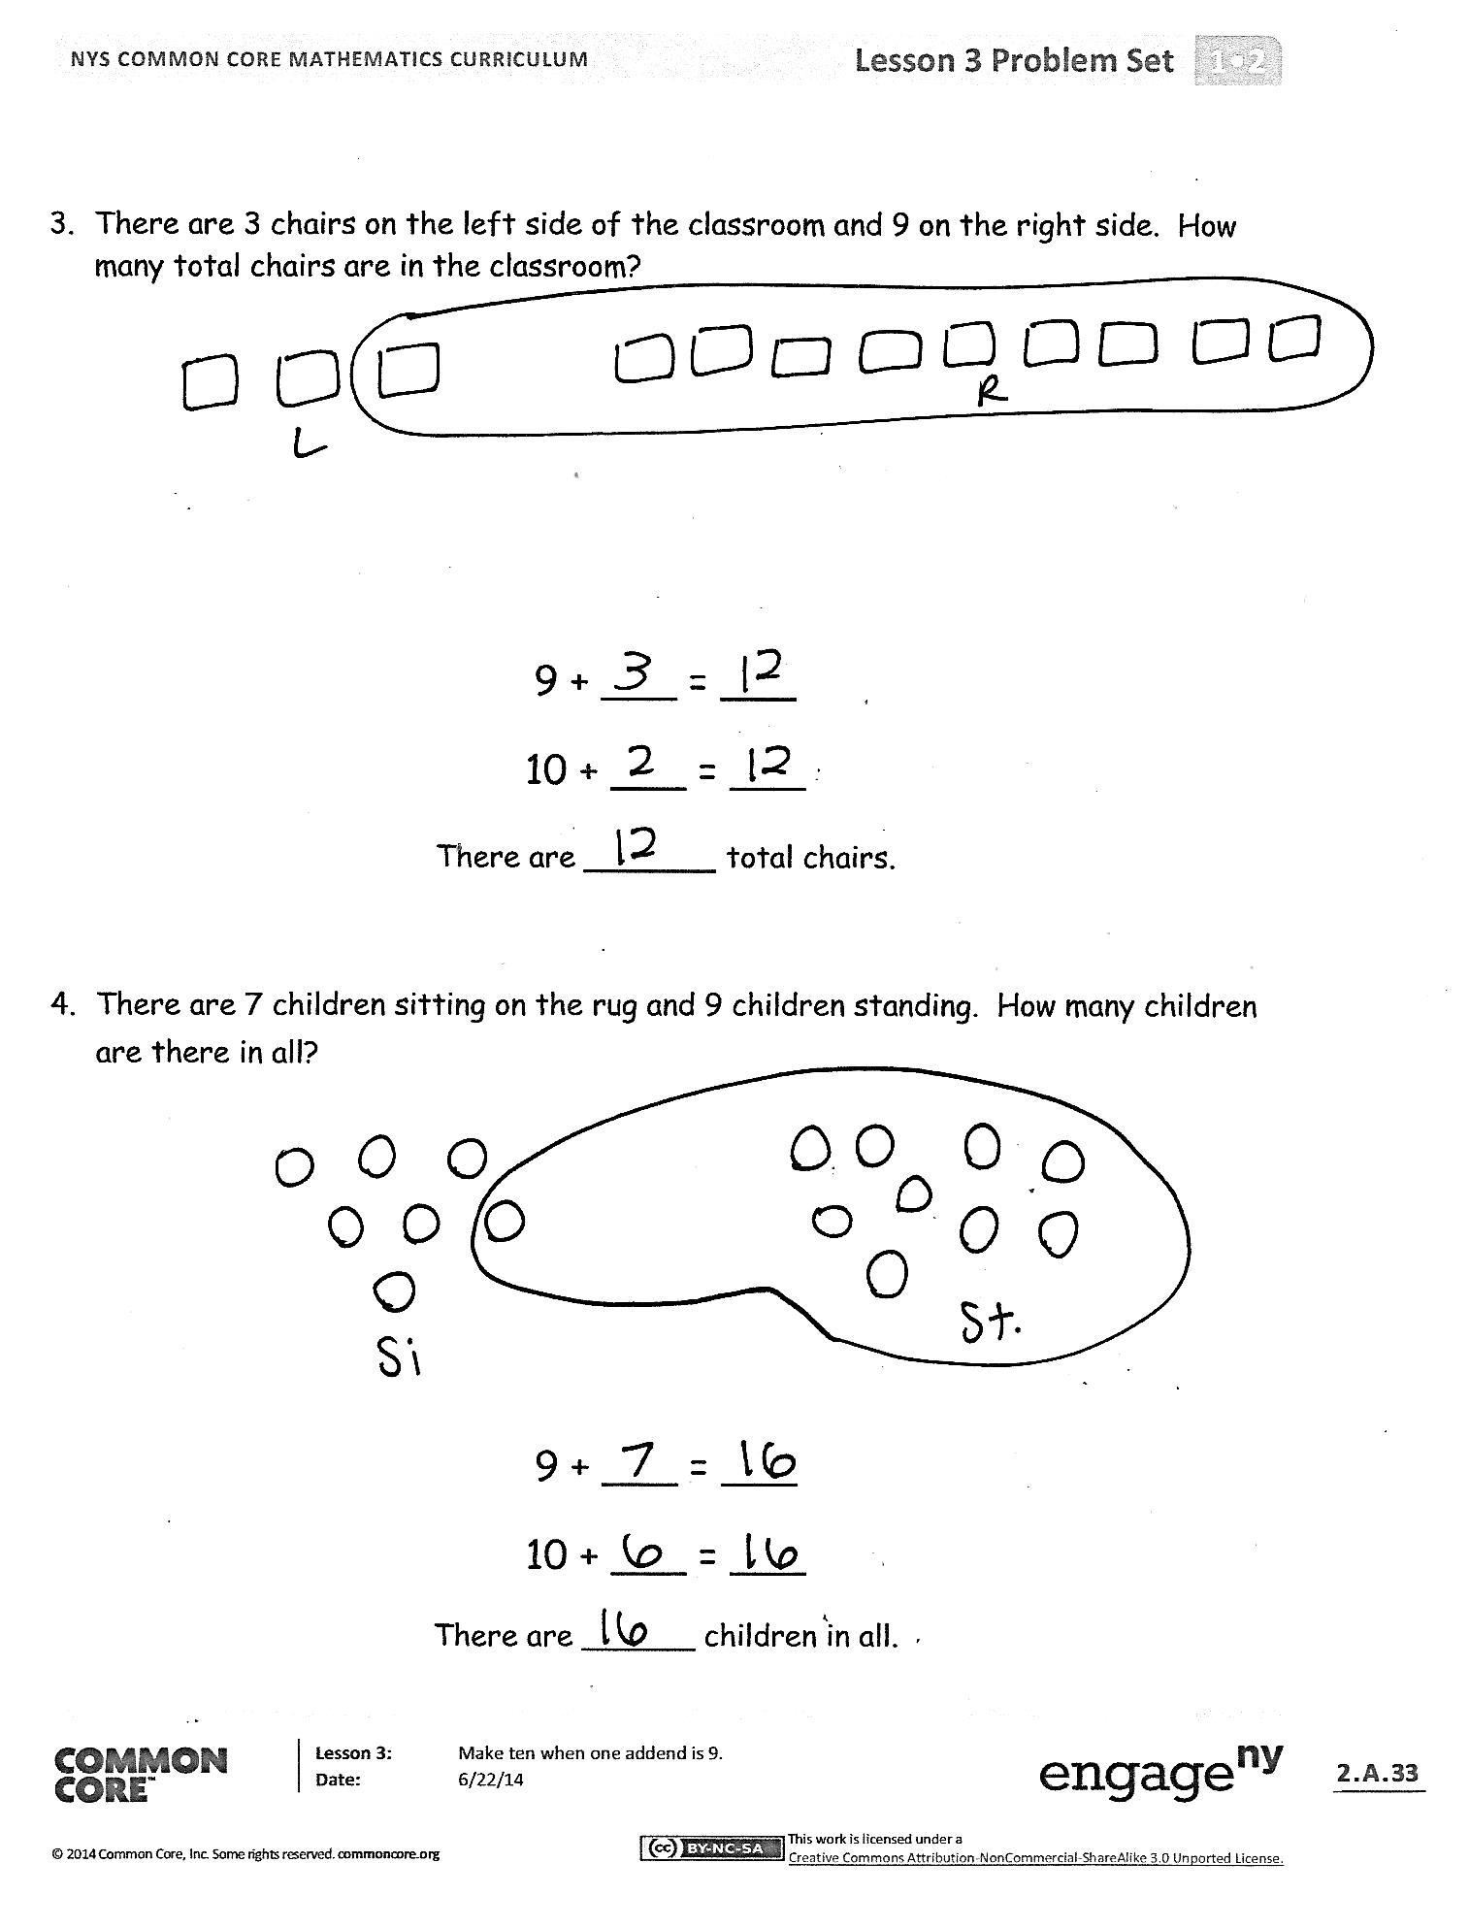
Problem Set (10 minutes)
Students should do their personal best to complete the Problem Set within the allotted 10 minutes. For some classes, it may be appropriate to modify the assignment by specifying which problems they work on first. Some problems do not specify a method for solving. Students should solve these problems using the RDW approach used for Application Problems.
Note: Students should save the Problem Sets from this lesson through Lesson 6. They provide comparisons for the students when they begin making ten when one addend is 8. Setting up a portfolio of past Problem Sets and strategies helps students access these readily.
Student Debrief (10 minutes)
Lesson Objective: Make ten when one addend is 9.
The Student Debrief is intended to invite reflection and active processing of the total lesson experience.
Invite students to review their solutions for the Problem Set. They should check work by comparing answers with a partner before going over answers as a class. Look for misconceptions or misunderstandings that can be addressed in the Debrief. Guide students in a conversation to debrief the Problem Set and process the lesson.
You may choose to use any combination of the questions below to lead the discussion.
- Look at Problem 1. What are the two number sentences that show your work?
- Look at Problem 1 and Problem 3 with a partner. How was setting up the problem to complete Problem 1 different from setting up Problem 3? What did you need to be sure to do? Why?
- How can solving Problem 1 help you solve Problem 4?
- After you made ten, what did you notice about the addend you broke apart? (The other addend is left with 1 less!)
- What new strategy did we use today to solve math problems? How is it more efficient than counting on to add?
- Look at your Application Problem. How could you use the make ten strategy to solve the problem?
Exit Ticket (3 minutes)
After the Student Debrief, instruct students to complete the Exit Ticket. A review of their work will help you assess the students’ understanding of the concepts that were presented in the lesson today and plan more effectively for future lessons. You may read the questions aloud to the students.

Name Date
Draw and circle to show how you made ten to help you solve the problem.
- Maria has 9 snowballs and Tony has 6. How many snowballs do they have in all?

Maria
Tony

9 and ______ make ______
10 and ______ make ______
Maria and Tony have ______ snowballs in all.

- Bob has 9 raisins and Jonny has 4. How many raisins do they have altogether?

9 + ___ = ___
10 + ___ = ___
Bob and Jonny have ______ raisins altogether.

- There are 3 chairs on the left side of the classroom and 9 on the right side. How many total chairs are in the classroom?

9 + ___ = ___
10 + ___ = ___
There are ______ total chairs.

- There are 7 children sitting on the rug and 9 children standing. How many children are there in all?

9 + ___ = ___
10 + ___ = ___
There are ______ children in all.
Name Date
Draw and circle to show how to make ten to solve. Complete the number sentences.
Tammy has 4 books and John has 9 books. How many books do Tammy and John have altogether?

___ + ___ = ___
___ + ___ = ___ Tammy and John have ____ books.

Name Date
Draw, label, and circle to show how you made ten to help you solve.
Complete the number sentences.
- Ron has 9 marbles and Sue has 4 marbles.
How many marbles do they have in all?

9 and ______ make ______
10 and ______ make ______

Ron and Sue have _____ marbles.
2. Jim has 5 cars and Tina has 9. How many cars do they have altogether?

9 and ______ make ______
10 and ______ make ______

Jim and Tina have ___ cars.

3. Stan has 6 fish and Meg has 9. How many fish do they have in all?

9 + ___ = ___
10 + ___ = ___ Stan and Meg have ___ fish.
- Rick made 7 cookies and Mom made 9. How many cookies did Rick and Mom make?

9 + ___ = ___
10 + ___ = ___ Rick and Mom made ____ cookies.
- Dad has 8 pens and Tony has 9. How many pens do Dad and Tony have in all?

9 + ___ = ___
10 + ___ = ___
Dad and Tony have ___ pens.

