Lesson 2
Objective: Use the associative and commutative properties to make ten with three addends.

Suggested Lesson Structure
 Fluency Practice (12 minutes)
 Application Problem (5 minutes)
 Concept Development (33 minutes)
 Student Debrief (10 minutes)
Total Time (60 minutes)
Fluency Practice (12 minutes)
- Take Out 1: Number Bonds 1.OA.6 (5 minutes)
- 5-Group Flash: Partners to Ten 1.OA.6 (5 minutes)
- Say Ten Conversion 1.NBT.2 (2 minutes)
Take Out 1: Number Bonds (5 minutes)
Materials: (S) Personal white board
Note: This is an anticipatory fluency activity for the make ten strategy with an addend of 9. Students take 1 from the other addend. The goal is for them to be able to do so quickly and accurately.
Say a number within 10. Students quickly write a number bond for the number said, using 1 as a part, and hold up their personal white boards when finished.
5-Group Flash: Partners to Ten (5 minutes)
Materials: (T) 5-Group cards (Lesson 1 Fluency Template) (S) Personal white board
Note: This is a maintenance fluency with partners to ten to facilitate the make ten addition strategy.
Flash a card for 1 to 3 seconds (e.g., 9). Students write two expressions that make ten (e.g., 9 + 1 and 1 + 9).

Say Ten Conversion (2 minutes)
Note: This activity strengthens students’ understanding of the place value system as it relates to counting.
Call out numbers between 10 and 20, alternating between saying the number the regular or the Say Ten way. When you use the Say Ten way, students say the number the regular way. When you use the regular way, students say it the Say Ten way. Play for a minute and then give students a chance to be the caller.
Application Problem (5 minutes)
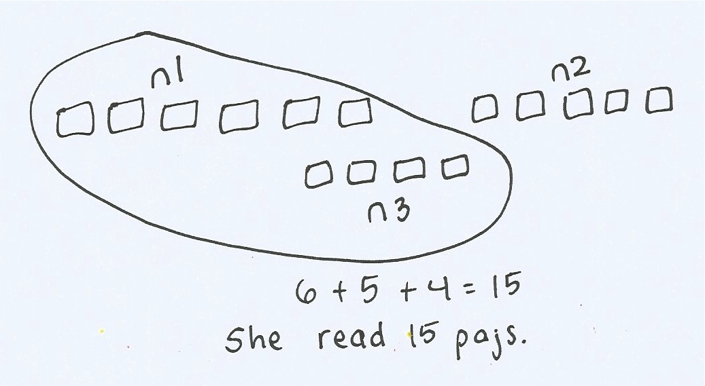
Lisa was reading a book. She read 6 pages the first night, 5 pages the next night, and 4 pages the following night. How many pages did she read?
Make a drawing to show your thinking. Write a statement to go with your work.
Extension: If she read a total of 20 pages by the fifth night, how many pages could she have read on the fourth night and the fifth night?
Note: This problem applies the Lesson 1 objective of adding three addends, two of which make ten. The two addends that make ten are separated within the story during the Student Debrief in connection with today’s lesson.
Concept Development (33 minutes)
Materials: (S) Personal white board
Have students sit in a semicircle at the meeting area with their materials.

NOTES ON
MULTIPLE MEANS
OF REPRESENTATION:
During this lesson it is important for students to articulate the way they chose to solve a problem so that other students can hear how they are thinking. This helps guide students towards the most efficient choice as they benefit from hearing strategies multiple times.

T: (Write 5 + 3 + 5 = ___ on the board.) Draw to solve for this unknown.
S: (Draw to solve, as the teacher circulates and notices student strategies.)
T: Let’s see how our friends solved this. (Select a student who added all in a row and a student who rearranged the addends to share their work.)
S: I added 5 + 3 and remembered that was 8. Then, I counted up 5 more from 8 and got 13! I drew the groups of 5 together and added those first since I knew they made ten. Then I added. 10 and 3 is 13!
T: Talk with your partner. How were the strategies used by your classmates similar and different from one another? Which one was correct?
S: (Discuss, as the teacher circulates and listens.) They were both correct! Bob put the fives together and made ten, and Jo added them in order.
T: So, even though they added two different numbers together first, did they get the same total?
S: Yes!
T: Wow! Okay, let’s try this again. Let’s use Bob’s strategy of making ten from two of our addends. (Write 7 + 5 + 3 = ___.) Write the equation. Draw to show the three amounts.
S: (Draw to show the three quantities.)
T: What two numbers make ten?

NOTES ON
MULTIPLE MEANS
OF ENGAGEMENT:
Addends should be chosen so that students can easily identify the partners to ten, recognizing that they can add these two addends first, regardless of where they are positioned within the number sentence. If students are not fluent with 7 and 3, they may be replaced with 9 and 1, respectively.

S: 7 and 3!
T: Good. Show that 7 and 3 make ten in your drawing by circling like we did yesterday with the string.
S: (Circle the 3 and the 7, making a group of 10.)
T: Here is a new number sentence that shows what numbers you added first. (Write 7 + 3 + 5 = ___.)
MP.7
T: I’ll make a number bond to show how you made ten from two numbers. (Bond the 7 and 3 to make ten.)
T: You just showed 10 and 5 more, which equals?
MP.7
S: 15!
T: Good. I’ll show how we solved for the unknown. I’ll write the new number sentence explaining what we just did, starting with 10.
S: (Solve 7 + 3 + 5 = ___, while the teacher writes 10 + 5 = 15.)
T: Jo showed us at the beginning of the lesson that she could solve from left to right, without moving the addends around, in order to get the same answer as Bob. Work and talk with your partner to see if this is true again!
Repeat this process, using the following suggested sequence: 9 + 2 + 1, 2 + 4 + 8 (highlighting that students might begin with the 8 rather than the 2), 4 + 3 + 6, and 3 + 8 + 7. Students complete the number sentence while the teacher completes the drawing for the third example.
Problem Set (10 minutes)
Students should do their personal best to complete the Problem Set within the allotted 10 minutes. For some classes, it may be appropriate to modify the assignment by specifying which problems they work on first. Some problems do not specify a method for solving. Students should solve these problems using the RDW approach used for Application Problems.
Note: Look at the example for Problem 1 in the Problem Set. Discuss the importance of making a simple math drawing by drawing three different simple shapes to represent three different numbers in the equation, reminding children about their experience using different concrete materials during previous lessons. Model this drawing if necessary.
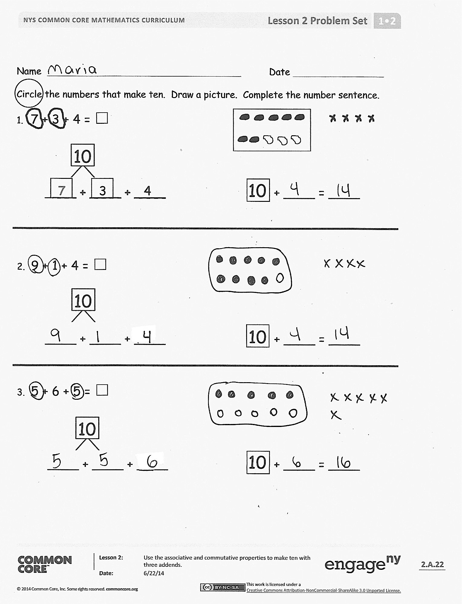
Student Debrief (10 minutes)
Lesson Objective: Use the associative and commutative properties to make ten with three addends.
The Student Debrief is intended to invite reflection and active processing of the total lesson experience.
Invite students to review their solutions for the Problem Set. They should check work by comparing answers with a partner before going over answers as a class. Look for misconceptions or misunderstandings that can be addressed in the Debrief. Guide students in a conversation to debrief the Problem Set and process the lesson.
You may choose to use any combination of the questions below to lead the discussion.
- Look at your Problem Set. We added amounts in different orders. When we did this, did we get the same amount? Is this always true?
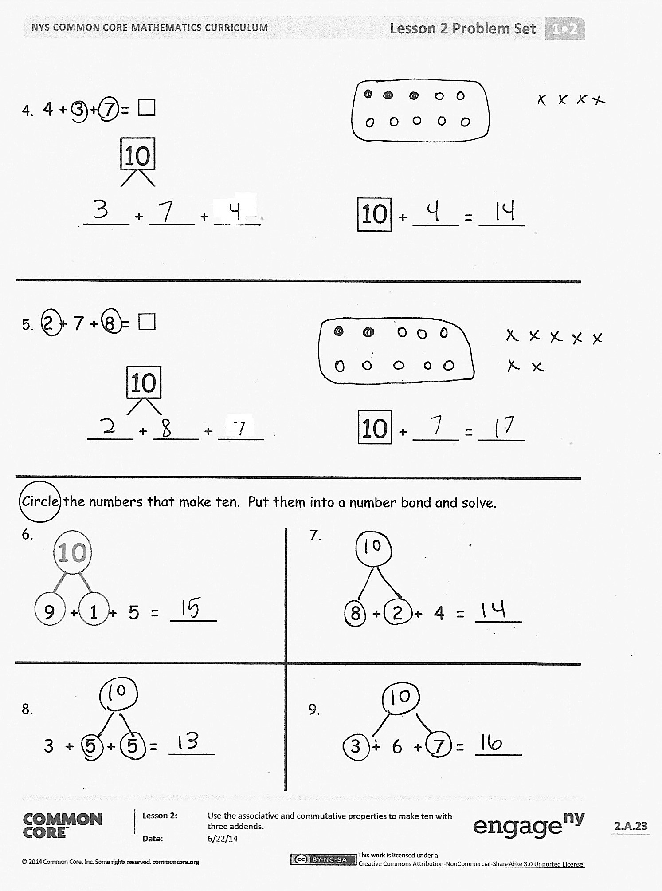
- Talk with your partner. How did you organize your drawings to show the three different amounts? How did you show that you used the make ten strategy in your drawing?
- Look at Problem 1 and Problem 4. What similarities do you notice?
- Are there any problems in the Problem Set that you can solve using your knowledge of doubles?
- Look at Problem 9. How did you show the number bond for making ten? How is it different from some of your other bonds? (Students share strategies of number bond above or below or rewrite the number sentence below to enable the addends that make ten to be adjacent.)
Exit Ticket (3 minutes)
After the Student Debrief, instruct students to complete the Exit Ticket. A review of their work will help you assess the students’ understanding of the concepts that were presented in the lesson today and plan more effectively for future lessons. You may read the questions aloud to the students.

Name Date
Circle the numbers that make ten. Draw a picture. Complete the number sentence.
- 7 + 3 + 4 = ☐
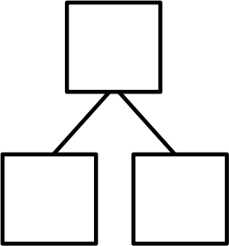
10
7 3 4

____ + ____ + ____ 10 + ____ = ____

- 9 + 1 + 4 = ☐
10

____ + ____ + ____ 10 + ____ = ____

- 5 + 6 + 5 = ☐
10

____ + ____ + ____ 10 + ____ = ____

- 4 + 3 + 7 = ☐
10

____ + ____ + ____ 10 + ____ = ____

- 2 + 7 + 8 = ☐
10

____ + ____ + ____ 10 + ____ = ____

Circle the numbers that make ten. Put them into a number bond and solve.
10
- 7.

- + 1 + 5 = ____ 8 + 2 + 4 = ____

- 9.
3 + 5 + 5 = ____ 3 + 6 + 7 = ____
Name Date
Circle the numbers that make ten.
Draw a picture and complete the number sentences to solve.

- 8 + 2 + 3 = ____

____ + ____ = ____

10 + ____ = ____

- 7 + 4 + 3 = ____

____ + ____ = ____

10 + ____ = ____

Name Date
Circle the numbers that make ten. Draw a picture. Complete the number sentence.
- 6 + 2 + 4 = ☐
10
6 2

____ + ____ + ____ 10 + ____ = ____

- 5 + 3 + 5 = ☐

____ + ____ + ____ 10 + ____ = ____

- 5 + 2 + 8 = ☐

____ + ____ + ____ ____ + 10 = ____
- 2 + 7 + 3 = ☐

____ + ____ + ____ ____ + 10 = ____

Circle the numbers that make ten and put them into a number bond. Write a new number sentence.
10

3 + 5 + 7 = ____ ____ + ____ = ____

4 + 8 + 2 = ____ ____ + ____ = ____

Challenge: Circle the addends that make ten. Circle the true number sentences.

- 5 + 5 + 3 = 10 + 3
- 4 + 6 + 6 = 10 + 6
- 3 + 8 + 7 = 10 + 6
- 8 + 9 + 2 = 9 + 10

