Lesson 39
Objective: Analyze the addition chart to create sets of related addition and subtraction facts.

Suggested Lesson Structure
 Fluency Practice (17 minutes)
 Application Problem (5 minutes)
 Concept Development (28 minutes)
 Student Debrief (10 minutes)
Total Time (60 minutes)
Fluency Practice (17 minutes)
- Decompose Teen Numbers K.NBT.1 (2 minutes)
- Sprint: Decomposing Teen Numbers K.NBT.1 (10 minutes)
- Number Bond Roll 1.OA.6 (5 minutes)
Decompose Teen Numbers (2 minutes)
Note: Reviewing the Kindergarten standard K.NBT.1 will prepare students for problem-solving strategies presented in Module 2.
Ask questions to decompose teen numbers. Instruct students to answer at a signal.
Use the following suggested questions: What is 14 the Say Ten way? 12 is 10 and…? 17 is 7 and…?
Sprint: Decomposing Teen Numbers (10 minutes)
Materials: (S) Decomposing Teen Numbers Sprint
Note: This activity addresses the core fluency objective for Grade 1 of adding and subtracting within 10.
Number Bond Roll (5 minutes)
Materials: (S) Die (with 6 replaced by 0), personal white board
Note: Reviewing number bonds allows students to build and maintain fluency with addition and subtraction facts within 10.
Assign partners of equal ability. Each student rolls 1 die. Students use the numbers on their own die and their partner’s die as the parts of a number bond. Instruct each student to write a number bond, two addition sentences, and two subtraction sentences on their boards. Once completed, the students check each other’s work.
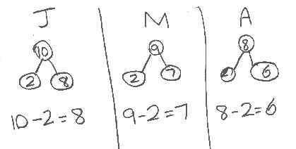
Application Problem (5 minutes)
John has 10 pencils. Mark has 9 pencils. Anna has 8 pencils. They each lost two of their pencils. How many do they each have now? Write a number bond and number sentence for each student.
Note: This problem continues to apply subtraction objectives in solving word problems. During the Debrief, the relationship between the three embedded problems will be discussed.
Concept Development (28 minutes)

NOTES ON
MULTIPLE MEANS
OF ACTION AND EXPRESSION:
When students are not able to participate in the traditional partner share, they can use their white boards to adjust. Partners can still participate by jotting questions and answers to one another on their boards.

Materials: (T) Addition chart (Lesson 21 Template) (S) Addition chart (Lesson 21 Template), subtraction expression cards (Lesson 38 Template) per group, personal white board
T: Look at 5 + 2 on the addition chart. (Point to 5 + 2 on the chart.) Who can share a subtraction sentence and an addition sentence that have the same parts and total?
S: 7 – 5 = 2 and 5 + 2 = 7.
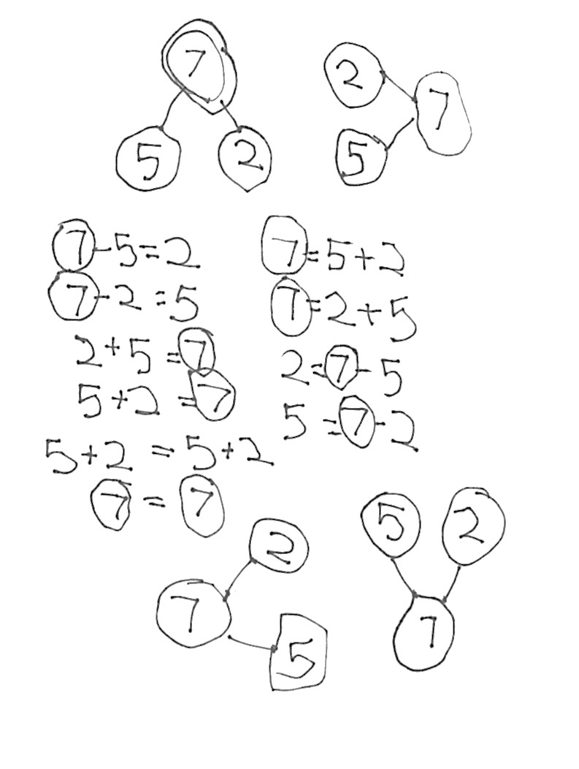
T: Let’s all write that set on our board. Write the number bond too.
T/S: (Write 7 – 5 = 2, 5 + 2 = 7, and matching number bond.)
T: There are more addition facts that we can make from this same number bond. What is one of them?
S: 2 + 5 = 7!
T: Let’s write that number sentence as well.
S: (Write 2 + 5 = 7.)
T: We can also write a number sentence matching two addition expressions without totals. Turn and talk with your partner to discuss what this number sentence might be. Write it on your board. (Circulate and listen.)
MP.7
S: (Discuss and write 5 + 2 = 2 + 5.)
T: I saw many of you write 5 + 2 = 2 + 5. 5 + 2 is equal to, or the same as, 2 + 5.
T: There are other number sentences that have the same parts and total. Talk with your partner to decide what they could be, and write them on your board. (Circulate and listen.)
S: (Discuss and write 7 – 2 = 5.)
T: See if you can write your number bond in different ways, too. Circle your totals!
T: Look how many facts you can share using your knowledge of one fact.
Assign pairs of students different number bonds from which to make as many varied number sentences as they can. Have them make a poster and prepare to share their ideas with peers.
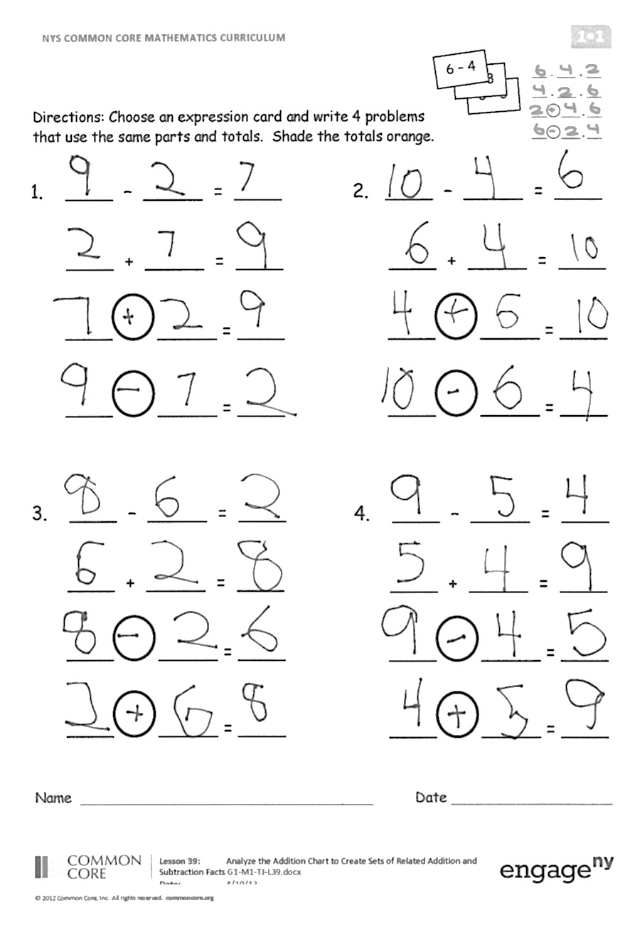
Problem Set (10 minutes)
Students should do their personal best to complete the Problem Set within the allotted 10 minutes. For some classes, it may be appropriate to modify the assignment by specifying which problems they work on first. Some problems do not specify a method for solving. Students solve these problems using the RDW approach used for Application Problems.
Student Debrief (10 minutes)
Lesson Objective: Analyze the addition chart to create sets of related addition and subtraction facts.
The Student Debrief is intended to invite reflection and active processing of the total lesson experience.
Invite students to review their solutions for the Problem Set. They should check work by comparing answers with a partner before going over answers as a class. Look for misconceptions or misunderstandings that can be addressed in the Debrief. Guide students in a conversation to debrief the Problem Set and process the lesson.

NOTES ON
MULTIPLE MEANS
OF ENGAGEMENT:
Adjust Problem Set directions as needed to suit specific learning needs. Some students may need to write a number bond before writing the number sentences.

You may choose to use any combination of the questions below to lead the discussion.
- Hold up a subtraction expression. What number sentences we can make? What number sentence can we make that uses both of the addition expressions?
- Look at Problem 1. Write the number sentence that uses both addition expressions below your work.
- How does knowledge of one addition or subtraction fact help you know other facts? Use an example from your Problem Set to explain your thinking.
- Look at your Application Problem. Where are the related addition facts on the addition chart? How are the three number bonds similar? How are they different?
- Have different groups present their work from the Concept Development. Let the others ask them questions about their work.
Exit Ticket (3 minutes)
After the Student Debrief, instruct students to complete the Exit Ticket. A review of their work will help you assess the students’ understanding of the concepts that were presented in the lesson today and plan more effectively for future lessons. You may read the questions aloud to the students.

Name Date
A

*Write the missing number for each sentence.
Number correct:
1 | 8 and 2 make ☐ |  | 16 | 11 is 10 and ☐
2 | 9 and 1 make ☐ |  | 17 | 11 is 1 and ☐
3 | 7 and 3 make ☐ |  | 18 | 12 is 2 and ☐
4 | 6 and ☐ make 10 |  | 19 | 11 is ☐ and 1
5 | 4 and ☐ make 10 |  | 20 | 14 is 10 and ☐
6 | 5 and ☐ make 10 |  | 21 | 15 is ☐ and 5
7 | ☐ and 5 make 10 |  | 22 | 18 is 10 and ☐
8 | 13 is 10 and ☐ |  | 23 | 20 is 10 and ☐
9 | 14 is 10 and ☐ |  | 24 | 2 more than 10 is ☐
10 | 16 is 10 and ☐ |  | 25 | 10 more than 2 is ☐
11 | 17 is 10 and ☐ |  | 26 | 10 is ☐ less than 12
12 | 19 is 10 and ☐ |  | 27 | 10 is ☐ less than 12
13 | 18 is 10 and ☐ |  | 28 | 8 less than 18 is ☐
14 | 12 is 10 and ☐ |  | 29 | 6 less than 16 is ☐
15 | 13 is 10 and ☐ |  | 30 | 10 less than 20 is ☐
Name Date
Number correct:
B

*Write the missing number for each sentence.
1 | 9 and 1 make ☐ |  | 16 | 12 is 10 and ☐
2 | 8 and 2 make ☐ |  | 17 | 12 is 2 and ☐
3 | 6 and 4 make ☐ |  | 18 | 11 is 1 and ☐
4 | 7 and ☐ make 10 |  | 19 | 11 is ☐ and 1
5 | 3 and ☐ make 10 |  | 20 | 15 is 10 and ☐
6 | 7 and ☐ make 10 |  | 21 | 14 is ☐ and 4
7 | ☐ and 5 make 10 |  | 22 | 19 is 10 and ☐
8 | 14 is 10 and ☐ |  | 23 | 20 is 10 and ☐
9 | 13 is 10 and ☐ |  | 24 | 1 more than 10 is ☐
10 | 17 is 10 and ☐ |  | 25 | 10 more than 1 is ☐
11 | 16 is 10 and ☐ |  | 26 | 10 is ☐ less than 11
12 | 15 is 10 and ☐ |  | 27 | 10 is ☐ less than 11
13 | 19 is 10 and ☐ |  | 28 | 7 less than 18 is ☐
14 | 11 is 10 and ☐ |  | 29 | 7 less than 16 is ☐
15 | 12 is 10 and ☐ |  | 30 | 10 less than 20 is ☐

Name Date

Study the addition chart to solve and write related problems.

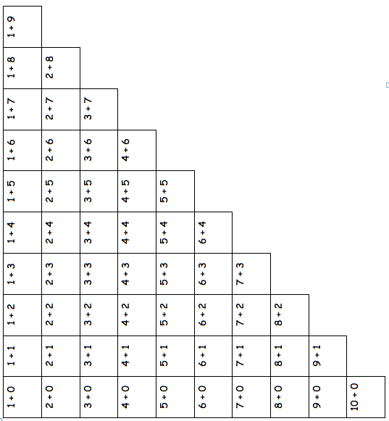
Pick a subtraction card.
Find the related addition fact on the chart and shade it in.
Write the subtraction sentence and the shaded addition sentence.
Write the other two related facts.
Continue for at least 4 turns.
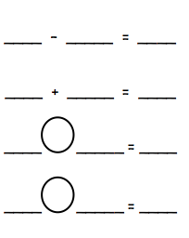
Choose an expression card, and write 4 problems that use the same parts and totals. Shade the totals orange.
8 – 3
8 – 3
6 – 4
2. ____ – _____ = ____

____ + _____ = ____

____ _____ = ____

____ _____ = ____
1. ____ – _____ = ____

____ + _____ = ____

____ _____ = ____

____ _____ = ____

4. ____ – _____ = ____

____ + _____ = ____

____ _____ = ____

____ _____ = ____
3. ____ – _____ = ____

____ + _____ = ____

____ _____ = ____

____ _____ = ____

Name Date

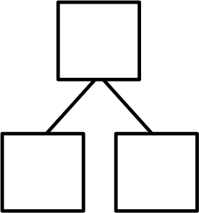
Write the related number sentences for the number bonds.
7
8
1. 2.

9

10

____ – _____ = ____

____ + _____ = ____

____ _____ = ____

____ _____ = ____
____ – _____ = ____

____ + _____ = ____

____ _____ = ____

____ _____ = ____

Name Date

Solve the un-shaded addition problems below.

1 + 0 | 1 + 1 | 1 + 2 | 1 + 3 | 1 + 4 | 1 + 5 | 1 + 6 | 1 + 7 | 1 + 8 | 1 + 9
2 + 0 | 2 + 1 | 2 + 2 | 2 + 3 | 2 + 4 | 2 + 5 | 2 + 6 | 2 + 7 | 2 + 8
3 + 0 | 3 + 1 | 3 + 2 | 3 + 3 | 3 + 4 | 3 + 5 | 3 + 6 | 3 + 7
4 + 0 | 4 + 1 | 4 + 2 | 4 + 3 | 4 + 4 | 4 + 5 | 4 + 6
5 + 0 | 5 + 1 | 5 + 2 | 5 + 3 | 5 + 4 | 5 + 5
6 + 0 | 6 + 1 | 6 + 2 | 6 + 3 | 6 + 4
7 + 0 | 7 + 1 | 7 + 2 | 7 + 3
8 + 0 | 8 + 1 | 8 + 2
9 + 0 | 9 + 1
10 + 0

2
4
6
4 + 2

Pick an addition fact from the chart. Use the grid to write the two subtraction facts that would have the same number bond. Repeat, in order to make a set of subtraction flash cards. To help you practice your addition and subtraction facts even more, make your own number bond flash cards with the templates on the last page.

