Lesson 19: The Euclidean Algorithm as an Application of the Long Division Algorithm

Student Outcomes
- Students explore and discover that Euclid’s Algorithm is a more efficient means to finding the greatest common factor of larger numbers and determine that Euclid’s Algorithm is based on long division.

Lesson Notes
Students look for and make use of structure, connecting long division to Euclid’s Algorithm.
MP.7
Students look for and express regularity in repeated calculations leading to finding the greatest common factor of a pair of numbers.
These steps are contained in the Student Materials and should be reproduced, so they can be displayed throughout the lesson:
Euclid’s Algorithm is used to find the greatest common factor (GCF) of two whole numbers.
MP.8
- Divide the larger of the two numbers by the smaller one.
- If there is a remainder, divide it into the divisor.
- Continue dividing the last divisor by the last remainder until the remainder is zero.
- The final divisor is the GCF of the original pair of numbers.
In application, the algorithm can be used to find the side length of the largest square that can be used to completely fill a rectangle so that there is no overlap or gaps.

Classwork
Opening (5 minutes)
Lesson 18 Problem Set can be discussed before going on to this lesson.

Opening Exercise (4 minutes)
Scaffolding:
- Students who are not fluent using the standard division algorithm or have difficulty estimating can use a calculator to test out multiples of divisors.
- There are three division warm-ups on your Student Material page today. Please compute them now. Check your answer to make sure it is reasonable.
Opening Exercise
Euclid’s Algorithm is used to find the greatest common factor (GCF) of two whole numbers.
- Divide the larger of the two numbers by the smaller one.
- If there is a remainder, divide it into the divisor.
- Continue dividing the last divisor by the last remainder until the remainder is zero.
- The final divisor is the GCF of the original pair of numbers.

$383÷4=95.75$ $432÷12=36$ $403÷13=11$

Discussion (2 minutes)
- The Opening Exercise was meant for you to recall how to determine the quotient of two numbers using long division. You have practiced the long division algorithm many times. Today’s lesson is inspired by Euclid, a Greek mathematician who lived around 300 B.C. He discovered a way to find the greatest common factor of two numbers that is based on long division.

Example 1 (10 minutes): Euclid’s Algorithm Conceptualized
- What is the GCF of $60$ and $100$?
  - $20$
- What is the interpretation of the GCF in terms of area? Let’s take a look.
Project the following diagram:
Example 1: Euclid’s Algorithm Conceptualized
$100$ units
$20$ units
$60$ units
$20$ units

- Notice that we can use the GCF of $20$ to create the largest square tile that will cover the rectangle without any overlap or gaps. We used a $20×20$ tile.
- But, what if we didn’t know that? We could start by guessing. What is the biggest square tile that we can guess?
  - $60×60$

Display the following diagram:
$60$ units
$60$ units
$40$ units
$100$ units

- It fits, but there are $40$ units left over. Do the division problem to prove this.
$$1$$
$$\left.60\right)100$$
$- 60$
$40$

Teacher note: With each step in this process, please write out the long division algorithm that accompanies it.
It is important for students to make a record of this as well. The remainder becomes the new divisor and continues until the remainder is zero.
- What is the leftover area?
  - $60×40$
- What is the largest square tile that we can fit in the leftover area?
  - $40×40$

Display the following diagram:
$60$ units
$60$ units
$40$ units
$100$ units

- What is the leftover area?
$$2$$
$$\left.20\right)40$$
$- 40$
$0$
  - $20×40$
- What is the largest square tile that we can fit in the leftover area?
  - $20×20$
- When we divide $40$ by $20$, there is no remainder. So, we have tiled the entire rectangle.
- If we had started tiling the whole rectangle with squares, the largest square we could have used would be $20$ by $20$.
Take a few minutes to allow discussion, questions, and clarification.

Example 2 (5 minutes): Lesson 18 Classwork Revisited
During Lesson 18, students found the GCF of several pairs of numbers.
- Let’s apply Euclid’s Algorithm to some of the problems from our last lesson.
Example 2: Lesson 18 Classwork Revisited
  - Let’s apply Euclid’s Algorithm to some of the problems from our last lesson.
    - What is the GCF of $30$ and $50$?
$$10$$

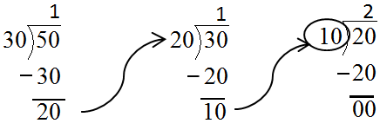
    - Using Euclid’s Algorithm, we follow the steps that are listed in the opening exercise.
When the remainder is zero, the final divisor is the GCF.
  - Apply Euclid’s Algorithm to find the GCF $(30,45)$.
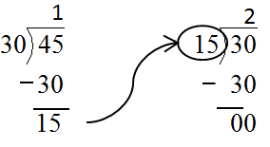
$15$

Example 3 (5 minutes): Larger Numbers
Example 3: Larger Numbers
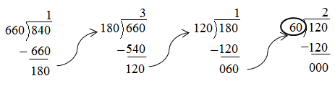
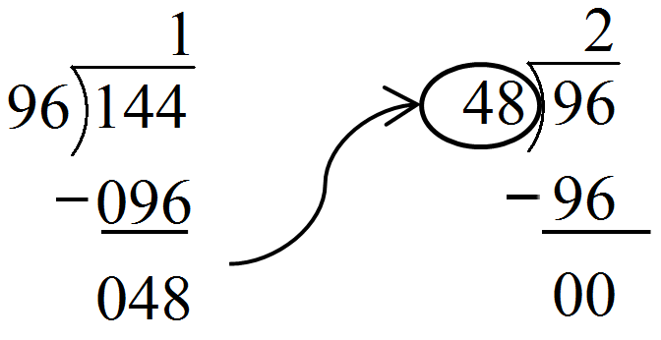
GCF $(96, 144)$ GCF $(660, 840)$

Example 4 (5 minutes): Area Problems
Example 4: Area Problems
The greatest common factor has many uses. Among them, the GCF lets us find out the maximum size of squares that will cover a rectangle. When we solve problems like this, we cannot have any gaps or any overlapping squares. Of course, the maximum size squares will be the minimum number of squares needed.
A rectangular computer table measures $30$ inches by $50$ inches. We need to cover it with square tiles. What is the side length of the largest square tile we can use to completely cover the table so that there is no overlap or gaps?

$$50$$
$$50$$

$$30$$
$$30$$

Direct students to consider the GCF $(30, 50)$, which they already calculated. It should become clear that squares of $10$ inches by $10$ inches will tile the area.
Scaffolding:
- To find the GCF of two numbers, give students rectangular pieces of paper using the two numbers as length and width (e.g., $6$ by $16$ cm.).
- Challenge students to mark the rectangles into the largest squares possible, cut them up, and stack them to assure their “squareness.”
- $GCF(6,16)=2$

- If we use squares that are $10$ by $10$, how many will we need?
$3·5$, or $15$ squares

- If this were a giant chunk of cheese in a factory, would it change the thinking or the calculations we just did?
No.

- How many $10$ inch × $10$ inch squares of cheese could be cut from the giant $30$ inch × $50$ inch slab?
$$15$$

Closing (4 minutes)
Scaffolding:
- Ask students to compare the process of Euclid’s Algorithm with a subtraction-only method of finding the GCF:
- List the two numbers.
- Find their difference.
- Keep the smaller of the two numbers; discard the larger.
- Use the smaller of the two numbers and the difference to form a new pair.
- Repeat until the two numbers are the same. This is the GCF.
Teacher resource:
http://www.youtube.com/watch?v=2HsIpFAXvKk
- Euclid’s Algorithm is used to find the greatest common factor (GCF) of two whole numbers. The steps are listed on your Student Page and need to be followed enough times to get a zero remainder. With practice, this can be a quick method for finding the GCF.
- Let’s use the steps to solve this problem: Kiana is creating a quilt made of square patches. The quilt is $48$ inches in length and $36$ inches in width. What is the largest size of square length of each patch?
- Divide the larger of the two numbers by the smaller one. What is the quotient?
  - $1$
- If there is a remainder, divide it into the divisor. What is the remainder?
  - $12$
- What is the divisor?
  - $36$
- Divide $36$ by $12$. What is the quotient?
  - $3$
- Continue dividing the last divisor by the last remainder until the remainder is zero. Is the remainder zero?
  - Yes.
- The final divisor is the GCF of the original pair of numbers. What is the final divisor?
  - $12$

Exit Ticket (5 minutes)
Name ___________________________________________________ Date____________________
Lesson 19: The Euclidean Algorithm as an Application of the Long Division Algorithm

Exit Ticket

Use Euclid’s Algorithm to find the greatest common factor of $45$ and $75$.
Exit Ticket Sample Solutions

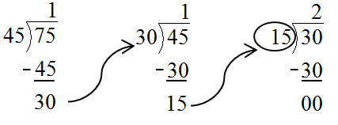
Use Euclid’s Algorithm to find the greatest common factor of $45$ and $75$.

GCF $\left(45,75\right)=15$

Problem Set Sample Solutions

- Use Euclid’s Algorithm to find the greatest common factor of the following pairs of numbers:
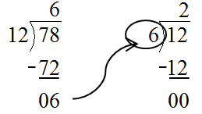
  - GCF $(12,78)$
GCF $\left(12,78\right)=6$

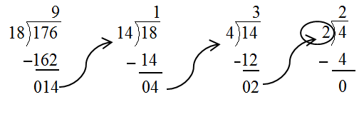
  - GCF $(18,176)$
GCF $\left(18,176\right)=2$

- Juanita and Samuel are planning a pizza party. They order a rectangular sheet pizza which measures $21$ inches by $36$ inches. They tell the pizza maker not to cut it because they want to cut it themselves.
  - All pieces of pizza must be square with none left over. What is the length of the side of the largest square pieces into which Juanita and Samuel can cut the pizza?
GCF $\left(21,36\right)=3$. They can cut the pizza into $3$ by $3$ inch squares.

  - How many pieces of this size will there be?
$7·12=84$. There will be $84$ pieces.

- Shelly and Mickelle are making a quilt. They have a piece of fabric that measures $48$ inches by $168$ inches.
  - All pieces of fabric must be square with none left over. What is the length of the side of the largest square pieces into which Shelly and Mickelle can cut the fabric?
GCF $\left(48,168\right)=24$

  - How many pieces of this size will there be?
$2·7=14$. There will be $14$ pieces.

