Lesson 14: The Division Algorithm—Converting Decimal Division into Whole Number Division Using Fractions

Student Outcomes
- Students use the algorithm to divide multi-digit numbers with and without remainders. Students compare their answer to estimates to justify reasonable quotients.
- Students understand that when they “bring down” the next digit in the algorithm, they are distributing, recording, and shifting to the next place value.

Classwork
Example 1 (5 minutes)
Students will review how to divide a whole number by a number that is not a factor resulting in a non-whole number quotient. They will first estimate the quotient. Then, they will use the division algorithm to get an exact answer. Finally, they will compare the two to decide if the answer is reasonable.
Example 1
Divide: $31,218÷132$.
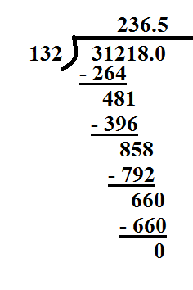
As we divide, we can use our knowledge of place value to guide us.
$312$ hundreds $÷132$: $2$ hundreds
$481$ tens $÷132$: $3$ tens
$858$ ones $÷132$: $6$ ones
$660$ tenths $÷132$: $5$ tenths
MP.2

- Estimate the quotient.
  - Answers may vary. Possible estimates include the following: $30,000÷100=300$ or
$30,000÷150=200$.
- How was solving this question similar to the questions you solved in Lessons 12 and 13?
  - Answers may vary. To get the quotient in all questions, I used the division algorithm where I divided two whole numbers.

- How was solving this question different from the questions you solved in Lessons 12 and 13?
  - Answers may vary. In this example, the divisor is not a factor of the dividend. I know this because the quotient is not a whole number. When I got to the ones place, I still had a remainder, so I placed a zero in the tenths place to continue dividing. Then, I divided $660$ tenths by $132$ ones. The answer to this question has a decimal in the quotient, but the other lessons had whole number quotients.

Example 2 (5 minutes)
- We have seen questions with decimals in the quotient. Now, let’s discuss how we would divide when there are decimals in the dividend and divisor.
Please note that this question is quite difficult. Students will most likely struggle with this question for quite some time, so you may want to offer this question as a challenge.
Example 2
Divide: $974.835÷12.45$.

Point out that all whole number division that students have done up until now has involved dividing two quantities that are ultimately counting with the same unit, ones (e.g., $32,218$ ones divided by $132$ ones).
MP.2
- Now, let’s take a look at what this question is asking, including the units.
  - $974$ ones and $835$ thousandths, $12$ ones and $45$ hundredths
- What do you notice about these two numbers?
  - They do not have the same unit.
- How could we rewrite these numbers so that they have the same units?
  - $974.835÷12.450$
  - $974,835$ thousandths, $12 ,450$ thousandths
- Now, the division problem that we need to solve is $974,835$ thousandths $÷ 12,450$ thousandths.
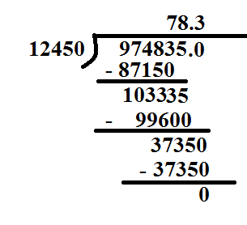

Example 3 (5 minutes)
Example 3
A plane travels $3,625.26$ miles in $6.9$ hours. What is the plane’s unit rate?

- What is this question asking us to do?
  - This question is asking me to divide the miles by hours so that I can find out how many miles the plane went in $1$ hour, as we did in Module 1.
- How can we rewrite $3,625.26$ ($362,526$ hundredths) and $6.9$ ($69$ tenths) using the same units?
  - First, I would rewrite the question as $3,625.26÷6.90$. This is the same as $362,526$ hundredths$÷690$ hundredths.
- Now we can solve by dividing $362,526÷690$.
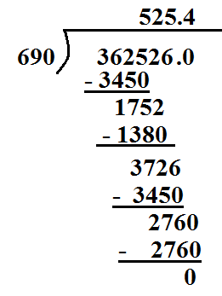
- Let’s check our answer to ensure that it is reasonable. What are some different ways that we can do this?
  - We can multiply the quotient with the original divisor and see if we get the original dividend. $6.9×525.4=3,625.26$.
  - We could also estimate to check our answer. $3,500÷7=500.$ Because we rounded down, we should expect our estimate to be a little less than the actual answer.

Exercises 1–7 (20 minutes)
Students can work on the problem set alone or in partners. Students should be estimating the quotient first and using the estimate to justify the reasonableness of their answer.
Exercises 1–7
Estimate the quotient first. Use the estimate to justify the reasonableness of your answer.
- Daryl spent $\$4.68$ on each pound of trail mix. He spent a total of $\$14.04$. How many pounds of trail mix did he purchase?
Estimate: $15÷5=3$
$14.04÷4.68$ $1,404$ hundredths $÷ 468$ hundredths
$1,404÷468=3$
Our estimate of $3$shows that our answer of $3$is reasonable.
- Kareem purchased several packs of gum to place in gift baskets for $\$1.26$ each. He spent a total of $\$8.82$. How many packs of gum did he buy?
Estimate: $9÷1=9$
$8.82÷1.26$ $882$ hundredths $÷ 126$ hundredths
$882÷126=7$packs of gum
Our estimate of $9$ shows that our answer of $7$ is reasonable.

- Jerod is making candles from beeswax. He has $132.72$ ounces of beeswax. If each candle uses $8.4$ ounces of beeswax, how many candles can he make? Will there be any wax left over?
Estimate: $120÷8=15$
$132.72÷8.4$ $13,272$ hundredths $÷ 84$ tenths $13,272$ hundredths $÷ 840$ hundredths
$13,272÷840=15$ candles; there is wax left over.
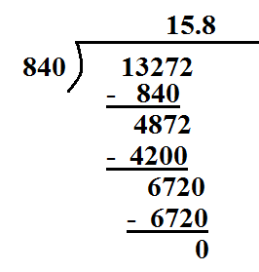
Our estimate of $15$ shows that our answer of $15.8$ is reasonable.

- There are $20.5$ cups of batter in the bowl. If each cupcake uses $0.4$ cups of batter, how many cupcakes can be made?
Estimate: $20÷0.5=40$
$20.5÷0.4$ $205$ tenths $÷ 4$ tenths
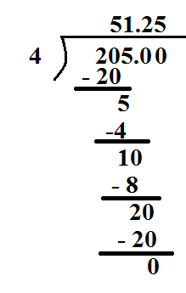
Only $51$ cupcakes can be made. There is not quite enough for $52$.
Our estimate of $40$shows that our answer of $51.25$is reasonable.

- In Exercises 3 and 4, how were the remainders, or extra parts, interpreted?
In both Exercises 3 and 4, the remainders show that there was not quite enough to make another candle or cupcake. In the candle example, there was wax left over that could be saved for the next time there is more wax. However, in the cupcake example, the leftover batter could be used to make a smaller cupcake, but it would not count as another whole cupcake.

- $159.12÷6.8$
Estimate: $160÷8=20$
$159.12÷6.8$ $15,912$ hundredths $÷ 68$ tenths $15,912$ hundredths $÷680$ hundredths
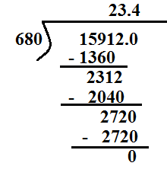
Our estimate of $20$ shows that our answer of $23.4$ is reasonable.

- $167.67÷8.1$
Estimate: $160÷8=20$
$167.67÷8.1 16,767$hundredths $÷ 81$tenths $16,767$ hundredths $÷810$ hundredths
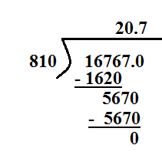
Our estimate of $20$shows that our answer of $20.7$is reasonable.

Closing (5 minutes)
- Describe the steps that you use to change a division question with decimals to a division question with whole numbers.
  - If the divisor and or the dividend are not whole numbers, we find the largest common unit, smaller than one, which allows us to rewrite each as a whole number multiple of this common unit.
  - Example:
$1,220.934$ ones $÷54.34$ ones
$12,209.34$ tenths $÷543.4$ tenths
$122,093.4$hundredths $÷5,434$ hundredths
$1,220,934$thousandths $÷54,340$ thousandths
We could keep going, and both the dividend and divisor would still be whole numbers, but we were looking for the largest common unit that would make this happen.

Exit Ticket (5 minutes)

Name ___________________________________________________ Date____________________
Lesson 14: The Division Algorithm—Converting Decimal Division into Whole Number Division Using Fractions

Exit Ticket

- Lisa purchased almonds for $\$3.50$ per pound. She spent a total of $\$14.70$. How many pounds of almonds did she purchase?

- Divide: $125.01÷5.4$. Then, check your answer for reasonableness.

Exit Ticket Sample Solutions

- Lisa purchased almonds for $\$3.50$ per pound. She spent a total of $\$14.70$. How many pounds of almonds did she purchase?
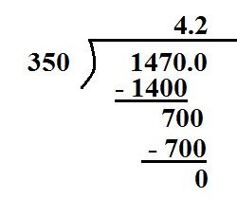
Lisa purchased $4.2$ pounds of almonds.

- Divide: $125.01÷5.4$. Then, check your answer for reasonableness.
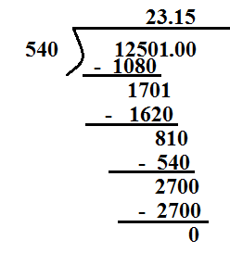
The quotient of $125.01$and $5.4$ is $23.15$.
Estimate: $125÷5=25$
My estimate of $25$ is near $23$, which shows that my answer is reasonable.

Problem Set Sample Solutions

- Aslan purchased $3.5$ lb. of his favorite mixture of dried fruits to use in a trail mix. The total cost was $\$16.87$. How much does the fruit cost per pound?
$16.87÷3.5 1,687$ hundredths $÷350$ hundredths
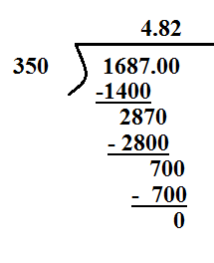
The dried fruit costs $\$4.82$per pound.

- Divide: $994.14÷18.9$.
$994.14÷18.9 99,414$hundredths $÷1,890$ hundredths

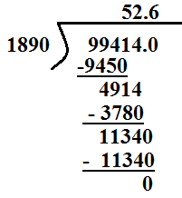
$994.14÷18.9=52.6$

