Lesson 13: Dividing Multi-Digit Numbers Using the Algorithm

Student Outcomes
- Students understand that the standard algorithm of division is simply a tally system arranged in place value columns.

Classwork
Example 1 (6 minutes)
The first example is a review from Lesson 12 that will prepare students to start taking a deeper look at the division algorithm.
Example 1
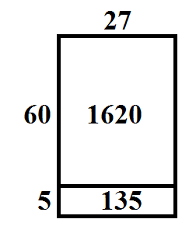
- Create a model to divide: $1,755÷27$.
Answers may vary. One possible solution:

MP.6
&
MP.8
- Use the division algorithm to show $1,755÷27$.
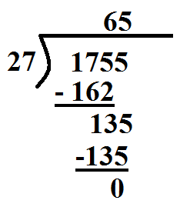
- Looking at your division work, where did the numbers $162$ and $135$ come from?
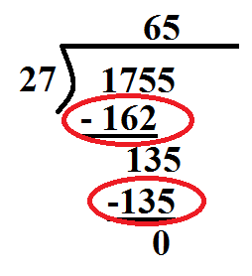
  - The $162$ comes from $27×6$. This is really showing $27×60$, which is $1,620$. The $135$ comes from $27×5$.
- If you had to describe what is happening underneath the division bar in your own words, what would you say? (For struggling students, have them think back to what they did when they used a model.)
  - The work under the long division bar shows how I keep track of the parts that I have already divided out. Then, I can see what remains to continue the process.

- Check your work.
$27×65=1,755$
Scaffolding:
For classes that need more practice, use the following examples:
$$7,182÷21=342$$
$$2,312÷34=68$$

Example 2 (6 minutes)
Example 2
Find the quotient of $205,276÷38$.
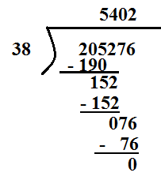
MP.6
&
MP.8

- How can we use estimation to start solving this problem?
  - Answers will vary. I can start by determining how many times $40$will divide into $200$ thousands. I know that $40×5=200$. So, I will start the division process by placing a $5$over the $5$in $205,276$. This $5$ represents $5$ thousands. So, we will show in the long division that $200$ thousands $÷38=5$thousands.
- Why did you divide $40$ into $200$ instead of $200,000$?
  - I thought of this problem as $40$ into $200$ thousands so that I could divide $40$ into $200$to make the division simpler.
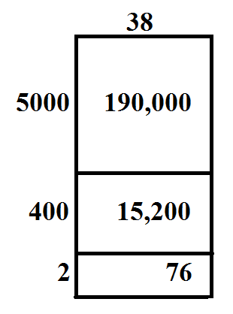
Give students a chance to complete the division. Students should also be creating a model to show the connection between the algorithm and the model.
- After you divided by $400$, what did you do next?
  - I had brought down the seven to complete the next step. However, $38$ does not divide into $7$ one or more times. This told me to put a $0$ in the tens place and bring down the $6$ to continue dividing.
- Imagine that your friend wrote $542$ as the answer. How could you prove to your friends that $542$ is not the solution?
  - Answers may vary. I could use estimation. I would round the divisor and quotient and multiply them to see if I get an estimate that is close to the dividend, $40×500=20,000$. The estimate is about $10$ times too small. So, I can tell that the numbers are in the wrong place. I should have an estimate around $200,000$.
Now, let’s use the algorithm to work through a division question that involves a much larger number.

Example 3 (6 minutes)
Example 3
Find the quotient of $17,216,673÷23$.

- When working with a dividend as large as this, what would happen if we tried to solve this question using a model?
  - Answers will vary. The model would be difficult to make because it could have many parts for the different place values.
MP.6
&
MP.8
- It might be difficult to figure out how many times $23$ goes in to this whole number. So, we can break this into parts. Does $23$ go into $1$ one or more times? Does $23$ go into $17$ one or more times? Will $23$ divide into $172$one or more times?
  - $23$ does not go into $1$ or $17$ one or more times. However, $23$ will go into $172$ one or more times.
- Could we use estimation to help us start the problem?
  - We could think about $175÷25$ or $180÷20$(or other possible estimations that are backed by mathematical reasoning).
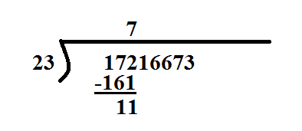
Remind students that what we are actually doing is $172$hundred thousands $÷23=7$ hundred thousands.
Each step can be represented using the units.

- Why would we place the $7$ over the $2$ and not somewhere else? What does the $7$ represent?
  - The $7$shows how many times $23$ goes into $172$, but it really represents how many times $23$ goes into $17,200,000$. Because the $7$ represents $700,000$, we place the $7$over the $2$in the hundred thousands place.
- When we subtracted, we got an $11$. What does this $11$ represent?
  - The $11$ shows the difference between $172$ and $161$, but it actually represents $1,100,000$. This is the amount remaining after $23$groups of $700,000$ are taken from $17,200,000$.

- After we have completed this first set of steps, where do we go next?
  - We could keep repeating the process until we reach the ones place.
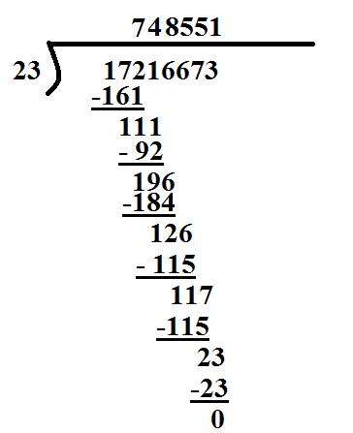
When discussing the remaining steps, you can refer to them as follows:
$111$ ten thousands $÷23$: $4$ ten thousands
$196$thousands $÷23$: $8$ thousands
$126$hundreds $÷23$: $5$hundreds
$117$tens $÷23$: $5$ tens
$23$ ones $÷23=1$
MP.6
&
MP.8

- How can we determine if the answer is reasonable?
  - We could multiply the quotient with the divisor. $748,551×23=17,216,673.$
  - We could also use an estimate to check our work. $20,000,000÷20=1,000,000$. Our estimate is slightly larger because we rounded the dividend up.

Exercises 1–6 (20 minutes)
Give students a chance to practice using the division algorithm. Students may not be able to complete all questions in the time given.
Exercises 1–6
For each question, you need to do the following:
  - Solve the question. Next to each line, explain your work using place value.
  - Evaluate the reasonableness of your answer.
- $89$ ten thousands $÷12$: $7$ ten thousands
$51$ thousands $÷12$: $4$thousands
$31$ hundreds $÷12$: $2$hundreds
$75$ tens $÷12$:$6$tens
$36$ ones $÷12$: $3$ ones

- $74,263×12=891,156$

- $891,156÷12$
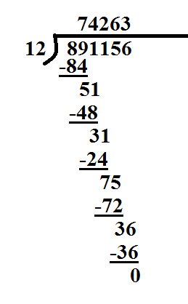

- $484,692÷78$

- $484$ thousands $÷78$: $6$ thousands
$166$ hundreds $÷78$: $2$ hundreds
$109$ tens $÷78$: $1$ ten
$312$ ones $÷78$: $4$ ones

- $6,214×78=484,692$

- $281$ thousands $÷33$: $8$ thousands
$178$ hundreds $÷33$: $5$ hundreds
$138$ tens $÷33$: $4$ tens
$66$ ones $÷33$: $2$ ones

- $8,542×33=281,886$

- $229$ ten thousands $÷37$:$6$ten thousands
$75$ thousands $÷37$:$2$ thousands
$15$ hundreds $÷37$:$0$ hundreds
$151$ tens $÷37$:$4$ tens
$37$ ones $÷37$:$1$ one

- $62,041×37=2,295,517$

- $952$ thousands $÷112$:$8$thousands
$564$ hundreds $÷112$:$5$ hundreds
$44$ tens $÷112$:$0$ tens
$448$ ones $÷112$: $4$ ones

- $8,504×112=952,448$

- $1,823$ thousands $÷245$: $7$ thousands
$1,085$ hundreds $÷245$: $4$ hundreds
$1,053$ tens $÷245$: $4$ tens
$735$ ones $÷245$: $3$ ones

- $7,443×245=1,823,535$

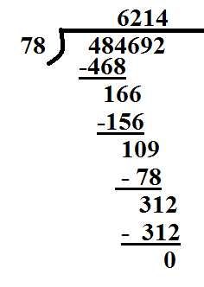

- $281,886÷33$
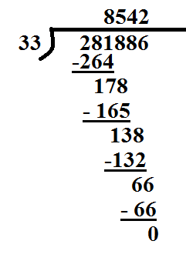

- $2,295,517÷37$
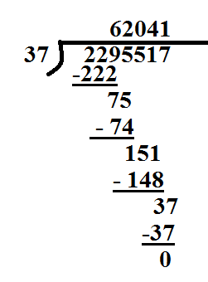

- $952,448÷11$
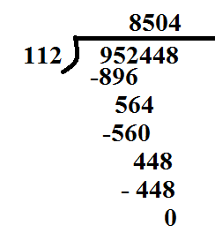

- $1,823,535÷245$
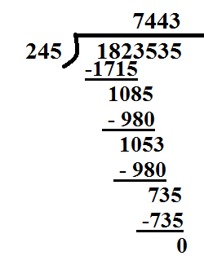
Closing (3 minutes)
- Explain in your own words how the division algorithm works.
  - Answers will vary. Sample response: The division algorithm shows successive estimates of the quotient organized by place value, or the division algorithm breaks one large division problem into several smaller ones organized by place value.

Exit Ticket (4 minutes)
Name ___________________________________________________ Date____________________
Lesson 13: Dividing Multi-Digit Numbers Using the Algorithm

Exit Ticket

Divide using the division algorithm: $392,196÷87$.

Exit Ticket Sample Solutions

Divide using the division algorithm: $392,196÷87$.
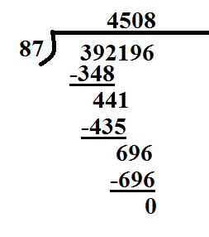

Problem Set Sample Solutions

- $459,054÷54$
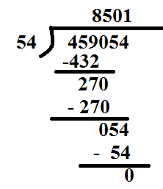

- $820,386÷102$
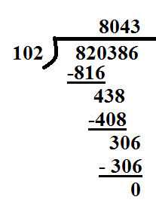

- $1,183,578÷227$
