Lesson 12: Estimating Digits in a Quotient

Student Outcomes
- Students connect estimation with place value in order to determine the standard algorithm for division.

Classwork
Opening Exercise (5 minutes)
Opening Exercise
Show an example of how you would solve $5,911÷23$. You can use any method or model to show your work. Just be sure that you can explain how you arrived at your solution.
There are many possible models. Here is one possible solution:
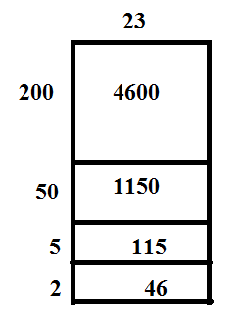

$$5,911÷23=257$$

We may want to check our work to see if our answer is reasonable. One way to do this is to estimate our answer.
- Estimate the quotient of $5,911$ and $23$.
  - Answers will vary. Sample solution: First I would round the numbers to $6,000$and $20$.
  - Answer will vary. Sample solution: $6,000÷20=300$.
- Using your estimation, would you say that the answer you came up with in your model is reasonable?
- Answers will vary. Sample solution: Yes, $257$ is close to $300$. This shows that my answer is reasonable.
- Would you expect your estimated answer to be greater than or less than the actual answer? Why?
- Answers will vary. Sample solutions: Since I chose to round $23$ to $20$, I expect that the estimated answer will be greater than the actual quotient. If I had rounded up to $25$, the estimated answer would be smaller than the actual quotient. (Students could also respond that $5,911$ was rounded to $6,000$. Because the number was rounded up, we know that the estimate will be larger than the actual answer.)
- What other ways can we check our solution?
  - I can use the inverse of division (multiplication) to check my work.

Example 1 (10 minutes)
Example 1
We can also use estimates before we divide to help us solve division problems. In this lesson, we will be using estimation to help us divide two numbers using the division algorithm.
Estimate the quotient of $8,085÷33$. Then, divide.
$8,100÷30=270$.

- How could I round these numbers to get an estimate?
  - There are many possible solutions. For example, $8,000÷30$; $8,000÷35$; $8,100÷30$; $8,100÷35$.
- Why is $8,100$ and $30$ the best option?
  - $3$ is not a factor of $8$, but it is a factor of $81$.
- How can we use this to help us divide $8,085$ by $33$?
  - When I begin to divide, I use $270$to help me choose what numbers to divide by. My actual answer should be near $270$. The first number I used in my area model will be $200$. Then, I will see that the remainder is $1,485$. I know that $30×50=1,500$, which is too big. So, I will choose one less ten and try $40$.
MP.8
Create a model to show the division of $8,085$ by $33$.
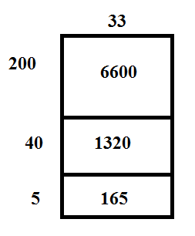
- We can keep track of the areas in the model and what we have left by making a list and subtracting. We will create a list to keep track of the amounts the same way we created the diagram.
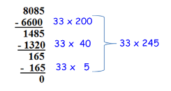

- Now, we can relate this model to the standard division algorithm.
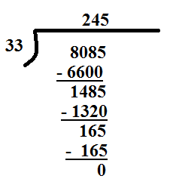
MP.8

At this point, you are just showing how this work is the same as the work that is shown in the model.
- What does the $2$represent on top of the division bar?
  - We divided $80$ hundreds by $33$, so the $2$ represents $2$ hundreds.
- How did we use the $200$ in the previous model?
  - $33×200=6,600$
- What does the $4$ represent on top of the division bar?
  - We divided $148$ tens by $33$, so the $4$represents $4$ tens.
- How was the$40$ used in the previous model?
  - $33×40=1,320$.
- Now let’s check our division. How can we use the quotient to check our work?
  - $245×33=8,085$.

Example 2 (10 minutes)
Example 2
Use estimation and the standard algorithm to divide: $1,512÷27$.

Students will estimate the quotient first and use the estimate to help them divide using the algorithm.
- Share an estimate that can be used to help us divide.
  - Answers may vary. $1,500÷30=50$.
- In the algorithm, we can show that there are fifty $27$s by placing a $5$ over the tens place. We know that $5$ tens is $50$. This is really showing that $151$ tens $÷27=5$ tens.
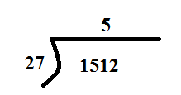

- What would typically be the next step if you were creating a model? (Students can create the model while solving to further solidify the connection.)
  - I would multiply $50×27$, which is $1,350$. Then, I would subtract $1,350$ from $1,512$. 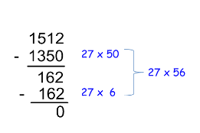
We will show these same steps in the algorithm.
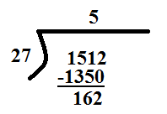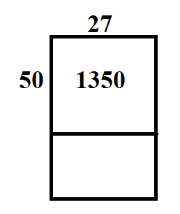
MP.8
- What would we do next?
  - $162$ ones $÷27$. I know that $30×5$ is $150$. So, I am going to estimate that the answer is greater than $5$. Maybe there are six $27$s in $162$.
- We will show the same steps again where we check our work by multiplying and subtracting.
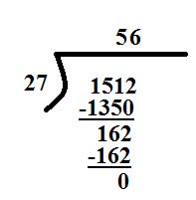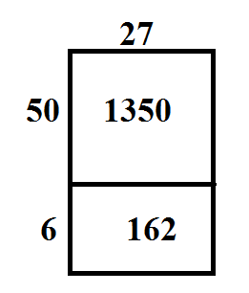
- Finally, we will check our work. Remind me one more time how we can check our quotient.
  - We can multiply $27×56$ and see if the product is $1,512$.

Exercises 1–4 (10 minutes)
Exercises 1–4
- $1,008 ÷48$
  - Estimate the quotient.
Answers may vary.
$$1,000÷50=20$$

  - Use the algorithm to divide. Draw a model to show how the steps relate to the steps used in the algorithm.
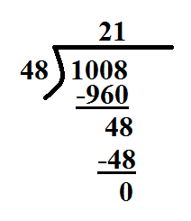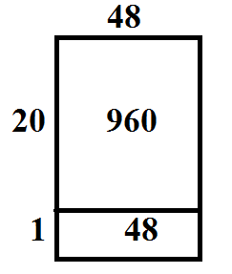

  - Check your work.
$$48×21=1,008$$

- $2,508÷33$
  - Estimate the quotient.
Answers may vary.
$$2,400÷30=80$$

  - Use the algorithm to divide. Draw a model to show how the steps relate to the steps used in the algorithm.
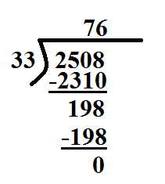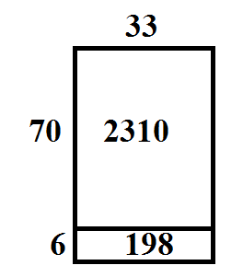

  - Check your work.
$$33×76=2,508$$

- $2,156÷28$
  - Estimate the quotient.
Answers may vary.
$$2,100÷30=70$$

  - Use the algorithm to divide.
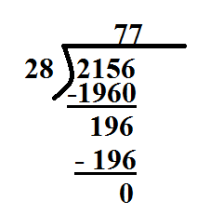

  - Check your work.
$$28×77=2,156$$
- $4,732÷52$
  - Estimate the quotient.
Answers may vary.
$$5,000÷50=100$$

  - Use the algorithm to divide.
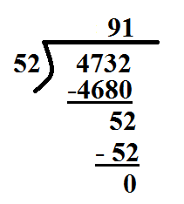

  - Check your work.
$$52×91=4,732$$

Closing (5 minutes)
- How does estimation help you with the process of finding the exact quotient?
  - My estimate gives me an idea of what number my answer should be close to. For example, if I have an estimate of $75$, I know not to try a number in the hundreds.
- In the previous problem, we used $100$ to approximate the quotient $4,732÷52$. How did we know that our actual quotient would be in the $90$s and not $100$ as our approximation suggested? When using your estimate, how do you know if your estimate is too big?
  - I know that $100×52=5,200$, and this is greater than $4,732$. This tells me to start with a $9$ in the tens place.
- When using your estimate, how do you know if your estimate is too small?
  - When I subtract, the difference is bigger than the divisor.

Exit Ticket (5 minutes)

Name ___________________________________________________ Date____________________
Lesson 12: Estimating Digits in a Quotient

Exit Ticket

- Estimate the quotient: $1,908÷36$.

- Use the division algorithm and your estimate to find the quotient: $1,908÷36$.

- Use estimation to determine if $8,580÷78$ has a quotient in the $10$s, $100$s, or $1000$s.

Exit Ticket Sample Solutions

- Estimate the quotient: $1,908÷36$.
$$2,000÷40=50$$

- Use the division algorithm and your estimate to find the quotient: $1,908÷36$.
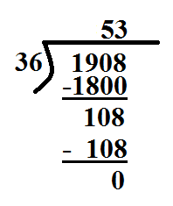

- Use estimation to determine if $8,580÷78$ has a quotient in the $10$s, $100$s, or $1000$s.
I would round $8,580$ to $8,800$ and $78$ to $80$. $8,800÷80=110$. I know that the quotient should be in the $100$s.

Problem Set Sample Solutions

Complete the following steps for each problem:
  - Estimate the quotient.
  - Use the division algorithm to solve.
  - Show a model that supports your work with the division algorithm.
  - Check your work.

- $3,312÷48$
$$3,500÷50=70$$
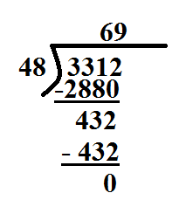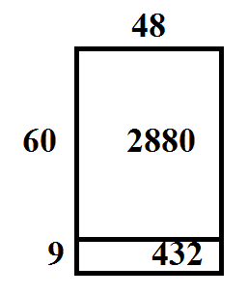
$$48×69=3,312$$

- $3,125÷25$
$$3,000÷30=100$$
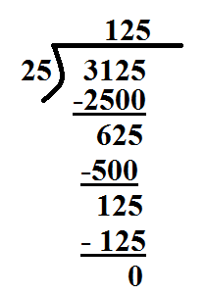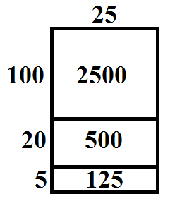

$$25×125=3,125$$

- $1,344÷14$
$$1,400÷14=100$$
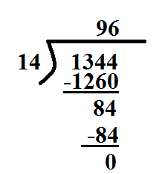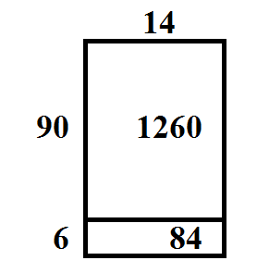
$$14×96=1,344$$

