Lesson 20: Comparison Shopping—Unit Price and Related Measurement Conversions

Student Outcomes
- Students solve problems by analyzing different unit rates given in words, tables, equations, and graphs.

Classwork
An activity will be completed in order to gain confidence in comparing rates in tables, graphs, and equations.

Example 1 (5 minutes): Notes from Exit Ticket
Discuss the results of the Exit Ticket from the day before. Make sure students are able to interpret rates and unit rates given information in tables, graphs, and equations.
Example 1: Notes from Exit Ticket
Take notes from the discussion in the space provided below.
Notes:

Exploratory Challenge (30 minutes)
Have students work on the following exercises in pairs or individually. Tell students that this information was practiced in the previous lesson, so this is an opportunity for extra practice.
Allow students to use calculators and remind them to round any answers dealing with money to the nearest penny.
MP.2
Walk around the room while students are working to check for understanding. If the teacher is not confident with the students’ skills after the previous lesson, these questions can be completed one at a time with a discussion after each problem.
If problems are not done one at a time, provide students time to share their answers and their methods of arriving at an answer. This time can also be used for students to ask any questions they may have.

Exploratory Challenge
- Mallory is on a budget and wants to determine which cereal is a better buy. A $10$-ounce box of cereal costs $\$2.79$, and a $13$-ounce box of the same cereal costs $\$3.99$.
  - Which box of cereal should Mallory buy?
Because the $10$-ounce box costs about $28$ cents per ounce, and the $13$-ounce box costs about $31$ cents per ounce, Mallory should buy the $10$-ounce box of cereal.

  - What is the difference between the two unit prices?
The $10$-ounce box of cereal would be preferred because it is $3$ cents cheaper per ounce.

- Vivian wants to buy some watermelon. Kingston’s Market has $10$-pound watermelons for $\$3.90$, but the Farmer’s Market has $12$-pound watermelons for $\$4.44$.
  - Which market has the best price for watermelon?
The Farmer’s Market has the best price for watermelons.

  - What is the difference between the two unit prices?
The $12$-pound watermelon is a better deal because it is $2$ cents cheaper per pound.

- Mitch needs to purchase soft drinks for a staff party. He is trying to figure out if it is cheaper to buy the $12$-pack of soda or the $20$-pack of soda. The $12$-pack of soda costs $\$3.99$, and the $20$-pack of soda costs $\$5.48$.
MP.2
  - Which pack should Mitch choose?
$20$-pack of soda for $\$5.48$

  - What is the difference between the costs of one can of soda between the two packs?
The difference between the costs of one can of soda is $6$ cents.

- Mr. Steiner needs to purchase $60$ AA batteries. A nearby store sells a $20$-pack of AA batteries for $\$12.49$ and a $12$-pack of the same batteries for $\$7.20$.
  - Would it be less expensive for Mr. Steiner to purchase the batteries in $20$-packs or $12$-packs?
He should purchase five $12$-pack of batteries for $\$7.20$ for a total cost of $\$36.00$.

  - What is the difference between the costs of one battery?
The difference between the costs of one battery is $2$ cents.

- The table below shows the amount of calories Mike burns as he runs.
Number of Miles Ran | $$3$$ | $$6$$ | $$9$$ | $$12$$
Number of Calories Burned | $$360$$ | $$720$$ | $$1,080$$ | $$1,440$$
Fill in the missing part of the table.

- Emilio wants to buy a new motorcycle. He wants to compare the gas efficiency for each motorcycle before he makes a purchase. The dealerships presented the data below.
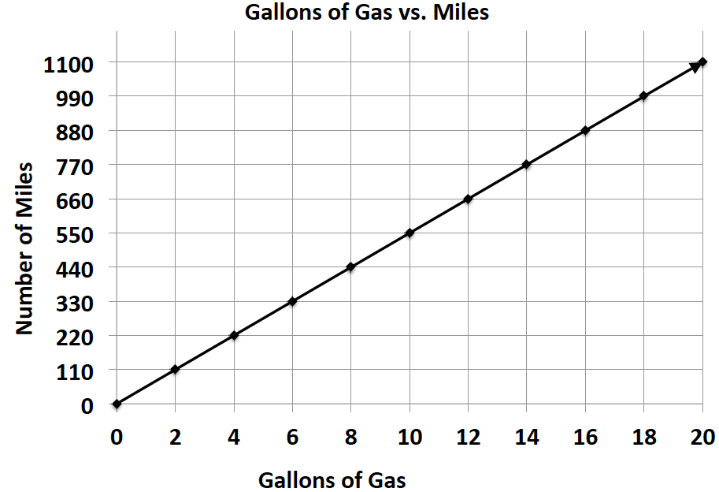
Sports Motorcycle: Leisure Motorcycle:
Number of Gallons of Gas | $$5$$ | $$10$$ | $$15$$ | $$20$$
Number of Miles | $$287.5$$ | $$575$$ | $$862.5$$ | $$1,150$$

Which motorcycle is more gas efficient and by how much?
The sports motorcycle gets $2.5$ more miles per gallon of gas.

- Milton Middle School is planning to purchase a new copy machine. The principal has narrowed the choice to two models: SuperFast Deluxe and Quick Copies. He plans to purchase the machine that copies at the fastest rate. Use the information below to determine which copier the principal should choose.
SuperFast Deluxe:
Quick Copies:
$$c = 1.5t$$
(where $t$ represents the amount of time in seconds and $c$ represents the number of copies)
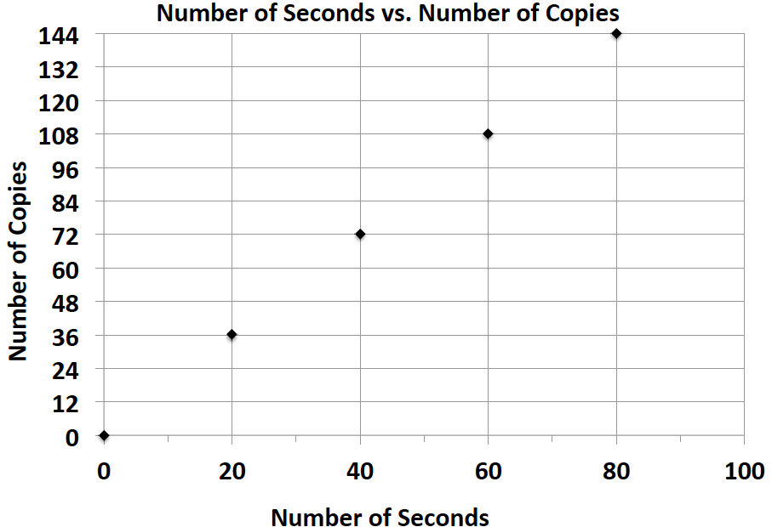

MP.2

SuperFast Deluxe

- Elijah and Sean are participating in a walk-a-thon. Each student wants to calculate how much money he would make from his sponsors at different points of the walk-a-thon. Use the information in the tables below to determine which student would earn more money if they both walked the same distance. How much more money would that student earn per mile?
Number of Miles Walked | $$7$$ | $$14$$ | $$21$$ | $$28$$
Money Earned in Dollars | $$35$$ | $$70$$ | $$105$$ | $$140$$
Elijah’s Sponsor Plan:

Sean’s Sponsor Plan:
Number of Miles Walked | $$6$$ | $$12$$ | $$18$$ | $$24$$
Money Earned in Dollars | $$33$$ | $$66$$ | $$99$$ | $$132$$

Sean earns $50$ cents more than Elijah every mile.

- Gerson is going to buy a new computer to use for his new job and also to download movies. He has to decide between two different computers. How many more kilobytes does the faster computer download in one second?
Choice 1: The rate of download is represented by the equation: $k=153t$, where $t$ represents the amount of time in seconds and $k$ represents the number of kilobytes.
Choice 2: The rate of download is represented by the equation: $k=150t$, where $t$ represents the amount of time in seconds and $k$ represents the number of kilobytes.
Choice $1$ downloads $3$ more kilobytes per second than Choice $2$.

- Zyearaye is trying to decide which security system company he will make more money working for. Use the graphs below that show Zyearaye’s potential commission rate to determine which company will pay Zyearaye more commission. How much more commission would Zyearaye earn by choosing the company with the better rate?
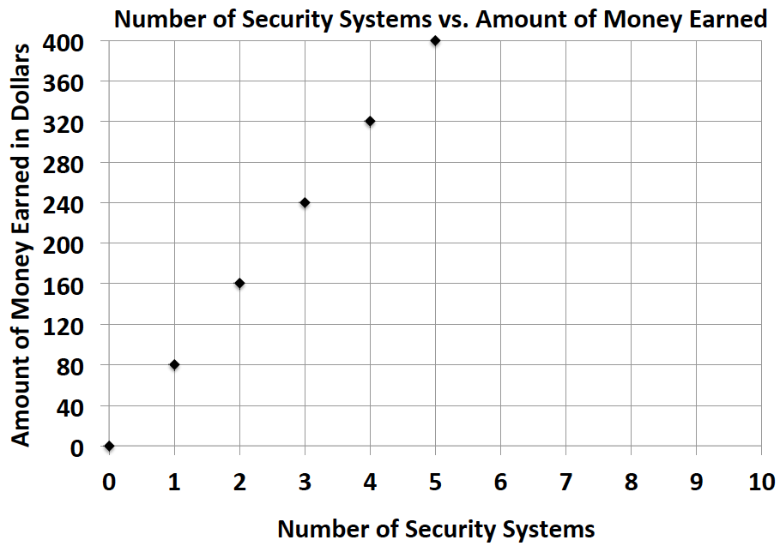
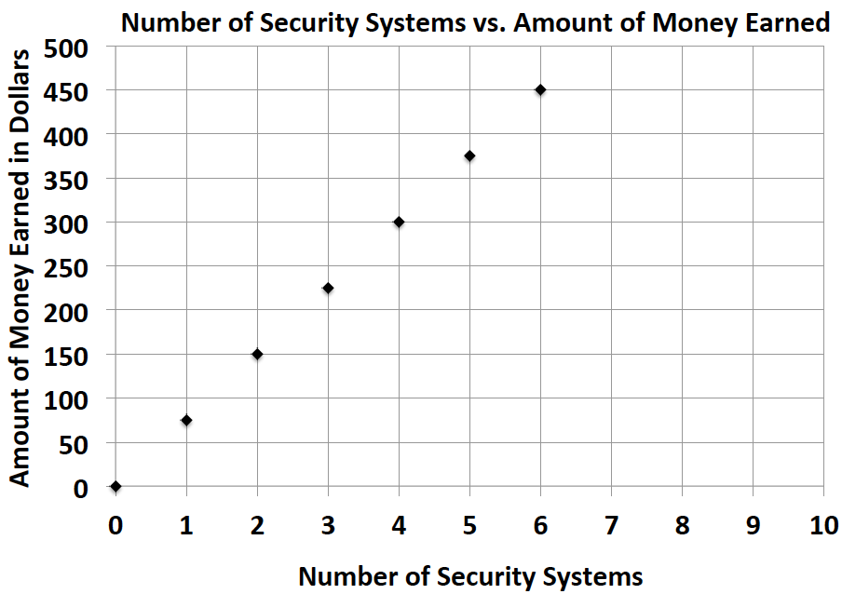
Superior Security: Top Notch Security:

MP.2

Superior Security would pay $\$5$ more per security system sold than Top Notch Security.

- Emilia and Miranda are sisters, and their mother just signed them up for a new cell phone plan because they send too many text messages. Using the information below, determine which sister sends the most text messages. How many more text messages does this sister send per week?
Emilia:
Number of Weeks | $$3$$ | $$6$$ | $$9$$ | $$12$$
Number of Text Messages | $$1,200$$ | $$2,400$$ | $$3,600$$ | $$4,800$$

Miranda: $m=410w$, where $w$ represents the number of weeks and $m$ represents the number of text messages.
Miranda sends $10$ more text messages per week than Emilia.

Closing (5 minutes)
- What did all of the problems we solved today have in common?
Each involved using unit rates, although the information was provided in different forms.

Lesson Summary
Unit Rate can be located in tables, graphs, and equations.
- Table – the unit rate is the value of the first quantity when the second quantity is 1.
- Graphs – the unit rate is the value of $r$ at the point $(1, r)$.
- Equation – the unit rate is the constant number in the equation. For example, the unit rate in $r=3b$ is $3$.

Exit Ticket (5 minutes)

Name ___________________________________________________ Date____________________
Lesson 20: Comparison Shopping—Unit Price and Related Measurement Conversions

Exit Ticket

Value Grocery Mart and Market City are both having a sale on the same popular crackers. McKayla is trying to determine which sale is the better deal. Using the given table and equation, determine which store has the better deal on crackers? Explain your reasoning. (Remember to round your answers to the nearest penny.)

Value Grocery Mart:
Number of Boxes of Crackers | $$3$$ | $$6$$ | $$9$$ | $$12$$
Cost (in dollars) | $$5$$ | $$10$$ | $$15$$ | $$20$$

Market City:
$c = 1.75b$, where $c$ represents the cost in dollars and $b$ represents the number of boxes of crackers

Exit Ticket Sample Solutions

Value Grocery Mart and Market City are both having a sale on the same popular crackers. McKayla is trying to determine which sale is the better deal. Using the given table and equation, determine which store has the better deal on crackers. Explain your reasoning. (Remember to round your answers to the nearest penny.)
Value Grocery Mart:
Number of Boxes of Crackers | $$3$$ | $$6$$ | $$9$$ | $$12$$
Cost (in dollars) | $$5$$ | $$10$$ | $$15$$ | $$20$$
Market City:
$c = 1.75b$, where $c$ represents the cost in dollars and $b$ represents the number of boxes of crackers
Value Grocery Mart is better because one box of crackers would cost $\$1.67$. One box of crackers at Market City would cost $\$1.75$, which is a little more expensive than Value Grocery Mart.
Problem Set Sample Solutions

The table below shows the amount of money Gabe earns working at a coffee shop.
Number of Hours Worked | $$3$$ | $$6$$ | $$9$$ | $$12$$
Money Earned (in dollars) | $$40.50$$ | $$81.00$$ | $$121.50$$ | $$162.00$$

- How much does Gabe earn per hour?
Gabe earns $\$13.50$ per hour.

- Jordan is another employee at the same coffee shop. He has worked there longer than Gabe and earns $\$3$ more per hour than Gabe. Complete the table below to show how much Jordan earns.
Hours Worked | $$4$$ | $$8$$ | $$12$$ | $$16$$
Money Earned (in dollars) | $$66$$ | $$132$$ | $$198$$ | $$264$$

- Serena is the manager of the coffee shop. The amount of money she earns is represented by the equation: $m=21h$, where $h$ is the number of hours Serena works and $m$ is the amount of money she earns. How much more money does Serena make an hour than Gabe? Explain your thinking.
$21-13.5=7.50$Serena makes $\$7.50$ per hour more than Gabe.

- Last month, Jordan received a promotion and became a manager. He now earns the same amount as Serena. How much more money does he earn per hour now that he is a manager than he did before his promotion? Explain your thinking.
Jordan now makes the same amount as Serena, which is $\$21$ an hour. Jordan previously made $\$16.50$ an hour, so $21-16.50=\$4.50$. Therefore, Jordan will make an additional $\$4.50$ an hour now that he is a manager.

